Test case 1: Login with Admin role with correct username and password.

Test case 2: Login with User role

Expected: system should show not allow further navigation

**Test case 3:** Login with Admin role and wrong user name/password

Expected: system should show not allow further navigation

**Test case:4** Login with Admin and configure new teacher (from below screen shot click on Configure Teachers)

Expected: New Teacher should be persisted and shown the list

**Test case 5:** Login with Admin and configure new teacher (from below screen shot click on Configure Teachers) and try entering the teacher ID which is already present

Expected: New Teacher should not persisted and provide message to UI

**Test case 6:** Login with Admin and View all teachers (from below screen shot click on View all teachers)

Expected: Teachers information should be extracted from DB and shown on UI.

**Test case 7:** Login with Admin and Configure new subjects from UI (from below screen shot click on Configure Subjects)

Expected: Subjects information should be persisted into DB and shown on UI.

**Test case 8:** Login with Admin and Configure new subjects from UI, the respective SubjectID already exist in the DB (from below screen shot click on Configure Subjects)

Expected: Subjects information should be persisted into DB and shown on UI.

**Test case 9:** Login with Admin and Extract all subjects from UI, in the DB (from below screen shot click on View all Subjects)

Expected: Subjects information should be extracted from DB and shown on UI.

**Test case 10:** Login with Admin and Configure new classes from UI (from below screen shot click on Configure Classes)

Expected: Classes information should be persisted into DB and shown on UI.

**Test case 11:** Login with Admin and Configure new classes from UI, but the respective class id already present (from below screen shot click on Configure Classes)

Expected: Classes information should not be persisted into DB and message shown on UI.

**Test case 12:** Login with Admin and View classes from UI (from below screen shot click on View Classes)

Expected: Classes information should not be persisted into DB and message shown on UI.

**Test case 13:** Login with Admin and Configure – Class with Teacher with Subjects from UI (from below screen shot click on Configure Class with Subjects)

Expected: Class with subject information should be persisted into DB.

**Test case 14:** Login with Admin and Configure – Class with Teacher with Subjects from UI, but enter the subject already assigned to the class (from below screen shot click on Configure Class with Subjects)

Expected: System should not allow, since for the given Class, respective Subject Id already assigned .

**Test case 14:** Login with Admin and Configure – Class with Teacher with Subjects from UI, but enter the class which is not part of already assigned to the class (from below screen shot click on Configure Class with Subjects)

Expected: System should not allow, since for the given Class, respective Subject Id already assigned.

**Test case 14:** Login with Admin and Configure – Class with Teacher with Subjects from UI, but enter the **Teacher** which is not part of already assigned to the **Teacher** (from below screen shot click on Configure Class with Subjects)

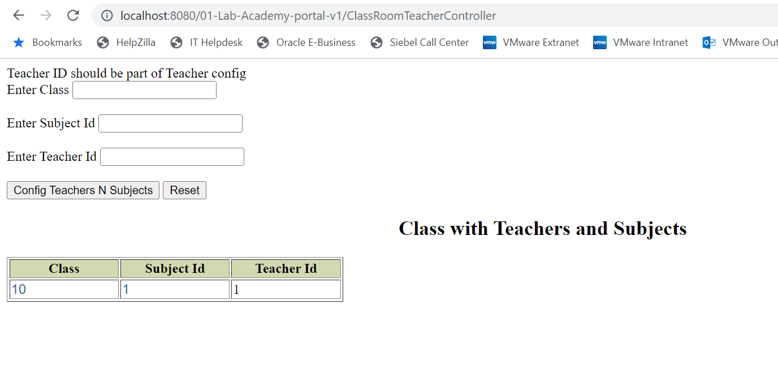

**Test case 15:** Login with Admin and View Class Teacher with Subjects – from UI select this option

Expected: System should extract Teacher with Subject details from DB and shown on the UI.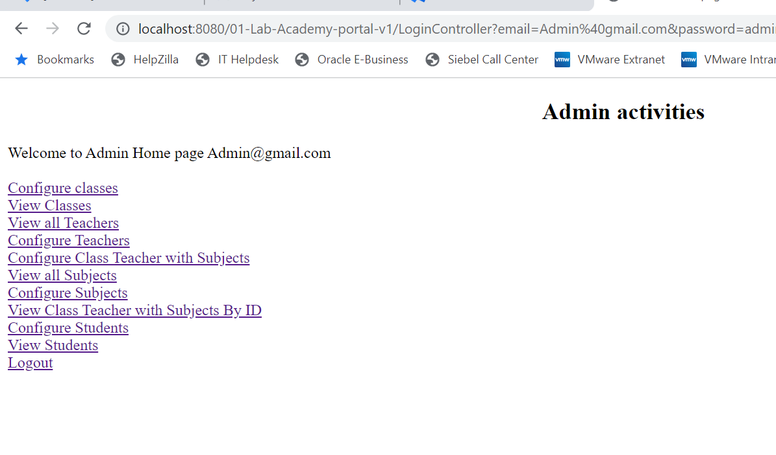

**Test case 16:** Login with Admin and Configure Students – from UI select this option (Configure Students)

Expected: System should persist Student records in the DB,

**Test case 17 :** Login with Admin and Configure Students, but respective Class number is not part of the Classes object – from UI select this option (Configure Students)

Expected: System should throw an error, since provided class number is not part of the DB and message shown to UI.

**Test case 18 :** Login with Admin and Configure Students, but respective Student name entered more character based on the DB.– from UI select this option (Configure Students)

Expected: System should throw an error, since provided student name is greater than of the DB and message shown to UI.

**Test case 18 :** Login with Admin, select View students (from the link)

Expected: System should extract the student details from the DB and shown on UI.

