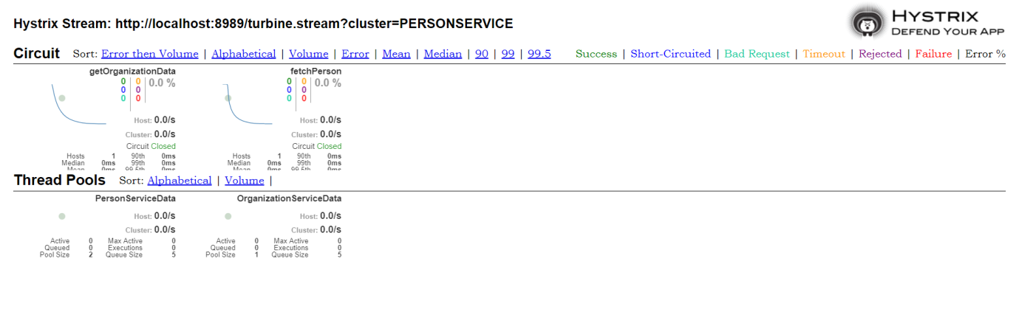

<http://localhost:8989/hystrix/>

**http://localhost:8989/turbine.stream?cluster=PERSONSERVICE**

Turbine + Hystrix

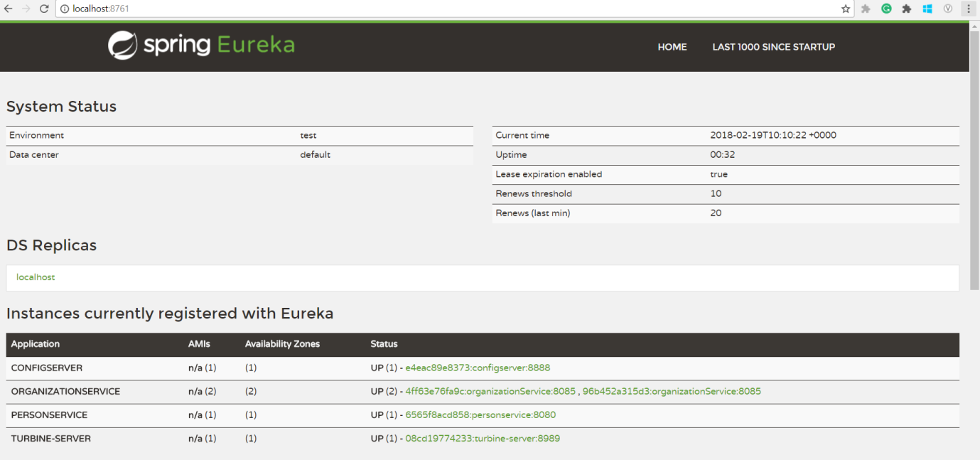

Eureka

ribbonTimeout = (ribbonReadTimeout + ribbonConnectTimeout) * (maxAutoRetries + 1) * (maxAutoRetriesNextServer + 1);

...

if(hystrixTimeout < ribbonTimeout) {

LOGGER.warn("The Hystrix timeout of " + hystrixTimeout + "ms for the command " + commandKey +

" is set lower than the combination of the Ribbon read and connect timeout, " + ribbonTimeout + "ms.");

}

Local Testing:  
  
1. Up the Mysql  
2. Up the redis

3. Auth –server access token

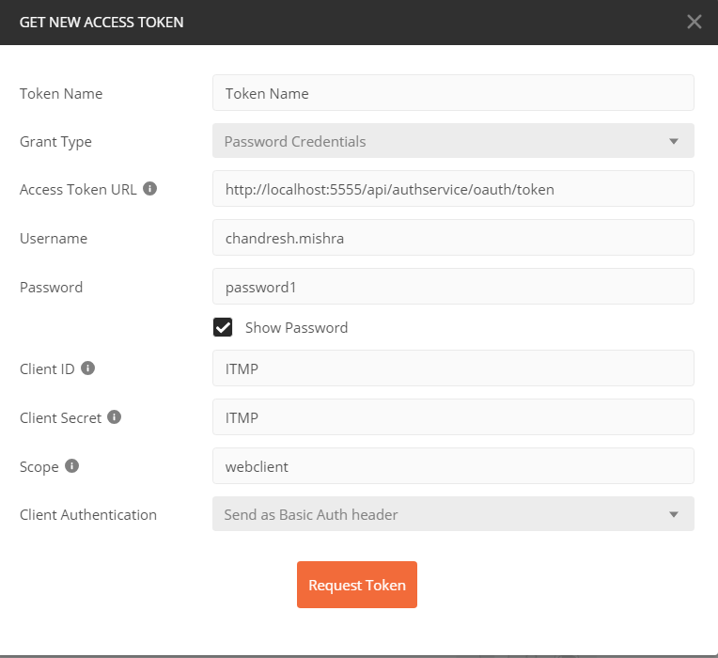

ZUUL: <http://localhost:5555/actuator/routes>

4. Eureka <http://localhost:8761/login>

5. Turbine <http://localhost:8989/hystrix/monitor?stream=http%3A%2F%2Flocalhost%3A8989%2Fturbine.stream%3Fcluster%3DPERSONSERVICE>

[**http://localhost:8989/turbine.stream?cluster=PERSONSERVICE**](http://localhost:8989/turbine.stream?cluster=PERSONSERVICE)

6. Rabbit MQ [http://localhost:15672](http://localhost:15672/)

7. Get from person

<http://localhost:5555/api/personservice/getPerson?nino=12345Ac&id=1>

8: zipkin <http://localhost:9411/zipkin/>

9: papertrail <https://papertrailapp.com/systems/setup?type=system&platform=unix>

10: chaos Monkey:

Status: <http://localhost:8085/actuator/chaosmonkey/status>

Enable: <http://localhost:8085/actuator/chaosmonkey/enable>

Update assaults: <http://localhost:8085/actuator/chaosmonkey/assaults>

{

"level": 1,

"latencyRangeStart": 22000,

"latencyRangeEnd": 40000

}

Watchers: <http://localhost:8085/actuator/chaosmonkey/watchers>

{

"controller": true,

"restController": true,

"service": false,

"repository": false,

"component": false

}

11: **Perfomance test-** gradle gatlingRun

12: org data get : <http://localhost:5555/api/orgservice/getOrganization/1>

Update: http://localhost:5555/api/orgservice/updateOrganization

{

"id": 1,

"organizationName": "JP Morgan chase",

"location": "Glasgow city center"

}