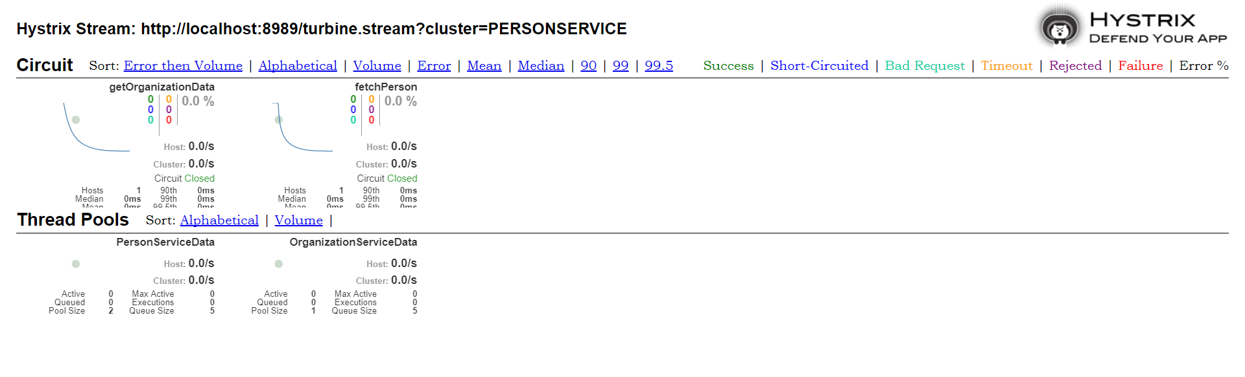

Turbine + Hystrix

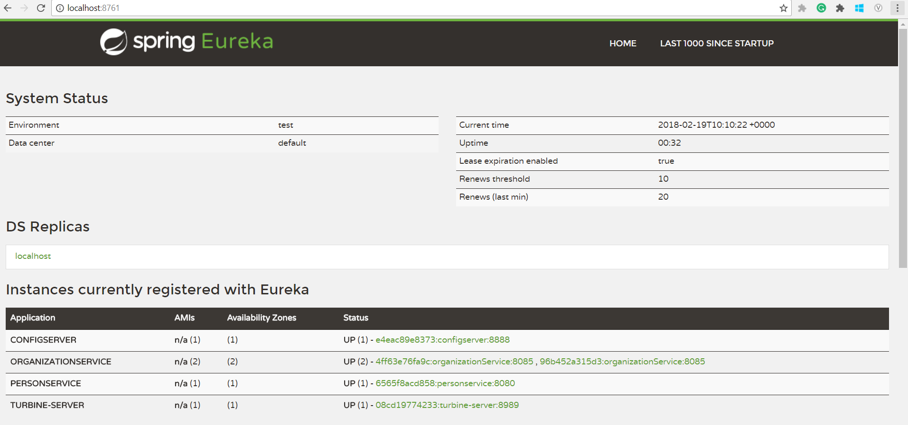

Eureka