AI-Powered Online Code Playground
(HTML, CSS, JavaScript)

1. Problem Statement

1. Problem Statement
Traditional online code editors allow users to write and execute code but provide limited assistance in identifying errors and understanding code functionality. Beginners often struggle with debugging syntax mistakes and learning programming concepts. There is a need for an intelligent coding platform that not only executes code but also assists users in detecting errors, debugging code, and understanding program behavior through Artificial Intelligence.
The objective of this project is to develop an AI-powered online code playground that integrates Machine Learning and Generative AI to provide real-time code execution, error prediction, AI-based debugging suggestions, and code explanations.

2. Approach

2. Approach

The project follows a modular approach consisting of Frontend, Backend, Machine Learning, and Generative AI components.
Step 1: Code Editing
Users write HTML, CSS, and JavaScript code using the Monaco Editor integrated into the frontend.
Step 2: Code Execution
The frontend combines the HTML, CSS, and JavaScript code and displays the output in a live preview section using an iframe.
Step 3: Error Prediction
When the user clicks "Check Errors", the code is sent to the Flask backend. A rule-based syntax checker validates HTML tags, brackets, and parentheses. The code is then analyzed by a Naive Bayes Machine Learning model trained on code samples to predict whether the code contains errors.
Step 4: AI Debugging
When the user clicks "Debug with AI", the code is sent to Google's Gemini AI through the backend. Gemini analyzes the code and provides debugging suggestions and possible fixes.
Step 5: Code Explanation
The "Explain Code" feature uses Gemini AI to generate beginner-friendly explanations describing what the code does and the concepts used.

3. System Architecture

3. System Architecture

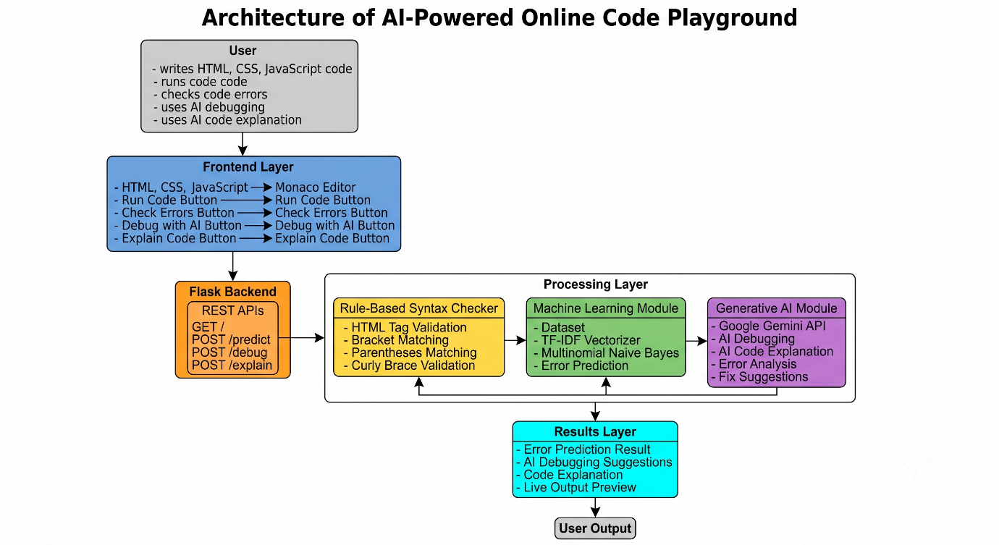
Figure 3.1 – System Architecture

4. Tools Used

4. Tools Used

Category | Tool/Technology
Frontend | HTML, CSS, JavaScript
Code Editor | Monaco Editor
Backend | Flask
API Communication | Flask-CORS
Programming Language | Python
Machine Learning | Scikit-Learn
ML Algorithm | Multinomial Naive Bayes
Feature Extraction | TF-IDF Vectorizer
Model Storage | Joblib
Generative AI | Google Gemini API
Version Control | Git
Repository Hosting | GitHub
Development Environment | Visual Studio Code

