**1. Vector Recycling**

* **Definition:** If we apply arithmetic operations to two vectors of unequal length, then the elements of the shorter vector are recycled to complete the operations.

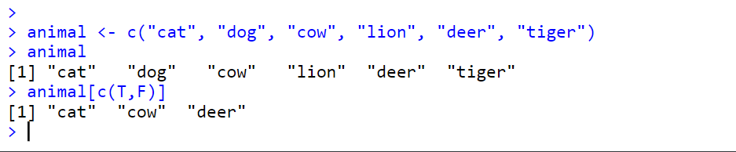

**2. Inner multiplication**

* **Definition**: this multiplication produces a scalar value.
* Syntax: %*%

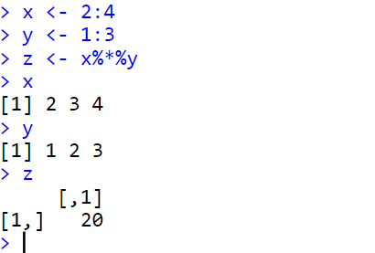

**3. Outer multiplication**

* **Definition**: it produces a matrix value.
* Syntax: %o%

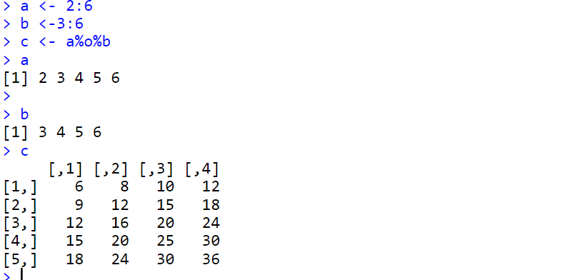

**4. Functions:**

* **sample()**
  + **Usage:**
    - To select a number of elements out of a Vector.
    - There are 2 types of sample: Sample with replacement and Sample without replacement.
    - Sample with replacement allows us to select the same element from the vector again.
    - Sample without replacement is the default function. It does not allow selecting the same element again and again
  + **Example**:

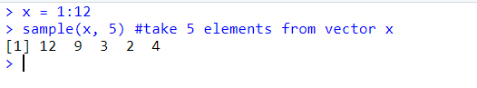

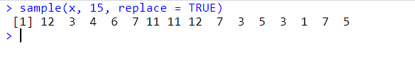

* **Warning:**
  + If our data set **x** has only one value. Ex: x = 4. ***sample()*** will interpret it as a vector that contains (1, 2, 3, 4)
  + **Program**:

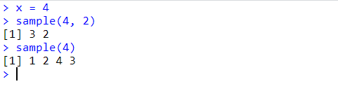

* **seq()**
  + **Usage:** to create a sequence of numbers.
  + **Program:**

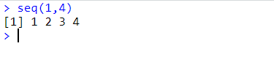

*by=2* increments number by 2.

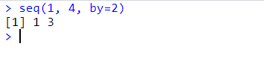

*length=6* tells the function to create 6 elements

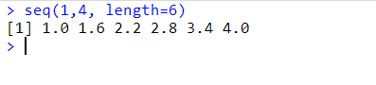

* **rep()**
  + **Usage:** to repeat

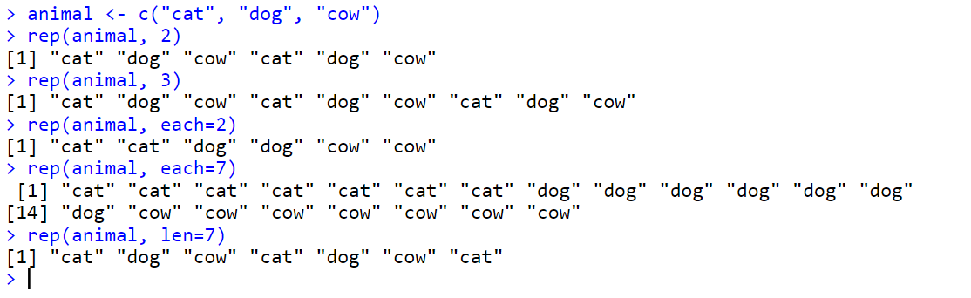

* **round()**:
  + **usage:** to round a number
  + **Example**:

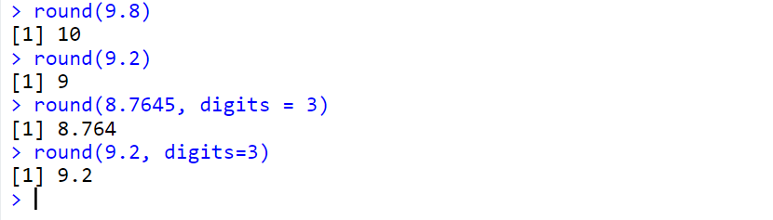

* **factorial()**
  + **Usage:** to calculate factorial
  + **Example:**

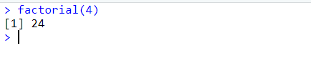

* **is()**
  + Functions to test inheritance relationships between an object and a class or between two classes (extends).
  + **program:**

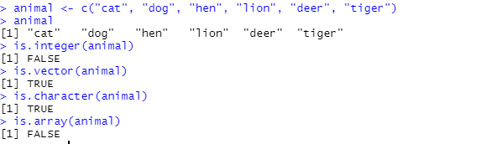

* **mean()**
  + **Usage:**  Find average (mean) of a sequence of numbers.
  + **Example:**

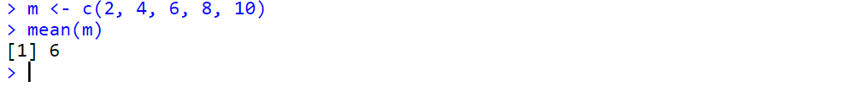

* **set.seed()**
  + **Usage:**  Function sets the starting number used to generate a sequence of random numbers.
  + **Example:**

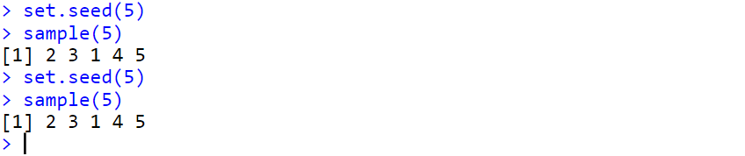

**5. Subset:** used to find the vector value of a given index and remove the elements from the vector

