Clearcase Installation

Steps to be done before installing Rational Clearcase.,

- Create group name auto ( Rht click My Computer → manage → Local users and groups → groups (Rht Click) → New Group)

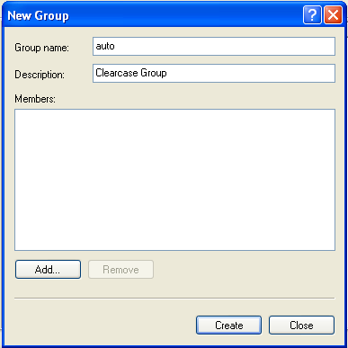

- Add your windows username to that auto group .

- Create new User Variable by Right Clicking

My computer -> Properties -> Advanced -> Environment Variables.,

- Variable name as CLEARCASE_PRIMARY_GROUP and Variable value as auto as shown in the following window.

- Similarly create System Variable with same values.,

- After creating these variables, Re-login (logout and login), to make active these system variables.,

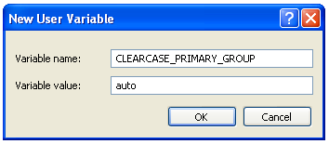

- To check the user is in auto group,( Note: After installing Clear case)
Goto C:\Program Files\Rational\ClearCase\etc\utils,

Open a command prompt and Drag and drop creds file into the command prompt. And just enter ., it will show whether the user is in auto group or none..

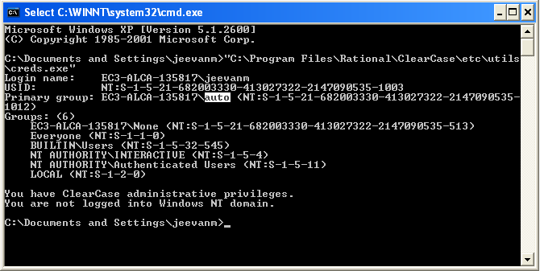

User should be under auto group as shown above else you need to proceed from step one….

Clearcase Installation

Now we can start installing clearcase…

Go to \\192.168.220.157\vobstore1\XP_5 (User name : user , Password : user123)

Run the setup….

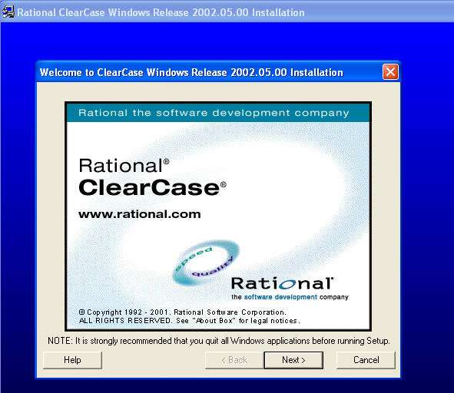

Click next..

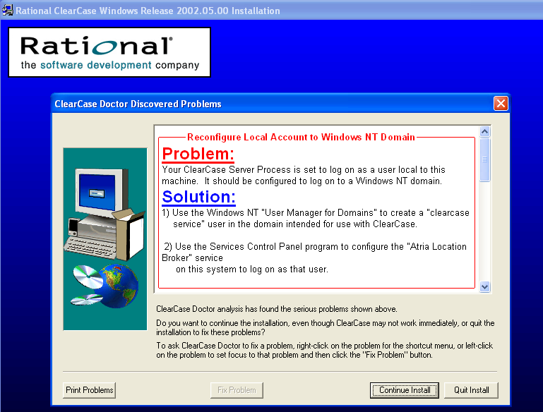
Click continue install,

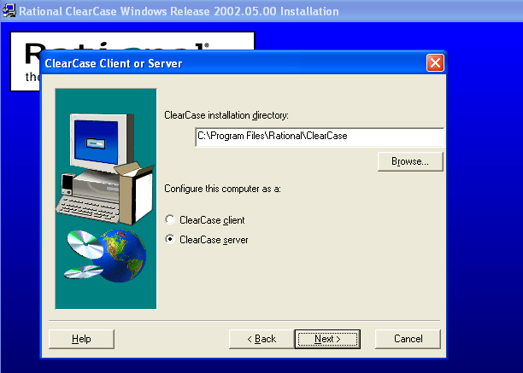

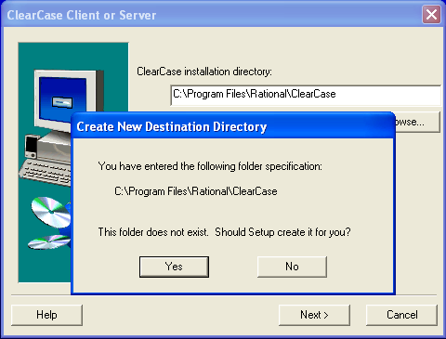

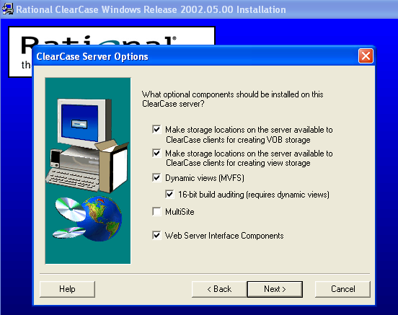
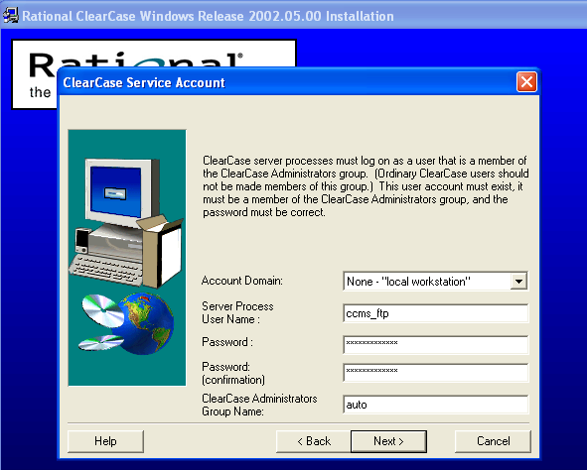
Give the username as ccms_ftp and password as Wipro@123.....

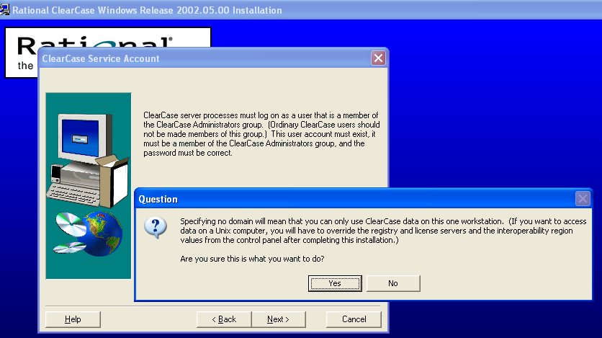

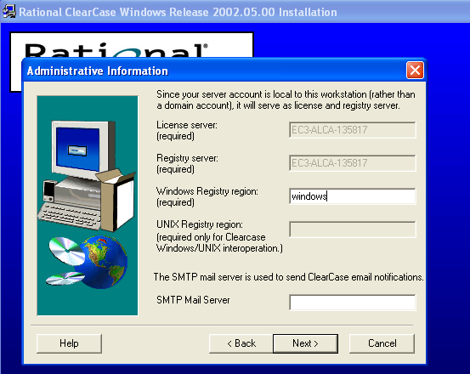

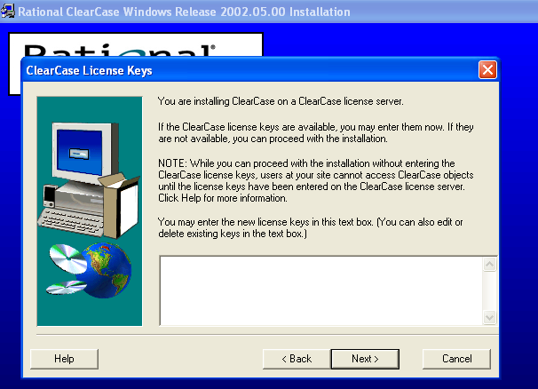

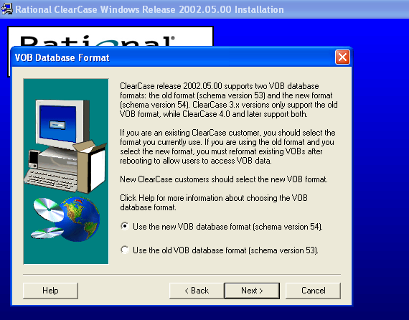

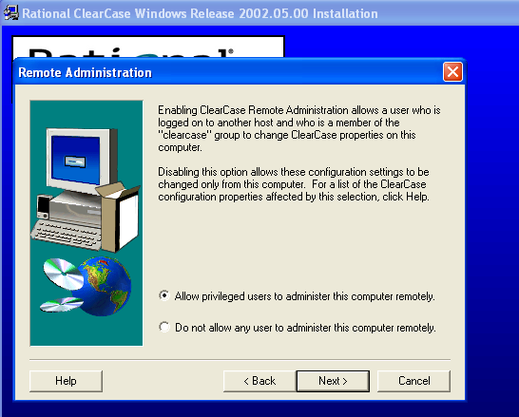

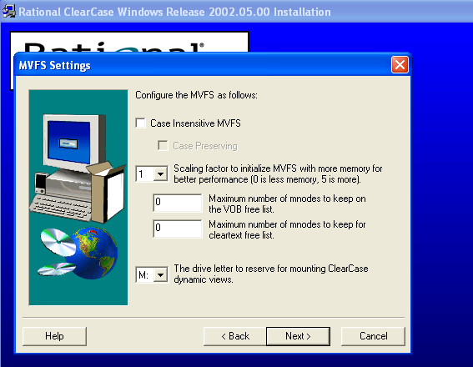

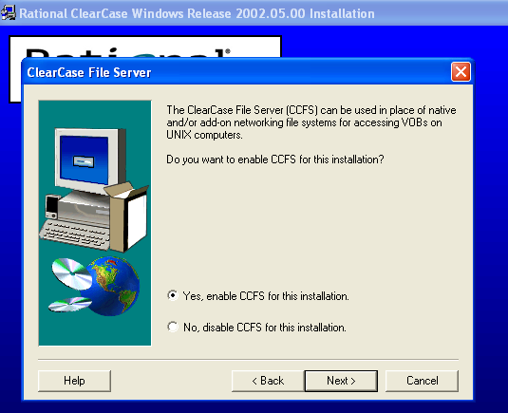

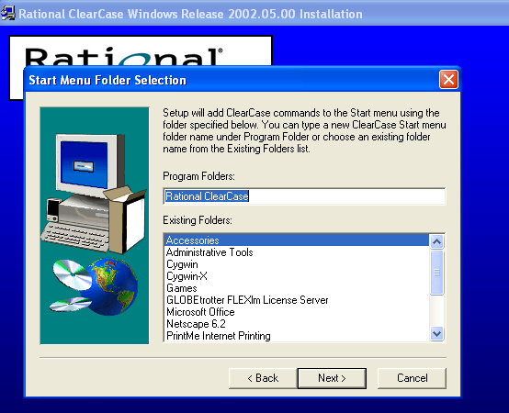

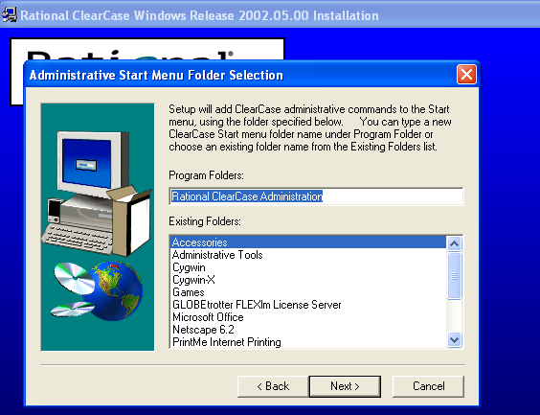

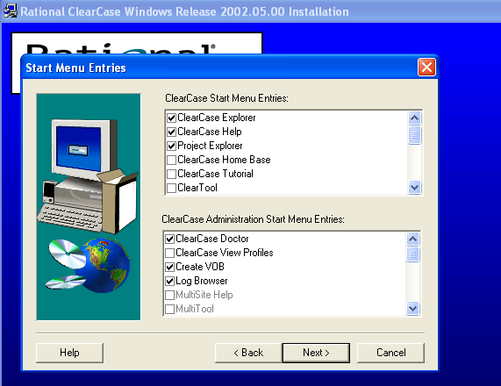

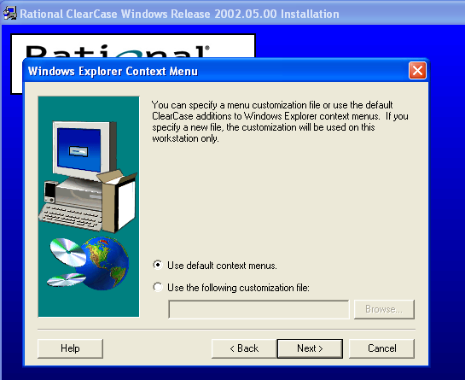

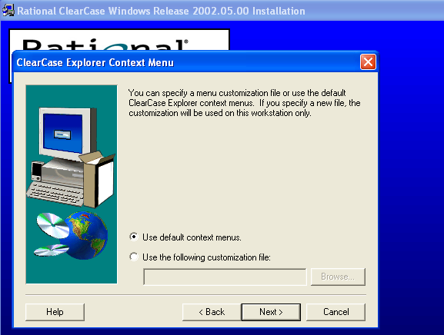

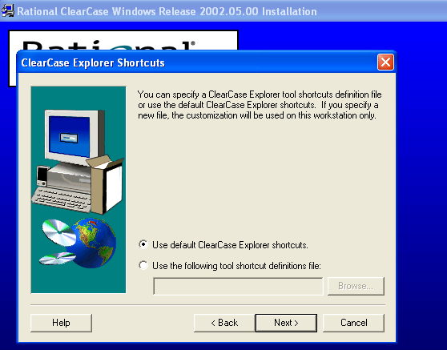
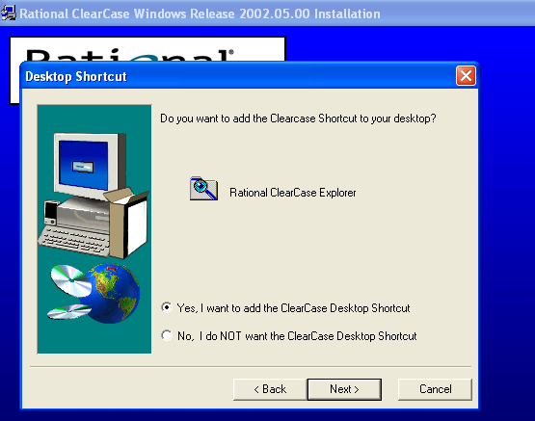
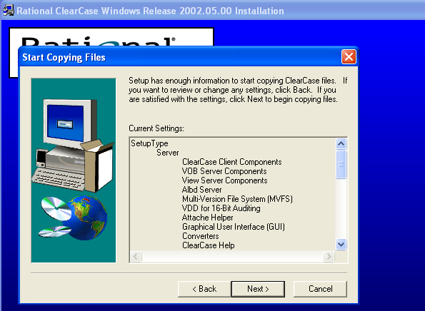
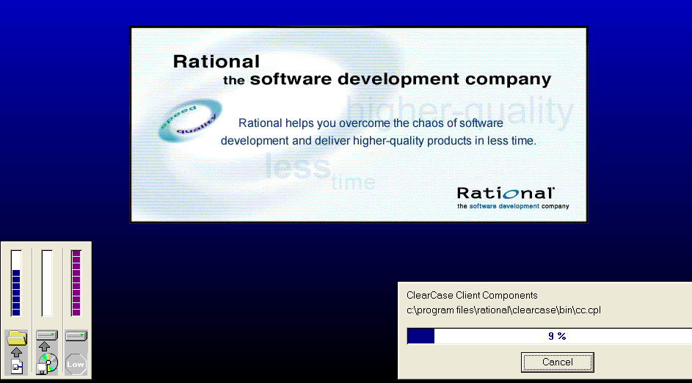

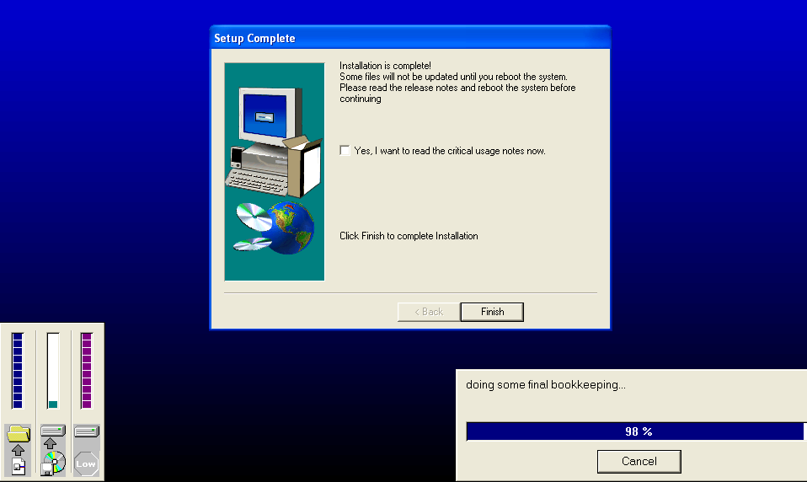

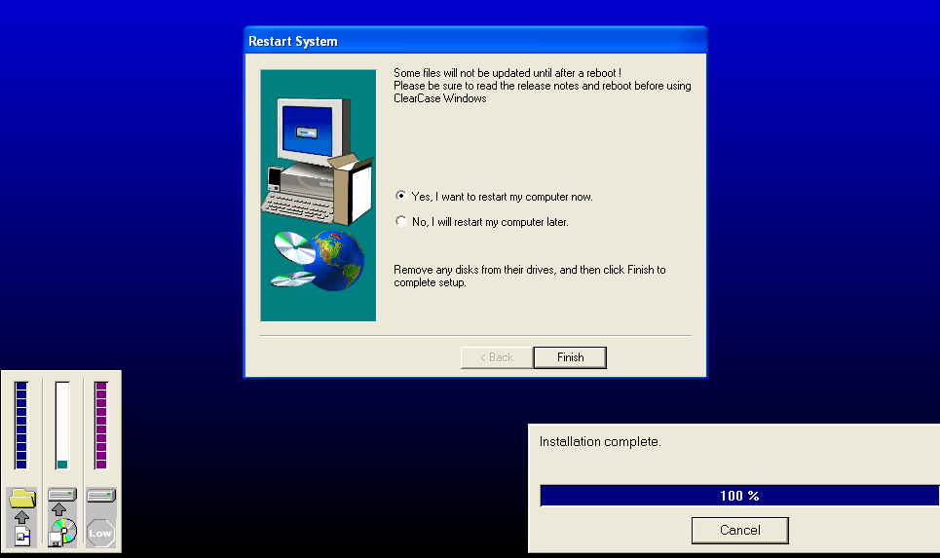

After rebooting

Go to control panel and open clearcase, give the information as shown in the following windows.,

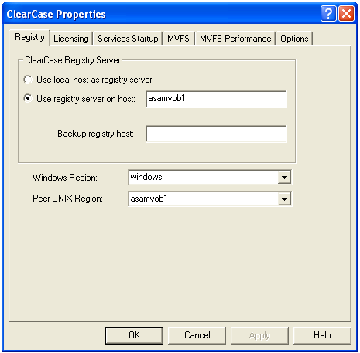

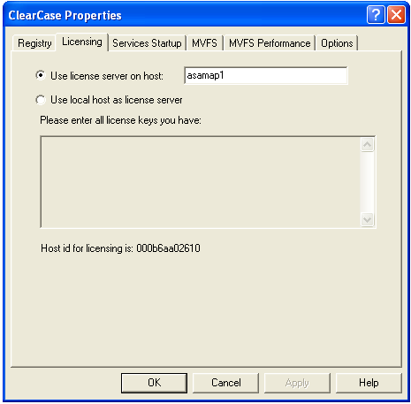

Give the server IP-Address or the hostname which is holding the clear case license…(ours is 192.168.220.251)(If you made an entry in hosts file you can give the hostname instead of Ip-Address) Start and stop the services.., as shown in the following.,
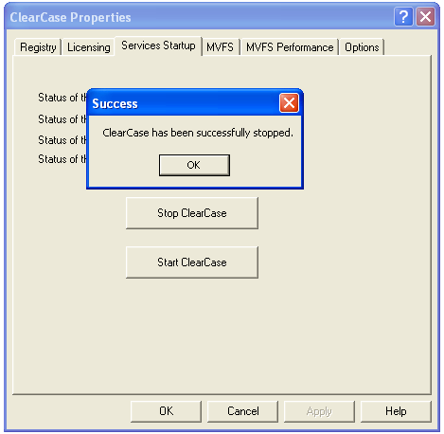

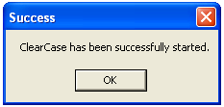

After that, Map a network drive to \\asamvob1\vobstore5 using the username cquser and password wipro123

Checking after installation

- Open ClearCase Explorer (Start – programs – Rational ClearCase – ClearCase Explorer.)

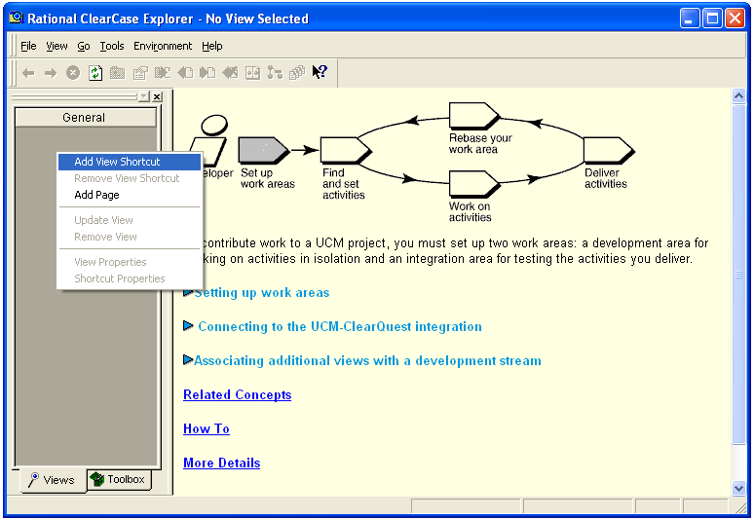

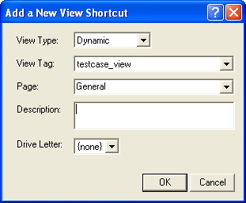

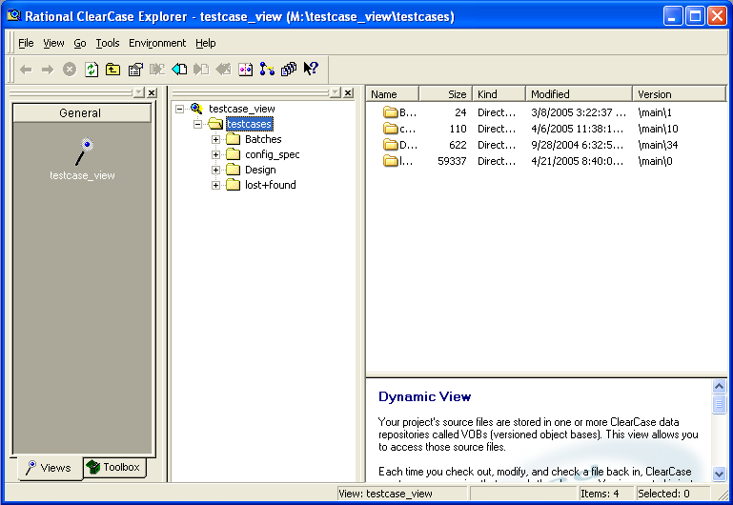

Right click at third column, and create new text document.., as shown in the following figure..,

I you able to create a new text document, it is understood that installation is successful else not yet..

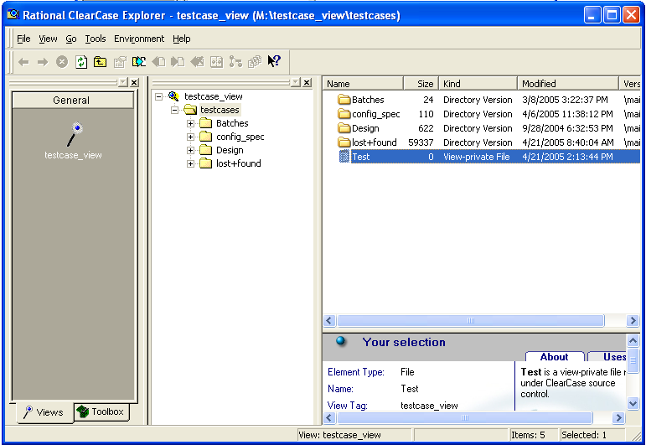

Thus the end of clearcase installation.,

FAQ:

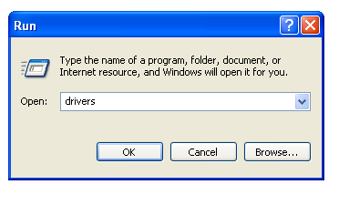

Click the etc directory., the following files will be there..

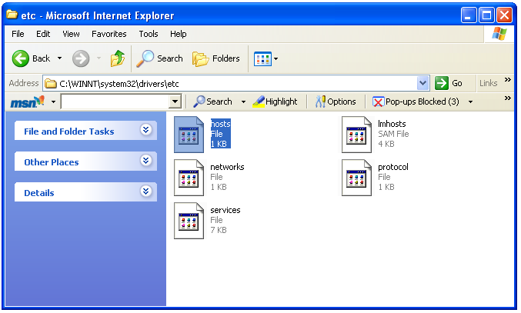

Click the hosts file and do the following entry……

192.168.220.157 asamvob1 #VOB server
192.168.220.251 asamap1 #License server
192.168.22.183 alcat134 #Oracle Server

