*Session 2: Assignment 1*

**Table of Contents**

1. Introduction
2. Problem Statement
3. Output
4. Introduction

This assignment will help you to consolidate the concepts learnt in the session.

1. Problem Statement

**Problem Statement 1:**

Write a Python Program to implement your own myreduce() function which works exactly

like Python's built-in function reduce()

**Problem Statement 2:**

Write a Python program to implement your own myfilter() function which works exactly

like Python's built-in function filter()

**NOTE: The solution shared through Github directory should contain the source**

**code used and screenshot of the output.**

1. Output

**Solution 1:** Python Program to implement your own myreduce() function:

**My Program:**

1. ***Create the iterable object containing numbers***

***>>>N=[2,4,5,9]***

1. ***Write lambda function return multiplication on two numbers***

***>>> lambda a,b:a*b***

1. ***Use lambda function and the iterable in 'myreduce()' function***

***>>>print reduce(lambda a,b:(a*b),N)***

***Output will be 360***

In the above, for the first time, **a** is assigned with the first value in the iterable, so **a= 2**. Now, **b** starts iterating from second item in the iterable onwards. Thus, in the first iteration, **a=2** and **b=4**. With this, we call our lambda function, which returns the product **2*4 = 8**. Now, for the second iteration, result value is stored in **a**, so **a = 8** and **b** gets the next item, means **b = 5**. Function gets called with this and returns **8*5=40.** For next iteration, **a=40** and **b=9**, the next item from the iterable, and this continues till we get the final result as **40*9=360.**

**Analysis:**

N= [2,4,5,9]

**# Iteration - 1**

*a=2 -> 1st list item*

*b=4 -> 2nd list item*

**result = 8**

**# Iteration - 2**

*a=8 -> Result from last iteration*

*b=5 -> 3rd list item*

**result = 40**

**# Last iteration**

*a=40 -> Result from last iteration*

*b=9 -> 4th list item*

**result = 360 -> Final result**

**Source Code:**

***N=[2,4,5,9]***

***reduce(lambda a,b:(a*b),N)***

**Output 360**

**The screenshot of the output:**

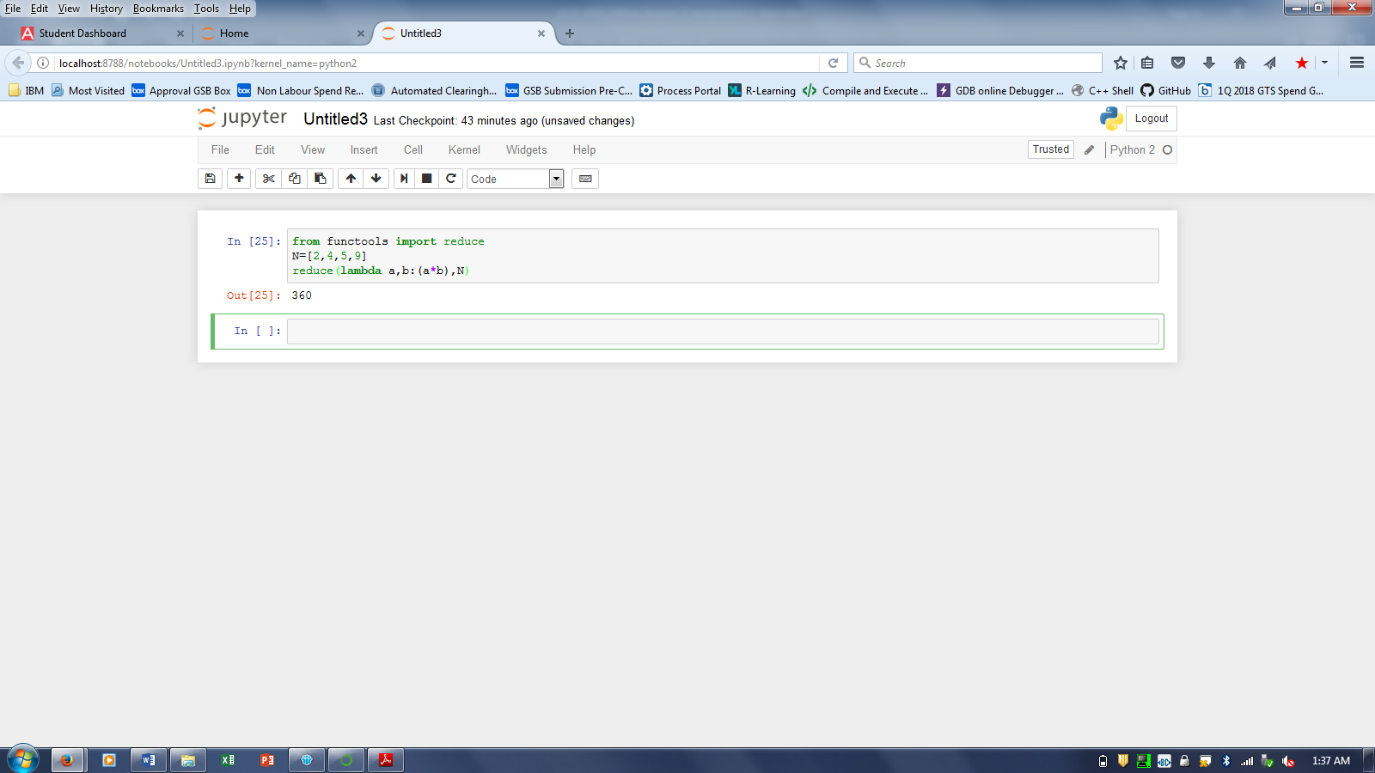

**Solution 2:** Python Program to implement your own myfilter() function:

**My Program:**

1. ***Let's find out odd numbers from 1 to 20***
2. ***Make a function***

>>> def odd_check(num):

if num%2 ==1:

return True

1. ***Let's filter a list of numbers***

>>> lst =range(20)

list(filter(odd_check,lst))

***Output will be-> [1, 3, 5, 7, 9, 11, 13, 15, 17, 19]***

1. ***Use lambda function for 'myfilter()' function***

>>> list(filter(lambda x: x%2==1,lst))

***Output will be-> [1, 3, 5, 7, 9, 11, 13, 15, 17, 19]***

**Source Code:**

def odd_check(num):

if num%2 ==1:

return True

lst =range(20)

list(filter(lambda x: x%2==1,lst))

**Output *[1, 3, 5, 7, 9, 11, 13, 15, 17, 19]***

**The screenshot of the output:**

