*Session 2: Assignment 3*

**Table of Contents**

1. Introduction
2. Problem Statement
3. Output
4. Introduction

This assignment will help you to consolidate the concepts learnt in the session.

1. Problem Statement

**Problem Statement 1:**

Write a Python Program(with class concepts) to find the area of the triangle using the

below formula.

area = (s*(s-a)*(s-b)*(s-c)) ** 0.5

Function to take the length of the sides of triangle from user should be defined in the

parent class and function to calculate the area should be defined in subclass.

**Problem Statement 2:**

Write a function filter_long_words() that takes a list of words and an integer n and returns

the list of words that are longer than n.

**NOTE: The solution shared through Github directory should contain the source**

**code used and screenshot of the output.**

1. Output

SOLUTION 1:

area = (s*(s-a)*(s-b)*(s-c)) ** 0.5

**Source Code:**

class Shape:

def __init__(self, no_of_sides):

self.n = no_of_sides

self.sides = [0 for i in range(no_of_sides)]

def inputSides(self):

self.sides = [float(input("Enter side "+str(i+1)+" : ")) for i in range(self.n)]

def dispSides(self):

for i in range(self.n):

print("Side",i+1,"is",self.sides[i])

class Triangle(Shape):

def __init__(self):

Shape.__init__(self,3)

def findArea(self):

a = 5

b = 6

c = 7

# calculate the semi-perimeter

s = (a + b + c) / 2

area = (s*(s-a)*(s-b)*(s-c)) ** 0.5

print('The area of the triangle is %0.2f' %area)

**Output: The area of the triangle is 14.70**

**The screenshot of the output:**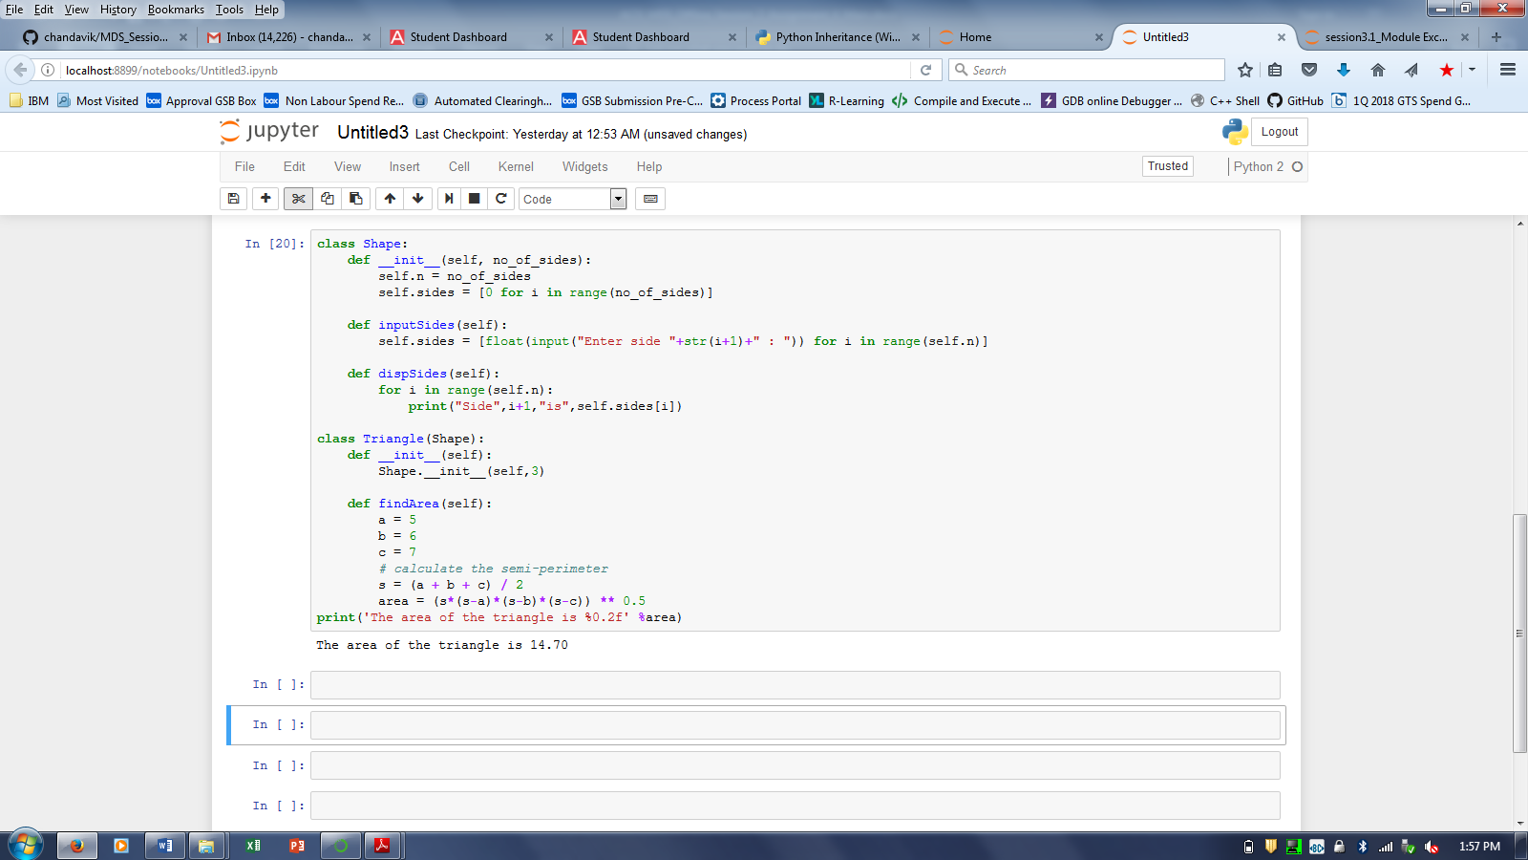

**SOLUTION-2:**

**Source Code:**

def filter_long_words(words, n):

return filter(lambda b: len(b) > n, words)

print filter_long_words(["apple","ball","cat","dog elephant"], 5)

**Output: ['dog elephant']**

**The screenshot of the output:**