*Session 2: Assignment 5*

**Table of Contents**

1. Introduction
2. Problem Statement
3. Output
4. Introduction

This assignment will help you to consolidate the concepts learnt in the session.

1. Problem Statement

**Problem Statement 1:**

Write a Python program using function concept that maps list of words into a list of integers representing the lengths of the corresponding words .

Hint: If a list [ ab,cde,erty] is passed on to the python function output should come as [2,3,4]

Here 2,3 and 4 are the lengths of the words in the list.

**Problem Statement 2:**

Write a Python function which takes a character (i.e. a string of length 1) and returns True if it is a vowel, False otherwise.

**NOTE: The solution shared through Github directory should contain the source**

**code used and screenshot of the output.**

1. Output

**SOLUTION 1:** Let the list of words be ['Apple','Mangoes','watermelon','grapes','kiwi']

**Source Code:** **Words=['Apple','Mangoes','watermelon','grapes','kiwi']**

**Integers=[]**

**for i in range(len(Words)):**

**Integers.append(len(Words[i]))**

**print ("List of word length: "+str(Integers))**

**Output:**  **List of word length: [5, 7, 10, 6, 4]**

**The screenshot of the output:**

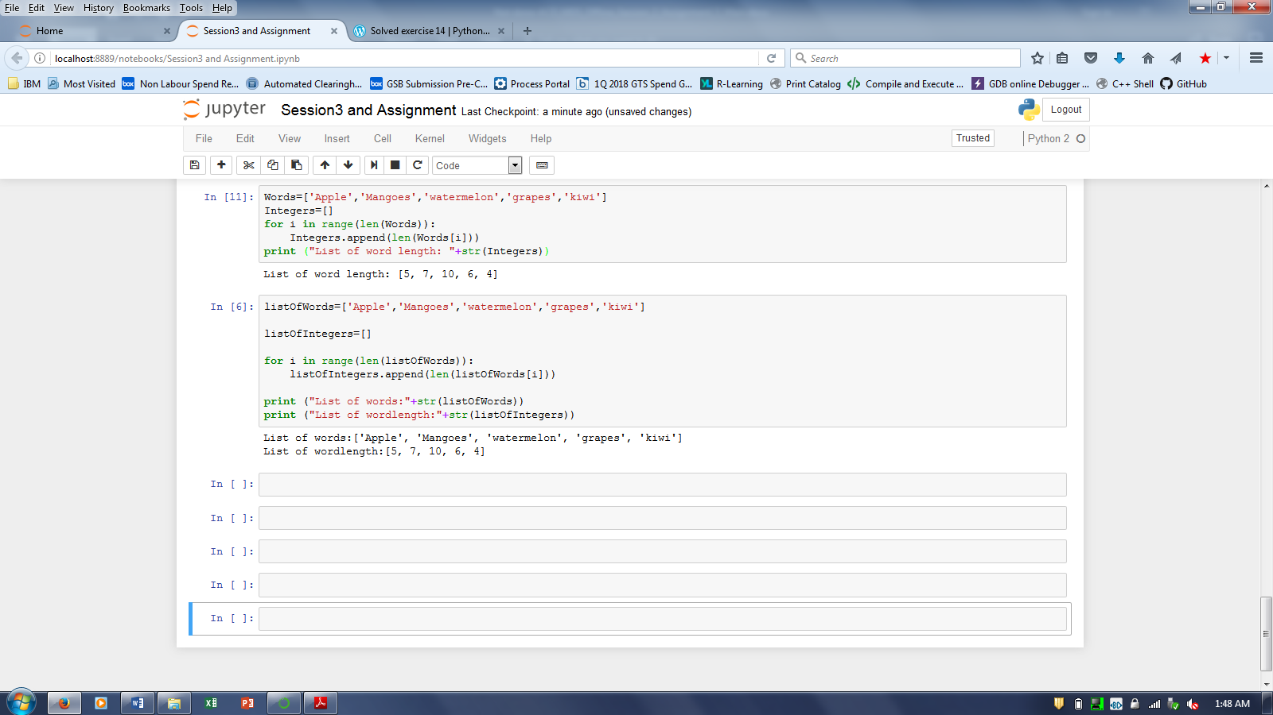

**SOLUTION-2:**

**Source Code:**

**def is_vowel(char):**

**all_vowels = 'aeiou'**

**return char in all_vowels**

**print(is_vowel('c'))**

**print(is_vowel('e'))**

**Output:** **False**

**True**

**The screenshot of the output:**

