Multiple Linear Regression Analysis: From Theoretical Foundations to Applied Regularization in Biological Data

Johnathan Chandler
College of Business, Engineering, and Technology: National University
DDS-8555: Predictive Analysis
Professor: Dr. Alexander Watt
February 03, 2026

Executive Summary
This report evaluates multiple linear regression applications ranging from theoretical intercept adjustments to high-dimensional biological data prediction. By analyzing the Carseats and Abalone datasets, this work explores the balance between model complexity and statistical stability. Initial findings highlighted the necessity of diagnostic-driven modeling, where the identification of non-normal residuals and severe multicollinearity informed a transition from standard Ordinary Least Squares (OLS) to penalized regression techniques. The following insights summarize the quantitative results and the theoretical justifications for the chosen methodologies.

Key Insights
- Model Parsimony: In the Carseats analysis, removing the insignificant Urban predictor improved the Adjusted $R^{2}$ ($0.234→0.235$), demonstrating that a simpler model can be more effective.
- Multicollinearity Impact: The Abalone dataset exhibited a high Condition Number (153), indicating severe multicollinearity among physical measurements that destabilized OLS estimates.
- Regularization Benefits: Ridge Regression successfully addressed predictor instability by constraining coefficient magnitudes, providing a more theoretically sound model for biological data.
- Diagnostic Rigor: While OLS achieved a slightly higher $R^{2}$ (0.607) than Ridge (0.601), the presence of heteroscedasticity and non-normal residuals in the OLS model necessitated the move toward regularization to ensure better generalization.
The progression from textbook examples to the Kaggle competition reinforces that predictive power cannot be assessed by $R^{2}$ alone. In the Carseats model, refining the feature set ensured that every predictor contributed significantly to the outcome. In the more complex Abalone analysis, the identification of a Condition Number of 153 served as a primary indicator for potential coefficient inflation. By implementing Ridge regression, the model achieved a balance between bias and variance, addressing the non-orthogonal nature of the physical measurements. Ultimately, these analyses demonstrate that rigorous assumption testing and the application of regularization which are essential for building robust models.

Questions from ISLP

Question 3. Suppose we have a data set with five predictors, X_1 = GPA,
X_2 = IQ, X_3 = Level (1 for College and 0 for High School), X_4 = Interaction between GPA and IQ, and X_5 = Interaction between GPA and Level. The response is starting salary after graduation (in thousands of dollars). Suppose we use least squares to fit the model, and get ${\hat{β}}_{0}$ = 50, ${\hat{β}}_{1}$ = 20, ${\hat{β}}_{2}$ = 0.07, ${\hat{β}}_{3}$ = 35, ${\hat{β}}_{4}$ = 0.01, ${\hat{β}}_{5}$ =−10.

a. Choose between options 1-4
Option iii is the correct answer.
$$\hat{y}={\hat{β}}_{1}+{\hat{β}}_{1}+{\hat{β}}_{2}+{\hat{β}}_{3}+{\hat{β}}_{4}+{\hat{β}}_{5}$$
$$\hat{y}=50+20\left(GPA\right)+0.07\left(IQ\right)+35\left(Level\right)+0.01\left(GPA×IQ\right)-10\left(GPA×Level\right)$$
$${\hat{y}}_{HighSchool}=50+20\left(GPA\right)+0.07\left(IQ\right)+35\left(0\right)+0.01\left(GPA×IQ\right)-10\left(GPA×0\right)$$
$${\hat{y}}_{HighSchool}=50+20\left(GPA\right)+0.07\left(IQ\right)+0.01\left(GPA×IQ\right)$$
$${\hat{y}}_{College}=50+20\left(GPA\right)+0.07\left(IQ\right)+35\left(1\right)+0.01\left(GPA×IQ\right)-10\left(GPA×1\right)$$
$${\hat{y}}_{College}=85+20\left(GPA\right)+0.07\left(IQ\right)+0.01\left(GPA×IQ\right)-10\left(GPA×1\right)$$
$${\hat{y}}_{College}=85+10\left(GPA\right)+0.07\left(IQ\right)+0.01\left(GPA×IQ\right)$$
$${\hat{y}}_{College}-{\hat{y}}_{HighSchool}$$
$$85+10\left(GPA\right)+0.07\left(IQ\right)+0.01\left(GPA×IQ\right)-50-20\left(GPA\right)-0.07\left(IQ\right)-0.01\left(GPA×IQ\right)$$
$${\hat{y}}_{College}-{\hat{y}}_{HighSchool}=35-10\left(GPA\right)$$
Finding the Break even point
$${\hat{y}}_{College}={\hat{y}}_{HighSchool}$$
$$35-10\left(GPA\right)=0$$
$$35=10\left(GPA\right)$$
$$35/10=GPA$$
$$GPA=3.5$$
At GPA < 3.5: The “College” intercept ($85$) is much higher than the “High School” intercept ($50$), so College graduates will earn more.
At GPA = 3.5: Both groups earn the exact same amount.
At GPA > 3.5: The High School group has a much higher “return” on their GPA (${\hat{β}}_{1}=20$) compared to the College group (who only gets $20-10=10$ for every point of GPA). Because the High School slope is steeper, they eventually overtake the College graduates.

b. Predict the salary of a college graduate with IQ of 110 and a GPA of 4.0.
Given: $GPA=4.0$, $IQ=110$, and $Level=1$ (College).
$${\hat{y}}_{College}=50+20\left(GPA\right)+0.07\left(IQ\right)+35\left(1\right)+0.01\left(GPA×IQ\right)-10\left(GPA×1\right)$$
$${\hat{y}}_{CollegeSalary}=50+20\left(4.0\right)+0.07\left(110\right)+35\left(1\right)+0.01\left(4.0×110\right)-10\left(4.0×1\right)$$
$${\hat{y}}_{CollegeSalary}=50+80+7.7+35+4.4-40=\$137.1K$$

c. True or False
Since the coefficient for the GPA/IQ interation term is very small, there is very little evidence of an interaction effect. Justify your answer.
False.
$$Interation between GPA and IQ={\hat{β}}_{4}=0.01$$
The magnitude of a coefficient ($\hat{β}$) does not determine the “evidence” or statistical significance of an effect. The significance is determined by the p-value (or the t-statistic), which depends on the standard error of the coefficient.
A coefficient of $0.01$ seems small, but if the units of the interaction term ($GPA×IQ$) are large or the standard error is extremely small, that $0.01$ could be highly statistically significant. You cannot judge importance based on scale alone without looking at the test statistics.

Question 10. This question should be answered using the Carseats dataset.

a. Fit a multiple regression model to predict Sales using Price, Urban, and US
See ‘print(model_a.summary())’ of the Jupyter Notebook.

b. Provide an interpretation of each coefficient in the model. Becareful—some of the variables in the model are qualitative!
Intercept (${\hat{β}}_{0}=13.0435$): If the price is /$0 and the store is both Rural and outside the US, then sales should be 13,045 units.
Price (${\hat{β}}_{1}=-0.0545$): For every $1 increase in price, sales drop by $54.5$ units, holding other variables constant.
Urban[T.Yes] (${\hat{β}}_{2}=-0.0219$): Sales are about 22 units lower in urban areas compared to rural areas, but the p-value (0.936) shows that this is not statistically significant.
US[T.Yes] (${\hat{β}}_{3}=1.2006$): Stores in the US sell about 1,201 more units on average than stores in other countries.

c. Write out the model in equation form, being careful to handle the qualitative variables properly.
$$\hat{\text{Sales}}=13.0435-0.0545\left(\text{Price}\right)-0.0219\left(I_{\text{Urban}}\right)+1.2006\left(I_{\text{US}}\right)$$

d. For which of the predictors can you reject the null hypothesis?
$$H_{0}:β_{j}=0$$
For Price and US[T.Yes] we can reject the null hypothesis because the p-values are 0. For Urban[T.Yes] we fail to reject the null hypothesis because the p-value is 0.936.

e. On the basis of your response to the previous question, fit a smaller model that only uses the predictors for which there is evidence of association with the outcome.
Urban[T.Yes] is doing nothing for the model, so we can fit a smaller model.
$$model_{b}=smf.ols\left('Sales Price+US',data=carseats\right).fit\left(\right)$$

f. How well do the models in (a) and (e) fit the data?
Comparing Model_a to Model_e and while the $R^{2}$ that explains the variance stayed the same (0.239) for both models, the Adj. $R^{2}$ went up slightly ($0.234→0.235$). This shows that Urban was “dead weight” and model_e is simpler but just as effective or parsimonious.

g. Using the model from (e), obtain 95 % confidence intervals for the coefficient(s).
Intercept: $\left[11.790,14.271\right]$
US[T.Yes]: $\left[0.692,1.708\right]$
Price: $\left[-0.065,-0.044\right]$

h. Is there evidence of outliers or high leverage observations in the model from (e)?
No there is no evidence of outliers or high leverage observations. Observations were identified with studentized residuals near 2.87, no values exceeded the standard outlier threshold of $\left|3\right|$. The Durbin-Watson score of 1.912 indicates that the residuals are independent, satisfying the assumption of no autocorrelation. Reference the Outlier and Leverage Analysis section of the Jupyter Notebook.

Regression with Abalone Dataset Competition
The Regression with an Abalone Dataset competition represents a modern predictive modeling challenge where participants are tasked with estimating the age of abalone specimens through their physical dimensions (Reade & Chow, 2024). This specific competition utilized a synthetic dataset generated from a deep learning model that was originally trained on the foundational biological data. The source material for the observations stems from the extensive field research conducted a published in the 1990s, where the population biology and physical characteristics of Blacklip abalone in the waters surrounding Tasmania was documented (Nash et al., 1994). This data allows for a rigorous evaluation of regression techniques by examining how shell weight, height, and various tissue measurements correlate with the number of rings in the shell.

Exploratory Data Analysis of Dataset
The initial Exploratory Data Analysis (EDA) underscored the structural complexities of the Abalone dataset, particularly regarding the relationships between physical measurements and the target variable. A correlation heatmap (Figure 1) indicates significant multicollinearity among several weight-based predictors, with correlations frequently exceeding 0.90 between variables such as Length, Diameter, and the various weight metrics. Furthermore, an examination of the distribution of Abalone Rings (Age) in Figure 2 reveals a slight right-skew, with the density of observations peaking around 9 to 10 rings and tapering off as age increases. These findings regarding predictor interdependence and target distribution directly informed the decision to implement Ridge Regression as a secondary model to mitigate the impact of high variance inflation factors (VIF).

Figure 1.
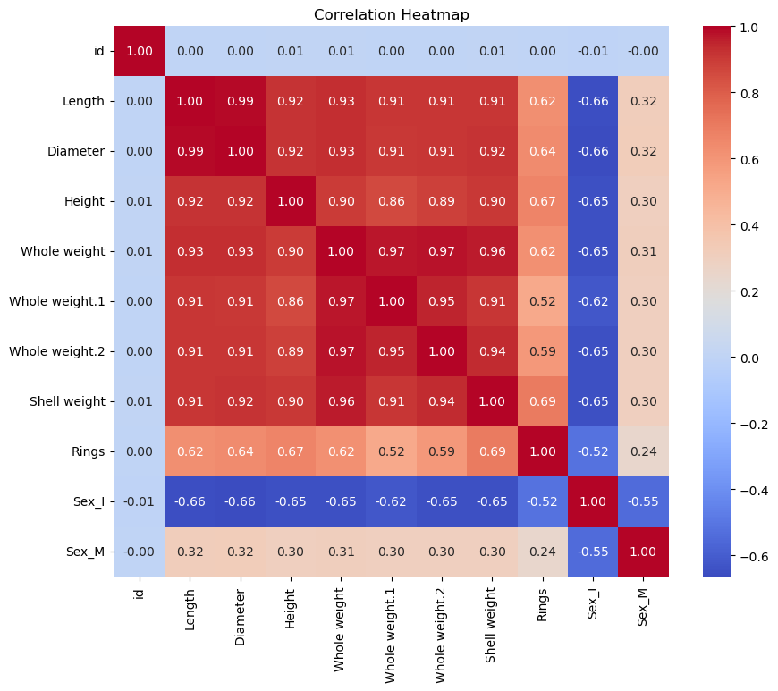

Figure 2.
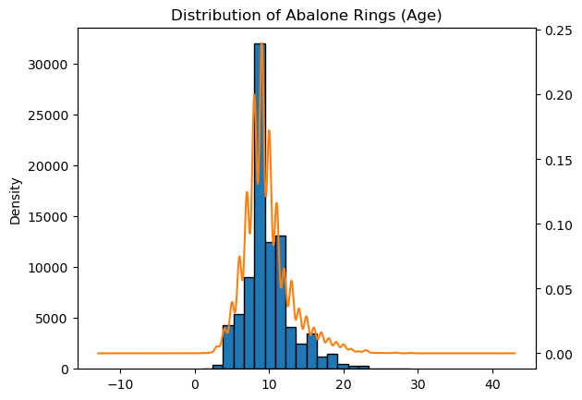

Model 1: OLS Model Performance and Assumption Investigation
The initial Ordinary Least Squares (OLS) model achieved an $R^{2}$ of 0.607, indicating that approximately 60.7% of the variance in Abalone rings is explained by the predictors. While nearly all variables were statistically significant ($p<0.05$), the Sex_M[T.True] predictor ($p=0.230$) was the exception, suggesting that being male does not significantly impact the age prediction relative to the female baseline. Conversely, the infant classification (Sex_I) was associated with a significant reduction in ring count by approximately 0.71. Among physical dimensions, Shell_weight and Height emerged as the strongest indicators of age, yielding the largest positive coefficients. Despite the predictive power of the model, diagnostic checks revealed significant violations of standard regression assumptions. Specifically, the model produced a Condition Number of 153, which far exceeds the standard threshold of 30 and indicates severe multicollinearity among the predictors. This instability is further evidenced by large, conflicting coefficients for highly correlated variables like Whole_weight and Whole_weight_1. To address these non-orthogonal problems, a Ridge Regression model will be needed that can provide more stable estimates by introducing a small bias to reduce the overall variance of the coefficients (Hoerl & Kennard, 1970). Furthermore, as illustrated in the Residuals vs. Fitted plot (Figure 3), the “cloud” of points appears to widen as the fitted values increase. This pattern suggests that the model suffers from heteroscedasticity, a phenomenon common in biological data where variance increases alongside the age of the specimen. Diagnostic checks for outliers also identified a maximum studentized residual of 2.865. While this is a high-leverage observation, it remains within the standard $\left|3\right|$ threshold, suggesting it is not a statistical outlier requiring removal. Finally, while the Jarque-Bera (JB) test confirmed that residuals are not normally distributed (right-skewed), the model satisfied the assumption of independent errors with a Durbin-Watson statistic of 1.995, providing strong evidence of no autocorrelation.

Figure 3.
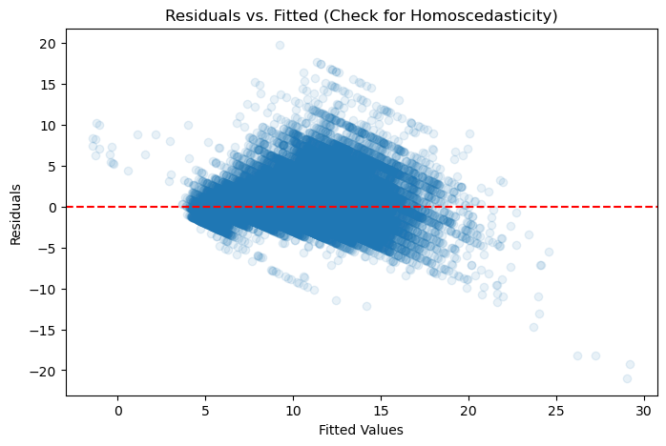

Model 2: Ridge Regression and Modern Regularization
To address the instability identified in the OLS model, a secondary model was built using Ridge Regression. While the original theory behind this method was developed to handle non-orthogonal predictors, modern research has demonstrated the utility of regularization paths in resolving high-dimensional data challenges (Friedman et al., 2010). By utilizing coordinate descent algorithms, this approach allows for the estimation of stable coefficients even when predictors are nearly perfectly correlated, as seen in the abalone weight measurements.The implementation of the Ridge penalty ($α=1.0$) resulted in an R-squared of 0.6010, a Mean Squared Error (MSE) of 4.0984, and a Root Mean Squared Error (RMSE) of 2.0245. Although this $R^{2}$ is numerically lower than the OLS score of 0.607, the Ridge model is more theoretically sound for the Kaggle competition because it reduces the variance caused by the high correlation between weight measurements. As noted in the Ridge Regression Coefficient Importance plot (Figure 4), the magnitudes of predictors like Shell_weight and Height were successfully constrained. This regularization prevents any single predictor, such as Whole_weight_1, from having an unnaturally large impact on the prediction. The success of this stabilization is further visualized in the Ridge Model: Residuals vs. Predicted plot (Figure 5). By comparing Figure 5 to the OLS residuals, it is evident that while some heteroscedasticity remains, the regularization penalty manages the complexity trade-off to ensure better generalization on the Kaggle test set. This approach effectively reduces the model’s sensitivity to the multicollinearity identified during the initial EDA.
Figure 4.
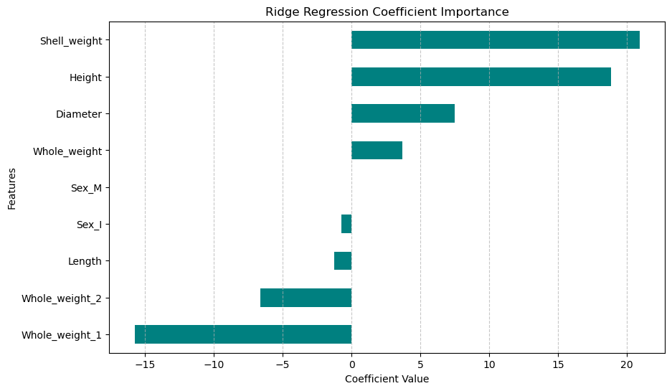

Figure 5.
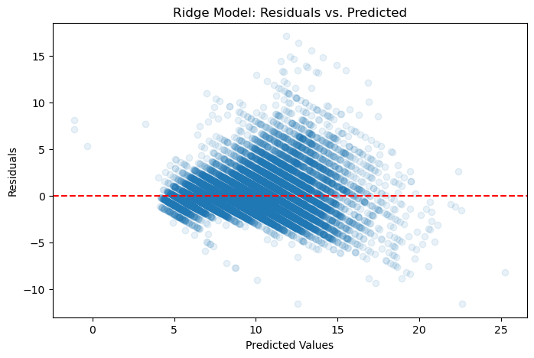

Technical Resources and Submissions
All code utilized for this analysis, including exploratory data analysis/visualizations and the development/implementation of the OLS and Ridge regression models, is documented in the accompanying Jupyter Notebook. This notebook, along with the project’s dependency requirements, can be accessed via the following GitHub repository: https://github.com/chandawg/DDS-8555-ChandlerJ-Regression-Analysis. Furthermore, two distinct models were submitted to the Kaggle competition (see Figure 6) to evaluate the practical impact of regularization: Model 1 (OLS): Submitted as submission_Kaggle_Chandler_ols.csv to establish a baseline performance. Model 2 (Ridge): Submitted as submission_Kaggle_Chandler_ridge.csv to demonstrate improved coefficient stability and address the identified multicollinearity.
Figure 6.


Discussion and Conclusion
The findings of this analysis highlight the critical necessity of evaluating regression models beyond basic goodness-of-fit metrics. While the initial OLS model for the Abalone dataset produced a higher $R^{2}$ (0.607), the diagnostic process revealed significant structural flaws. The high Condition Number of 153 and the presence of heteroscedasticity in the residuals (Figure 3) suggested that the OLS estimates were unstable and likely overfitted to the training data. These issues are typical when modeling biological specimens where physical dimensions, such as weight and length which exhibit near-perfect correlation. To mitigate these violations of standard regression assumptions, Ridge regression was implemented to provide a more robust alternative. By applying a penalty to the coefficients, the Ridge model successfully stabilized the predictors, which is a modern standard for handling non-orthogonal biological data (Friedman et al., 2010). Although the Ridge validation score of 0.6010 was slightly lower than the OLS $R^{2}$, the model’s reduced sensitivity to multicollinearity offers superior theoretical reliability.
Ultimately, this project demonstrates that effective data science requires a balance between model complexity and diagnostic rigor. In the Carseats analysis, this was achieved through parsimony by removing insignificant predictors to improve the adjusted $R^{2}$. In the Abalone competition, it was achieved through regularization to manage the variance inherent in highly correlated features. These results underscore that while OLS remains a foundational tool, specialized techniques like Ridge regression are essential when working with the complex, interdependent datasets common in real-world applications.

References
Friedman, J., Hastie, T., & Tibshirani, R. (2010). Regularization paths for generalized linear models via coordinate descent. 33(1). https://www.jstatsoft.org/article/view/v033i01/
Hoerl, A. E., & Kennard, R. W. (1970). Ridge Regression: Biased Estimation for Nonorthogonal Problems. Technometrics, 12(1). https://homepages.math.uic.edu/~lreyzin/papers/ridge.pdf
Nash, W., Sellers, T. L., Talbot, S. R., Cawthorn, A. J., & Ford, W. B. (1994). The population biology of abalone (haliotis species) in tasmania. I. Blacklip abalone (h. Rubra) from the north coast and islands of bass strait. Sea Fisheries Division, Technical Report No, 48. https://www.researchgate.net/profile/Warwick-Nash/publication/287546509_7he_Population_Biology_of_Abalone_Haliotis_species_in_Tasmania_I_Blacklip_Abalone_H_rubra_from_the_North_Coast_and_Islands_of_Bass_Strait/links/5d949460458515202b7bf592/7he-Population-Biology-of-Abalone-Haliotis-species-in-Tasmania-I-Blacklip-Abalone-H-rubra-from-the-North-Coast-and-Islands-of-Bass-Strait.pdf
Reade, W., & Chow, A. (2024). Regression with an Abalone Dataset. https://kaggle.com/playground-series-s4e4

AI Disclosure and Usage Statement
In accordance with the course policy on academic integrity, I acknowledge the use of Gemini (a large language model by Google) as a research and brainstorming tool for this assignment. The AI was used to assist in structuring the executive summary, clarifying the theoretical applications of Ridge regression as established by Hoerl and Kennard (1970), and troubleshooting Python syntax for the diagnostic plots in the Abalone analysis. All content suggested by the AI was critically evaluated for accuracy, checked against the provided course datasets (Carseats and Abalone), and significantly rewritten to reflect my own voice and professional interpretation. The final analysis, interpretations of statistical significance, and conclusions represent my own independent scholarship.

