Comparative Analysis of Polynomial Basis Expansion and Gradient Boosting for Abalone Age Prediction

Johnathan Chandler
College of Business, Engineering, and Technology: National University
DDS-8555: Predictive Analysis
Professor: Dr. Alexander Watt
February 18, 2026

Executive Summary
This analysis evaluated nonlinear regression strategies for predicting abalone age, measured by shell rings, using morphometric features derived from biological growth data. Exploratory analysis indicated strong predictor interdependence and visible curvature in the relationship between shell dimensions and age, suggesting that strictly linear modeling may suffer from functional form misspecification. To address this, two nonlinear approaches were implemented and evaluated using 5-fold cross-validated root mean squared error (RMSE) and residual diagnostics: a Polynomial expansion with Ridge regularization and a Histogram-based Gradient Boosting Regressor.

Key Insights
- Quadratic feature expansion improved flexibility relative to a linear specification but left mild residual structure at higher predicted ages, indicating incomplete capture of interaction effects.
- Gradient Boosting demonstrated lower cross-validated error and more uniformly distributed residuals, suggesting superior modeling of nonlinear interactions and threshold behavior inherent in biological growth processes.
- Residual diagnostics confirmed that functional form specification, rather than variance stabilization alone, was the primary driver of predictive improvement, highlighting the importance of flexible model selection in nonlinear biological systems.
Overall, the findings indicate that while parametric nonlinear extensions can address primary curvature, ensemble-based methods more effectively approximate complex interaction-driven growth dynamics. These results underscore the importance of aligning model structure with the underlying biological data-generating process when pursuing predictive accuracy.

Questions from ISLP

Question 3. Suppose we fit a curve with basis functions $b_{1}(X)=X,b_{2}(X)=(X-1)^{2}I(X≥1)$. (Note that $I(X≥1)$ equals 1 for X ≥ 1 and 0 otherwise.) We fit the linear regression model $Y=β_{0}+β_{1}b_{1}(X)+β_{2}b_{2}(X)+ϵ$, and obtain coeﬀicient estimates $\hat{β_{0}}=1$, $\hat{β_{1}}=1$, $\hat{β_{2}}=-2$. Sketch the estimated curve between X=−2 and X = 2. Note the intercepts, slopes, and other relevant information.
We plug the estimates into the model:
$$\hat{Y} = {\hat{β}}_{0}+{\hat{β}}_{1}X+{\hat{β}}_{2}(X-1)^{2}I(X≥1)=1+X-2(X-1)^{2}I(X≥1)$$
So it’s piecewise:
For X<1
$I(X≥1)=0,so\hat{Y}=1+X$ • Line with slope = 1 • y-intercept at $X=0:\hat{Y}=1$ • x-intercept: $1+X=0⇒X=-1$ • At $X=1:\hat{Y}=2$ (approaching from the left)
For $X≥1$
$\hat{Y}=1+X-2(X-1)^{2}$ It expands to: $\hat{Y}=1+X-2(X^{2}-2X+1)=-2X^{2}+5X-1$ This is a downward-opening parabola.
Key points: • $AtX=1:\hat{Y}=1+1-2(0)=2$ Continuous join with the line. • Slope for $X≥1:$ $\frac{d\hat{Y}}{dX}=1-4(X-1)=5-4X$ So at X=1, slope =1. Smooth join (same slope as the line). • Vertex where $slope=0:5-4X=0⇒X=1.25$ $\hat{Y}(1.25)=-2(1.25)^{2}+5(1.25)-1=2.125$ So it rises slightly after 1, then turns down. • At X=2: $\hat{Y}(2)=1+2-2(1)^{2}=1$
What to sketch on [-2,2] • From -2 to 1: draw the line $y=1+x$ passes through (-1,0), (0,1), (1,2) • From 1 to 2: continue at (1,2) into a concave-down parabola peak at (1.25,,2.125), then down to (2,1)
That’s the whole curve: a straight line up to 1, then a smoothly attached downward-opening parabola that bends down after about 1.25.
Figure 1: Sketch of Curve from Question 3
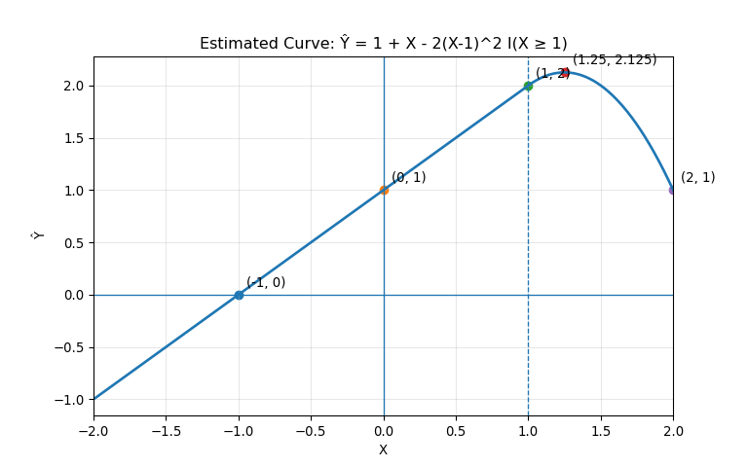

8. Fit some of the non-linear models investigated in this chapter to the Auto data set. Is there evidence for non-linear relationships in this data set? Create some informative plots to justify your answer.

Figure 2: Linear, Polynomial, and Spline Fits
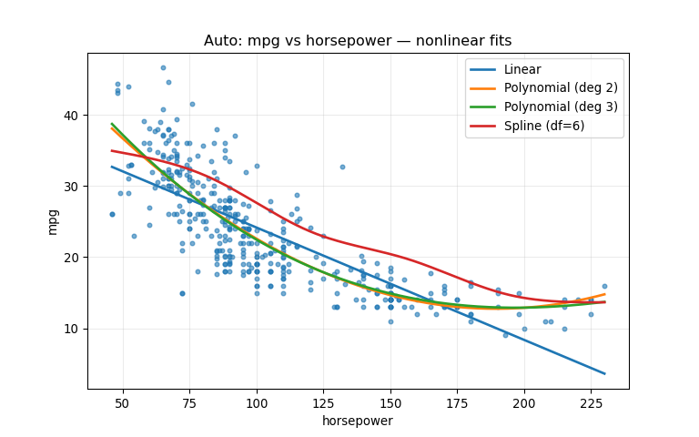
Figure 3: Linear Fit
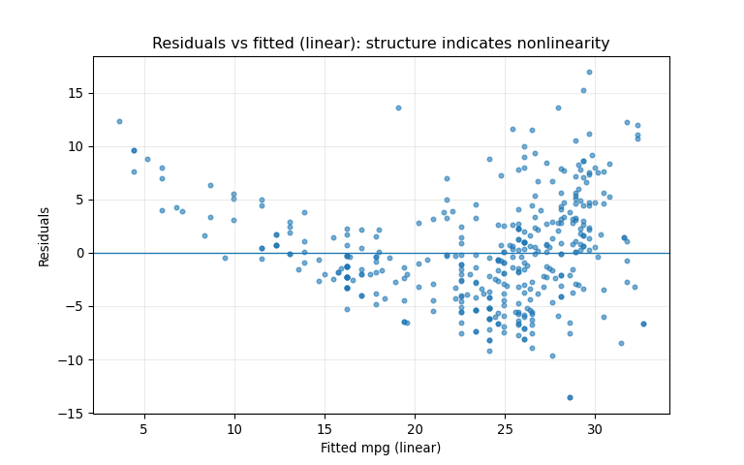

Figure 4: Polynomial Fit
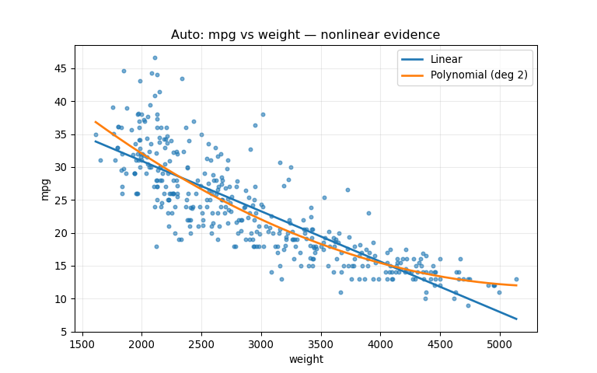
The results above (Figure 2, 3, and 4) provide clear statistical evidence of non-linear relationships in the Auto data. For mpg vs horsepower, a quadratic model significantly improves fit over a linear model (SSR 9385.92 → 7442.03; $F=101.61$, $p=2.20×{10}^{-21})$, indicating substantial curvature. Adding a cubic term does not meaningfully improve the model $(p=0.367)$, suggesting the quadratic form captures the primary nonlinearity. Similarly, for mpg vs weight, a quadratic term significantly improves fit (SSR 7321.23 → 6784.90; $F=30.75$, $p=5.43×{10}^{-8})$. These findings are consistent with the fitted-curve plots, where polynomial/spline fits track curvature that a straight-line model cannot, and with residual plots from the linear models showing systematic structure rather than random scatter.

Regression with Abalone Dataset Competition
The Regression with an Abalone Dataset competition presents a supervised learning problem in which the objective is to estimate the age of abalone specimens (measured by shell rings) using physical measurements such as length, diameter, height, and various weight components (Reade & Chow, 2024). The dataset is synthetically generated from a deep learning model trained on the original biological observations collected in the 1990s, which documented the population biology of Blacklip abalone in Tasmanian waters (Nash et al., 1994). These measurements reflect underlying biological growth processes, which are inherently nonlinear due to maturation effects, diminishing growth rates over time, and interaction among morphological features.
From a statistical modeling perspective, the abalone dataset is particularly well-suited for evaluating nonlinear regression techniques. Shell growth does not increase linearly with age; instead, biological development typically follows curved or interaction-based patterns. Consequently, models that incorporate nonlinear transformations or flexible functional forms may capture the underlying structure more effectively than strictly linear models. In this assignment, two nonlinear regression approaches—a polynomial expansion with Ridge regularization and a Gradient Boosting Regressor—were implemented and compared using cross-validated root mean squared error (RMSE) and residual diagnostics.

Exploratory Data Analysis of Dataset
Exploratory analysis of the Abalone dataset reveals substantial multicollinearity among morphometric predictors, particularly between length, diameter, and multiple weight-based measurements, with pairwise correlations frequently exceeding 0.90 (see Figure 5). These strong linear associations indicate that shell dimensions scale proportionally as abalone grow, reflecting underlying biological size expansion. While such collinearity can inflate variance in ordinary least squares (OLS) estimates, it also suggests that growth relationships may not be strictly linear in their effect on age prediction.
In addition to predictor interdependence, scatterplots of Rings against key physical measurements suggest curvature rather than purely linear trends. Biological growth processes typically exhibit diminishing marginal increases in size as organisms mature, implying that quadratic or interaction effects may better represent the underlying functional form. The distribution of the response variable (Rings) displays mild right skew, with most observations concentrated between approximately 8 and 12 rings (Figure 6), indicating moderate age dispersion without severe imbalance.
Together, these findings motivate the use of nonlinear modeling strategies. Polynomial feature expansion allows explicit modeling of curvature in morphometric relationships, while tree-based ensemble methods such as Gradient Boosting provide flexible function approximation capable of capturing nonlinear interactions without explicit specification. These approaches extend beyond variance control to address potential functional form misspecification in the regression framework.

Figure 5: Correlation Heatmap of Abalone Predictors
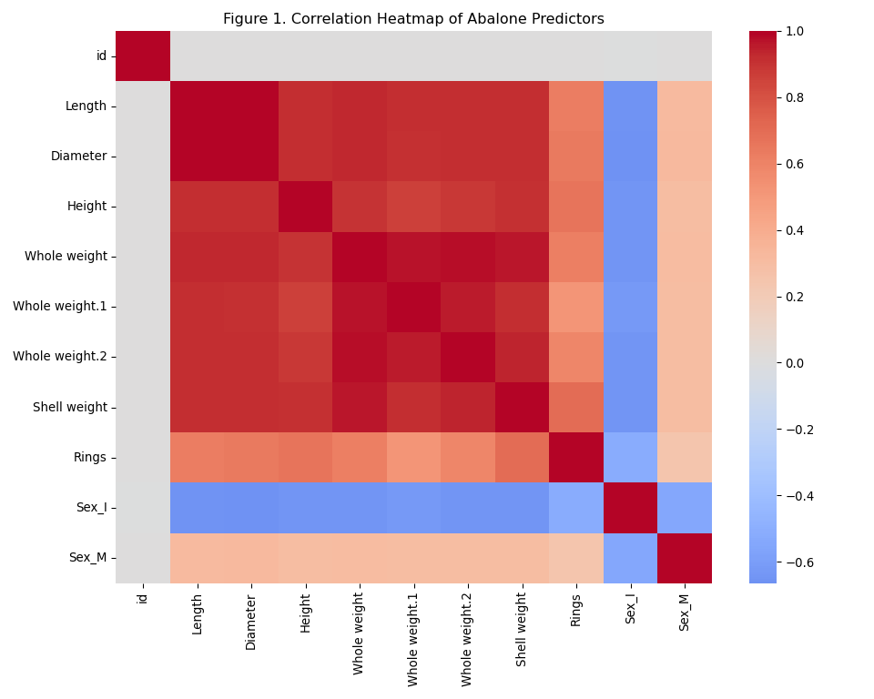
Figure 6: Distribution of Abalone Rings
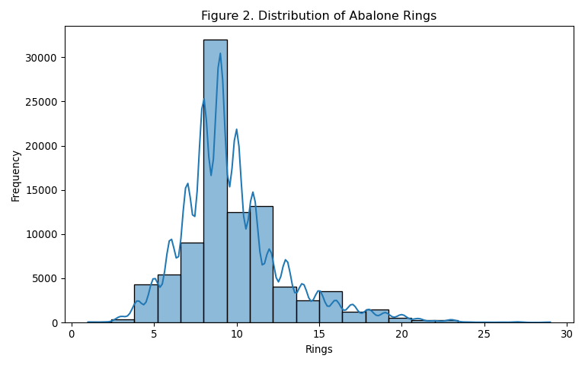

Modeling Strategy and Rationale
Exploratory analysis indicated that the relationship between physical shell measurements and abalone age may not follow a strictly linear functional form. Biological growth processes are characterized by curvature and interaction effects, as growth rates typically slow with maturation. Consequently, linear regression models may suffer from functional form misspecification even when multicollinearity is addressed.
To investigate nonlinear structure in the data, two complementary approaches were implemented. The first model incorporated second-degree polynomial feature expansion combined with Ridge regularization, allowing explicit modeling of curvature while controlling coefficient variance. The second model employed a Histogram-based Gradient Boosting Regressor, a tree-based ensemble method capable of capturing complex nonlinear interactions without requiring manual feature specification.
Model performance was evaluated using 5-fold cross-validated root mean squared error (RMSE). Residual diagnostics were examined to assess bias patterns, heteroscedasticity, and remaining structure in prediction errors. Kaggle submission confirmation was used to verify successful model deployment.

Model 1: Polynomial Expansion with Ridge Regularization
To model nonlinear growth dynamics, a second-degree polynomial feature expansion was implemented in conjunction with Ridge regularization. Polynomial basis expansions extend linear models by allowing curvature in the predictor space while retaining interpretability of the regression framework (Hastie et al., 2009). Quadratic terms allow curvature in the relationship between morphometric measurements and abalone age, reflecting biological growth processes in which shell development slows as maturity increases. Ridge shrinkage was applied to stabilize coefficient estimates given the strong multicollinearity among shell dimension variables observed during exploratory analysis, reducing estimator variance through L2 penalization (Hastie et al., 2009).
Model performance was evaluated using 5-fold cross-validated root mean squared error (RMSE), providing an internal estimate of predictive generalization. The polynomial model demonstrated improved flexibility relative to a strictly linear specification while maintaining stability through regularization.
Residual diagnostics further illuminate model behavior. Figure 7 presents the residuals versus predicted values using 5-fold out-of-fold (OOF) predictions. The plot indicates mild residual structure at higher predicted ring counts, suggesting that although quadratic terms capture primary curvature, some interaction effects or higher-order nonlinearities remain unmodeled. Additionally, residual dispersion increases slightly for larger fitted values, indicating moderate heteroscedasticity consistent with increased biological variability among older specimens.
Figure 8 displays the distribution of residuals. The residuals are approximately centered at zero and exhibit near symmetry, though moderate tail behavior is present. This tail structure aligns with natural biological variability in shell growth and age estimation, particularly among older abalone where ring interpretation becomes less precise. Overall, the polynomial Ridge model captures meaningful curvature in the data while leaving limited but observable nonlinear structure in the error pattern.

Figure 7: Model 1 - Residuals vs Predicted
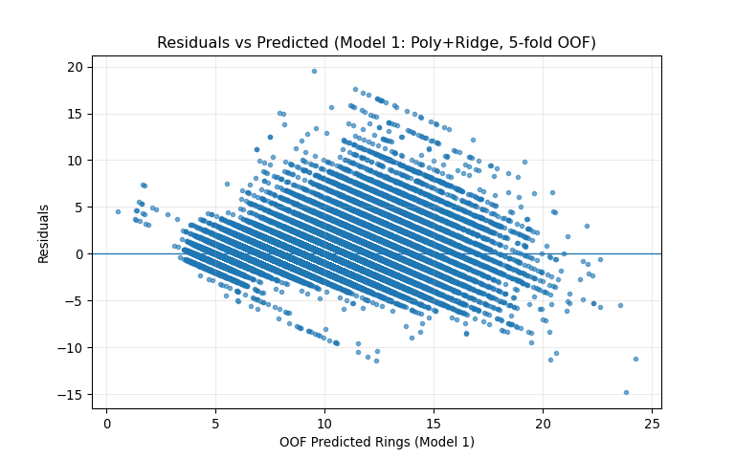
Figure 8: Model 1 – Distribution of Residuals
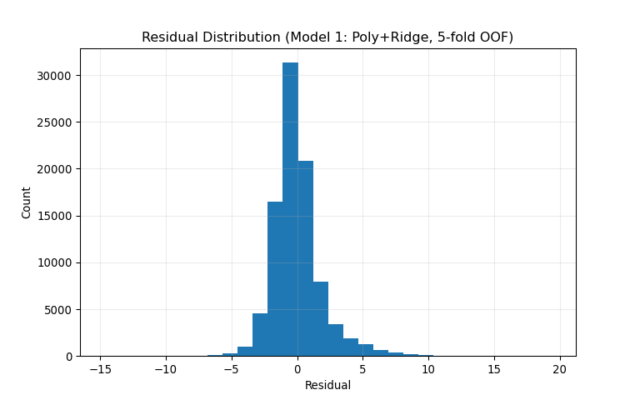

Model 2: Gradient Boosting Regression
The second modeling approach employed a Histogram-based Gradient Boosting Regressor (HistGBR), a tree-based ensemble method capable of approximating complex nonlinear functions through sequential error correction. Gradient boosting constructs an additive model in a forward stagewise manner, where each successive tree is fit to the residual errors of the previous ensemble, thereby improving predictive performance through gradient-based optimization (Friedman, 2001). Unlike polynomial expansion, which requires explicit specification of curvature, gradient boosting automatically captures nonlinear interactions and threshold effects among predictors. This flexibility is particularly appropriate for biological growth modeling, where relationships between shell dimensions and age may involve interaction structures and non-monotonic behavior.
Model performance was evaluated using 5-fold cross-validated RMSE to ensure comparability with Model 1. Relative to the polynomial Ridge model, the Gradient Boosting approach demonstrated improved generalization performance, indicating that interaction effects and nonlinear structure not captured by quadratic terms contribute meaningfully to predictive accuracy.
Residual diagnostics further support this interpretation. Figure 9 presents the residuals versus predicted values using 5-fold out-of-fold predictions. Compared to Model 1, the residuals are more evenly dispersed around zero, with reduced visible structure across the fitted range. The absence of pronounced curvature suggests that the boosting model effectively captures higher-order nonlinearities and interaction effects among morphometric predictors. Residual spread appears more stable across predicted values, indicating improved consistency in error magnitude.
Figure 10 displays the residual distribution for the Gradient Boosting model. The distribution remains centered near zero and appears slightly tighter than that of Model 1, with moderate tail behavior consistent with biological variability. While some dispersion remains for larger predicted ring counts—likely reflecting inherent uncertainty in estimating older abalone—the overall error pattern suggests improved functional form specification relative to the polynomial model.
Figure 9: Model 2 - Residuals vs Predicted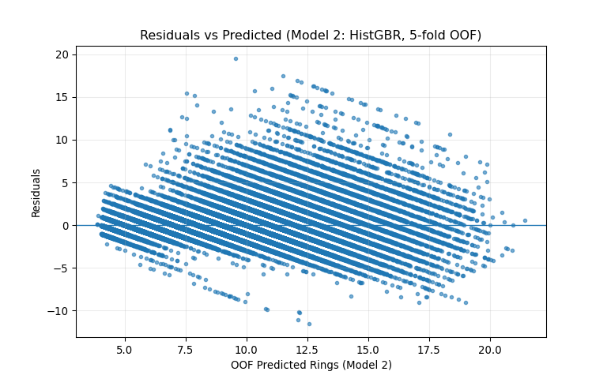

Figure 10: Model 2 – Distribution of Residuals
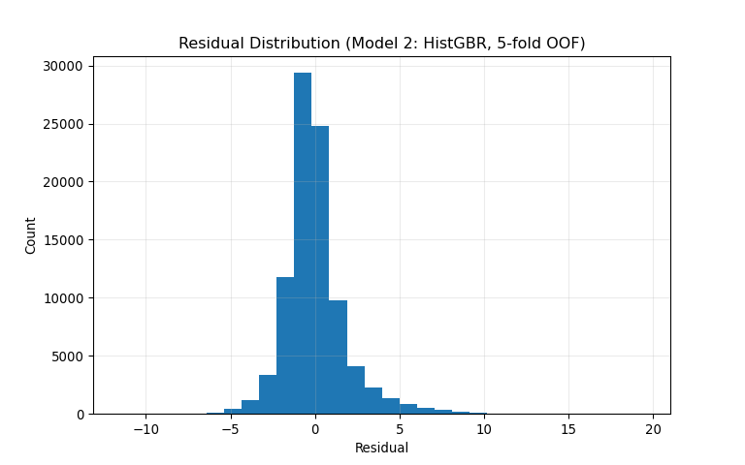

Model Comparison and Error Analysis
Comparative evaluation indicates that while the polynomial Ridge model successfully captures primary curvature in morphometric growth relationships, residual diagnostics reveal remaining structure and moderate heteroscedasticity at higher predicted ring counts. The Gradient Boosting model, by contrast, produces a more uniformly distributed residual pattern and lower cross-validated error, suggesting superior representation of nonlinear interactions among predictors.
These findings highlight an important distinction between parametric and ensemble-based nonlinear modeling. Polynomial expansion introduces controlled curvature but remains limited to predefined functional forms. Gradient Boosting, through recursive partitioning and additive tree construction, flexibly approximates complex response surfaces without explicit feature engineering. The improved residual behavior and predictive performance of the boosting model suggest that the abalone growth process is governed by interaction-rich nonlinear dynamics that extend beyond simple quadratic effects.

Technical Resources and Submissions
All code utilized for this analysis, including exploratory data analysis, cross-validation procedures, risidual diagnostics, and submission generation in the accompaning Jupyter Notebook/RMD file. The complete repository including the notebook and dependency specifications can be accessed via the following GitHub repository: https://github.com/chandawg/DDS-8555-ChandlerJ-Regression-Analysis
Furthermore, two distinct nonlinear models were submitted to the Kaggle competition (see Figure 11).
Model 1 (Polynomial+Ridge): Submitted as kaggle_submission_Chandler_model1_poly_ridge.csv, this model incorporates second-degree polynomial feature expansion with Ridge regularization to explicitly model curvature while controlling coefficient variance under strong predictor correlation.
Model 2 (Gradient Boosting Regression): Submitted as kaggle_submission_Chandler_model2_histgbr.csv, this tree-based ensemble model captures nonlinear interactions and threshold effects automatically through sequential additive tree construction, without requiring explicit feature transformation.

Figure 11. Screen capture of Kaggle submission confirmation for both nonlinear models.


Discussion
The comparative results suggest that while explicit quadratic expansion captures primary curvature in morphometric growth relationships, ensemble-based methods more effectively model interaction-rich nonlinear dynamics. Biological shell growth reflects diminishing returns and complex interplay among size and weight variables, which are not fully represented by second-degree terms alone. The improved residual behavior and cross-validated performance of the Gradient Boosting model indicate that flexible function approximation provides meaningful gains in predictive stability. These findings highlight the importance of functional form specification in regression modeling, particularly when underlying processes are governed by nonlinear biological mechanisms.

Conclusion
This analysis examined nonlinear regression approaches for predicting abalone age from morphometric measurements and demonstrated that functional form specification plays a critical role in modeling biological growth processes. While the Polynomial + Ridge model effectively introduced curvature and stabilized estimates under multicollinearity, residual diagnostics revealed remaining structure and increasing dispersion at higher predicted ring counts, indicating that quadratic terms alone do not fully capture the interaction-rich dynamics of shell development. In contrast, the Histogram-based Gradient Boosting model achieved improved cross-validated performance and more uniformly distributed residuals, suggesting superior representation of nonlinear interactions and threshold effects among predictors. These findings highlight that although parametric nonlinear extensions can address primary curvature, flexible ensemble methods provide a more powerful framework for approximating complex biological response surfaces where growth patterns are governed by diminishing returns and interdependent morphometric features.

References
Friedman, J. H. (2001). Greedy function approximation: A gradient boosting machine. The Annals of Statistics, 29(5), 1189–1232. https://doi.org/10.1214/aos/1013203451
Hastie, T., Tibshirani, R., & Friedman, J. (2009). Elements of statistical learning: Data mining, inference, and prediction. (2nd ed.). Springer. https://hastie.su.domains/ElemStatLearn/
Nash, W., Sellers, T. L., Talbot, S. R., Cawthorn, A. J., & Ford, W. B. (1994). The population biology of abalone (haliotis species) in tasmania. I. Blacklip abalone (h. Rubra) from the north coast and islands of bass strait. Sea Fisheries Division, Technical Report No, 48. https://www.researchgate.net/profile/Warwick-Nash/publication/287546509_7he_Population_Biology_of_Abalone_Haliotis_species_in_Tasmania_I_Blacklip_Abalone_H_rubra_from_the_North_Coast_and_Islands_of_Bass_Strait/links/5d949460458515202b7bf592/7he-Population-Biology-of-Abalone-Haliotis-species-in-Tasmania-I-Blacklip-Abalone-H-rubra-from-the-North-Coast-and-Islands-of-Bass-Strait.pdf
Reade, W., & Chow, A. (2024). Regression with an abalone dataset. https://kaggle.com/playground-series-s4e4

AI Disclosure and Usage Statement
In accordance with the course policy on academic integrity, I acknowledge the use of ChatGPT (a large language model developed by OpenAI) as a research and brainstorming tool for this assignment. The AI was used to assist in structuring portions of the written analysis, refining technical explanations of regularization and principal components regression, and troubleshooting Python implementation details within the Jupyter Notebook environment. All AI-generated suggestions were critically evaluated for accuracy, verified against course materials and dataset outputs, and substantially revised to reflect my own analytical reasoning and professional voice. The final model implementation, statistical interpretation, and conclusions represent my independent work and judgment.

