System Understanding Document

Application: Score Board Application

|  |  |
| --- | --- |
| Document Version: |  |
| Document Date: | 09/19/2019 |
| Author: | Chanda K Yadav |

Table of Contents

1 Application Overview 2

2 List of Screen 2

2.1 Scoreboard: 2

2.2 Player List: on click of Add-Update Players/Score Details 2

3 Technology Related 5

3.1 Source Code Control 5

3.2 Software Pre-requisites 5

4 DATA ARCHITECTURE 7

4.1 Database Details 7

# Application Overview

Score Board Application is a web application, which manage the score of players. It’s an application developed using Microsoft Technologies.

Application used to view, add, update, and delete the player’s scores.

In this application, Code First Approach is used to create database. Refer section 4 to know more about database restoration

# List of Screen

## Scoreboard:

This page consist of lists of players associated with score and rank of the player. The top scorer will be at the top of the scoreboard list

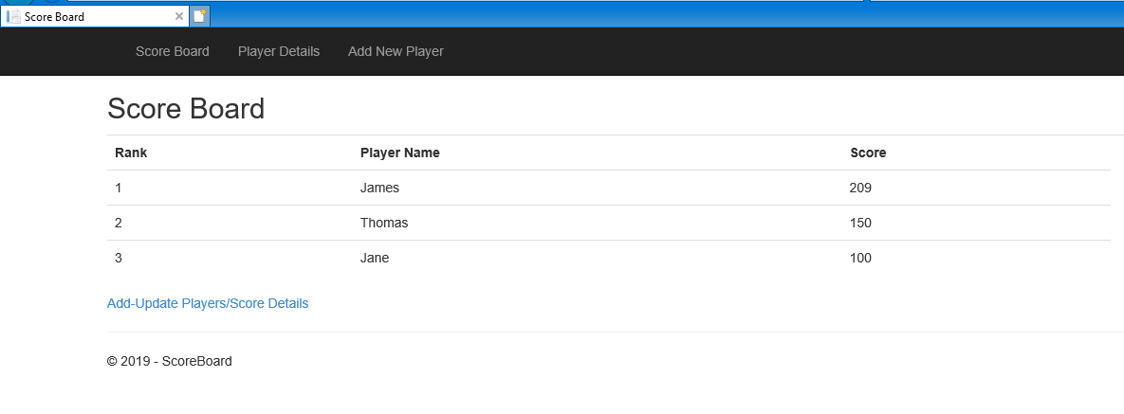

The screen consist of Add-Update Players/Score Details, which redirect to Player list screen where you see the player list with DML functionality.

The screen also consist of header with 3 links-

* Score Board-> Redirect to Score Board List screen
* Player Details 🡪 Redirect to Player List screen consist of Player details with facilities to modify the players record
* Add New Player-> Redirect directly to Create New Player with Score.

## Player List: on click of Add-Update Players/Score Details

This page show the Player details with facilities to modify the players record (Create, Edit, View, and Delete).

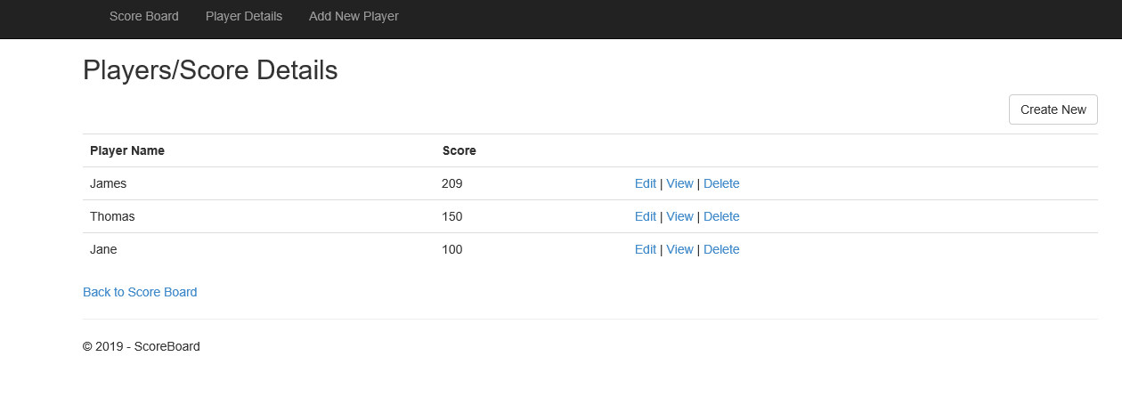

* **Create New**: Create new player with score having validation on Name and Score.

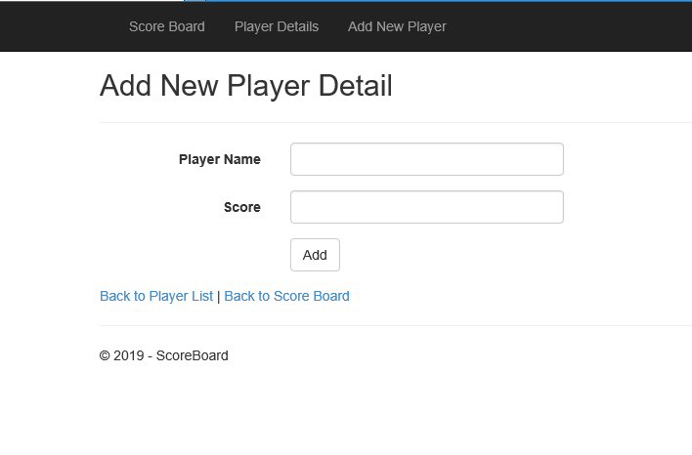

* **Edit**: Update player’s record.

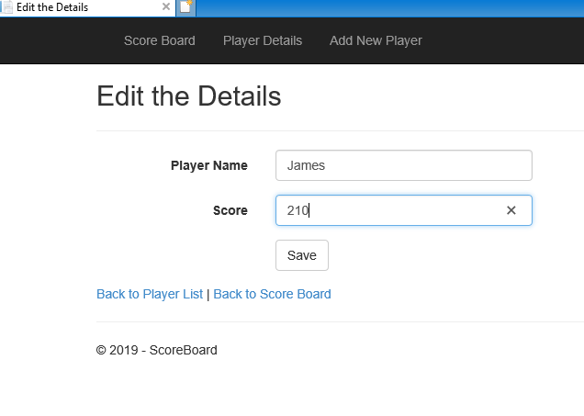

* **Delete**: Delete player’s record after confirmation.

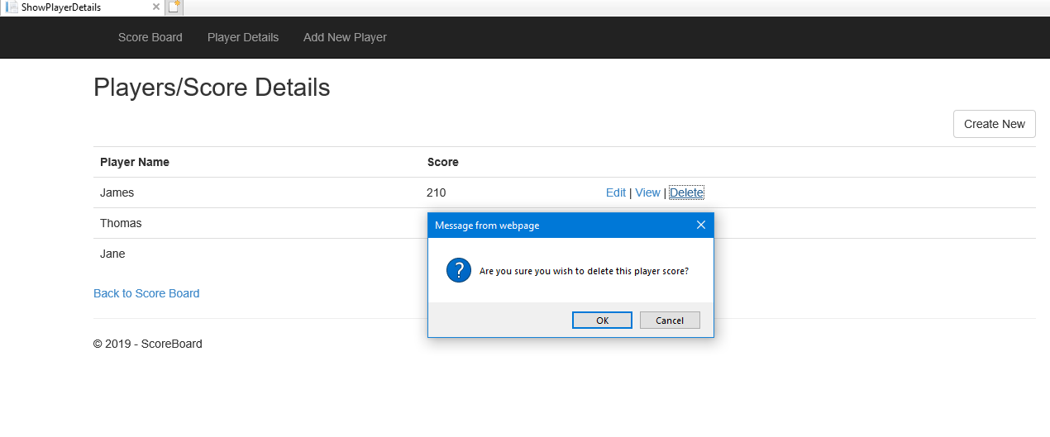

* **View**: View the single player details.

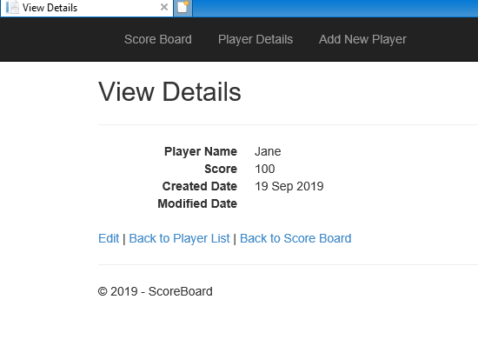

# Technology Related

## Source Code Control

Below are the details of location for Code Repository access:

URL: <https://github.com/chanday28/SelfDevelopment>

## Software Pre-requisites

**Software:**

List of software required along with Version.

|  |  |
| --- | --- |
| **Software name** | **Version** |
| **.NET Framework** | **4.5.2** |
| **Visual Studio .NET** | **Enterprise 2017** |
| **Microsoft’s SQL Server** | **2015** |

## 

**Nuget Package: Install Entity Framework 6.2 in visual studio**

# DATA ARCHITECTURE

## Database Details

**Database Name**: Score Board

**Table Name**: Player_Score – Store Player record

There are two ways to create database. I have chosen **Approach 1: Code-First Approach**

**Appoarch1:** Code-First Approach to create Database

1. Add connection string in Web.config:

<connectionStrings>

<add name="ScoreBoardContextDemo" connectionString="Server=.;Database=ScoreBoard;Trusted_Connection=True;"

providerName="System.Data.SqlClient" />

</connectionStrings>

As I have connected to local database so the server name is (.)

2. Open Scoreboard Web Application in Visual Studio

3. Build the application

4. Open Package Manager Console

Tools->Nuget Package Manager-> PakageMager Console

5. Write the command to enable the migration in the project. (If it is not enabled)

PM> Enable-Migrations

6. Generate Database

PM> Update-Database

Note: Another configuration is already there in Scoreboard Application repository.

**Appoarch2:** Restore Through back up file

1. Restore the database with help of back up file, which is in repository below path:

URL: [../ScoreBoard_Application/Database](https://github.com/chanday28/SelfDevelopment/tree/master/ScoreBoard_Application/Database)

Filename: ScoreBoard.bak

2. Restore it to Sql Server management Studio