Lab Programs 16-20
NAME: D. CHAND BASHA
REG NO: 192424218
- reviews = [
"The product is good and the quality is good",
"I like the product",
"The product is not bad"
]
words = " ".join(reviews).lower().split()
freq = {}
for w in words:
freq[w] = freq.get(w, 0) + 1
print(freq)
OUTPUT:
- import pandas as pd
import string
from collections import Counter
import matplotlib.pyplot as plt
df = pd.read_csv("data.csv")
stop_words = ["the","and","is","a","to","of","in"]
text = " ".join(df["feedback"]).lower()
text = text.translate(str.maketrans("", "", string.punctuation))
words = [w for w in text.split() if w not in stop_words]
freq = Counter(words)
N = int(input("Enter N: "))
topN = freq.most_common(N)
print(topN)
labels, values = zip(*topN)
colors = ["red", "blue", "green", "orange", "purple"]
plt.bar(labels, values, color=colors)
plt.show()
OUTPUT:
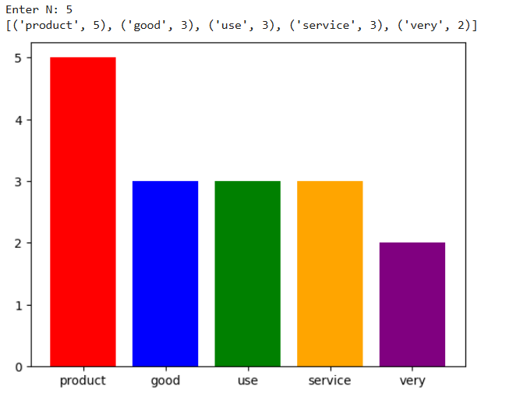

- import pandas as pd
import matplotlib.pyplot as plt
import numpy as np
# Data
data = {
"age": [23,25,27,31,33,35,37,39,41,43,45,47,49,51,53,55,57,59],
"fat": [15,16,17,18,20,22,23,24,25,26,27,29,30,31,33,35,36,37]
}
df = pd.DataFrame(data)
# Mean, Median, Std
print("Mean:\n", df.mean())
print("\nMedian:\n", df.median())
print("\nStandard Deviation:\n", df.std())
# ------ Create One Page with 3 Plots ------
plt.figure(figsize=(12, 10))
# 1. Boxplot (updated line)
plt.subplot(2, 2, 1)
plt.boxplot([df["age"], df["fat"]], tick_labels=["Age", "%Fat"])
plt.title("Boxplot for Age and %Fat")
# 2. Scatter Plot
plt.subplot(2, 2, 2)
plt.scatter(df["age"], df["fat"])
plt.xlabel("Age")
plt.ylabel("%Fat")
plt.title("Scatter Plot")
# 3. Q-Q Plot (Manual using NumPy)
plt.subplot(2, 1, 2)
ages = np.sort(df["age"])
n = len(ages)
prob = (np.arange(1, n+1) - 0.5) / n
theoretical_quantiles = np.quantile(np.random.normal(0, 1, 5000), prob)
plt.scatter(theoretical_quantiles, ages)
plt.plot(theoretical_quantiles, theoretical_quantiles, color="red")
plt.xlabel("Theoretical Quantiles")
plt.ylabel("Age")
plt.title("Q-Q Plot (Age)")
plt.tight_layout()
plt.show()
OUTPUT:
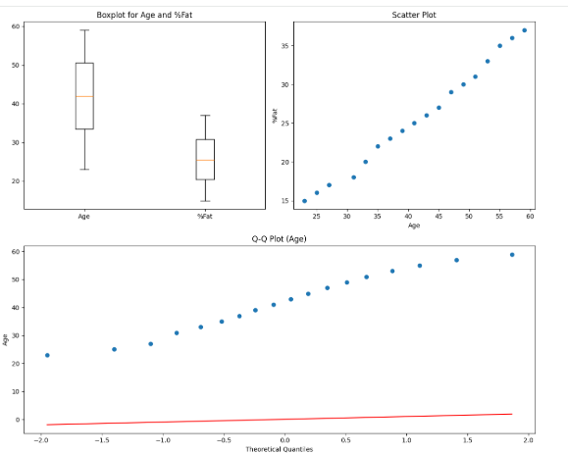

- import pandas as pd
df = pd.read_csv("sales_data.csv")
df["Total Sales"] = df["Quantity Sold"] * df["Unit Price"]
product_sales = df.groupby("Product")["Total Sales"].sum()
profit = product_sales * 0.20
print(profit.sort_values(ascending=False).head(5))
OUTPUT:

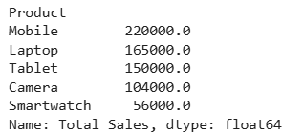
- import pandas as pd
df = pd.read_csv("customer_data.csv")
def segment(x):
if x >= 50000:
return "High Spender"
elif x >= 20000:
return "Medium Spender"
else:
return "Low Spender"
df["Segment"] = df["Total Spending"].apply(segment)
print(df.groupby("Segment")["Age"].mean())
OUTPUT:
