Lab Programs 21-40
Name: D.CHAND BASHA
Reg no:192424218
- import pandas as pd
import numpy as np
from scipy import stats
data = pd.read_csv("rare_elements.csv")["concentration"]
n = int(input("Enter sample size: "))
confidence = float(input("Enter confidence level (0.90, 0.95, 0.99): "))
precision = float(input("Enter desired precision: "))
sample = data.sample(n, replace=True) # FIXED
mean = np.mean(sample)
std = np.std(sample, ddof=1)
t = stats.t.ppf((1 + confidence) / 2, n - 1)
margin = t * (std / np.sqrt(n))
print("Sample Mean:", mean)
print("Confidence Interval:", (mean - margin, mean + margin))
print("Precision Achieved:", margin)
OUTPUT:
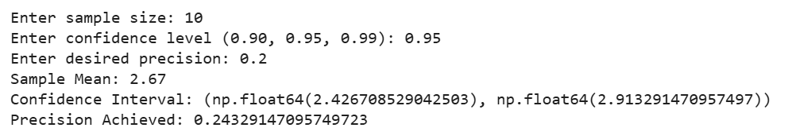
- import pandas as pd
from scipy import stats
data = pd.read_csv("customer_review.csv")["rating"]
mean = data.mean()
std = data.std()
n = len(data)
confidence = 0.95
t = stats.t.ppf((1 + confidence) / 2, n - 1)
margin = t * (std / (n ** 0.5)
print("Mean Rating:", mean)
print("95% Confidence Interval:", (mean - margin, mean + margin))
OUTPUT:
- import pandas as pd
from scipy.stats import ttest_ind
import matplotlib.pyplot as plt
df = pd.read_csv("treatment_data.csv")
control = df[df["group"]=="control"]["value"]
treat = df[df["group"]=="treatment"]["value"]
t, p = ttest_ind(control, treat)
plt.boxplot([control, treat], tick_labels=["Control", "Treatment"])
plt.title("Clinical Trial Results")
plt.ylabel("Values")
plt.show()
print("p-value:", p)
OUTPUT:
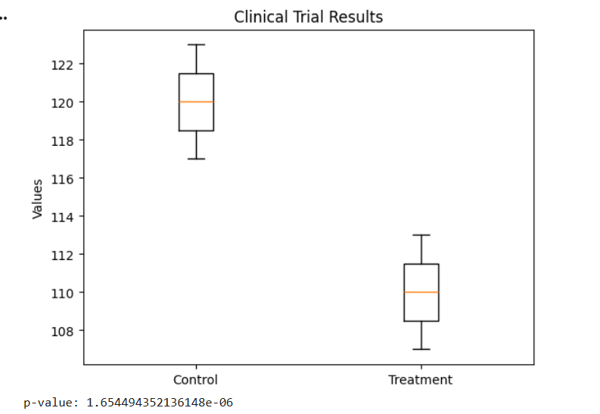
26. import pandas as pd
from sklearn.linear_model import LinearRegression
df = pd.read_csv("house_data.csv")
# Convert to numpy arrays (fix warning)
X = df[['area', 'bedrooms', 'location']].values
y = df['price'].values
model = LinearRegression()
model.fit(X, y)
# User input
area = float(input("Enter area: "))
bed = int(input("Enter bedrooms: "))
loc = int(input("Enter location (1/2/3): "))
# Prediction (list is fine because training had no feature names)
prediction = model.predict([[area, bed, loc]])
print("Predicted Price =", prediction[0])
OUTPUT:
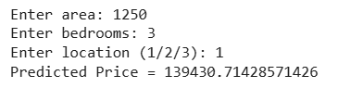

- # house_price_bivar_fixed.py
import pandas as pd
import numpy as np
from sklearn.linear_model import LinearRegression
from sklearn.metrics import r2_score, mean_squared_error
import matplotlib.pyplot as plt
df = pd.read_csv("houses.csv")
# Bivariate: size_sqft vs price
X = df[['size_sqft']].values # numpy array -> avoids sklearn feature-name warnings
y = df['price'].values
model = LinearRegression()
model.fit(X, y)
print(f"Coefficient (slope): {model.coef_[0]:.2f}")
print(f"Intercept: {model.intercept_:.2f}")
# Evaluate using train data
y_pred = model.predict(X)
r2 = r2_score(y, y_pred)
rmse = np.sqrt(mean_squared_error(y, y_pred)) # <- compatible replacement
print(f"R2 score: {r2:.4f}")
print(f"RMSE: {rmse:.2f}")
# Save line plot
plt.scatter(X.flatten(), y)
plt.plot(X.flatten(), y_pred)
plt.xlabel("Size (sqft)")
plt.ylabel("Price")
plt.title("Size vs Price")
plt.savefig("size_price_plot.png")
print("\nSaved plot: size_price_plot.png")
OUTPUT:
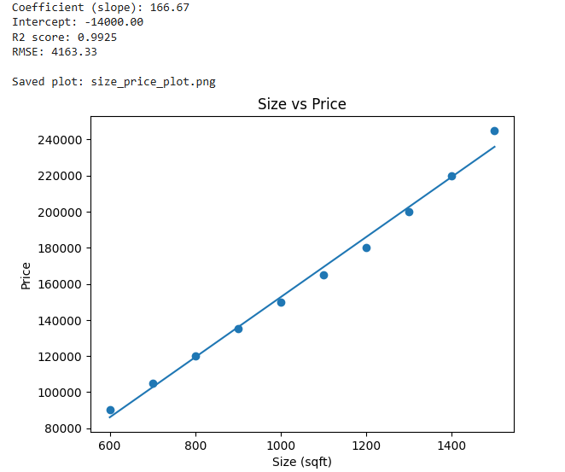

- import pandas as pd
import numpy as np
from sklearn.linear_model import LinearRegression
from sklearn.metrics import r2_score, mean_absolute_error
from sklearn.model_selection import train_test_split
df = pd.read_csv("cars.csv")
features = ['engine_cc','horsepower','fuel_efficiency','age']
X = df[features].values
y = df['price'].values
X_train, X_test, y_train, y_test = train_test_split(X,y, test_size=0.25, random_state=42)
model = LinearRegression()
model.fit(X_train, y_train)
y_pred = model.predict(X_test)
print("R2:", r2_score(y_test, y_pred))
print("MAE:", mean_absolute_error(y_test, y_pred))
# Feature importance via coefficients
for feat, coef in zip(features, model.coef_):
print(f"{feat}: {coef:.2f}")
OUTPUT:
