**External Libraries Used**

* **react-redux**: Manages application state, especially for API calls and data handling.
* **react-native-toast-message**: Displays toast messages for user notifications.
* **react-native-reanimated-carousel**: Provides a carousel component for displaying product images.
* **@react-native-google-signin/google-signin**: Implements Google OAuth for user authentication.
* **react-native-paper**: Offers UI components for a styled and cohesive design.
* **@expo/vector-icons**: Provides icons for use within the app.

**Features**

1. **Authentication Screen**
   * Allows users to sign in using Google OAuth.
   * Utilizes **@react-native-google-signin/google-signin** for Google Sign-In functionality.
2. **Profile Screen**
   * Displays user profile information after successful authentication.
   * Integrates with APIs to demonstrate handling of loading states, errors, and data retrieval.
   * Utilizes **react-native-reanimated-carousel** to display product images fetched from a fake API.

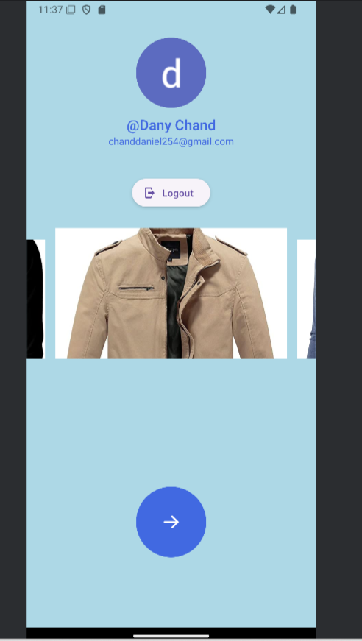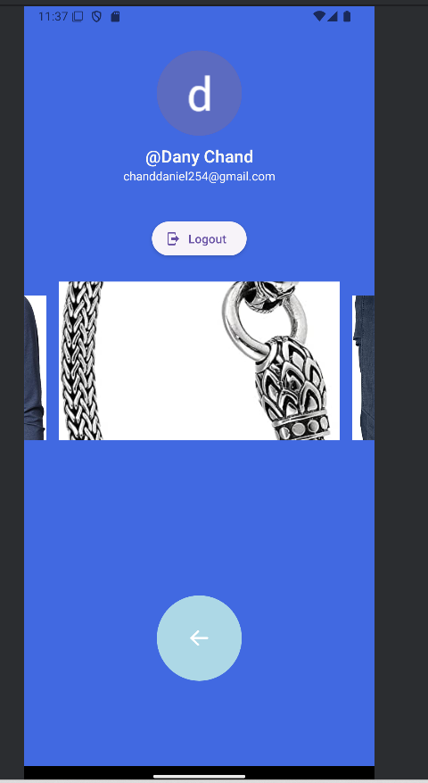

To run the application and test it using Expo's development build, follow these steps:

1. Navigate to the root folder of your project and execute **npm install**.
2. Ensure you have an Android emulator set up or a physical Android device connected.
3. Run **npx expo run:android** to start the application in Expo's development mode.

Please note that : **@react-native-google-signin/google-signin**, require testing specifically in the development build rather than just using **expo start.** This ensures that all features are correctly integrated and functioning as expected in a build version of the application.