# Connecting ABAP System to SAP Cloud platform using Cloud connectors and HTTP Destinations

Prerequisites:

1. SAP Hana Cloud platform (Trail version)
2. JDK(Java Development Toolkit) version 1.8 or above
3. Cloud Connectors

Setting the JAVA_HOME environment variable in windows.

Prior to setting the JAVA_HOME environment variable, JDK installation should be done

Goto windows advanced stings and click on Environment variables.

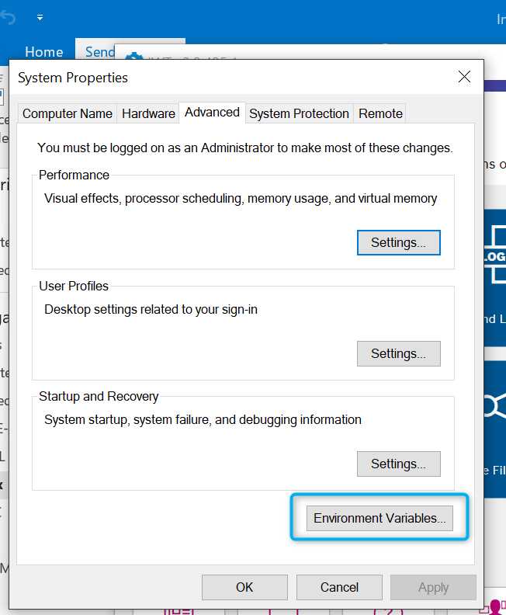

Click on New

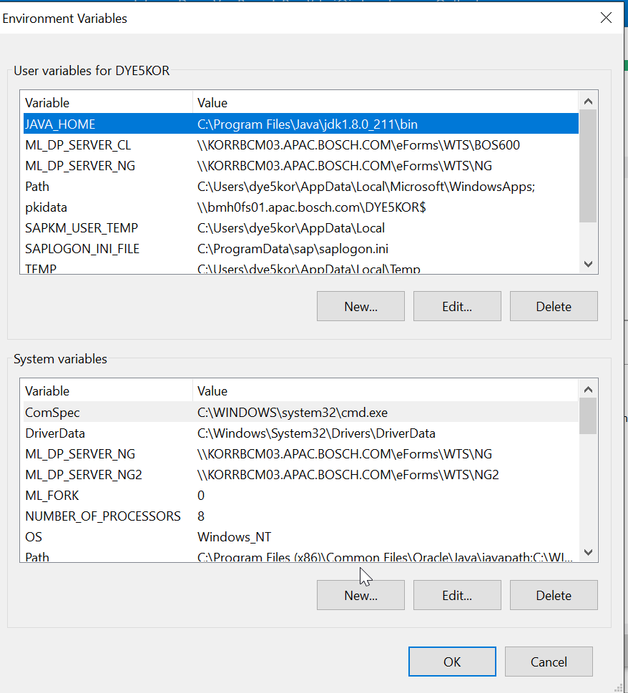

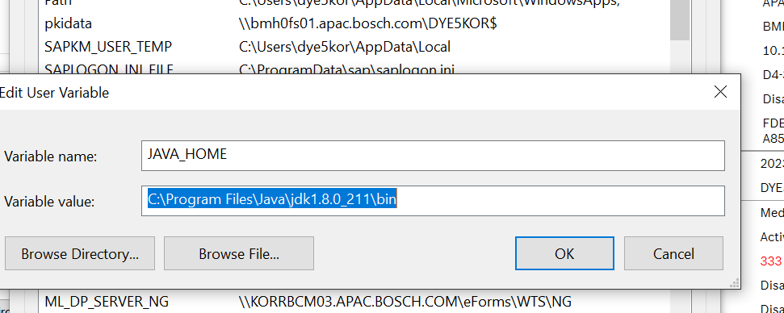

Down load and install the cloud connectors from the below SAP official website.

<https://tools.hana.ondemand.com/#cloud>

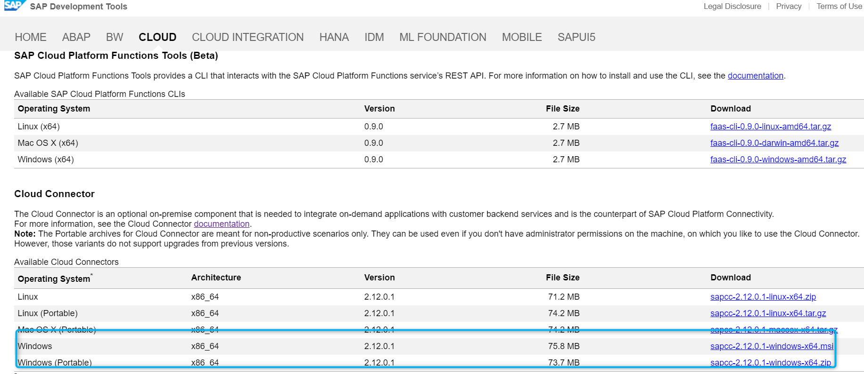

Once the download is complete run the .msi file to complete the cloud connectors installation.

During installation choose the path of JAVA_HOME Environment variable path which was set above.

Once cloud connectors are installed successfully Please login into the below url.

<https://localhost:8443/>

Username: Administrator

Password: manage

Proxy: rb-proxy-static.bosch.com:8080

Once you have been logged in with the above credentials system asks for the password change.

Change the password and re login again then you will be able to see the below screen.

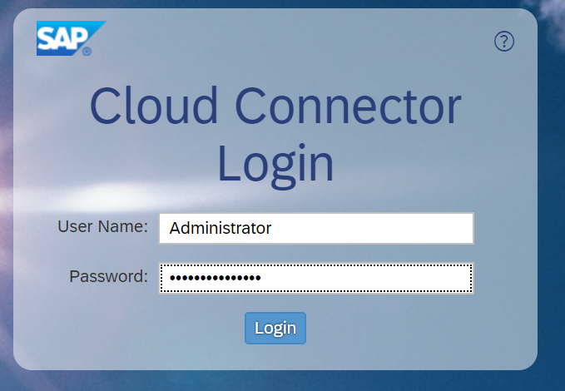

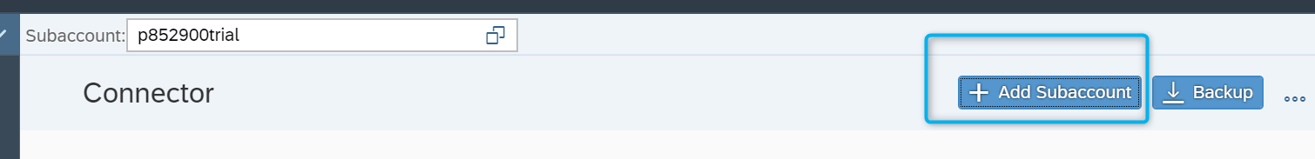

Click on Add Subaccount to link with your SAP Hana cloud Platform trial account.

Enter the Details as below and click on save.

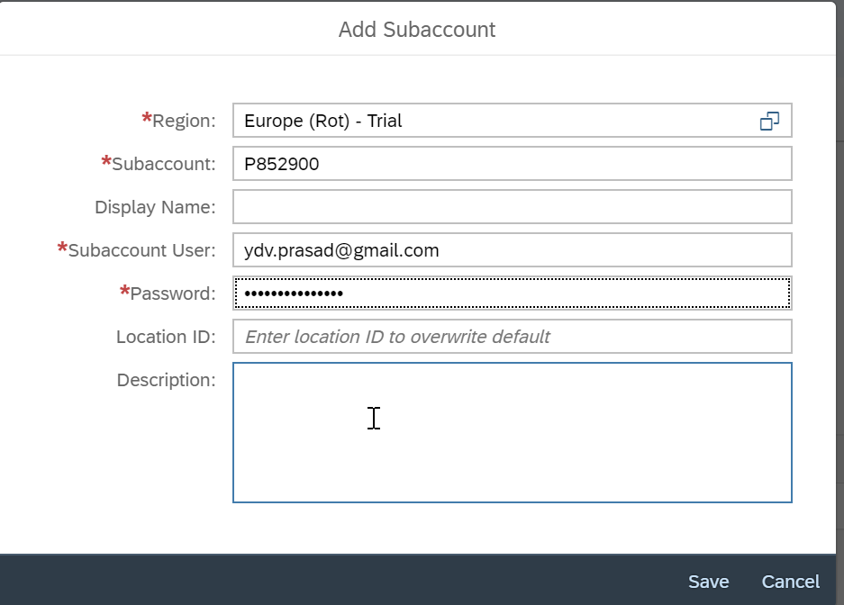

Once it is saved then you can check you trail account linked with cloud connectors in Subaccount Dashboard.

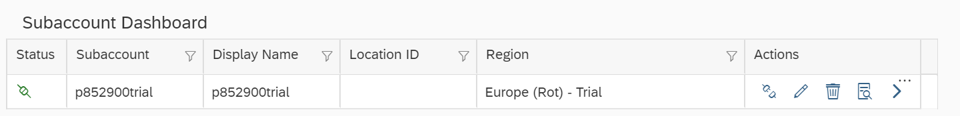

Click on **Cloud to on premise** from the left pane.

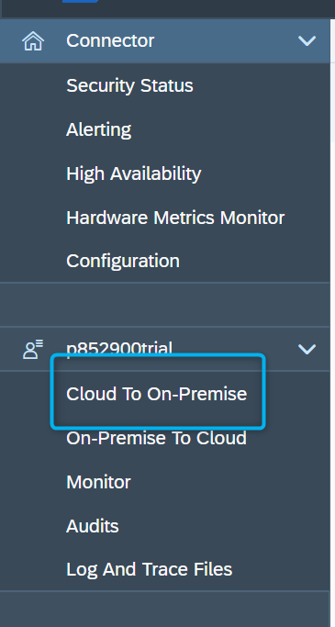

From Access control Tab click on + button to Map the ABAP system.

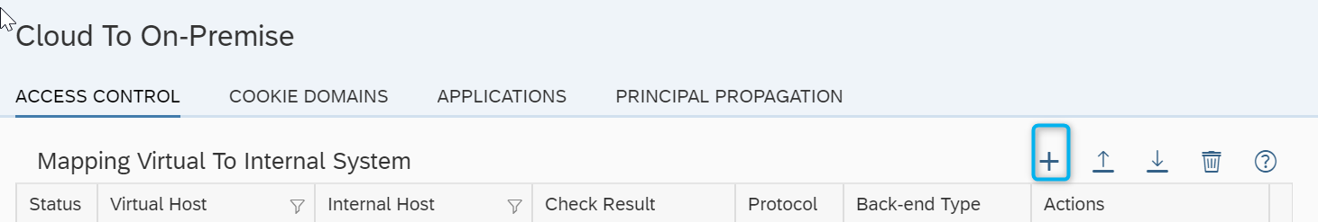

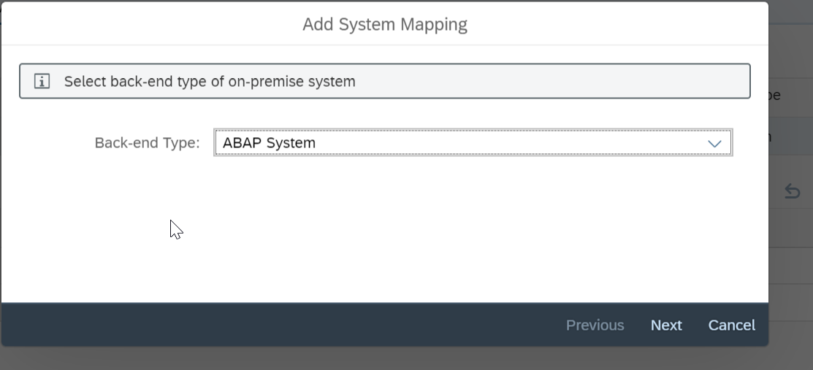

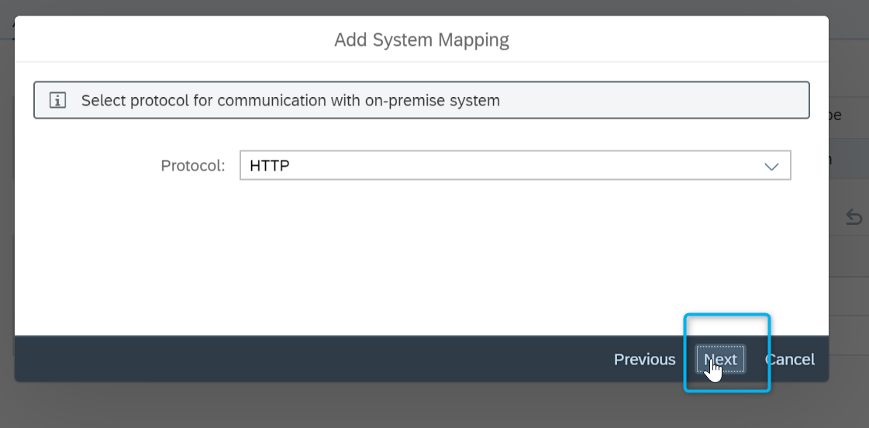

Provide the internal host(Sap server) and port number.

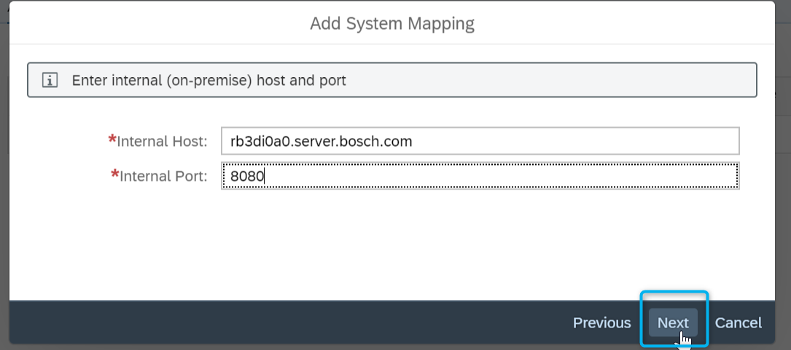

We can use the same internal host details for virtual host.

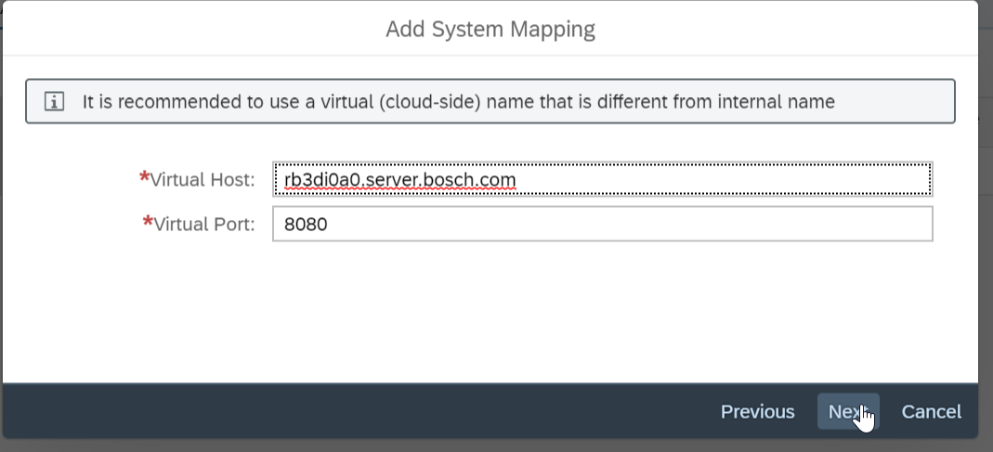

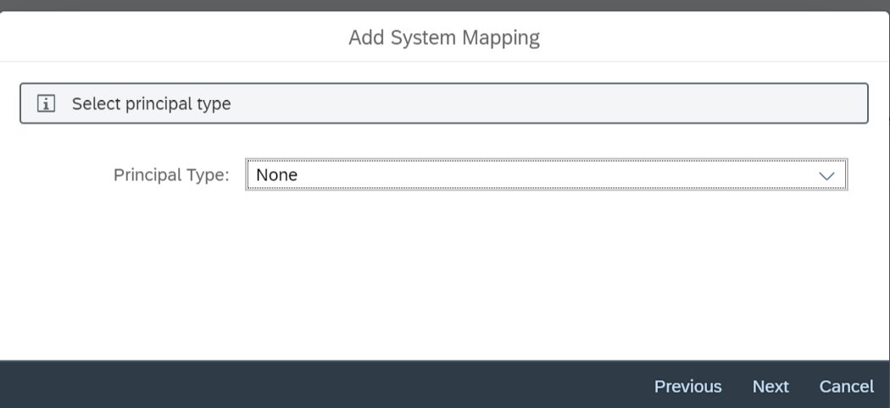

Once the mapping has been done to internal host we can see the below screen with the check result

Status unchecked.

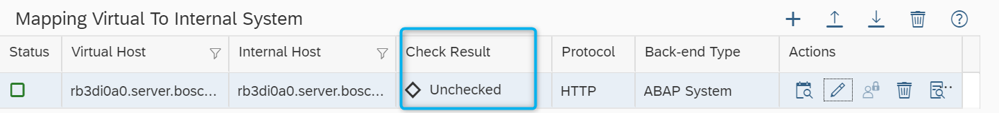

Click on the below shown button to check the abap mapped system status weather it can be reachable or not.

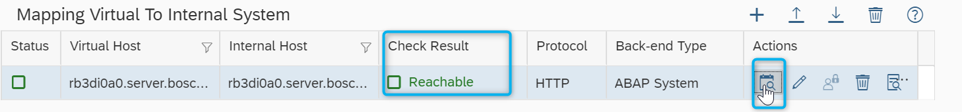



We can also add the Odata service Url path to access the OData services or any resources.

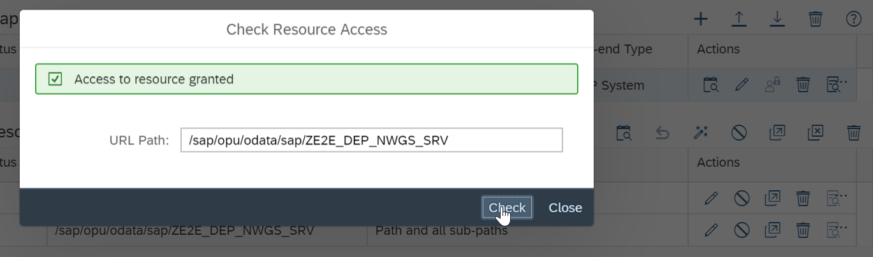

Once the cloud connector configuration is successful we can see the same connection available in SAP Hana cloud platform which is liked to our subaccount.

