**step1:** cds init trialbalance_app

**step2:** cds import C_TRIALBALANCE_CDS.edmx

**step3:** changes in package.json file

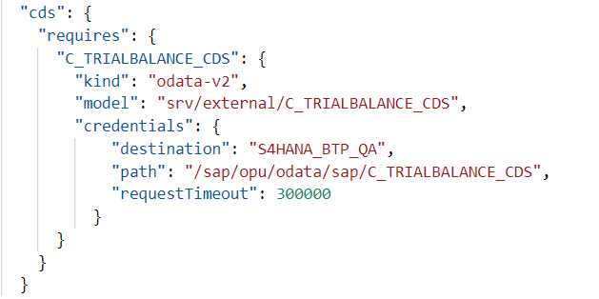

**step4:** Create a Destination Service Instance in Cloud Foundry

**Service Name:** demo-destination

**Plan:** lite

**step5:** cds add mta

**step6:** cds compile srv/ --to xsuaa > xs-security.json

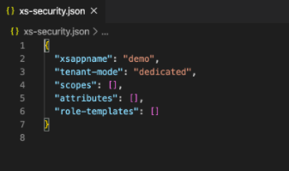

**step7:**

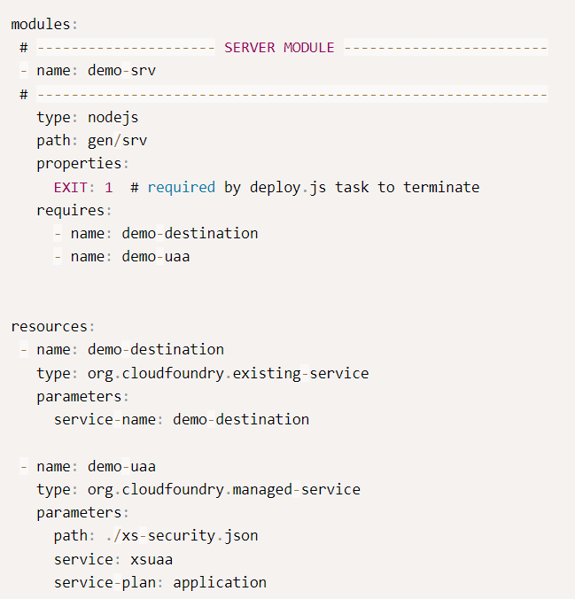

**step8:** build mta and deploy

**step9:** For Adding UI refer below link:

https://developers.sap.com/tutorials/hana-cloud-cap-create-ui.html