Technical Specification

Mobile

**Engineering Drawing Fiori Application**

**Date Created : 07-12-2022**

**Document Information**

|  |  |
| --- | --- |
| **Process Area-Sub Area** |  |
| **Type of development** | Fiori Based Application |
| **FS Definition Form ID** |  |
| **SAP Version** |  |
| **Global / Local** | Is this solution Global and will not change based on Segment/ Country/Company code/Plant or combination of Organizational entities?  • If this is a local requirement specific to a Segment/ Country/Company code/Plant or combination of Organizational entities then please specify the detail. |

**Approval**

|  |  |  |  |  |
| --- | --- | --- | --- | --- |
| **Approved by** | **Name** | **Role** | **Signature** | **Date** |
| Development Team Lead | Vivek | Team Lead |  |  |
| Peer Review | Chamdeep | Senior UI5 developer |  |  |

**Document History**

|  |  |  |  |  |  |
| --- | --- | --- | --- | --- | --- |
| **TS Version** | **FS**  **Version** | **Author** | **Reason for change** | **Page number & Section** | **Date** |
| 1.0.0 |  | Chamdeep | Create New TS Document |  | 7-12-2022 |
|  |  |  |  |  |  |

|  |
| --- |
| **Related Documents** |
|  |
|  |

Table of Contents

1. General Information 4

2. Document Control 5

**2.1** **Version History** 5

**2.2** **List of Quality Reviewers** 5

**2.3** **Authorisers for sign off** 5

**2.4** **Distribution** 5

3. User Stories covered by the SAP UI5 screens 6

3.1. Process Maps / User Journey on screen 6

4. UI5 Definition 6

4.1. App Context and Definition 6

4.2. Hub Service Registration and Back end development 6

4.3. Screen Layout 6

4.4. Screen Flow / Wireframes 6

4.5. Screen Design And Service Mapping 7

4.6. Validations 7

4.7. Events and Buttons 7

4.8. Calculation columns 7

4.9. Method Implementation Details and Suedo code 8

4.10. Performance Tweaks 8

4.11. I18n and Theme 8

5. Webservices / Proxy / OData Specific Information (if any) 9

5.1. OData Service Model 9

5.2. OData Service Entity Details 9

6. Acceptance Criteria 9

7. Assumptions 10

8. Performance Consideration 10

9 Security Requirements/ Authorization Details 10

10 Issues and Risks 10

10.1. Issues 11

10.2. Risks 11

11 Dependencies 11

12 Technical Details 11

13 Additional Information and attachments 11

14 Unit Test Plan 12

# General Information

|  |  |  |  |
| --- | --- | --- | --- |
| **WRICEF ID** |  | | |
| **Description** | Engineering Drawings Library | | |
| **Deployment Phase** |  | | |
| **Fiori app./Transaction(s) (if applicable)** | zengdrawing | | |
| **Git URL** | https://MHIRJ@dev.azure.com/MHIRJ/MHIRJ_S4HANA/_git/MHIRJ_DRS_CP | | |
| **Package** |  | | |
| **Module** |  | | |
| **Data Conversion/Interface User/User Group** |  | | |
| **Execution Mode** | Online | | |
| **Run Frequency** | On Request | **Language** | EN |

| **Transport Information** |
| --- |

**To be filled by Developer**

|  |  |  |  |
| --- | --- | --- | --- |
| **Change Request #** | **CHARM ID** | **Object Identifier**  **(Program ID, Layout Set ID, etc)** | **Object Type**  **(Program, Transaction, Layout Set)** |
|  |  |  |  |
|  |  |  |  |
|  |  |  |  |

|  |
| --- |
| **Related Documents** |
|  |
|  |

# Document Control

2. 1. **Version History**

This table records the status and version history of this document

|  |  |  |  |  |
| --- | --- | --- | --- | --- |
| **Version** | **Date** | **Author** | **Status**  **(draft, peer review etc)** | **Version History** |
| 1.0.0 | 07-12-2022 | Chamdeep | In Draft |  |
|  |  |  |  |  |

2. 1. **List of Quality Reviewers**

This table records the quality reviewers of this document

|  |  |  |
| --- | --- | --- |
| **Name** | **Role** | **Response** |
| Chamdeep | Senior UI developer |  |
|  |  |  |
|  |  |  |
|  |  |  |
|  |  |  |
|  |  |  |

2. 1. **Authorisers for sign off**

This table records the pre-defined person(s) required to sign off the complete document.

|  |  |  |
| --- | --- | --- |
| **Authoriser** | **Role** | **Date of sign off** |
|  |  |  |
|  |  |  |

2. 1. **Distribution**

This document is being distributed to the following authorised people/sections.

|  |  |
| --- | --- |
| **Authoriser** | **Role** |
|  |  |

# User Stories covered by the SAP UI5 screens

|  |  |  |  |  |  |
| --- | --- | --- | --- | --- | --- |
| **ID** | **As a** | **I want** | **So that** | **Acceptance criteria** | **How Met?**  **(be clear if not met by SAP)** |
|  | Web application | UI5 screen to display engineering drawing application screens | Customer can get the list of documents and details | User will be able to get list or documents. | Fiori application is developed to display documents and details |
|  |  |  |  |  |  |
|  |  |  |  |  |  |
|  |  |  |  |  |  |



## Process Maps / User Journey on screen

# UI5 Definition

## App Context and Definition

|  |  |
| --- | --- |
| **UI5 App Name** | zengdrawing |
| **UI5 App Type** | Custom Fiori App |
| **Launch Page** | Workzone |
| **URL** | TBD |
| **Package / ICF Node** | **NA** |

## Hub Service Registration and Back end development

|  |  |  |
| --- | --- | --- |
| **HUB System** | **Backend System** | **System Alias** |
| NA | NA | NA |

## Screen Layout

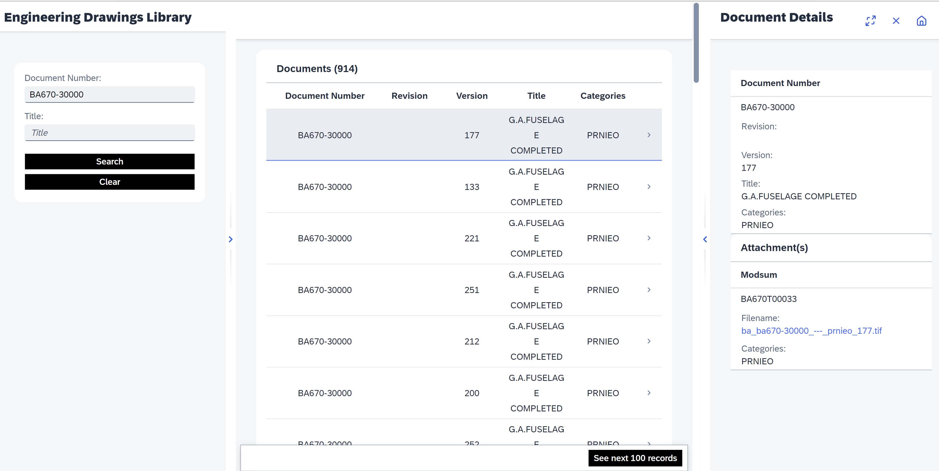

## Screen Flow / Wireframes

|  |  |  |  |  |  |
| --- | --- | --- | --- | --- | --- |
| **Screen Name / Section Name** | **Navigation** | | **Controller Name** | **Parameters Passed** | **Description** |
|  |  |  |  |  |  |
|  |  |  |  |  |  |

## Screen Design And Service Mapping

|  |  |  |  |  |  |
| --- | --- | --- | --- | --- | --- |
| **Screen Name** | **Field Name** | **UI5 Data Type** | **Control Used** | **Service Name & EntitySet** | **Mandatory** |
| Detail | DocumentName | Output | sap.m.Text | N/A | No |
| Detail | DocumentTitle | Output | sap.m.Text | N/A | No |
| Detail | RevisionNumber | Output | sap.m.Text | N/A | No |
| Detail | DocVersion | Output | sap.m.Text | N/A | No |
| Detail | CategoryName | Output | sap.m.Text | N/A | No |
| Detail | UNID | Output | sap.m.Text | N/A | No |
| Detail | DocumentNameIndex | Output | sap.m.Text | N/A | No |
| DetailDetail | Modsum | Output | sap.m.Text | N/A | No |
| DetailDetail | FileInfo | Output | sap.m.Link | N/A | No |
|  |  |  |  |  |  |

## Validations

|  |  |  |  |  |  |
| --- | --- | --- | --- | --- | --- |
| **Screen Name / Section Name** | **Field Name** | **Validation** | **Error/Warning Message** | **Device type validation** | **Description of the scenario** |
| Master | DocumentName | DocumentName or DocumentTile | At least Document Number Or Title is mandatory | N/A | Error will trigger , If DocumentName or DocumentTile are empty. |
|  |  |  |  |  |  |

## Events and Buttons

|  |  |  |  |  |
| --- | --- | --- | --- | --- |
| **Screen Name / Section Name** | **Button Name** | **Event** | **JS Function Called** | **Description of the behaviour/business logic** |
| Master | Search | Press | onSearch | Service call to get list of documents |
| Master | Clear | Press | onClear | Clear DocumentName and DocumentTitle |
| Master |  |  | setDialogBusyOff | To stop busy indicator |
| Detail/Item ->DocumentDetails | Link | Press | onListItemPress | Service call to get list of attachments |
| Detail |  |  | onMoreDataLoad | Pagination to load next 100 records |
| Detail |  |  | getDrawingData | Get initial 100 records on onRoutematched method |
| Detail |  |  | onListItemPress | Navigate to DetailDetail screen |
| Detail |  |  | handleFullScreen | Expand fullscreen |
| Detail |  |  | handleExitFullScreen | Collapse full screen |
| Detail |  |  | handleClose | Close view |

## Calculation columns

|  |  |  |
| --- | --- | --- |
| Calculation Columns | Column ID | Calculation |
|  |  |  |
|  |  |  |
|  |  |  |
|  |  |  |
|  |  |  |

## Method Implementation Details and Suedo code

**Master.Controller:**

onInit: to get getDRSConfig info.

onSearch: to do validaitons and navigate to detail view.

**Detail.Controller:**

onInit: get initial 100 documents.

onMoreDataLoad: Pagination implemented for next 100 records.

onListItemPress: Navigate to detaildetail screen.

**DetailDetail.Controller:**

onInit: get attachment list.

onPressDownload: to download selected attachment.

## Performance Tweaks

* As it is online application, network, server performance will impact on application.
* User should not have access to more tiles in FLP, will impact the app performance.
* Data fetching/ filter/ sorting is handled by back-end. App performance is depending on backend service performance.

## I18n and Theme

* Theme : Theme should be inherited from fiori launchpad .

**Message File:**

|  |  |
| --- | --- |
| **Message File** | **File Name** |
| Default | i18n.properties |

# Webservices / Proxy / OData Specific Information (if any)



## OData Service Model

# Acceptance Criteria

1. Devices/Operating Systems to be supported Desktop based application using workzone  
2. Number of concurrent users  
3. Offline functionality needed  
4. Is Logging required Yes

5. Performance requirements

6. Development model (standard/agile/prototyping) – Agile

# Assumptions

# Performance Consideration

Purchase order number should not be blank in any of the po header lines.

Vendor notes input box should not be blank during posting

# Security Requirements/ Authorization Details

|  |  |
| --- | --- |
| **Catalogue Name** |  |
| **Group Name** |  |
| **Front-End Role** |  |
| **FLP URL** |  |
| **Application URL** |  |
| **Semantic Object** |  |
| **Semantic Action** |  |

# Issues and Risks



## Issues

| **Issue #** | **Date Raised** | **Issue Description** | **Issue Resolution** |
| --- | --- | --- | --- |
|  |  |  |  |
|  |  |  |  |



## Risks

* + Lack of data cause incomplete testing.
  + Large screen monitor required to test UX screen responsiveness.

.

# Dependencies

# Technical Details

/indexes/crjonlinefiltering-index/docs/?$count=true

/CRJ_API/CRJFile

# Additional Information and attachments

# 