Technical Specification

Mobile

**Request Material Return Authorization Fiori Application**

**Date Created : 07-12-2022**

**Document Information**

|  |  |
| --- | --- |
| **Process Area-Sub Area** |  |
| **Type of development** | Fiori Based Application |
| **FS Definition Form ID** |  |
| **SAP Version** |  |
| **Global / Local** | Is this solution Global and will not change based on Segment/ Country/Company code/Plant or combination of Organizational entities?  • If this is a local requirement specific to a Segment/ Country/Company code/Plant or combination of Organizational entities then please specify the detail. |

**Approval**

|  |  |  |  |  |
| --- | --- | --- | --- | --- |
| **Approved by** | **Name** | **Role** | **Signature** | **Date** |
| Development Team Lead | Vivek | Team Lead |  |  |
| Peer Review | Chamdeep | Senior UI5 developer |  |  |

**Document History**

|  |  |  |  |  |  |
| --- | --- | --- | --- | --- | --- |
| **TS Version** | **FS**  **Version** | **Author** | **Reason for change** | **Page number & Section** | **Date** |
| 1.0.0 |  | Chamdeep | Create New TS Document |  | 7-12-2022 |
|  |  |  |  |  |  |

|  |
| --- |
| **Related Documents** |
|  |
|  |

Table of Contents

1. General Information 4

2. Document Control 5

**2.1** **Version History** 5

**2.2** **List of Quality Reviewers** 5

**2.3** **Authorisers for sign off** 5

**2.4** **Distribution** 5

3. User Stories covered by the SAP UI5 screens 6

3.1. Process Maps / User Journey on screen 6

4. UI5 Definition 6

4.1. App Context and Definition 6

4.2. Hub Service Registration and Back end development 6

4.3. Screen Layout 6

4.4. Screen Flow / Wireframes 6

4.5. Screen Design And Service Mapping 7

4.6. Validations 7

4.7. Events and Buttons 7

4.8. Calculation columns 7

4.9. Method Implementation Details and Suedo code 8

4.10. Performance Tweaks 8

4.11. I18n and Theme 8

5. Webservices / Proxy / OData Specific Information (if any) 9

5.1. OData Service Model 9

5.2. OData Service Entity Details 9

6. Acceptance Criteria 9

7. Assumptions 10

8. Performance Consideration 10

9 Security Requirements/ Authorization Details 10

10 Issues and Risks 10

10.1. Issues 11

10.2. Risks 11

11 Dependencies 11

12 Technical Details 11

13 Additional Information and attachments 11

14 Unit Test Plan 12

# General Information

|  |  |  |  |
| --- | --- | --- | --- |
| **WRICEF ID** |  | | |
| **Description** | Request Material Return Authorization | | |
| **Deployment Phase** |  | | |
| **Fiori app./Transaction(s) (if applicable)** | mhirjrmra | | |
| **Git URL** | https://MHIRJ@dev.azure.com/MHIRJ/MHIRJ_S4HANA/_git/MHIRJ_MRA_CP | | |
| **Package** |  | | |
| **Module** |  | | |
| **Data Conversion/Interface User/User Group** |  | | |
| **Execution Mode** | Online | | |
| **Run Frequency** | On Request | **Language** | EN |

| **Transport Information** |
| --- |

**To be filled by Developer**

|  |  |  |  |
| --- | --- | --- | --- |
| **Change Request #** | **CHARM ID** | **Object Identifier**  **(Program ID, Layout Set ID, etc)** | **Object Type**  **(Program, Transaction, Layout Set)** |
|  |  |  |  |
|  |  |  |  |
|  |  |  |  |

|  |
| --- |
| **Related Documents** |
|  |
|  |

# Document Control

2. 1. **Version History**

This table records the status and version history of this document

|  |  |  |  |  |
| --- | --- | --- | --- | --- |
| **Version** | **Date** | **Author** | **Status**  **(draft, peer review etc)** | **Version History** |
| 1.0.0 | 07-12-2022 | Chamdeep | In Draft |  |
|  |  |  |  |  |

2. 1. **List of Quality Reviewers**

This table records the quality reviewers of this document

|  |  |  |
| --- | --- | --- |
| **Name** | **Role** | **Response** |
| Chamdeep | Senior UI developer |  |
|  |  |  |
|  |  |  |
|  |  |  |
|  |  |  |
|  |  |  |

2. 1. **Authorisers for sign off**

This table records the pre-defined person(s) required to sign off the complete document.

|  |  |  |
| --- | --- | --- |
| **Authoriser** | **Role** | **Date of sign off** |
|  |  |  |
|  |  |  |

2. 1. **Distribution**

This document is being distributed to the following authorised people/sections.

|  |  |
| --- | --- |
| **Authoriser** | **Role** |
|  |  |

# User Stories covered by the SAP UI5 screens

|  |  |  |  |  |  |
| --- | --- | --- | --- | --- | --- |
| **ID** | **As a** | **I want** | **So that** | **Acceptance criteria** | **How Met?**  **(be clear if not met by SAP)** |
|  | Web application | UI5 screen to submit request material return authorization | Customer can submit request | User will be able to submit the request. | Fiori application is developed request form. |
|  |  |  |  |  |  |
|  |  |  |  |  |  |
|  |  |  |  |  |  |



## Process Maps / User Journey on screen

# UI5 Definition

## App Context and Definition

|  |  |
| --- | --- |
| **UI5 App Name** | mhirjrmra |
| **UI5 App Type** | Custom Fiori App |
| **Launch Page** | Workzone |
| **URL** | TBD |
| **Package / ICF Node** | **NA** |

## Hub Service Registration and Back end development

|  |  |  |
| --- | --- | --- |
| **HUB System** | **Backend System** | **System Alias** |
| NA | NA | NA |

## Screen Layout

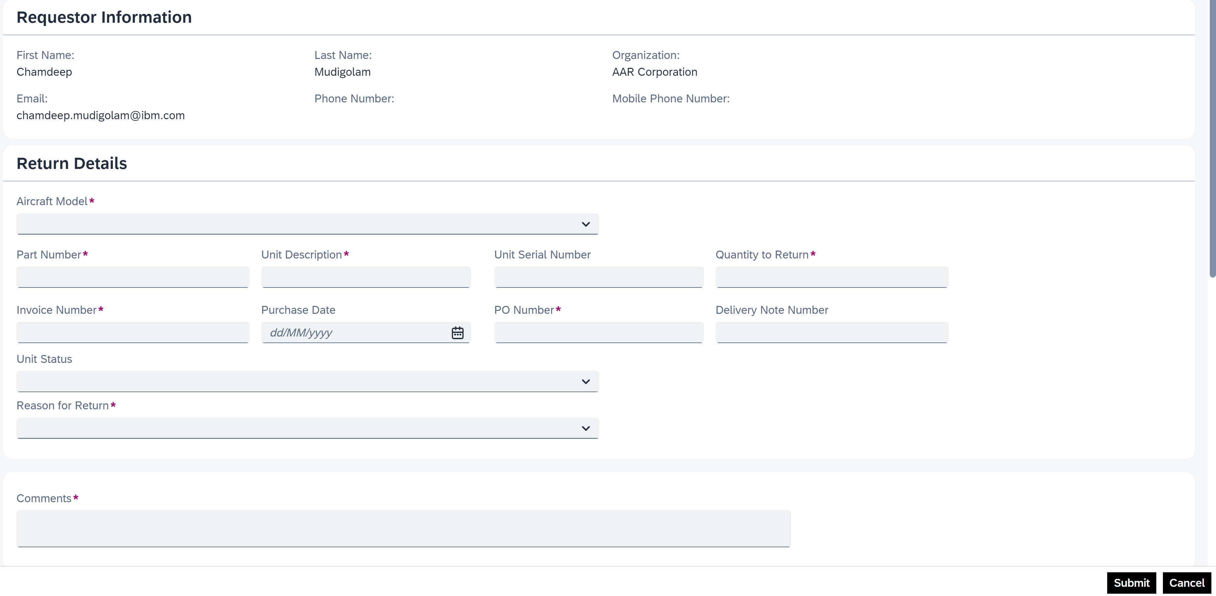

## Screen Flow / Wireframes

|  |  |  |  |  |  |
| --- | --- | --- | --- | --- | --- |
| **Screen Name / Section Name** | **Navigation** | | **Controller Name** | **Parameters Passed** | **Description** |
|  |  |  |  |  |  |
|  |  |  |  |  |  |

## Screen Design And Service Mapping

|  |  |  |  |  |  |
| --- | --- | --- | --- | --- | --- |
| **Screen Name** | **Field Name** | **UI5 Data Type** | **Control Used** | **Service Name & EntitySet** | **Mandatory** |
| View | First Name | Input | sap.m.Text | N/A | No |
| View | Last Name | Input | sap.m.Text | N/A | No |
| View | Organization | Input | sap.m.Text | N/A | No |
| View | Email | Input | sap.m.Text | N/A | No |
| View | Phone Number | Input | sap.m.Text | N/A | No |
| View | Mobile Phone Number | Input | sap.m.Text | N/A | No |
| View | Aircraft Model | Input | sap.m.ComboBox | N/A | Yes |
| View | Part Number | Input | sap.m.Input | N/A | Yes |
| View | Unit Description | Input | sap.m.Input | N/A | Yes |
| View | Unit Serial Number | Input | sap.m.Input | N/A | No |
| View | Quantity to Return | Input | sap.m.Input | N/A | Yes |
| View | Invoice Number | Input | sap.m.Input | N/A | Yes |
| View | Purchase Date | Input | sap.m.DatePicker | N/A | No |
| View | PO Number | Input | sap.m.Input | N/A | Yes |
| View | Delivery Note Number | Input | sap.m.Input | N/A | No |
| View | Unit Status | Input | sap.m.ComboBox | N/A | No |
| View | Reason for Return | Input | sap.m.ComboBox | N/A | Yes |
| View | Comments | Input | sap.m.TextArea | N/A | Yes |

## Validations

|  |  |  |  |  |  |
| --- | --- | --- | --- | --- | --- |
| **Screen Name / Section Name** | **Field Name** | **Validation** | **Error/Warning Message** | **Device type validation** | **Description of the scenario** |
| View | Aircraft Model | Aircraft Model can not be null | Mandatory Field (Aircraft Model) is required | N/A | Error will trigger , If Aircraft Model is null. |
| View | Part Number | Part Number can not be null | Mandatory Field (Part Number) is required | N/A | Error will trigger , If Part Number is null. |
| View | Unit Description | Unit Description can not be null | Mandatory Field (Unit Description) is required | N/A | Error will trigger , If Unit Description is null. |
| View | Quantity to Return | Quantity to Return can not be null | Mandatory Field (Quantity to Return) is required | N/A | Error will trigger , If Quantity to Return is null. |
| View | Invoice Number | Invoice Number can not be null | Mandatory Field (Invoice Number) is required | N/A | Error will trigger , If Invoice Number is null. |
| View | PO Number | PO Number can not be null | Mandatory Field (PO Number) is required | N/A | Error will trigger , If PO Number is null. |
| View | Reason for Return | Reason for Return can not be null | Mandatory Field (Reason for Return) is required | N/A | Error will trigger , If Reason for Return is null. |
| View | Comments | Comments can not be null | Mandatory Field (Comments) is required | N/A | Error will trigger , If Comments are null. |

## Events and Buttons

|  |  |  |  |  |
| --- | --- | --- | --- | --- |
| **Screen Name / Section Name** | **Button Name** | **Event** | **JS Function Called** | **Description of the behaviour/business logic** |
| View | Submit | Press | onSubmitPress | Service call to submit request |
| Master | Cancel | Press | onCancel | Clear all the user entered data |

## Calculation columns

|  |  |  |
| --- | --- | --- |
| Calculation Columns | Column ID | Calculation |
|  |  |  |
|  |  |  |
|  |  |  |
|  |  |  |
|  |  |  |
|  |  |  |

## Method Implementation Details and Suedo code

**View1.Controller:**

onInit: to get required information to submit the request.

toAddressInfo: to get address information.

getUserInfo: to get loggedin user information.

getJSONDataAirPubInfo: to get Aircraft model information.

uploadCompleted: will trigger once file upload is completed.

afterItemRemoved: used for deleting the file.

prepareMailContent: prepare mail content for submitting the request.

onSubmitPress: service call to submit the request.

clearControls: to clear the user entered the data.

## Performance Tweaks

* As it is online application, network, server performance will impact on application.
* User should not have access to more tiles in FLP, will impact the app performance.
* Data fetching/ filter/ sorting is handled by back-end. App performance is depending on backend service performance.

## I18n and Theme

* Theme : Theme should be inherited from fiori launchpad .

**Message File:**

|  |  |
| --- | --- |
| **Message File** | **File Name** |
| Default | i18n.properties |

# Webservices / Proxy / OData Specific Information (if any)



## OData Service Model

# Acceptance Criteria

1. Devices/Operating Systems to be supported Desktop based application using workzone  
2. Number of concurrent users  
3. Offline functionality needed  
4. Is Logging required Yes

5. Performance requirements

6. Development model (standard/agile/prototyping) – Agile

# Assumptions

# Performance Consideration

Purchase order number should not be blank in any of the po header lines.

Vendor notes input box should not be blank during posting

# Security Requirements/ Authorization Details

|  |  |
| --- | --- |
| **Catalogue Name** |  |
| **Group Name** |  |
| **Front-End Role** |  |
| **FLP URL** |  |
| **Application URL** |  |
| **Semantic Object** |  |
| **Semantic Action** |  |

# Issues and Risks



## Issues

| **Issue #** | **Date Raised** | **Issue Description** | **Issue Resolution** |
| --- | --- | --- | --- |
|  |  |  |  |
|  |  |  |  |



## Risks

* + Lack of data cause incomplete testing.
  + Large screen monitor required to test UX screen responsiveness.

.

# Dependencies

# Technical Details

/user-info/UserInfoEntity

/send-email/sendmail

/drop-down/getDropDownData

# Additional Information and attachments

# 