**Day-5 Task**

Output Screenshot:

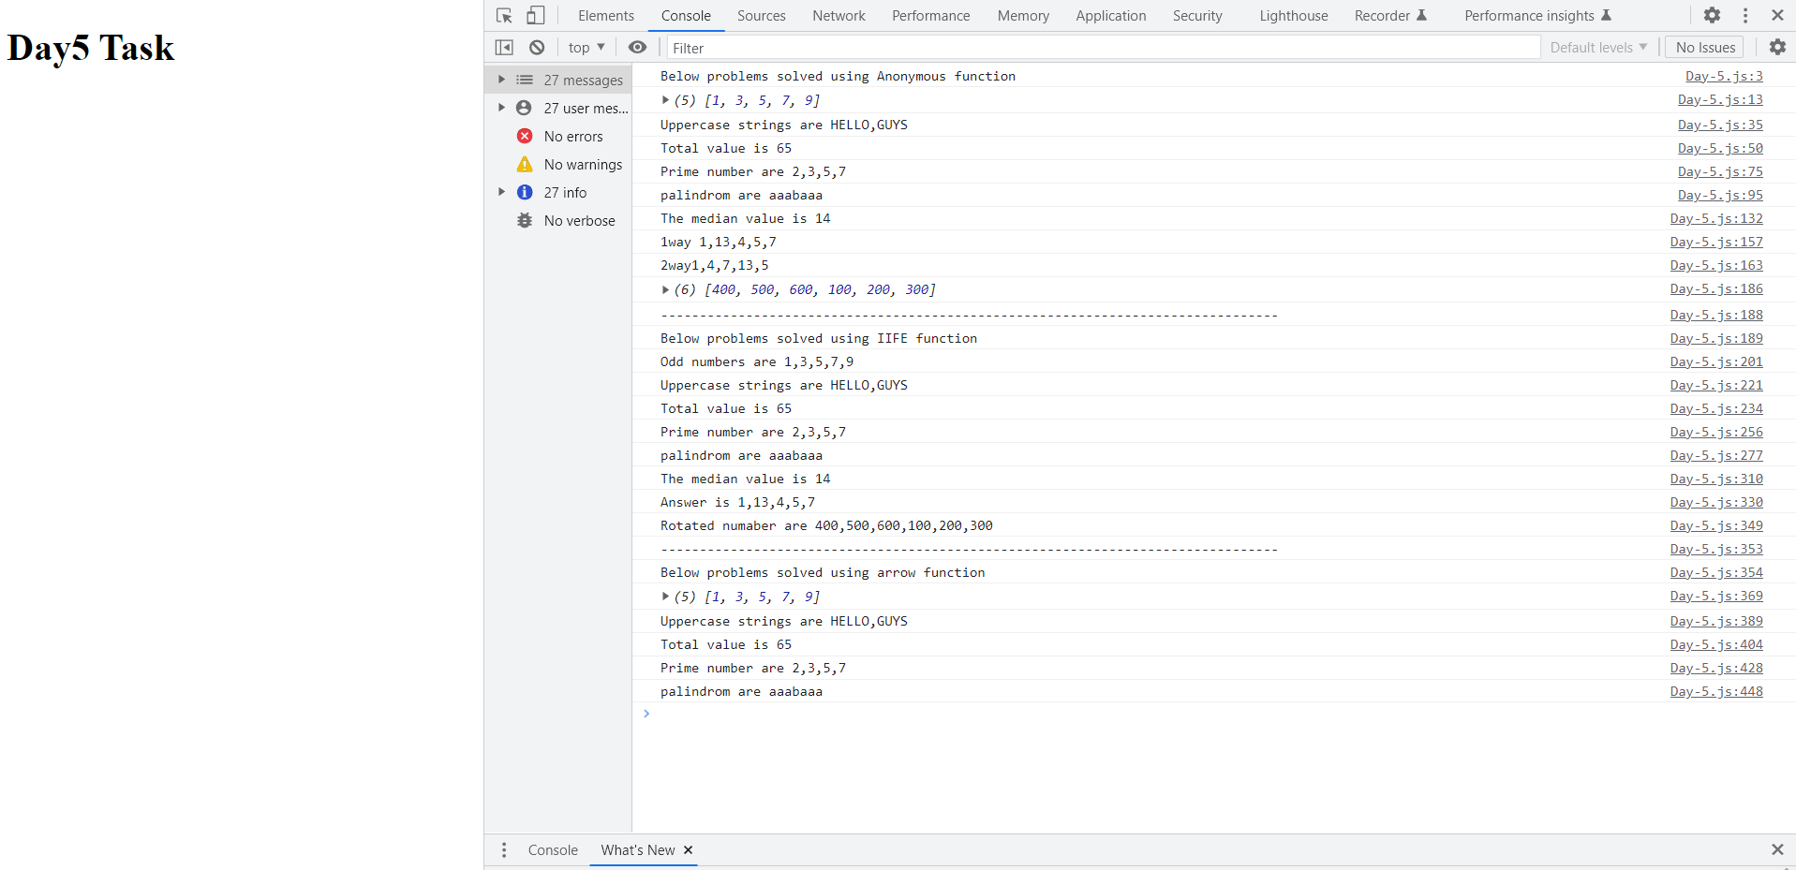

**Codekata practice:**

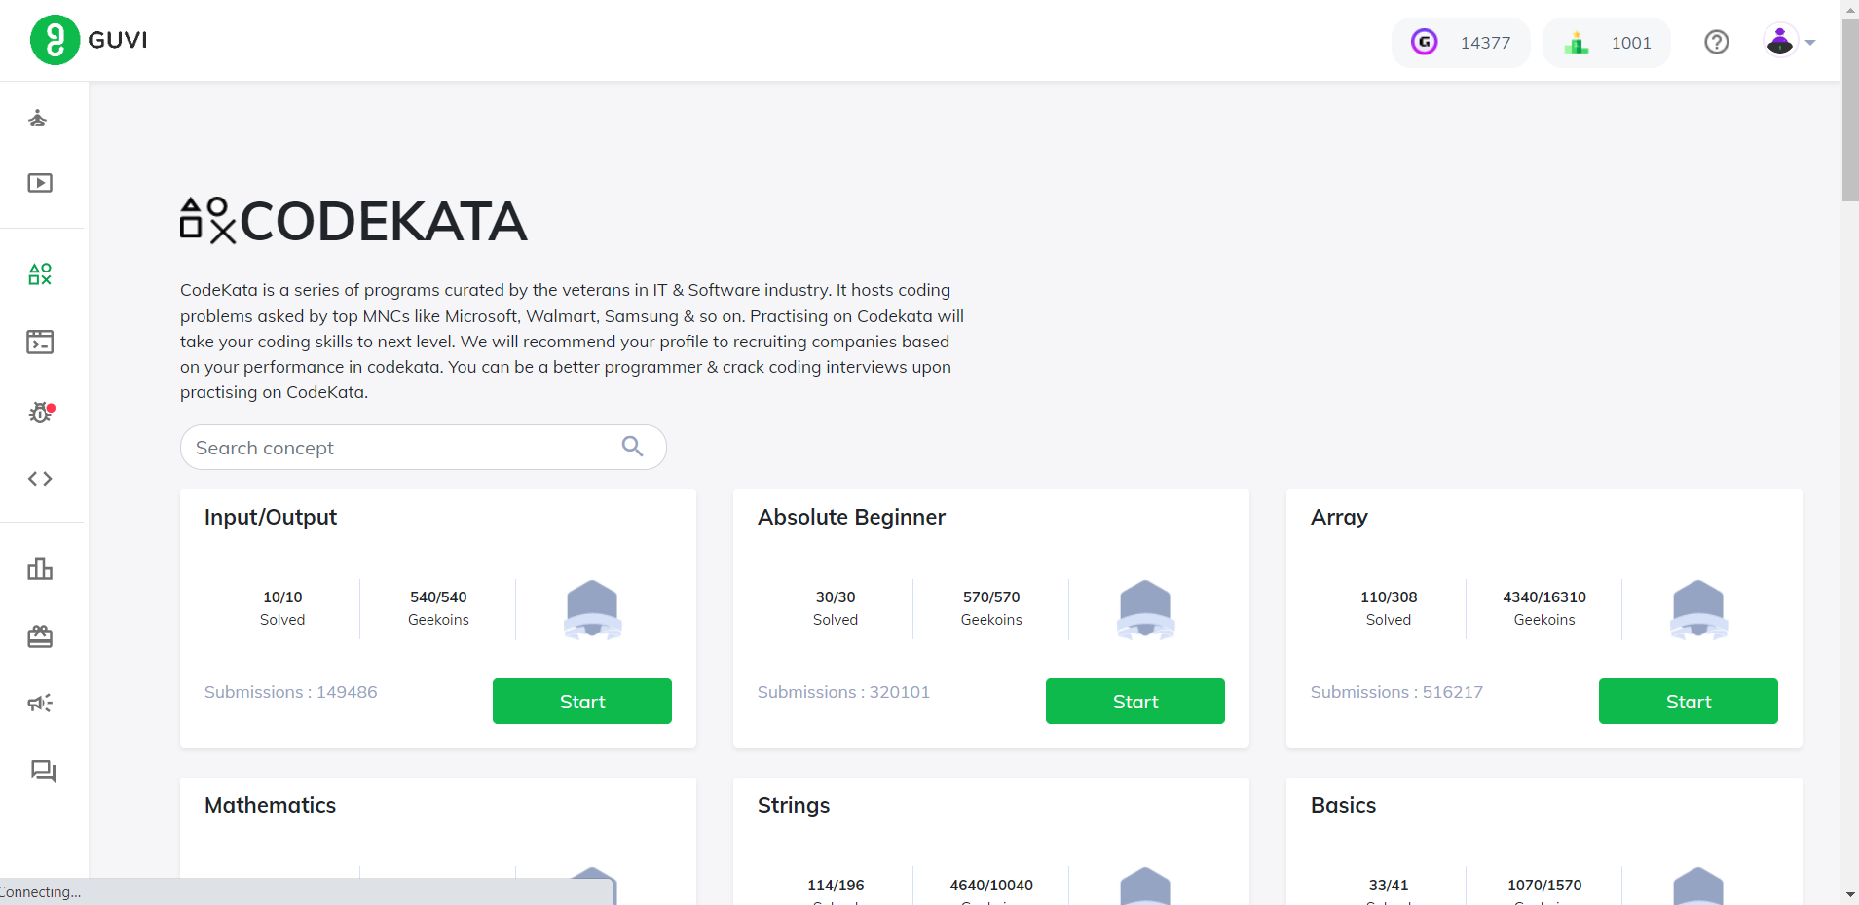

Last week I’m in 1196Th place Now I’m in 1001 place daily I solved 5+ problems.