**1.Difference between window, screen, document in JavaScript**

**Window:**

1. Incoming packets from server it send to browser(Google chrome) then browser give to the window and then webpage will display in document.
2. Window is a global object, Whenever we coded JS in window console place all the variable stored in window and we can access it further if needed.
3. Window is the place where is to display the document whenever we gave requested for webpage.
4. It is an object of the browser
5. Through window comment we can reload the webpage and see the length and height of the window.
6. And we can give alert message using window comment.
7. Window property are stored in window

**Syntax:**

window.propertyname()

**Example:**

dindow.alert(“Hey all”)

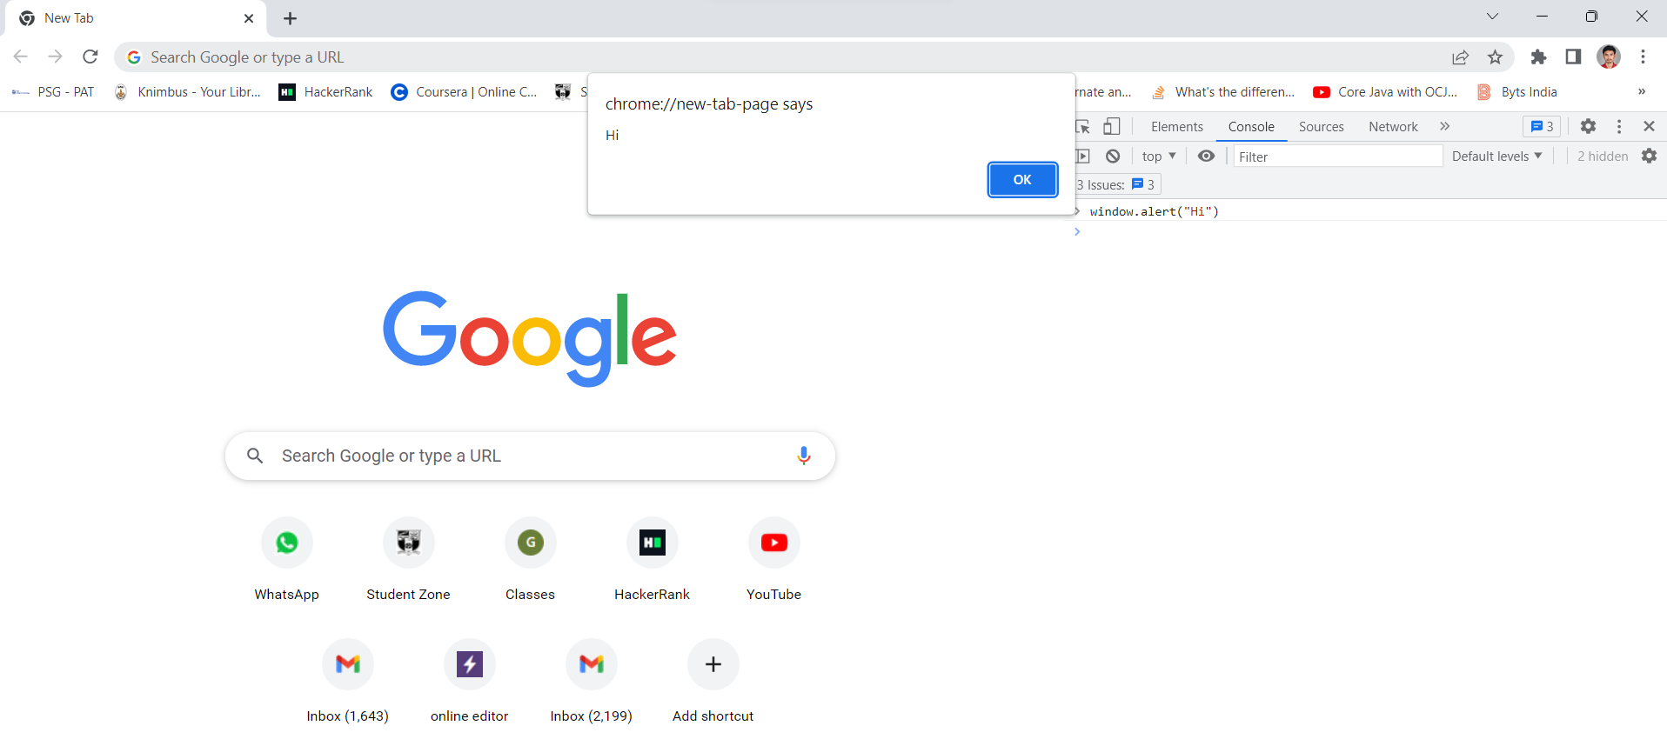

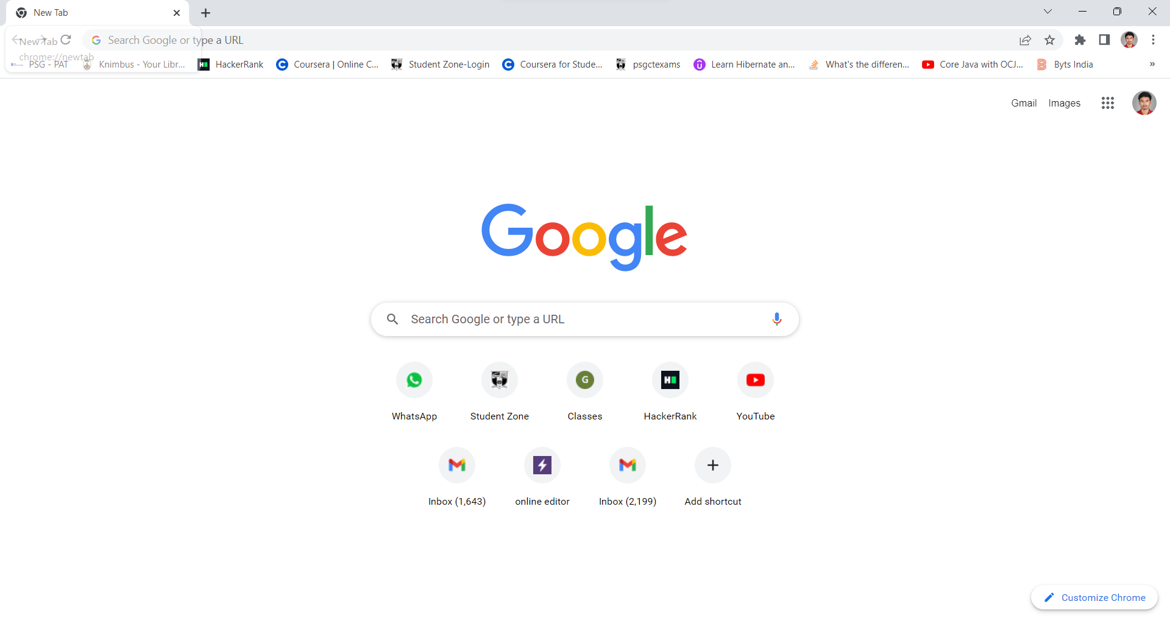

**This is the window/Tab**

**Document:**

1. Document is represent the webpages to loaded in window.
2. Ones window loaded then document loaded into a web-browser and we can manipulate element in the document.
3. Inside the window only document present, all document display in window **document contains** file of webpages like html, CSS, JS ,image files these all files are loaded inside the window object.
4. Document property like cookies, body, title,etc….
5. Like window document also have lot of property we can access through(.)Notation.

**Syntax:**

document.propertyname

**Example:**

document.location

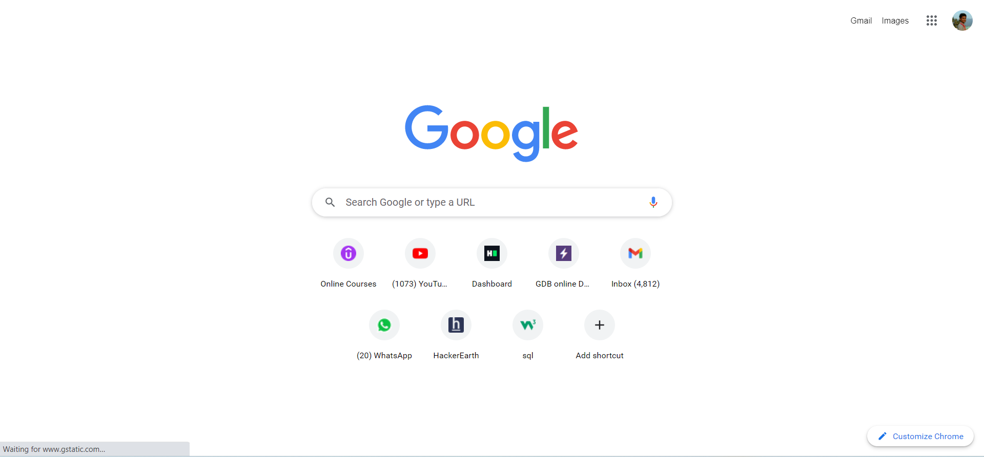

**This is document**

**Screen:**

1.Screen contains information about user screen

2.Used to display screen width, height, colorDepth, pixelDepth etc

3.Window object also has a screen object

4.It is not mandatory to write window before screen object

**Properties:**

screen.width

screen.height

screen.availWidth

**2. codekata practice**

Daily I solve more than 5+ problems, Last week I solved more than 20+ problems, I started coding practice from January month and solved till now more than 300+ problem. Now I’m in 1196th place.

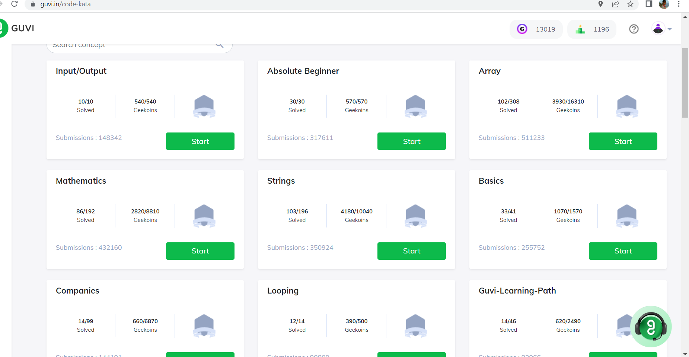

**3.For the given JSON iterate over all for loops:**

1. JavaScript object Notation

2. JSON used to send data between computers

3. Data in key-value pair

**Iterate For loop**

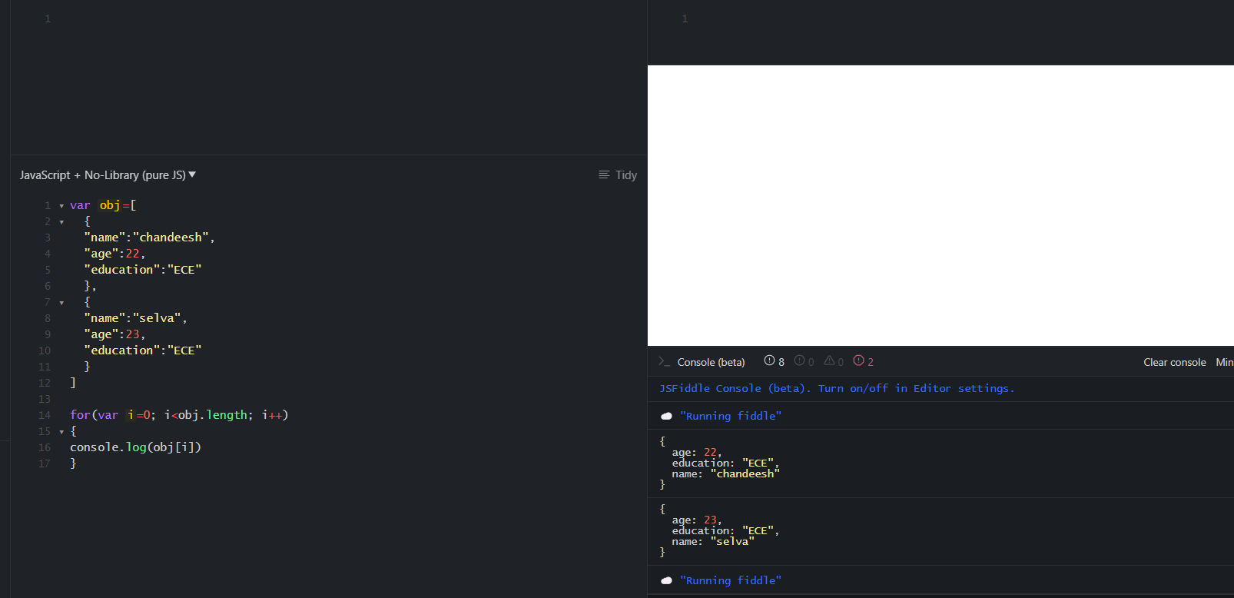

**Iterate For in**

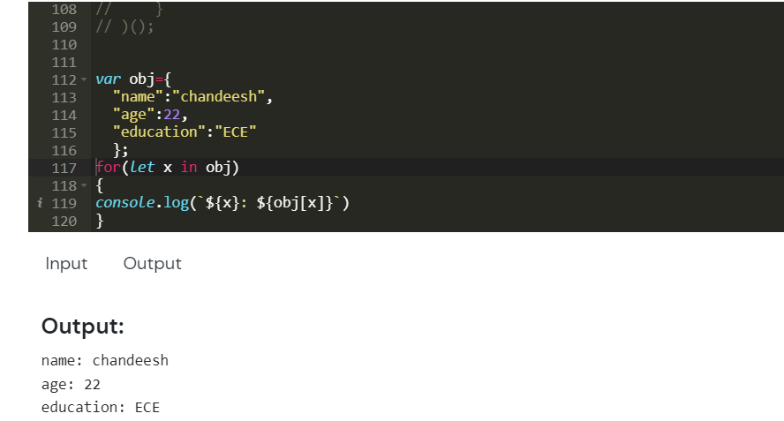

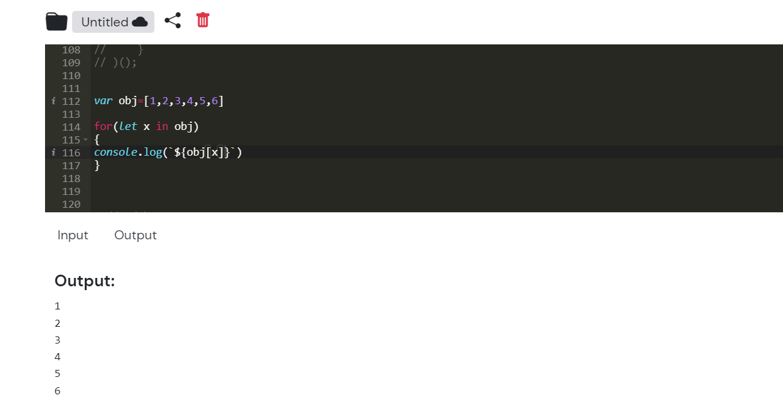

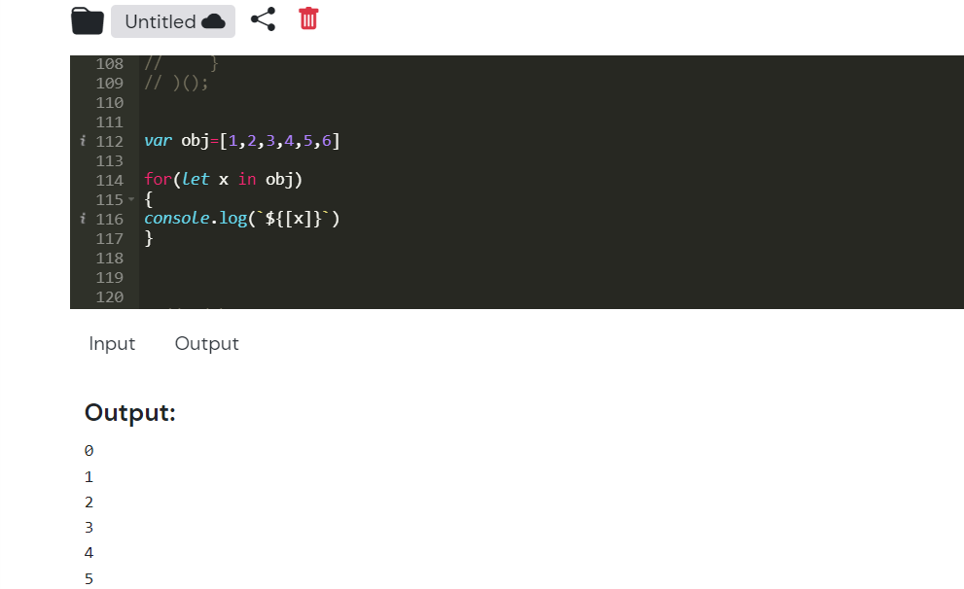

**Iterate For of, forEach**

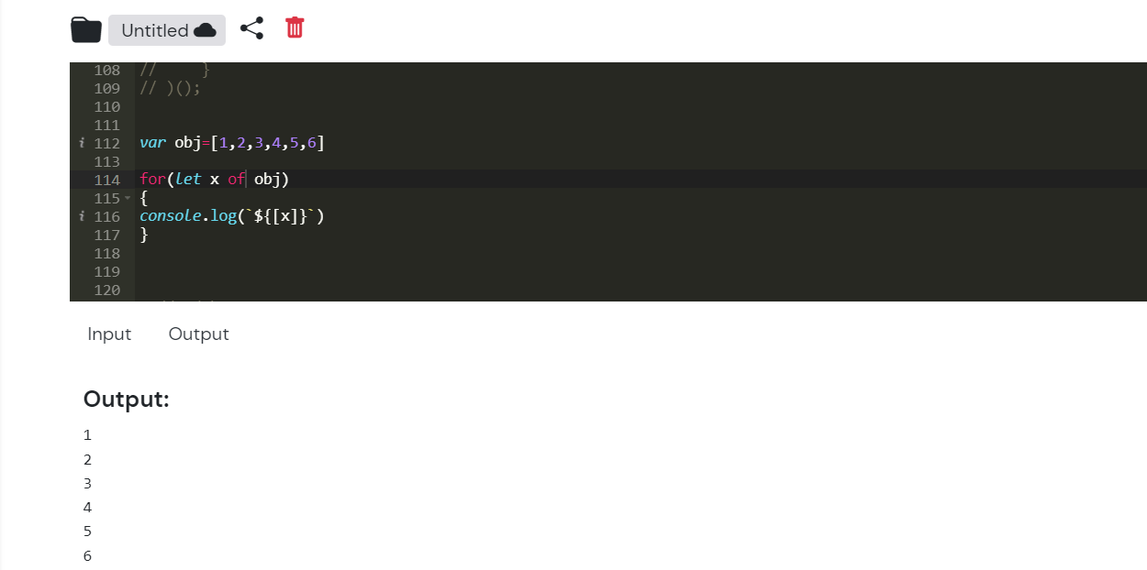

**4. Create your own resume data in JSON format:**

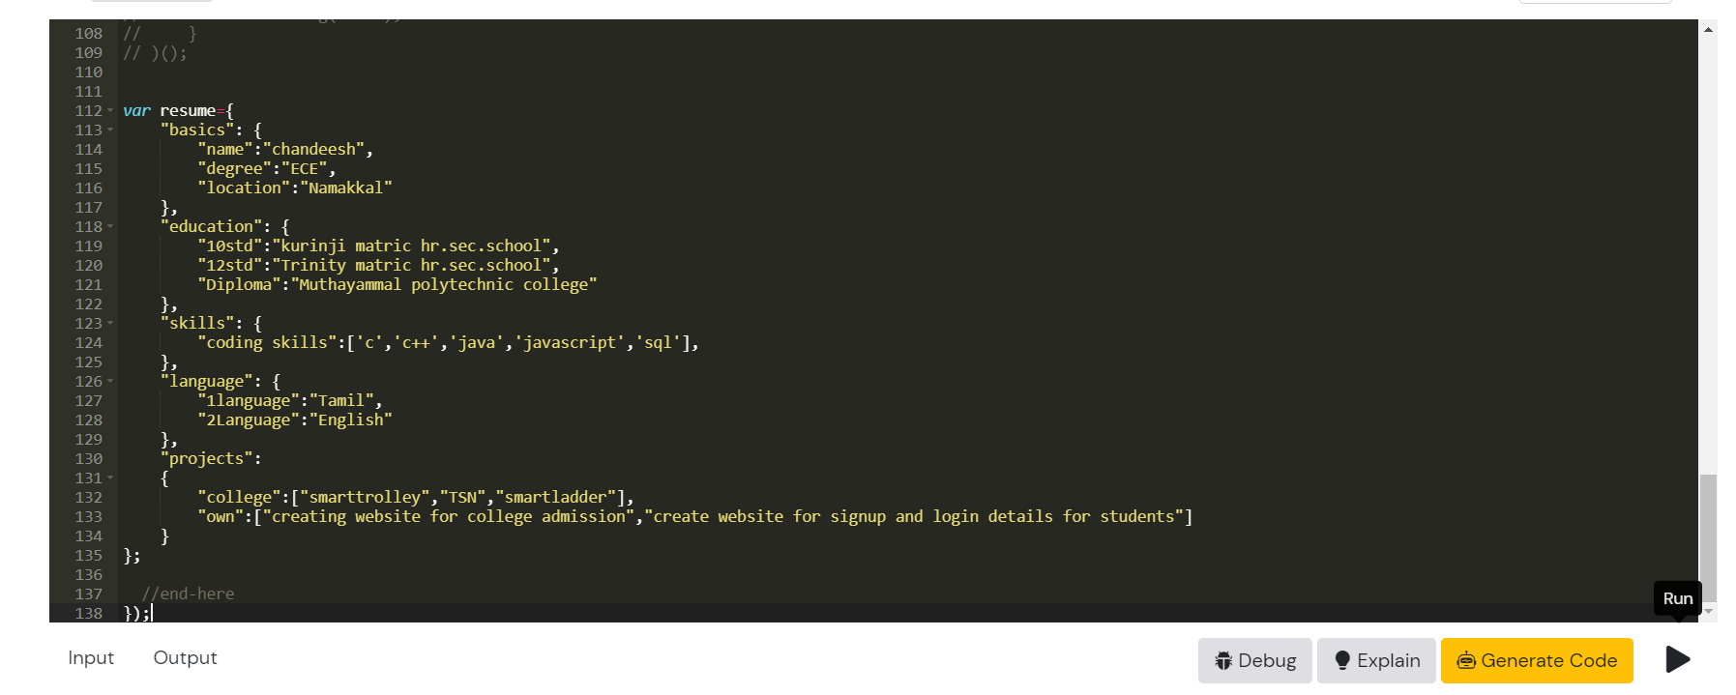

**Done By…**

**K.S CHANDEESH(B44WE ENGLISH)**