**1.Write about document and window objects?**

**Window:**

Window is a place where the webpages to display, whenever the window appear to show on the the contents of documents.

Window is the global object, whatever variable we created and assign to that variable these all stored in window when this happens? Only in if we do JS code in console window.

In the console window we can code that and there some syntax to do play with window

It is the very object that is loaded in webpage when the all the process of completed till render tree this gives to the window of the document.

Syntax:

window.innerHeight

window.alert(“Hello”)

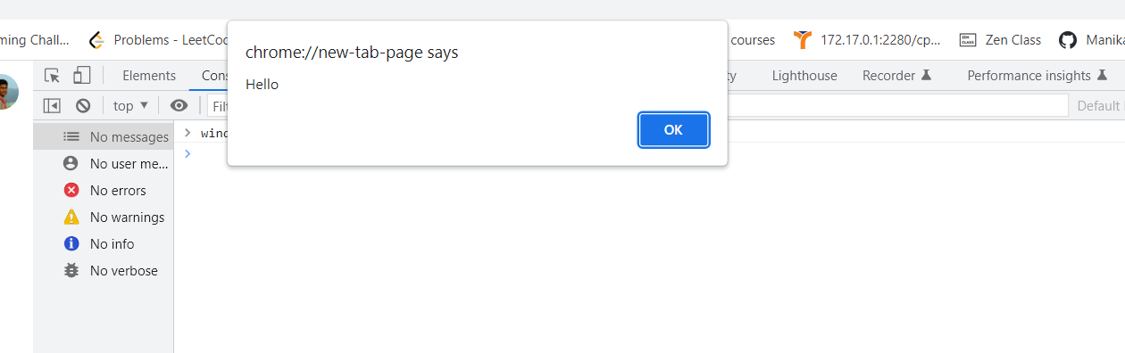

And there is lot function to play with window using(.)notation like…

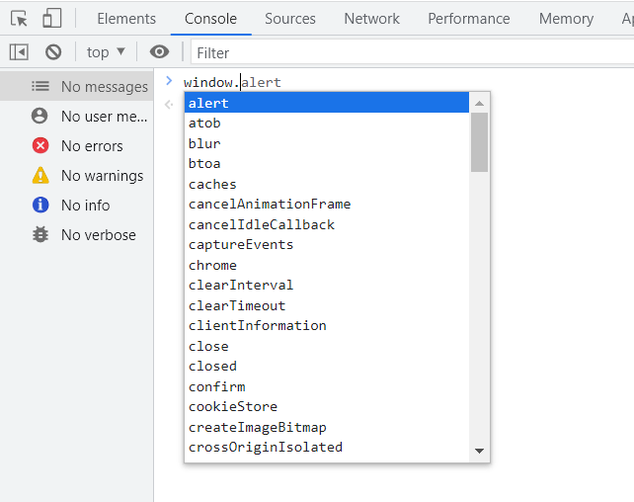

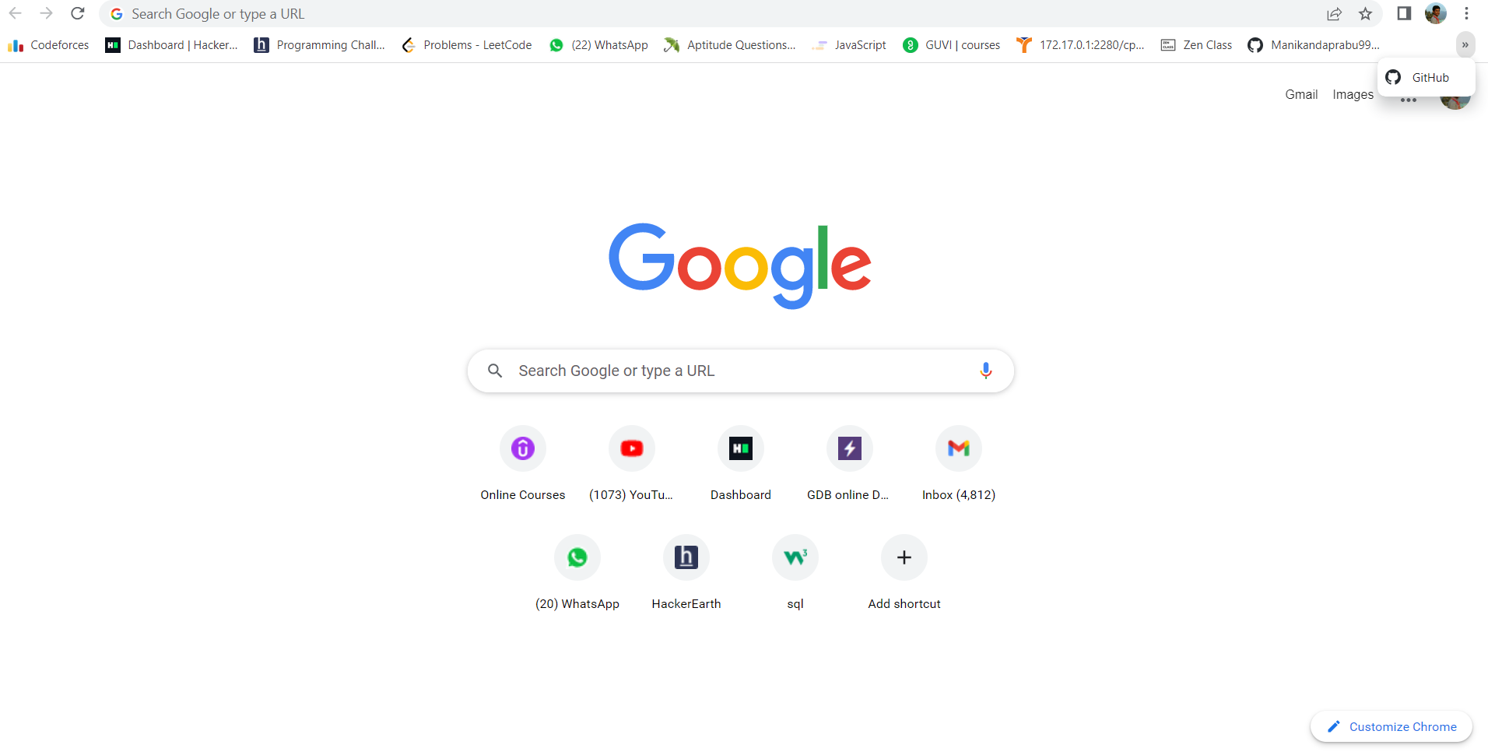

This is the entire called window/Tag.

**Document:**

This Document represent web pages that is loaded in window

And this is loaded inside the window.

The entire webpages called document of specified webpage and it consists of HTML,CSS,JS. And we able to modify the text in webpages using Document syntax in console.

Documents of properties like body, title, cookies, etc..

Same window also we have (.)Notation to play with lot of functions.

Syntax:

Document. Property name;

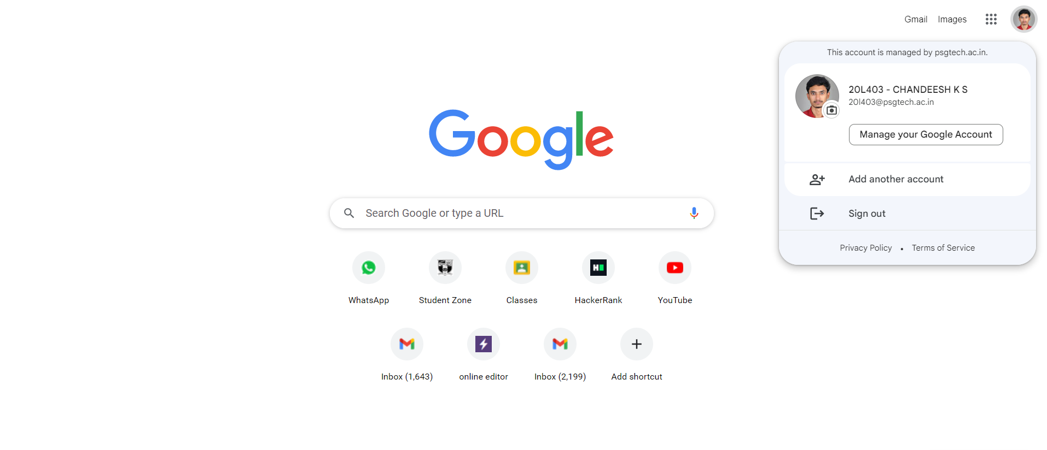

This is the entire Document below the tab.

DONE BY….K.S CHANDEESH B44WE batch.