**Output screenshot:**

1.How to compare two JSON have the same property.

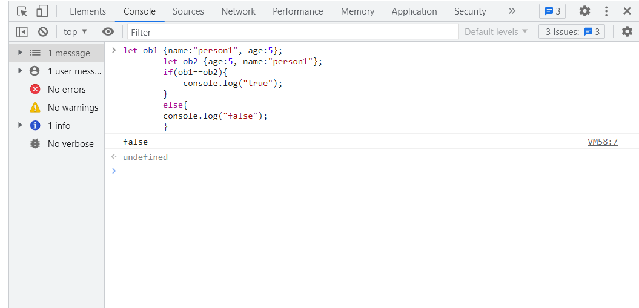

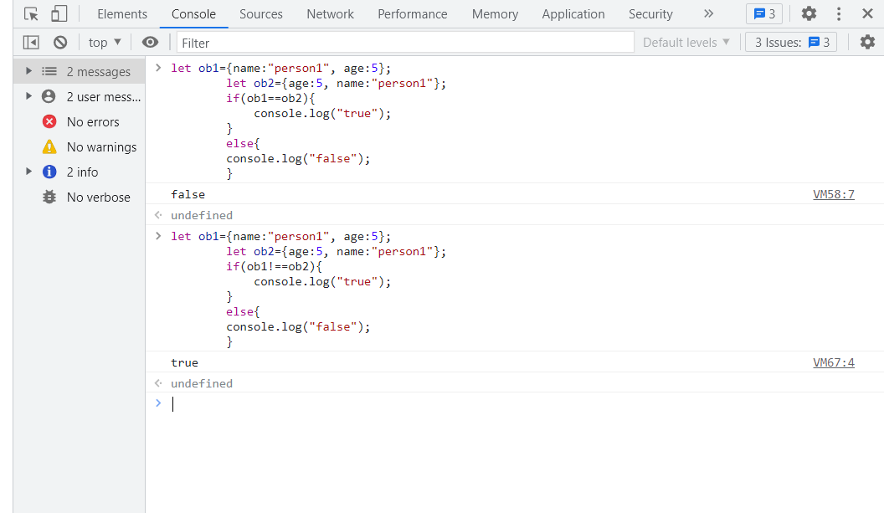

2. Get all flag data use XMLHttp request.

1way to get all country flag

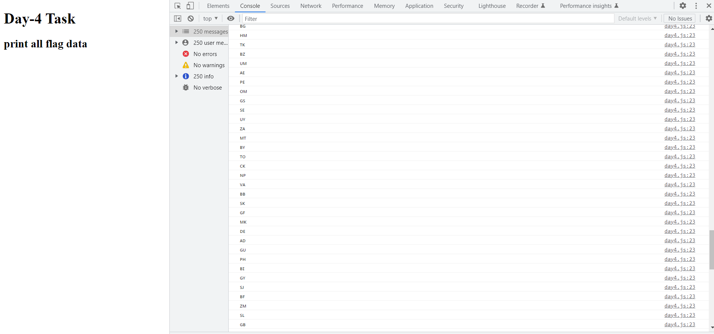

2way to get all country flag

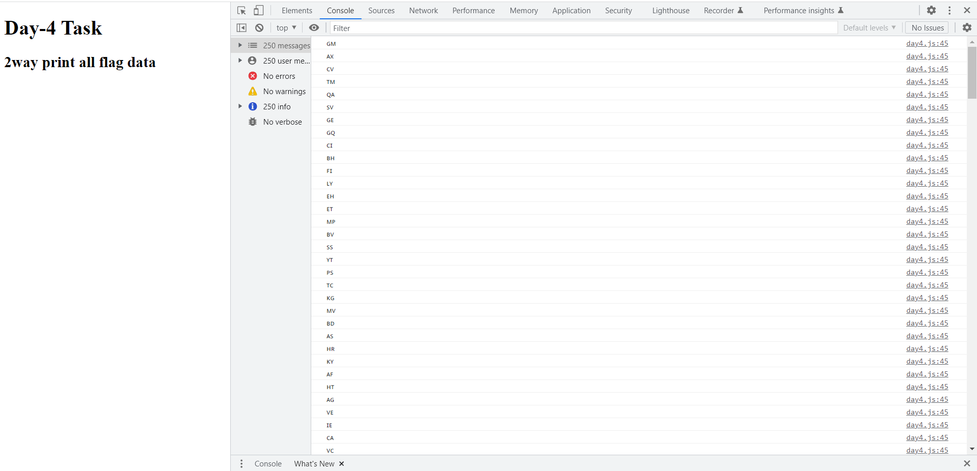

3.get all the countryname, regions, sub-regions, populations

