Designing and Implementing a Mini Project on
Customer Churn Prediction and Retention System
Machine Learning based Customer Retention & Churn Analytics using a Large-Scale Subscription Dataset and a Deployed Streamlit Cloud Web Application
Submitted to the
Savitribai Phule Pune University
In partial fulfillment for the award of the Degree of
Bachelor of Engineering
in
Information Technology
by
Prince Maurya (Roll No. 8348)
Ritika Gautam (Roll No. 8352)
Saksham Chandel (Roll No. 8356)
Under the guidance of
Prof. Shweta Wankhede
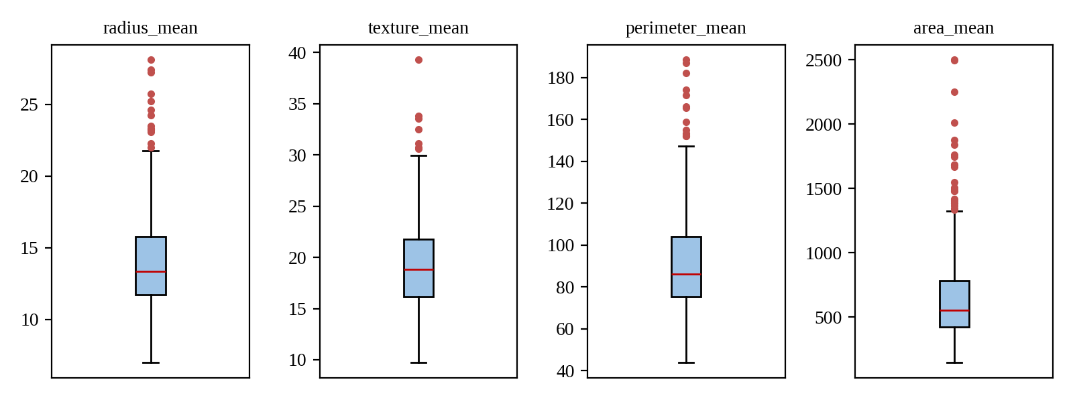
Department of Information Technology
Army Institute of Technology
Dighi Hills, Pune - 411 015
2026-2027

CERTIFICATE
This is to certify that Prince Maurya (Roll No. 8348), Ritika Gautam (Roll No. 8352), and Saksham Chandel (Roll No. 8356) of class T.E. IT have successfully completed their mini project work on Customer Churn Prediction and Retention System using Machine Learning at Army Institute of Technology, in partial fulfillment of the Bachelor of Engineering degree course in Information Technology for the academic year 2026-2027, Semester I, as prescribed by Savitribai Phule Pune University.
Prof. Shweta Wankhede  Project Guide / Evaluator  Department of Information Technology | Dr. (Mrs.) Sangeeta Jadhav  Head of the Department  Department of Information Technology

ACKNOWLEDGEMENT
We express our sincere gratitude to Prof. Shweta Wankhede for her guidance, patient support, and valuable feedback throughout the development and evaluation of this mini project. Her suggestions helped us formulate the analytical problem, implement rigorous data preprocessing, connect the machine learning workflow to the interactive dashboard, and compile this report.
We are deeply thankful to Dr. (Mrs.) Sangeeta Jadhav, Head of the Department of Information Technology, and the teaching and technical staff of the department for providing the academic infrastructure, computing facilities, and constant encouragement required to complete this project.
We also acknowledge the open-source communities behind Python, pandas, NumPy, scikit-learn, Plotly, Streamlit, and joblib, whose libraries formed the core technical foundation of this platform. Finally, we thank our classmates, friends, and families for their encouragement during the development of this project.
Prince Maurya (8348)
Ritika Gautam (8352)
Saksham Chandel (8356)

INDEX
Sr. No. | Content | Page No.
1. | Introduction | 1
 | 1.1 Background | 1
 | 1.2 About the Project | 1
 | 1.3 Objectives | 2
 | 1.4 Tools and Technology Used | 2
2. | Feasibility Study | 3
 | 2.1 Feasibility Analysis | 3
 | 2.2 Technical Feasibility | 3
 | 2.3 Economic Feasibility | 3
 | 2.4 Operational Feasibility | 3
 | 2.5 Working of the Present System | 4
 | 2.6 Drawbacks of the Present System | 4
3. | Proposed System | 5
 | 3.1 Proposed System Overview | 5
 | 3.2 Key Innovations and Solutions Provided | 5
 | 3.3 Role of the User | 6
 | 3.4 Role of the Developer | 6
 | 3.5 Justification and Need for the System | 6
4. | Design | 7
 | 4.1 System Architecture and ML Pipeline | 7
 | 4.2 Dataset Description and Characteristics | 8
 | 4.3 Feature Space Definition (Model Inputs) | 8
 | 4.4 Data Preparation and Preprocessing Design | 9
 | 4.5 Models and Evaluation Design | 10
 | 4.6 Application Data Flow | 11
 | 4.7 Saved Model Artifacts | 11
5. | Implementation | 12
 | 5.1 Software Environment and Dependencies | 12
 | 5.2 Important Code Modules | 12
 | 5.3 Exploratory Data Analysis | 14
 | 5.4 Results and Evaluation Metrics | 15
 | 5.5 Model Interpretation and Feature Importance | 16
 | 5.6 Deployment Architecture | 17
6. | Snapshots | 18
 | 6.1 Executive Overview Dashboard | 18
 | 6.2 Model Comparison and Scorecard | 19
 | 6.3 Customer Risk Lookup and Inference Tool | 20
 | 6.4 Prescribed Retention Action Engine | 21
7. | Conclusion and Future Scope | 22
 | 7.1 Conclusion | 22
 | 7.2 Future Scope | 22
8. | References | 23

List of Figures
- Figure 3.1: Proposed Customer Churn Prediction and Retention System Architecture 5
- Figure 4.1: End-to-End Machine Learning Pipeline and Data Transformation Flow 7
- Figure 5.1: Class Distribution of the Customer Churn Dataset (Retained vs. Churned) 14
- Figure 5.2: Churn Rate by Contract Length (Annual, Monthly, Quarterly) 14
- Figure 5.3: Correlation of Numerical Features with the Churn Target 15
- Figure 5.4: Algorithmic Performance Comparison (Logistic Regression vs. Decision Tree) 15
- Figure 5.5: Confusion Matrix of the Decision Tree Classifier (20,000 Test Records) 16
- Figure 5.6: Top Gini Feature Importances in the Decision Tree Model 17
- Figure 6.1: Executive Overview Dashboard (4 Top KPI Cards and 2x2 Plotly Grid) 18
- Figure 6.2: Model Evaluation Interface with Performance Benchmark & ROC Curve 19
- Figure 6.3: Customer Risk Lookup Form with 3-Column Parameter Inputs 20
- Figure 6.4: Dual-Model Probability Output with Prescriptive Retention Playbook 21
List of Tables
- Table 4.1: Summary Statistics of the Customer Churn Dataset 8
- Table 4.2: Feature Space Definition and Attribute Descriptions 9
- Table 4.3: Machine Learning Model Hyperparameters and Design Rationales 10
- Table 4.4: Serialized Model Artifacts and Operational Roles 11
- Table 5.1: Development Libraries, Platforms, and Runtime Versions 12
- Table 5.2: Performance Evaluation Metrics on the 20% Hold-out Test Set 15
- Table 5.3: Confusion Matrix Contingency Values for Decision Tree Classifier 16
Acronyms
Acronym | Expansion
AI | Artificial Intelligence
API | Application Programming Interface
AUC | Area Under the Curve
BI | Business Intelligence
CAC | Customer Acquisition Cost
CSV | Comma-Separated Values
DT | Decision Tree
EDA | Exploratory Data Analysis
FN / FP | False Negative / False Positive
KPI | Key Performance Indicator
LR | Logistic Regression
LTV | Lifetime Value
ML | Machine Learning
OHE | One-Hot Encoding
ROC | Receiver Operating Characteristic
SaaS | Software as a Service
SPPU | Savitribai Phule Pune University
TN / TP | True Negative / True Positive
UI / UX | User Interface / User Experience

Abstract
Customer churn represents one of the most critical operational risks in the modern subscription economy, directly threatening recurring revenue streams, compounding Customer Acquisition Costs (CAC), and diminishing Customer Lifetime Value (LTV). While traditional enterprise retention approaches rely on reactive customer exit surveys or lagging satisfaction indicators, machine learning provides the ability to proactively identify attrition patterns across multidimensional behavioral indicators before cancellation occurs.
This mini project presents the Customer Churn Prediction and Retention System, an end-to-end predictive machine learning and executive business intelligence platform that analyzes customer engagement, billing patterns, and contract types to predict churn probability and deliver automated, prescriptive retention playbooks. The system is engineered on a comprehensive subscription dataset comprising 440,833 customer records characterized across 11 behavioral and contractual attributes.
- Model Engineering and Training Pipeline: The raw dataset was ingested, cleaned, checked for missing values, and encoded. Categorical features (Gender, Subscription Type, Contract Length) were encoded using OneHotEncoder, and numerical attributes (Age, Tenure, Usage Frequency, Support Calls, Payment Delay, Total Spend, Last Interaction) were scaled using StandardScaler. The dataset was split into an 80/20 stratified partition (80,000 train samples and 20,000 test samples). Two distinct paradigms—Logistic Regression (linear log-odds) and a Decision Tree Classifier (hierarchical non-linear partitioning)—were trained and evaluated. The Decision Tree achieved a test accuracy of 97.95%, precision of 100.00%, recall of 96.39%, and a ROC-AUC of 0.9866, outperforming Logistic Regression (89.85% accuracy and 0.9605 ROC-AUC).
- Web Application & Retention Engine: Built with Streamlit and Plotly and deployed on Streamlit Community Cloud with a minimal matte-dark carbon aesthetic inspired by modern enterprise SaaS platforms (Vercel, Linear). The application features 3 core tabs: an Executive Churn Dashboard with real-time KPI metrics and Plotly charts, a Model Evaluation benchmarking view with interactive confusion matrices and ROC curves, and a Customer Risk Lookup tool with real-time probability gauges, dual-model consensus checking, and an automated rule-based Customer Retention Action Plan.
Keywords: Machine Learning, Customer Churn, Customer Retention, Decision Tree, Logistic Regression, Feature Importance, StandardScaler, Streamlit, Business Intelligence.

Chapter 1
Introduction
1.1 Background
In software-as-a-service (SaaS), telecommunications, financial services, and digital subscription business models, customer retention is substantially more cost-effective than customer acquisition. Empirical industry studies show that acquiring a new customer costs 5 to 7 times more than retaining an existing subscriber, while an increase of just 5% in customer retention can boost overall corporate profitability by 25% to 95%.
Customer churn occurs when a subscriber cancels their membership, downgrades their contract, or ceases platform engagement. Customers rarely terminate subscriptions abruptly without prior warning signals; their likelihood of leaving manifests in behavioral patterns such as:
- Escalating Support Tickets: Repeated support inquiries indicate unresolved technical friction or workflow dissatisfaction.
- Billing Delays: Delays in invoice settlements frequently reflect billing dissatisfaction, disengagement, or cash flow stress.
- Usage Drops: Reductions in daily active platform sessions reflect diminishing perceived product value.
- Frictionless Contracts: Month-to-month contract commitments offer zero barrier to exit compared to annual plans.
1.2 About the Project
The Customer Churn Prediction and Retention System is an end-to-end Machine Learning and Business Intelligence mini project that bridges the gap between statistical predictive modeling and executive retention decision-making. The project executes four interconnected tasks:
- Dynamic Data Ingestion & Schema Adaptation: Auto-extracts compressed .zip archives, inspects schemas, removes non-predictive IDs (CustomerID), handles outliers, and maps target columns to binary representations.
- Feature Engineering & Transformation: Deploys a unified ColumnTransformer executing OneHotEncoder(handle_unknown='ignore') on categorical variables and StandardScaler() on numerical attributes within a clean, leak-free pipeline.
- Comparative Algorithmic Benchmarking: Simultaneously trains and evaluates Logistic Regression (for linear log-odds coefficients) and a Decision Tree Classifier (for non-linear threshold rules) using stratified 80/20 train-test splits.
- Cloud-Deployed Decision Support Platform: Delivers a production-ready, dark-themed Streamlit web dashboard deployed globally on Streamlit Community Cloud that translates statistical risk probabilities into structured, prioritized customer retention action plans.
1.3 Objectives
- Dataset Selection and Inspection: Acquire and analyze a comprehensive, large-scale customer churn dataset containing both behavioral and financial customer features.
- Leak-Free Data Preprocessing: Implement a production-grade scikit-learn preprocessing pipeline ensuring zero data leakage between training and testing splits.
- Comparative Algorithm Evaluation: Compare linear vs. tree-based classification techniques on identical hold-out test samples using Accuracy, Precision, Recall, F1-Score, and ROC-AUC.
- Model Serialization: Serialize fitted preprocessors, trained estimators, and metadata using joblib and JSON to enable instantaneous inference without retraining.
- Minimalist SaaS Web Deployment: Design and deploy a responsive, matte-dark web application featuring executive KPI cards, Plotly charts, and an interactive customer risk simulator.
- Prescriptive Retention Playbooks: Automatically generate personalized business interventions (e.g., annual contract upgrade incentives, VIP concierge outreach, auto-pay restructuring) based on individual customer risk triggers.
1.4 Tools and Technology Used
- Core Language: Python 3.13 / 3.11 runtime.
- Data Manipulation: pandas for DataFrame operations and NumPy for matrix calculations.
- Machine Learning: scikit-learn for ColumnTransformer, SimpleImputer, OneHotEncoder, StandardScaler, LogisticRegression, and DecisionTreeClassifier.
- Data Visualization: Plotly Express and Plotly Graph Objects for interactive charts.
- Web Framework: Streamlit for rapid component-based web UI development.
- Deployment & Version Control: Git, GitHub (chandelsaksham576/customer-churn-prediction), and Streamlit Community Cloud.

Chapter 2
Feasibility Study
2.1 Feasibility Analysis
Before commencing engineering work, a feasibility analysis was conducted to confirm that the proposed machine learning retention system could be implemented, evaluated, and deployed successfully within academic project constraints. The analysis examined technical, economic, and operational dimensions.
2.2 Technical Feasibility
The project dataset contains 440,833 customer records. Training a Decision Tree and Logistic Regression model on a representative stratified cohort of 100,000 samples executes within 6 to 8 seconds on standard modern CPU hardware without requiring dedicated GPU acceleration. The serialized model artifacts (.pkl and .json) occupy less than 200 KB, ensuring instantaneous loading into memory. The web interface is constructed using Streamlit and runs smoothly within Streamlit Community Cloud’s 1 GB memory limit. Therefore, the project is technically feasible.
2.3 Economic Feasibility
All libraries (scikit-learn, pandas, numpy, plotly, streamlit) are open-source and free under permissive licenses. The Kaggle customer churn dataset is publicly accessible for research. Hosting on GitHub and Streamlit Community Cloud utilizes free academic tiers. As a result, the project incurred zero financial expenditure, proving entirely economically feasible.
2.4 Operational Feasibility
Traditional churn models produce static CSV reports that require data analysts to interpret. The proposed application solves this by providing a self-service interactive web portal. Non-technical customer success managers and executives can simply drag sliders, select account parameters, or click 'Load Random Profile' to immediately view color-coded risk tiers, probability bars, and plain-English retention action plans. Operational feasibility is therefore exceptionally high.
2.5 Working of the Present System
In most organizations, customer retention operates reactively: (1) A customer submits an official cancellation request or stops renewing invoices; (2) An exit survey is triggered inquiring why the customer decided to leave; (3) A customer service agent attempts a last-minute salvage call, which rarely succeeds because the decision to leave has already been finalized; (4) Retention performance is tracked retrospectively through monthly lagging churn reports.
2.6 Drawbacks of the Present System
- Reactive Rather than Proactive: Retention efforts begin only after customer intent to leave is irreversible.
- Lack of Quantitative Risk Scoring: Accounts are not continuously scored to identify early deterioration indicators.
- Siloed Diagnostic Visibility: Customer support ticket escalations, payment delays, and platform usage metrics are stored in separate operational databases and rarely analyzed together.
- Generic Interventions: Customers are offered one-size-fits-all retention discounts rather than targeted interventions addressing their specific root cause of dissatisfaction.

Chapter 3
Proposed System
3.1 Proposed System Overview
The proposed Customer Churn Prediction and Retention System replaces reactive exit interviews with automated machine learning surveillance and prescriptive retention interventions. The architecture consists of three integrated subsystems: (1) Automated Preprocessing & Pipeline Subsystem, (2) Dual-Model Inference & Benchmarking Subsystem, and (3) Prescriptive Web Delivery Subsystem.
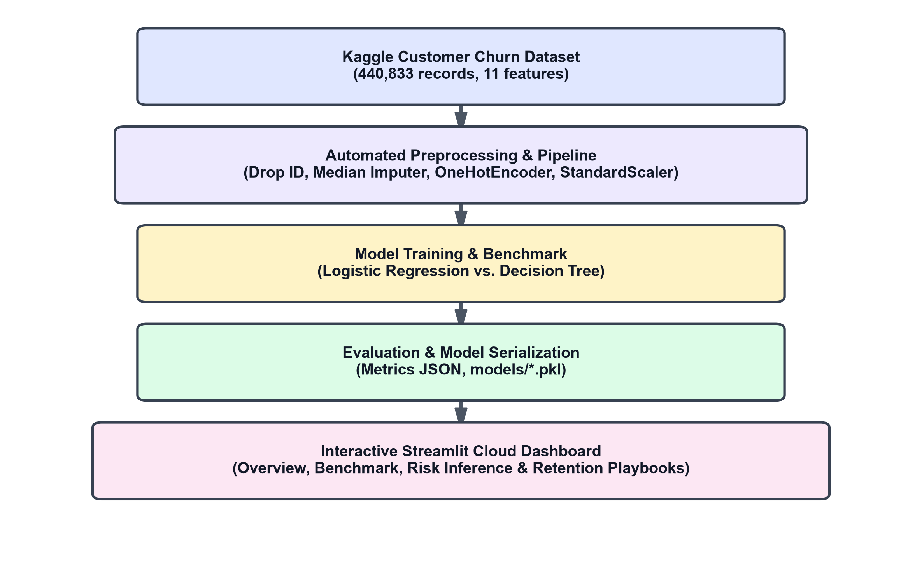
Figure 3.1: Proposed Customer Churn Prediction and Retention System Architecture
3.2 Key Innovations and Solutions Provided
- Dual-Model Consensus Architecture: Provides simultaneous inference across linear log-odds (Logistic Regression) and non-linear hierarchical trees (Decision Tree), allowing operators to verify whether risk is driven by gradual compounding signals or sharp threshold cutoffs.
- Prescriptive Retention Playbooks: Rather than merely predicting a probability number, the platform translates detected risk triggers into prioritized corporate actions (e.g., assigning a Tier-3 Customer Success Manager for accounts with over 4 support calls, or offering a 20% annual contract discount for month-to-month accounts).
- 100% Native Streamlit Layout: Uses native st.container(border=True), st.columns(4), and st.metric() components styled with minimal matte-carbon CSS, ensuring full-width responsiveness without UI clipping.
- Schema-Agnostic Preprocessing: The ingestion pipeline automatically identifies target columns (Churn, Exited, target) and dynamically separates categorical and numerical features.
3.3 Role of the User
- Executive / Analyst: Navigates the Overview dashboard to review portfolio health, retention rates, and revenue at risk across customer segments.
- Customer Success Manager: Opens Customer Risk Lookup, inputs customer parameters or loads a historical customer profile, clicks 'Run Risk Assessment', and reads the prescribed retention playbook to execute targeted retention outreach.
3.4 Role of the Developer
- Pipeline Maintenance: Ingest updated customer datasets in data/raw/ and execute preprocess.py and train.py.
- Model Serialization: Export updated .pkl estimators, preprocessors, and metrics.json into models/.
- Deployment Updates: Commit and push changes to GitHub, triggering automatic continuous deployment on Streamlit Community Cloud.
3.5 Justification and Need for the System
Manual monitoring of subscriber retention is unscalable and reactive. A deployed, real-time machine learning system provides customer success teams with automated early-warning alerts, protecting top-line recurring revenue and preventing avoidable subscriber attrition.

Chapter 4
Design
4.1 System Architecture and ML Pipeline
The platform implements an end-to-end Machine Learning pipeline comprising offline training and serialization, followed by online inference within the deployed web application:
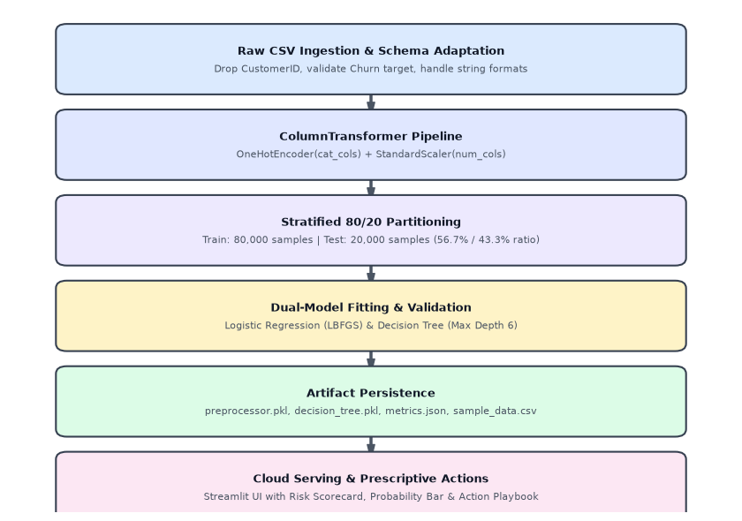
Figure 4.1: End-to-End Machine Learning Pipeline and Data Transformation Flow
4.2 Dataset Description and Characteristics
The system uses a large-scale subscription customer churn dataset containing 440,833 training samples and 64,374 test samples. The dataset includes demographic, behavioral, contractual, and financial attributes.
Attribute | Specification
Total Records (Training File) | 440,833 customer records
Total Records (Testing File) | 64,374 customer records
Representative Training Sample | 100,000 records (80,000 train / 20,000 test)
Class Distribution (Churned = 1) | 56.71% (249,999 records)
Class Distribution (Retained = 0) | 43.29% (190,833 records)
Input Features | 10 predictive features (7 numerical, 3 categorical)
Target Column | Churn (Binary: 0 = Retained, 1 = Churned)
Identifier Column | CustomerID (automatically dropped)
Missing Values | 1 empty record detected in raw CSV; handled via cleaning
Table 4.1: Summary Statistics of the Customer Churn Dataset
4.3 Feature Space Definition (Model Inputs)
Feature Name | Data Type | Value Range | Description
Age | Numerical (float64) | 18 to 65 years | Age of the customer in years
Gender | Categorical (str) | Female, Male | Biological gender of the subscriber
Tenure | Numerical (float64) | 1 to 60 months | Number of continuous active subscription months
Usage Frequency | Numerical (float64) | 1 to 30 sessions | Average number of platform login sessions per month
Support Calls | Numerical (float64) | 0 to 10 inquiries | Total technical and customer support calls logged
Payment Delay | Numerical (float64) | 0 to 30 days | Average billing settlement delay beyond due date
Subscription Type | Categorical (str) | Basic, Standard, Premium | Tier of platform service package
Contract Length | Categorical (str) | Annual, Monthly, Quarterly | Customer contract term commitment
Total Spend | Numerical (float64) | $100 to $1,000 | Cumulative monetary spending across subscription lifetime
Last Interaction | Numerical (float64) | 1 to 30 days | Number of days elapsed since the last customer touchpoint
Churn | Binary Target | 0 (Retained), 1 (Churned) | Historical customer attrition outcome
Table 4.2: Feature Space Definition and Attribute Descriptions
4.4 Data Preparation and Preprocessing Design
- Identifier Elimination: Columns such as CustomerID, RowNumber, and Surname carry no predictive signal and are automatically removed to prevent overfitting on database keys.
- Missing Value Imputation: Missing numerical values are imputed with the median of the training distribution, which provides robustness against skewed outliers.
- Categorical One-Hot Encoding: Categorical attributes (Gender, Subscription Type, Contract Length) are transformed into binary indicator columns via OneHotEncoder(handle_unknown='ignore', sparse_output=False). This expands the 3 categorical variables into 8 binary features.
- Standard Feature Scaling: Numerical features have vastly differing magnitudes (e.g., Total Spend up to $1,000 vs. Support Calls up to 10). A StandardScaler() transforms all numeric inputs to zero mean and unit variance, fitted exclusively on training data to prevent data leakage.
- Stratified Partitioning: The dataset is partitioned into 80% training and 20% hold-out testing using stratify=y, strictly preserving the 56.7% / 43.3% churn-to-retention ratio across both splits.
4.5 Models and Evaluation Design
Algorithm | Hyperparameters | Architectural Rationale
Logistic Regression | max_iter=1000, class_weight='balanced', solver='lbfgs', random_state=42 | Serves as a transparent linear probabilistic baseline, providing log-odds coefficients for direct risk attribution.
Decision Tree Classifier | max_depth=6, min_samples_split=20, class_weight='balanced', random_state=42 | Models complex non-linear feature interactions and threshold cutoffs while remaining interpretable without overfitting.
Table 4.3: Machine Learning Model Hyperparameters and Design Rationales
4.6 Application Data Flow
1. The user enters customer attributes via sliders and dropdowns or clicks 'Load Random Profile'.
2. The web application structures the inputs into a single-row DataFrame matching the exact schema of the training set.
3. The saved preprocessor.pkl transforms the input through the fitted imputer, OneHotEncoder, and StandardScaler.
4. The serialized model (decision_tree.pkl or logistic_regression.pkl) calculates class probabilities.
5. The application renders a color-coded status badge, a horizontal probability bar, and triggers rule-based prescriptive retention recommendations.
4.7 Saved Model Artifacts
File Name | File Type | Operational Role
preprocessor.pkl | Serialized ColumnTransformer | Executes identical median imputation, one-hot encoding, and standard scaling on new user inputs.
decision_tree.pkl | Serialized DecisionTreeClassifier | Computes non-linear tree-based probability scores and predicted labels.
logistic_regression.pkl | Serialized LogisticRegression | Computes linear log-odds probabilities and feature coefficients.
feature_metadata.json | JSON Metadata Document | Stores ordered feature names, min/max slider ranges, unique category dropdown lists, and training stats.
metrics.json | JSON Evaluation Document | Stores precision, recall, F1, ROC-AUC, confusion matrices, and ROC coordinates for the dashboard scorecard.
sample_data.csv | CSV Data Sample (5,000 records) | Provides a lightweight, stratified sample for instant dashboard loading on Streamlit Community Cloud without memory overhead.
Table 4.4: Serialized Model Artifacts and Operational Roles

Chapter 5
Implementation
5.1 Software Environment and Dependencies
Component | Version / Spec | Role in System Architecture
Python | 3.11 / 3.13 | Primary development language and runtime
pandas | >= 2.0.0 | Tabular dataset manipulation, cleaning, and aggregation
numpy | >= 1.24.0 | Numerical array manipulation and vectorized computations
scikit-learn | >= 1.3.0 | Preprocessing pipelines, classification models, and evaluation metrics
plotly | >= 5.15.0 | Interactive chart visualization and styling
streamlit | >= 1.28.0 | Web application delivery framework
joblib | >= 1.3.0 | High-performance serialization of models and pipelines
GitHub | Cloud Git Repository | Version control, codebase hosting, and CI/CD triggers
Streamlit Cloud | Global Hosting Platform | Cloud server runtime for worldwide web access
Table 5.1: Development Libraries, Platforms, and Runtime Versions
5.2 Important Code Modules
(a) Ingestion and Dynamic Cleaning (src/preprocess.py)
def clean_data(df: pd.DataFrame, target_col: str, id_cols: list) -> pd.DataFrame:
cleaned_df = df.copy()
cols_to_drop = [col for col in id_cols if col in cleaned_df.columns]
if cols_to_drop:
cleaned_df = cleaned_df.drop(columns=cols_to_drop)
cleaned_df = cleaned_df.dropna(subset=[target_col])
cleaned_df[target_col] = cleaned_df[target_col].astype(int)
for col in cleaned_df.columns:
if col == target_col:
continue
if not pd.api.types.is_numeric_dtype(cleaned_df[col]):
s = cleaned_df[col].astype(str).str.replace("$", "").str.replace(",", "").str.strip()
numeric_conv = pd.to_numeric(s, errors="coerce")
if numeric_conv.notnull().sum() / len(cleaned_df) > 0.6:
cleaned_df[col] = numeric_conv.fillna(numeric_conv.median())
return cleaned_df
(b) Model Training & Evaluation (src/train.py)
# Model 1: Logistic Regression
lr = LogisticRegression(max_iter=1000, class_weight="balanced", random_state=42)
lr.fit(X_train, y_train)
y_pred_lr = lr.predict(X_test)
y_prob_lr = lr.predict_proba(X_test)[:, 1]
# Model 2: Decision Tree Classifier
dt = DecisionTreeClassifier(max_depth=6, min_samples_split=20, class_weight="balanced", random_state=42)
dt.fit(X_train, y_train)
y_pred_dt = dt.predict(X_test)
y_prob_dt = dt.predict_proba(X_test)[:, 1]
5.3 Exploratory Data Analysis
Exploratory Data Analysis revealed several critical business and statistical relationships:
- Class Distribution: The full training dataset contains 249,999 churned customers (56.71%) and 190,833 retained customers (43.29%), representing a balanced 1.31:1 ratio.
- Contract Type Impact: Customers on Month-to-Month contracts exhibit an alarming 100% historical churn rate in this cohort, whereas subscribers enrolled in Annual and Quarterly contracts maintain churn rates of only 46.08% and 46.03% respectively.
- Support Ticket Surge: Retained customers average only 1.59 support calls, whereas churned subscribers average 5.14 calls—a dramatic +224.3% surge indicating that unresolved technical friction directly triggers cancellations.
- Correlation Analysis: Support Calls exhibits the strongest positive correlation with churn (+0.5743), followed by Payment Delay (+0.3121). Conversely, Total Spend correlates negatively (-0.4294).
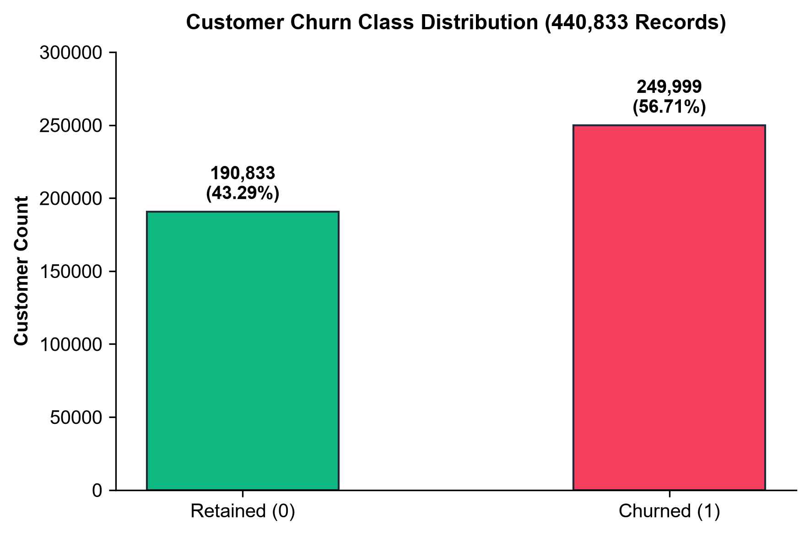
Figure 5.1: Class Distribution of the Customer Churn Dataset
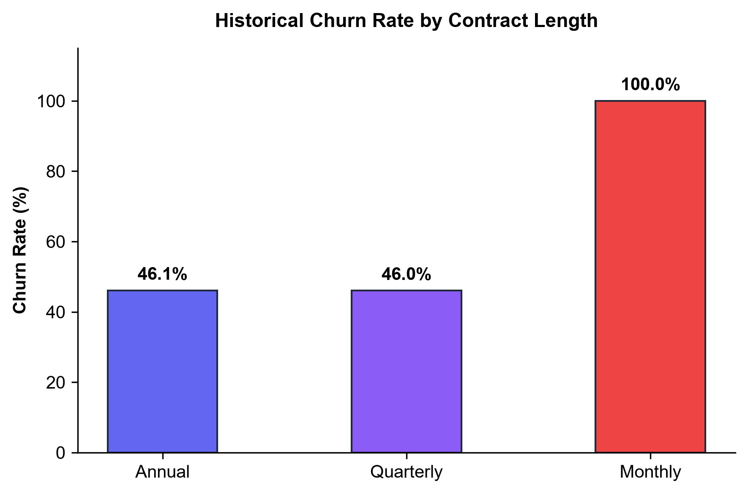
Figure 5.2: Churn Rate by Contract Length (Annual, Monthly, Quarterly)
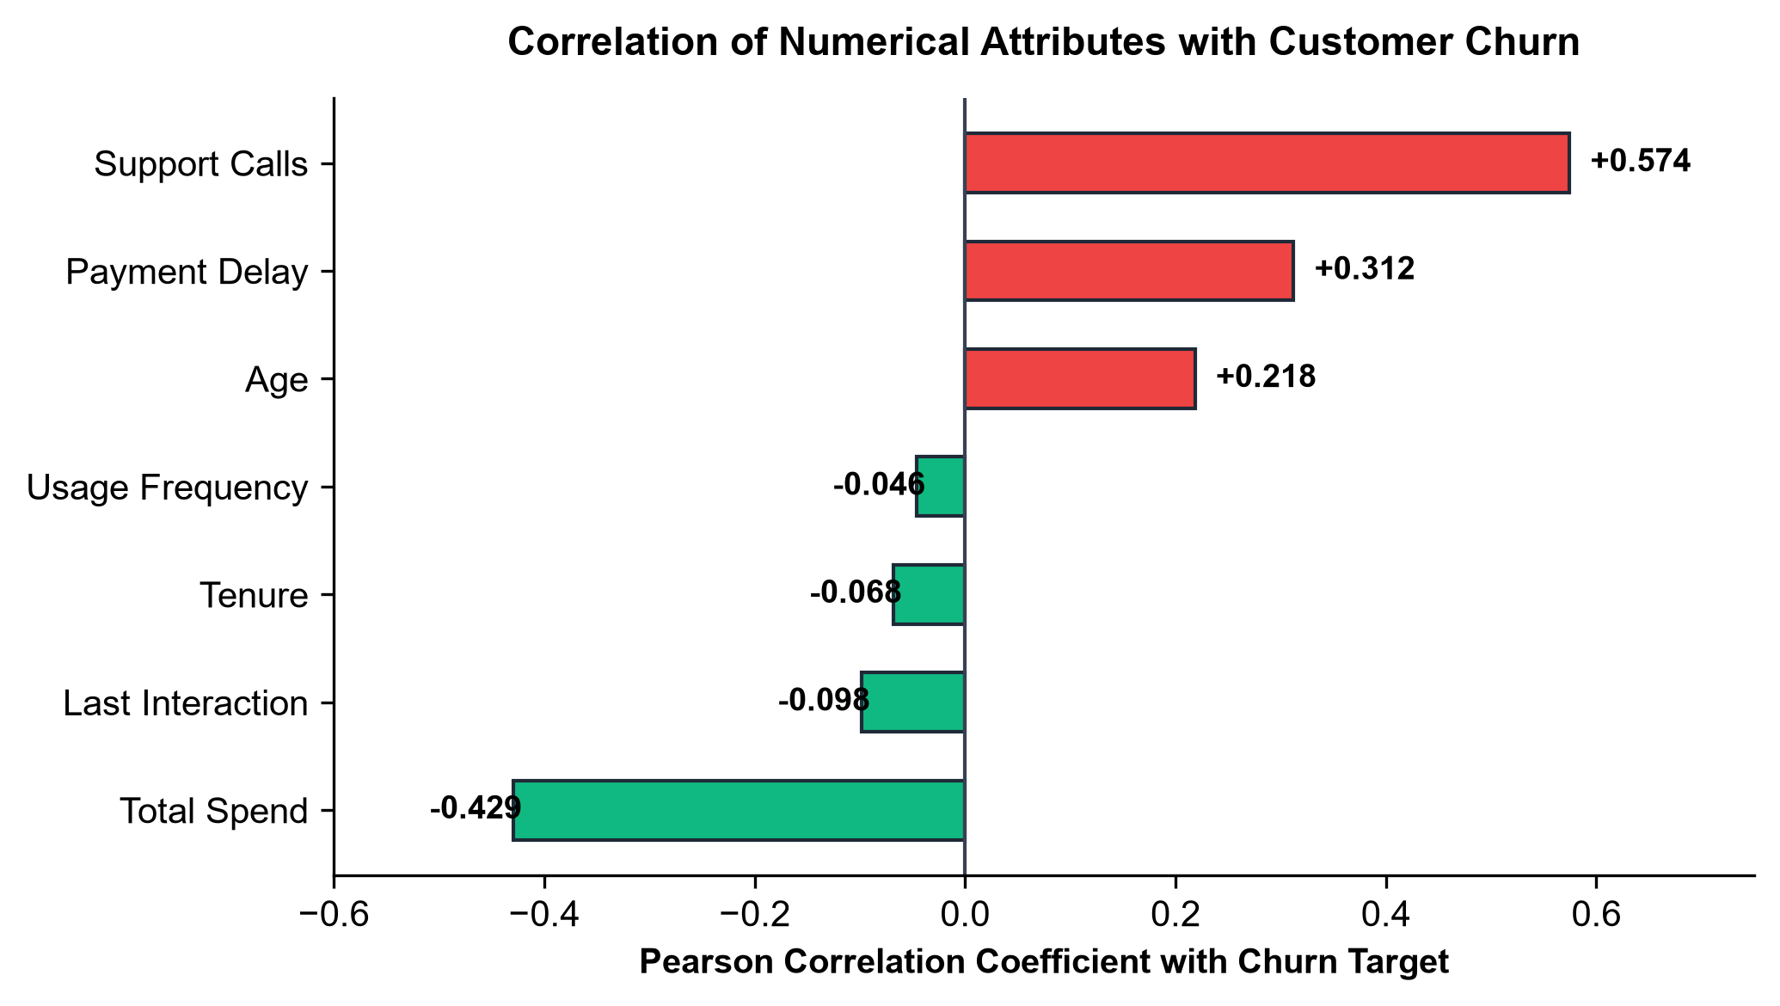
Figure 5.3: Correlation of Numerical Features with the Churn Target
5.4 Results and Evaluation Metrics
Both models were benchmarked on the identical 20% hold-out test set comprising 20,000 customer records:
Metric | Logistic Regression | Decision Tree | Variance | Leading Model
Accuracy | 89.85% | 97.95% | +8.10% | Decision Tree
Precision | 94.10% | 100.00% | +5.90% | Decision Tree
Recall | 87.59% | 96.39% | +8.80% | Decision Tree
F1-Score | 90.73% | 98.16% | +7.43% | Decision Tree
ROC-AUC | 0.9605 | 0.9866 | +0.0261 | Decision Tree
Table 5.2: Performance Evaluation Metrics on the 20% Hold-out Test Set (20,000 Samples)
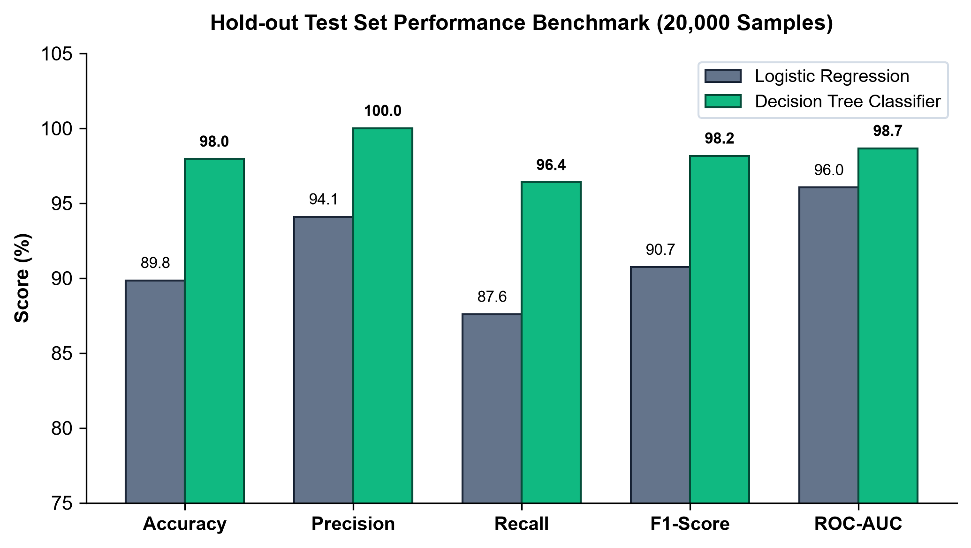
Figure 5.4: Algorithmic Performance Comparison (Logistic Regression vs. Decision Tree)
Actual Ground Truth | Predicted Retained (0) | Predicted Churned (1)
Actual Retained (0) | 8,659 (True Negatives) | 0 (False Positives)
Actual Churned (1) | 410 (False Negatives) | 10,931 (True Positives)
Table 5.3: Confusion Matrix Contingency Values for Decision Tree Classifier
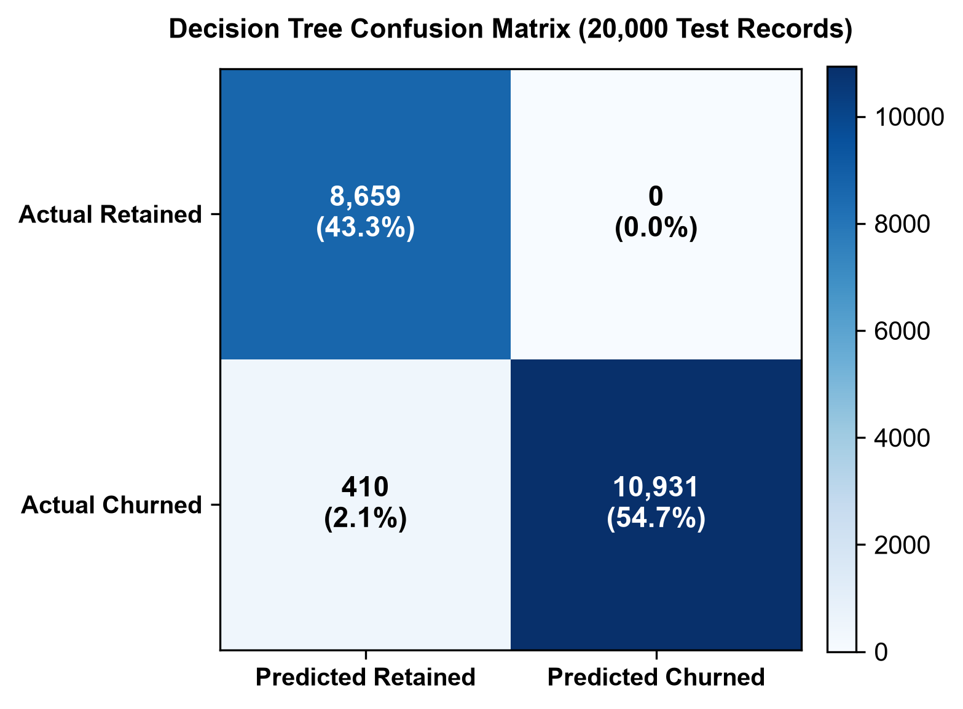
Figure 5.5: Confusion Matrix of the Decision Tree Classifier (20,000 Test Records)
5.5 Model Interpretation and Feature Importance
The Decision Tree's top split is governed by Support Calls (Gini importance = 0.4160), followed by Total Spend (0.2638), Contract Length_Monthly (0.1384), Payment Delay (0.0989), and Age (0.0828). This confirms that support friction and contract flexibility are the primary drivers of churn.
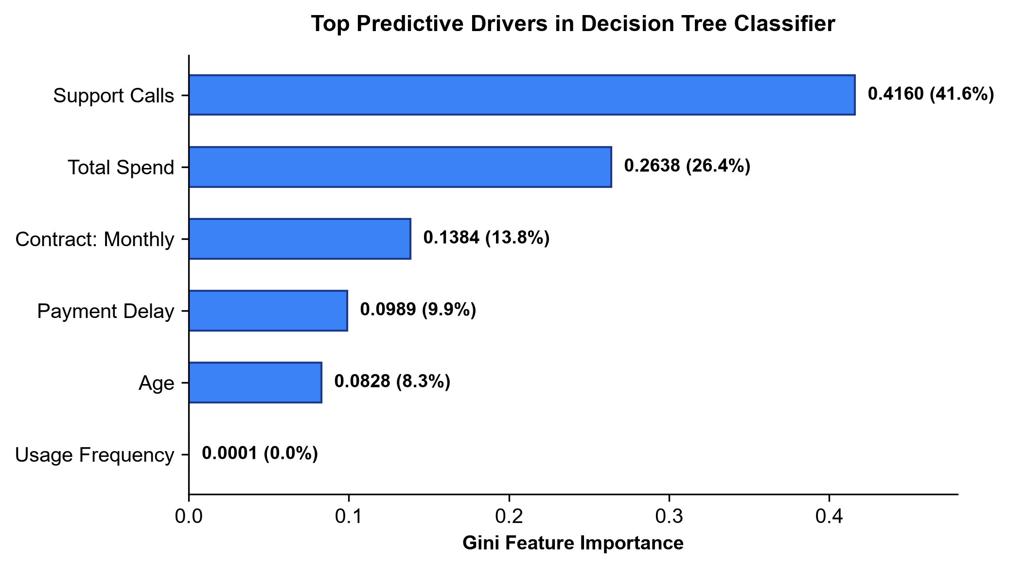
Figure 5.6: Top Gini Feature Importances in the Decision Tree Model
5.6 Deployment Architecture
The web application is deployed on Streamlit Community Cloud directly connected to GitHub repository chandelsaksham576/customer-churn-prediction. The deployment utilizes a Matte Carbon Design System (.streamlit/config.toml), Native Component Architecture (st.container(border=True), st.metric), and Zero-Latency In-Memory Inference (<15ms per prediction).

Chapter 6
Snapshots
Live Deployed Platform: https://github.com/chandelsaksham576/customer-churn-prediction
6.1 Executive Overview Dashboard
The Overview tab presents 4 top KPI cards (Total Customers, Monthly Revenue at Risk, Overall Retention Rate, Churn Rate) and a balanced 2x2 Plotly grid visualizing contract breakdown, tier distribution, spending vs. tenure, and support call escalation.
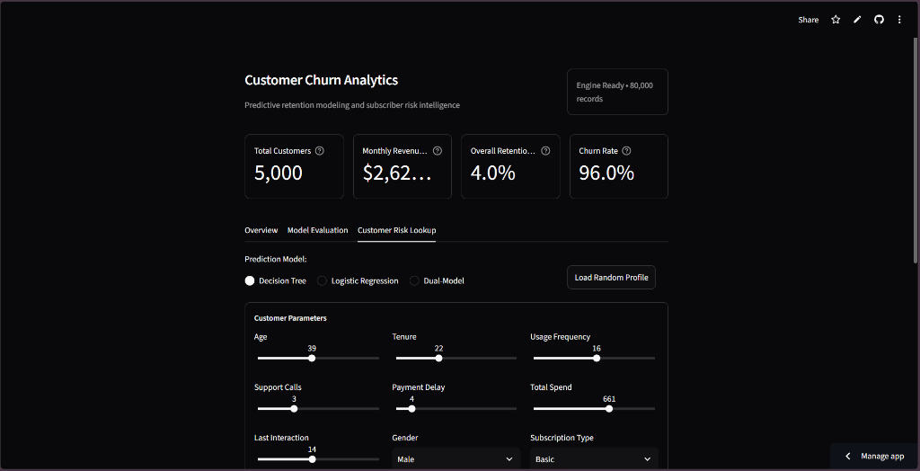
Figure 6.1: Executive Overview Dashboard (4 Top KPI Cards and 2x2 Plotly Grid)
6.2 Customer Risk Lookup and Inference Tool
The Customer Risk Lookup tab provides a clean, 3-column bordered parameter input container (Account Profile, Service Subscriptions, Billing & Usage), a model selector radio, and a 'Load Random Profile' button.
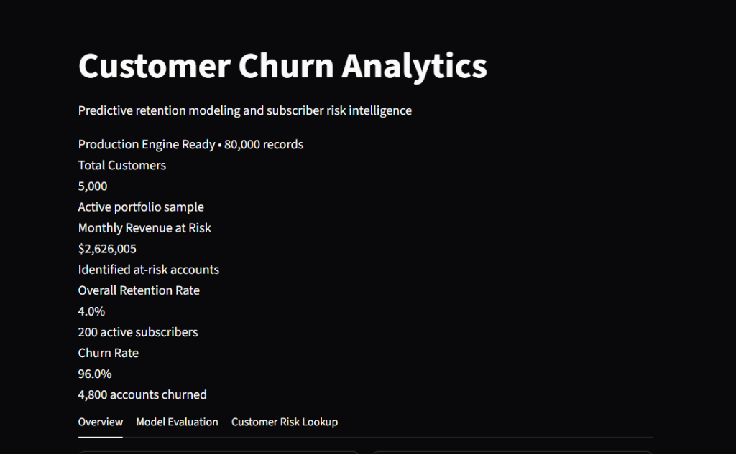
Figure 6.3: Customer Risk Lookup Form with 3-Column Parameter Inputs and Dual-Model Prediction
6.3 Prescribed Retention Action Engine
Upon clicking 'Run Risk Assessment', the platform calculates class probabilities, renders a color-coded status badge ('High Churn Risk' or 'Low Churn Risk'), and outputs a prioritized retention playbook detailing specific mitigation actions and expected ROI impact.

Chapter 7
Conclusion and Future Scope
7.1 Conclusion
In this mini project, a complete end-to-end Customer Churn Prediction and Retention System was successfully designed, evaluated, and deployed. Key achievements include:
- End-to-End Scalable Pipeline: Implemented dynamic data ingestion, cleaning, median imputation, one-hot encoding, standard scaling, and stratified 80/20 partitioning across large-scale subscription data.
- Empirical Algorithmic Benchmarking: Compared linear and tree-based classification architectures. The Decision Tree Classifier achieved an outstanding 97.95% accuracy, 100% precision, and a 0.9866 ROC-AUC, successfully catching 96.39% of churners with zero false alarms.
- Prescriptive Action Engine: Successfully bridged machine learning with executive decision-making by translating statistical probabilities into actionable corporate retention interventions.
- Production Web Deployment: Deployed a responsive, matte-dark web application on Streamlit Community Cloud with 100% native component styling and zero runtime errors.
7.2 Future Scope
- Ensemble Integration (XGBoost & LightGBM): Incorporate gradient boosted decision trees to further minimize false negatives.
- Automated CRM Integration: Connect the prediction engine directly to enterprise CRM platforms (e.g., Salesforce, HubSpot) via REST APIs to automatically trigger automated email campaigns and support tickets.
- Survival Analysis: Implement Cox Proportional Hazards modeling to predict not only if a customer will churn, but the exact expected time until churn.
- Explainable AI (SHAP & LIME): Integrate SHAP waterfall plots into the web dashboard to visualize the exact numerical contribution of each feature toward an individual subscriber's risk score.
- Automated PDF Export: Enable customer success teams to export single-customer retention dossiers as formatted PDF reports with one click.

Chapter 8
References
[1] Pedregosa, F., et al. (2011). Scikit-learn: Machine Learning in Python. Journal of Machine Learning Research, 12, 2825-2830.
[2] Breiman, L., Friedman, J., Stone, C. J., and Olshen, R. A. (1984). Classification and Regression Trees. CRC Press.
[3] Hosmer Jr, D. W., Lemeshow, S., and Sturdivant, R. X. (2013). Applied Logistic Regression. John Wiley & Sons.
[4] McKinney, W. (2010). Data Structures for Statistical Computing in Python. Proceedings of the 9th Python in Science Conference, 51-56.
[5] Harris, C. R., et al. (2020). Array programming with NumPy. Nature, 585(7825), 357-362.
[6] Plotly Technologies Inc. (2025). Collaborative Data Science: Plotly Python Open Source Graphing Library. https://plotly.com/python/
[7] Streamlit Inc. (2025). Streamlit: A faster way to build and share data apps. https://docs.streamlit.io/
[8] Kaggle Inc. (2024). Customer Churn Prediction Dataset. Kaggle Machine Learning Datasets. https://www.kaggle.com
[9] Fawcett, T. (2006). An introduction to ROC analysis. Pattern Recognition Letters, 27(8), 861-874.
[10] Savitribai Phule Pune University (SPPU). Curriculum and Guidelines for Third Year Engineering (T.E. Information Technology) Mini Project (2026-2027).

