DarshanEase – Online Temple Darshan Ticket Booking System
Technology: MERN Stack (MongoDB, Express.js, React.js, Node.js)
GitHub: https://github.com/chandhinichikkala-10/DarshanEase-2026.git

Abstract
DarshanEase is a MERN stack application developed to simplify temple darshan ticket booking. It provides secure registration, login, temple browsing, search, booking, and booking history through a responsive interface using React, Node.js, Express.js, and MongoDB.

Introduction
Temple booking is traditionally manual and time-consuming. DarshanEase automates this process through a secure web application following MVC architecture and REST APIs.

Existing System
Manual booking causes long queues, paperwork, and inconvenience. Records are difficult to maintain and there is no centralized booking system.

Proposed System
The proposed solution provides online registration, authentication, temple browsing, booking, and booking history using a MongoDB-backed MERN application.

Objectives
• Online booking
• Secure login
• Responsive UI
• REST APIs
• MongoDB integration
• Booking history
• Scalable architecture

Technology Stack
Frontend: React.js, HTML5, CSS3, Bootstrap, JavaScript, Axios.
Backend: Node.js, Express.js.
Database: MongoDB & Mongoose.
Tools: Git, GitHub, VS Code, Postman.

MERN Architecture
React frontend communicates with Express REST APIs. Controllers process requests, Models interact with MongoDB, and JSON responses update the UI.

MVC Architecture
Model manages database schemas. View is the React interface. Controller contains application logic for authentication, temple management, and bookings.

Modules
User Authentication, Temple Management, Temple Search, Ticket Booking, My Bookings, Logout.

REST APIs
POST /api/users/register
POST /api/users/login
GET /api/temples
POST /api/bookings/book
GET /api/bookings

Database
Database: darshan_booking
Collections: users, temples, bookings.

Testing
Registration, Login, Search, Booking, and My Bookings were tested successfully.

Future Enhancements
Payment gateway, QR tickets, Email/SMS notifications, Admin dashboard, Slot management, Analytics, Mobile application.

Conclusion
DarshanEase demonstrates practical implementation of MERN stack development with secure authentication, responsive UI, MVC architecture, and MongoDB integration.

Project Screenshots

Landing Page
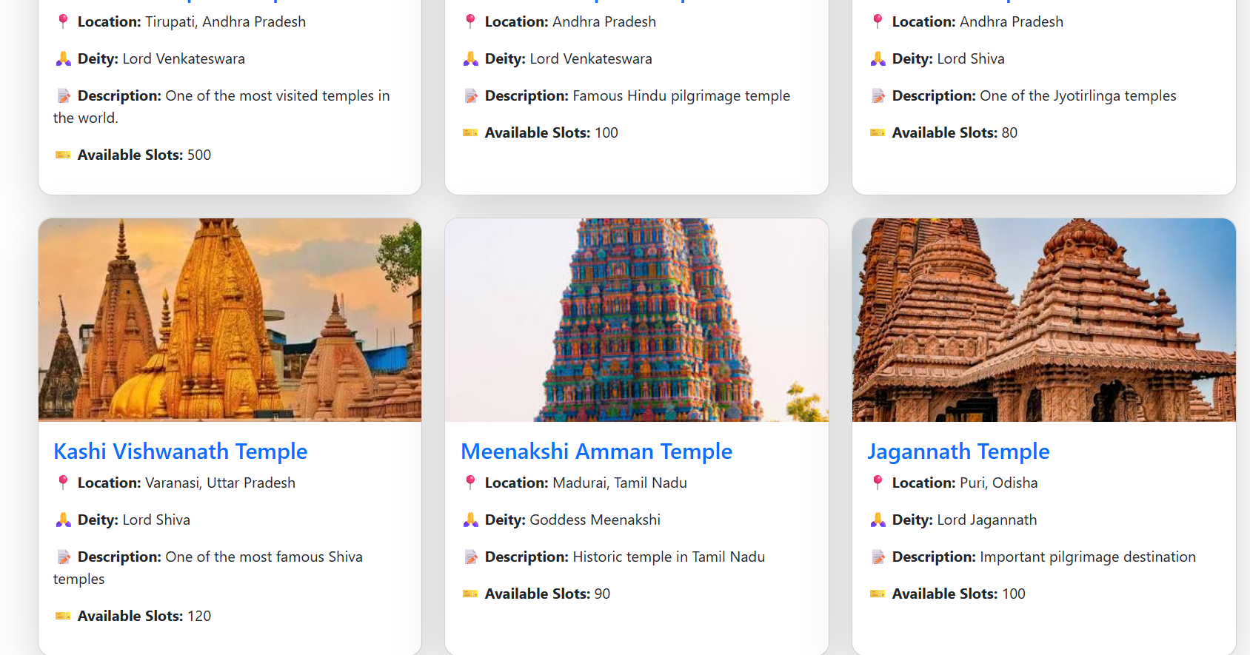
Figure: Landing Page
This screen demonstrates the landing page functionality of the DarshanEase application. It provides users with an intuitive interface and integrates seamlessly with the backend APIs and MongoDB database.

Temple List
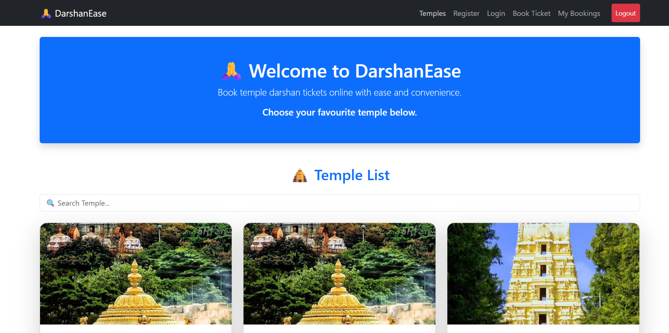
Figure: Temple List
This screen demonstrates the temple list functionality of the DarshanEase application. It provides users with an intuitive interface and integrates seamlessly with the backend APIs and MongoDB database.

Registration Page
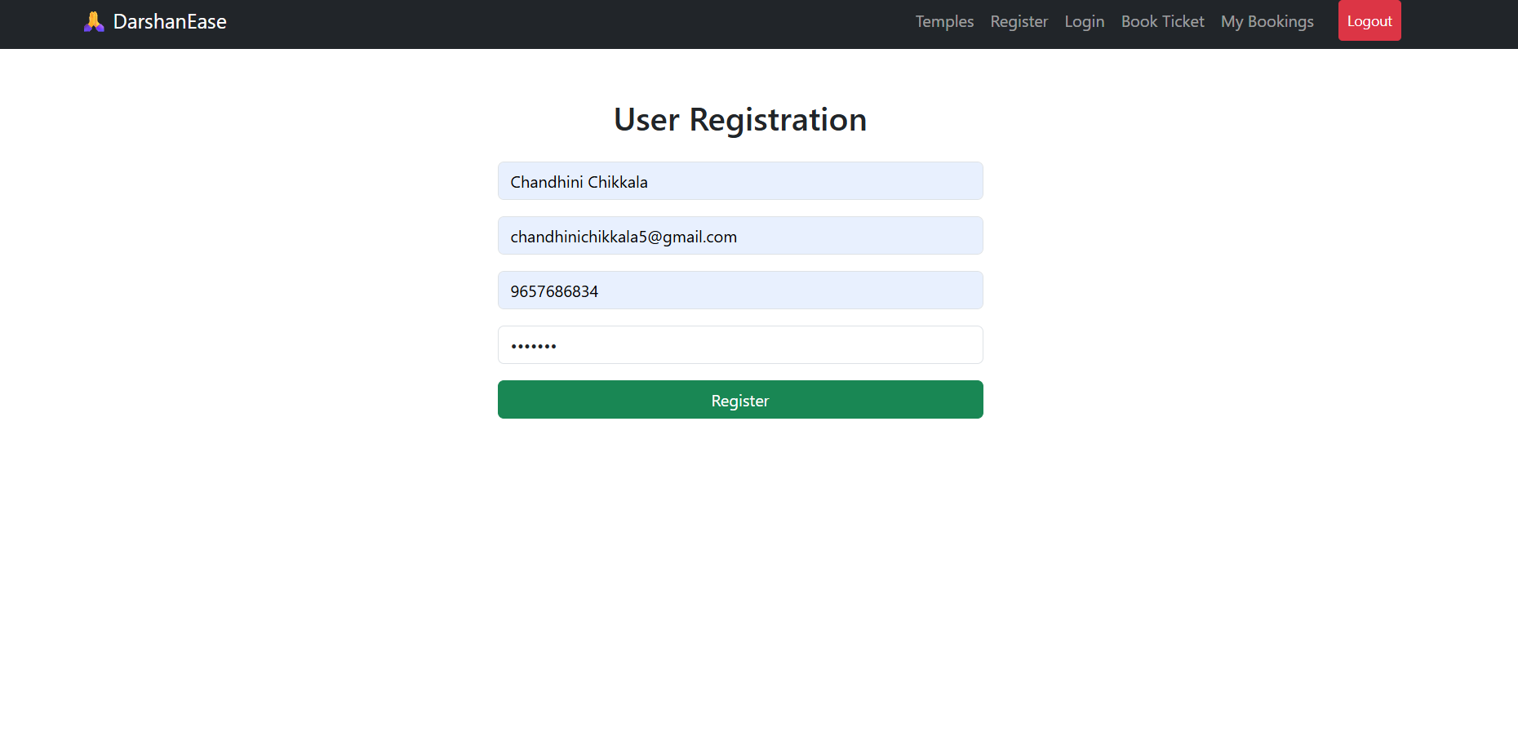
Figure: Registration Page
This screen demonstrates the registration page functionality of the DarshanEase application. It provides users with an intuitive interface and integrates seamlessly with the backend APIs and MongoDB database.

Book Ticket
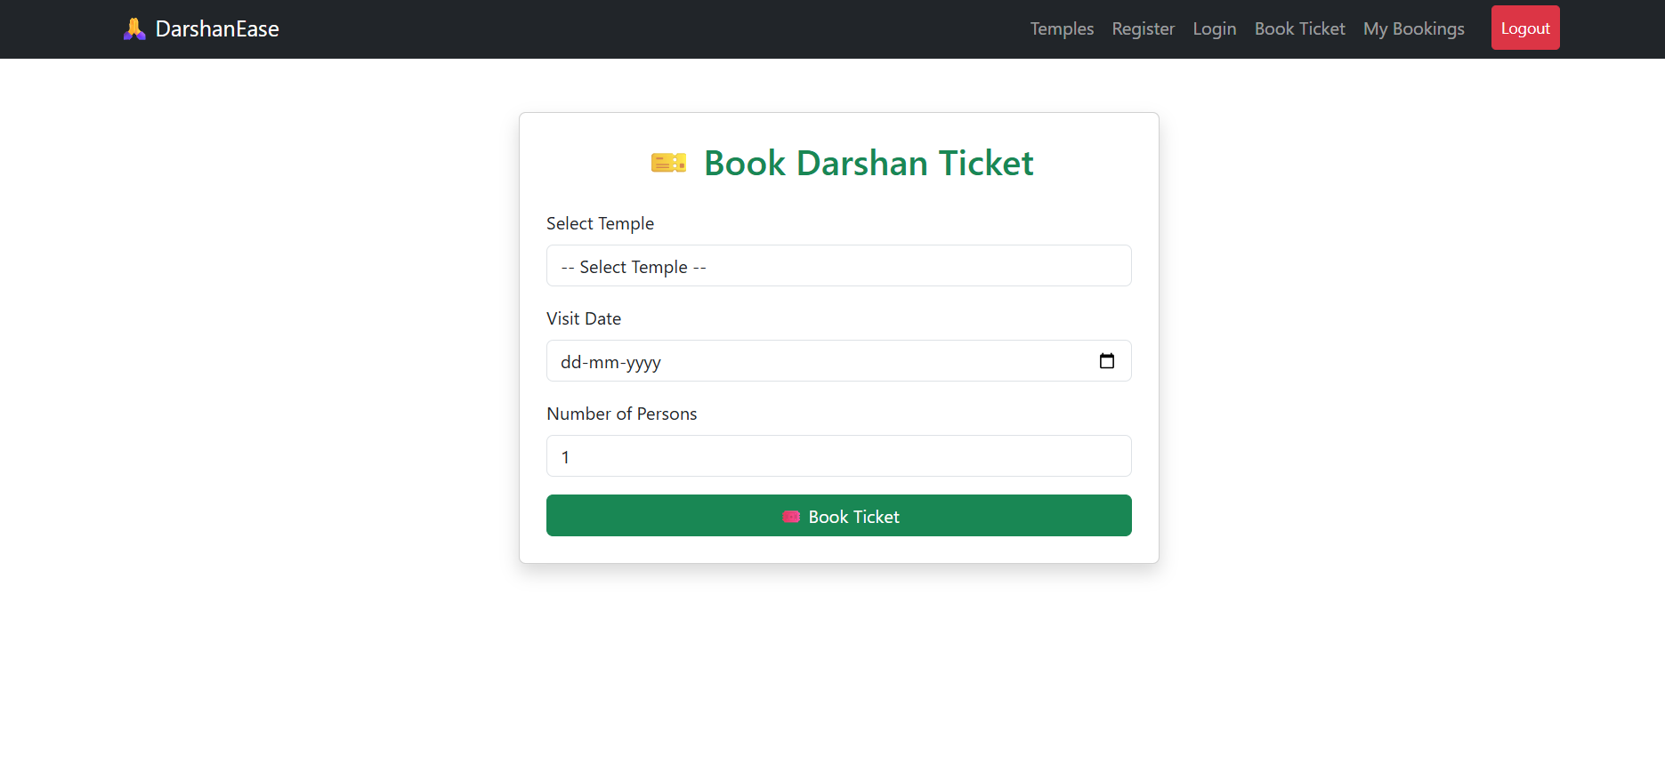
Figure: Book Ticket
This screen demonstrates the book ticket functionality of the DarshanEase application. It provides users with an intuitive interface and integrates seamlessly with the backend APIs and MongoDB database.

My Bookings
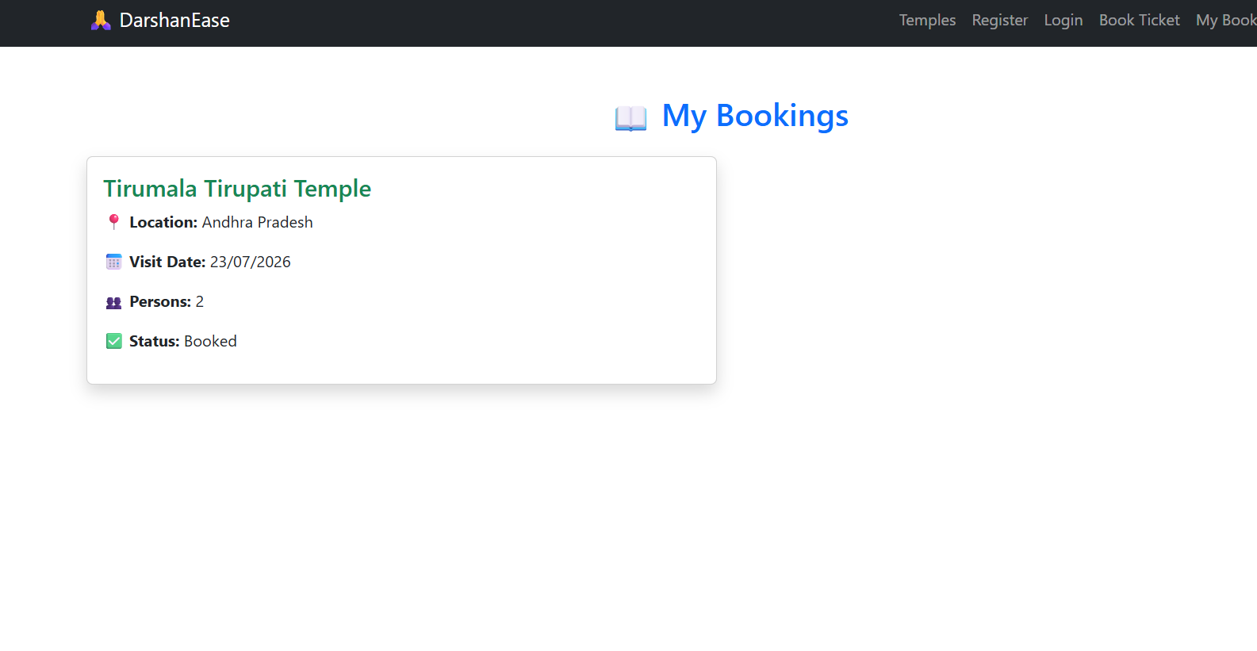
Figure: My Bookings
This screen demonstrates the my bookings functionality of the DarshanEase application. It provides users with an intuitive interface and integrates seamlessly with the backend APIs and MongoDB database.

Home Page
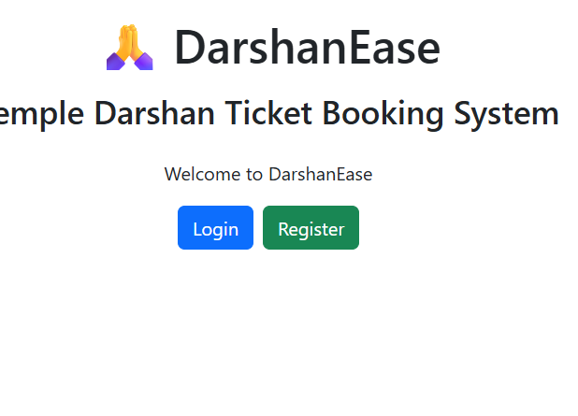
Figure: Home Page
This screen demonstrates the home page functionality of the DarshanEase application. It provides users with an intuitive interface and integrates seamlessly with the backend APIs and MongoDB database.

