1.Get the Customer name, product name, total price based on quantity from the tables mentioned above.

**Sql:**

Select c.name as customer_name ,p.name as Product_Name,(p.price * o.quantity) as Total_Price

from customer c

join orders o on c.id=o.customer_id

join product p on o.product_id =p.id;

**OUTPUT:**

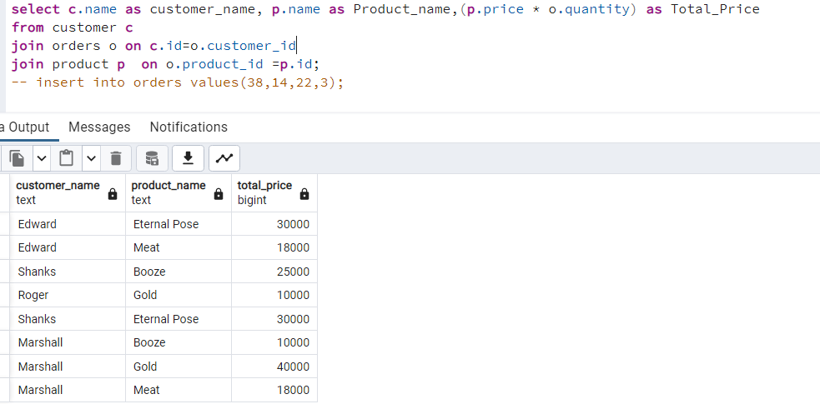

2. Get the Customer name and total amount spent by each customer from the tables mentioned above.

SQL:

Select c.name as Customer_name ,sum(p.price * o.quantity) as Total_Amount_spent

From customer c

Join orders o on c.id=o.customer_id

Join product p on p.id=o.product_id

group by c.name;

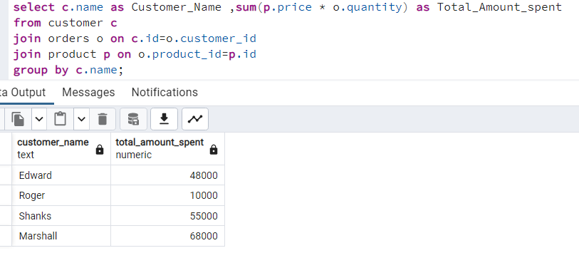

3. Update the records by multiplying the price by 2 for which the price is above 7000 in the Product table.

SQL:

update product

set price = price * 2

where price > 7000;

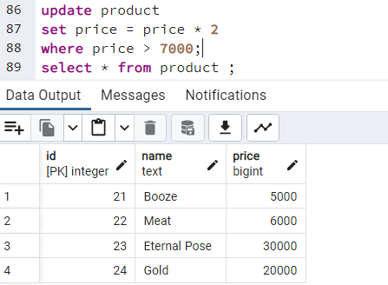

4. Delete a record from the customer table whose name has the word ‘hal’.

SQL:

delete from customer

where name like '%hal%';

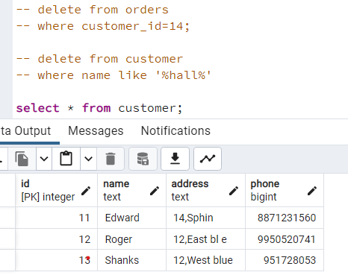

5. Consider a table with columns Id,Name,CGPA.The table contains lots of duplicate records. Write a query to ignore the duplicate records..

SQL:

Select distinct col 1, col 2 , col 3 ….

From table_name;

6. Write a query to know the difference between the timestamps ‘2022-06-26 14:55:59’ and ‘2022-06-11 12:03:59’ in hours.

SQL:

select timestampdiff (hour, '2022-06-11 12:03:59', '2022-06-26 14:55:59') as hour_difference**;**

or

select extract (epoch from('2022-06-26 14:55:59' ::timestamp- '2022-06-11 12:03:59' ::timestamp))/3600

as hours_diff ;

