**10. Write a C program that illustrates two processes communicating using shared memory**

**Program:**

#include<stdio.h>

#include<stdlib.h>

#include<unistd.h>

#include<sys/shm.h>

#include<string.h>

int main()

{

int i;

void *shared_memory;

char buff[100];

int shmid;

shmid=shmget((key_t)2345,1024,0666|IPC_CREAT);

printf("key of shared memory is %d\n",shmid);

shared_memory=shmat(shmid,NULL,0);

printf("process attached at %p\n",shared_memory);

printf("enter some data to write to shared memory\n");

read(0,buff,100);

strcpy(shared_memory,buff);

printf("you wrote:%s\n",(char *)shared_memory);

}

**Output**:

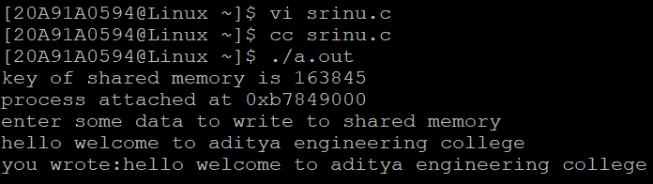

**11. Write C program to create a thread using pthreads library and let it run its function.**

**Program:**

#include<unistd.h>

#include<stdio.h>

#include<stdlib.h>

#include<pthread.h>

void *mythread(void *vargp)

{

sleep(1);

printf("welcome to threads\n");

return NULL;

}

int main()

{

pthread_t tid;

printf("before thread\n");

pthread_create(&tid,NULL,mythread,NULL);

pthread_join(tid,NULL);

exit(0);

}

**Output:**

