Name:__________________ ____ Date:___________

**F(x) is graphed below. Use it to answer questions 1-7.**

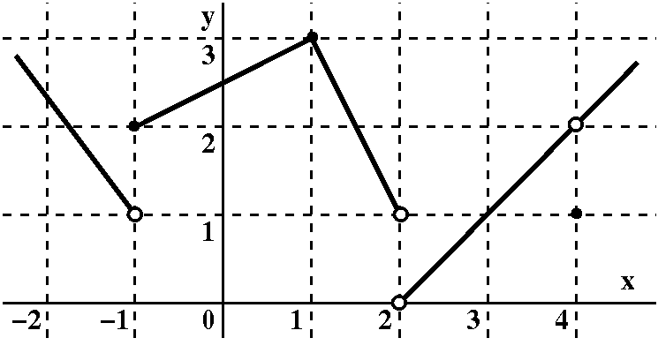

1. =
2. =
3. =
4. =
5. f(4)=
6. =
7. F(2)=

**Find the intervals where each function is continuous. Explain the type and location of any discontinuities.**

8.

9.

10.

**Find the limit**

11. 

12. 

13. 

14. **Find the equation of the line tangent to f(x)=x4-3x+7 at x=-1.**

**15. Find the derivative of:**

* 1. **F(x) = -3x3 + 2sinx**
  2. **G(x) =**
  3. **H(x) = **
  4. **J(s) = **
  5. **F(v) = **
  6. **K(x) = **

**16. Find the second derivative of .**

**17. Area The radius, r, of a circle is decreasing at a rate of 4 centimeters per minute.**

**Find the rate of change of area, A, when the radius is 5.**

**18. Find the absolute extrema for the function on the interval [-1,5].**

**19. For  on [0,2 $π$], find the intervals where the function is increasing, decreasing, and constant. State its relative maximums and relative minimums.**

**20. For , find the intervals where the function is concave up and concave down. State any inflection points.**

**21. An enclosed right circular cylinder is designed to hold 100 cubic inches of a liquid.**

1. **Write an equation representing the volume.**
2. **Write an equation representing the surface area. Draw a picture of the object.**
3. **Write surface area as a function as a function of r. (Hint: Use the equation in part a)**
4. **What radius would minimize the materials (surface area) to make this can?**

**22. **

**23. **

**24. **

**25. **

**Given that**

**26. Find **

**27. Find**

**28. Find **

**29. If f(x) is even, find, **

**30. For F(x)=, Find **

**31. Evaluate. Show all work.**

**32. **

**33. Find the area of the region formed by the intersecting y=4-x2 and y=x2-4.**