INTRODUCTION TO DBMS:
Data: facts that can be recorded those in the form of text, video, numbers, images etc..
Data base: collection of related data that represents real world entities
Information : meaningful or processed data
In dbms there is no redundancy problem, redundancy means that having the same information in many locations
In dbms , user is interacting with the dbms and dbms will interact with the data base to solve the query . dbms have some software tools to manage the data in the data base
Data base + dbms = data base system (complete package)
Applications:
1, tele communications
2. college data base or universities
Dbms stores data in such a way that it becomes easier to retrieve , manipulate the data.

Characterstics of dbms:
Normally the data can be in the form of file formats, to overcome the difficulties of traditional style , the new concept dbms was introduced.
Here are the some characterstics of dbms:
- Real world entity: a modern dbms uses the real world entities to design its architecture. Example for real world entity: in the school data base, students are considered as the entities and their age is considered as the attribute,, attribute is nothing but a column in the table.
- Relation – based tables: dbms allows the entities and relations among the tables to form tables.
- Less redundancy : by using the normalization technique we can reduce the redundancy problem in dbms.
- Consistency: it is the state where every relation in a database remains constant . dbms provide the excellent property of maintaining the consistency over the other storing applications like file processing systems.
- Query language: dbms is entirely a query language , which makes us to efficiently retrieve the data and manipulate the data
- Acid properties: dbms follows the concepts of atomicity , consistency, isolation and durability . these concepts are used in the transactions, which manipulate the data in the database. Acid properties help the data base to stay consistent when it facing the multi transactional environment.
- Multi user and concurrent access
- Multiple views
- Security

In dbms there are different users , they are responsible for different purposes. Some of the users are responsible for retrieve the data and some for the back up the data in the data base.
In dbms the users are classified into 3 ways:
- End users
- Administrators
- Designers
Administrators: they are responsible for administrating the data base and responsible for maintaining the dbms. They can give the permissions for who are going to use the adta base information who are not capable of using the data base information those all are comes under the administrator purpose.
Designers: designers are the group of people whose are responsible for designing the data base . they are worked together to maintain the data in the data base in which format the data can be entered into the data base. They identify and design the whole set of entities, relations, constraints and views.
End users: they are individuals whose day o day jobs require the acces to the data base to update and query.

DBMS ARCHITECTURE:
- The design of dbms depends on its architecture. It can be centralized or decentralized or hierarchical.
- The architecture of a dbms can be seen either as single -tier or multi-tier.
- An n-tier architecture divides the entire system into n independent modules, which can be independently modified altered, changed.
- In 1-tier architecture, there is only one entity so that the user can sit on the dbms and uses it. Any changes can be done in 1-tier can directly on the dbms itself.
- If the architecture of the dbms is 2-tier then the user cannot directly interact with the dbms,, Programmers use 2-tier architecture where they access the DBMS by means of an application. Here the application tier is entirely independent of the database in terms of operation, design, and programming.
- 3-tier architecture: a 3-tier architecture separates its tiers from ech other based on the usage of complexity of the users and how users are using the data which is present in the data base. It is the most common architecture which developers can used to design the architecture.
- 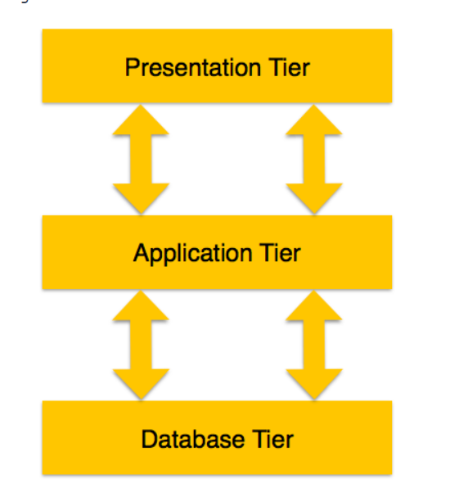
Data base tier : at this tier , the user is giving the query to this tier and this tier is responsible for forming and identifying the relations and constraints at this level.
Application tier(middle): For a user, this application tier presents an abstracted view of the database. End-users are unaware of any existence of the database beyond the application. At the other end, the database tier is not aware of any other user beyond the application tier. Hence, the application layer sits in the middle and acts as a mediator between the end-user and the database.
User (Presentation) Tier − End-users operate on this tier and they know nothing about any existence of the database beyond this layer. At this layer, multiple views of the database can be provided by the application. All views are generated by applications that reside in the application tier.

DBMS – DATA MODELS
Data models define how the logical structure of a database is modeled.
Data Models are fundamental entities to introduce abstraction in a DBMS.
Data models define how data is connected to each other and how they are processed and stored inside the system.
ENTITY – RELATIONSHIP MODEL:
ER model is based on the notation of real world entities and the relationship between them. While formulating real-world scenario into the database model, the ER Model creates entity set, relationship set, general attributes and constraints.
Er model is best suitable for conceptual design of the data base.
Er model is based on the :
- Entities and their attributes
- Relationships among the entities
Symbols used in the er model:
- Entity – rectangle
- Attribute – oval
- Relationship – rhombus
Def of entity: entity is a real world entity having properties called as attributes.
Ex: students are considered as an entity. In that students age is considered as an attribute.
Every attribute is defined by its set of values called domain.
Relationship: it means the logical association among entities is called relationship.
Relationships are mapped with entities in various ways. Mapping cardinalities define the number of association between two entities.
Mapping cardinalities −
- one to one
- one to many
- many to one
- many to many

Relational Model
The most popular data model in DBMS is the Relational Model. It is more scientific a model than others. This model is based on first-order predicate logic and defines a table as an n-ary relation.

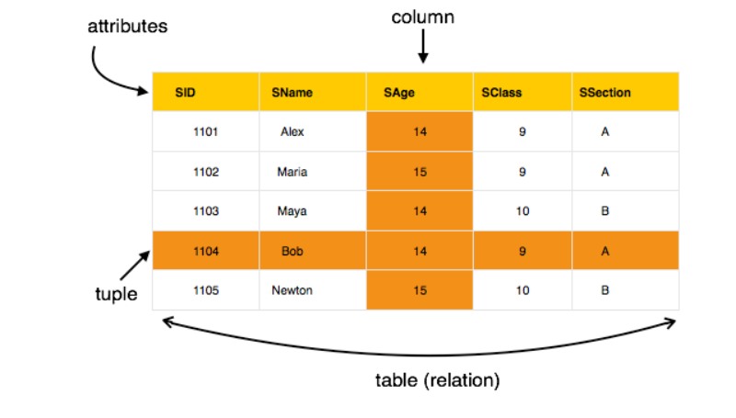

The main highlights of this model are −
- Data is stored in tables called relations.
- Relations can be normalized.
- In normalized relations, values saved are atomic values.
- Each row in a relation contains a unique value.
- Each column in a relation contains values from a same domain.

Database Schema
A database schema is the skeleton structure that represents the logical view of the entire database. It defines how the data is organized and how the relations among them are associated. It formulates all the constraints that are to be applied on the data.
A database schema defines its entities and the relationship among them. It contains a descriptive detail of the database, which can be depicted by means of schema diagrams. Its the database designers who design the schema to help programmers understand the database and make it useful.

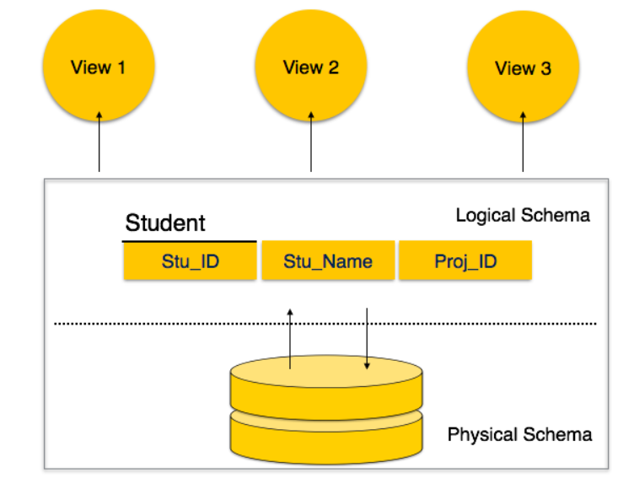

A database schema can be divided broadly into two categories −
- Physical Database Schema − This schema pertains to the actual storage of data and its form of storage like files, indices, etc. It defines how the data will be stored in a secondary storage.
- Logical Database Schema − This schema defines all the logical constraints that need to be applied on the data stored. It defines tables, views, and integrity constraints.

Database Instance
It is important that we distinguish these two terms individually. Database schema is the skeleton of database. It is designed when the database doesn't exist at all. Once the database is operational, it is very difficult to make any changes to it. A database schema does not contain any data or information.
A database instance is a state of operational database with data at any given time. It contains a snapshot of the database. Database instances tend to change with time. A DBMS ensures that its every instance (state) is in a valid state, by diligently following all the validations, constraints, and conditions that the database designers have imposed.
If a database system is not multi-layered, then it becomes difficult to make any changes in the database system.
Data Independence
A database system normally contains a lot of data in addition to users data. For example, it stores data about data, known as metadata, to locate and retrieve data easily. It is rather difficult to modify or update a set of metadata once it is stored in the database. But as a DBMS expands, it needs to change over time to satisfy the requirements of the users. If the entire data is dependent, it would become a tedious and highly complex job.
Metadata itself follows a layered architecture, so that when we change data at one layer, it does not affect the data at another level. This data is independent but mapped to each other.
Logical Data Independence
Logical data is data about database, that is, it stores information about how data is managed inside. For example, a table (relation) stored in the database and all its constraints, applied on that relation.
Logical data independence is a kind of mechanism, which liberalizes itself from actual data stored on the disk. If we do some changes on table format, it should not change the data residing on the disk.
Physical Data Independence
All the schemas are logical, and the actual data is stored in bit format on the disk. Physical data independence is the power to change the physical data without impacting the schema or logical data.
For example, in case we want to change or upgrade the storage system itself − suppose we want to replace hard-disks with SSD − it should not have any impact on the logical data or schemas.

Schema means : description of the data base and it is used to design the data base.
Schema is a blue print which is used to design the data base.
Schema contains table name, column name , data type and possible constraints.
Instance: content of a data base or table at a point of time.

