Centralized DBMS Architecture:
A centralized system operates through a central node. In centralized dbms architecture, all database operations , user interfaces and applications are managed by a single computer typically a main frame or powerful server.
Users would access the main frame through a terminals connected via network.
Client-server architecture: (dbms architecture)
- In the client-server architecture – server manages the resources and client consumed the resources.
- The clients and the servers are the logical entities they both worked together over a network to complete the task.
- Client-server architecture is a shared computer network architecture.
- 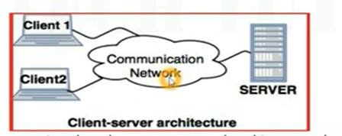
- Types of client-server architecture:
- 1-tier architecture
- 2-tier architecture
- 3-tier architecture
- N-tier architecture
In the 1-tier architecture the data base is directly available to the user. Any changes can be done by the user itself.
Advantages:
Easy to implement, cost is less

2-tier architecture:
2-tier architecture provides the client/server environment that helps to store the user interface .
The application on the client side establishes a connection with the server side to communicate with the dbms.
The user interfaces and application programs are done on the client-side.
The server side is responsible for query processing and transaction management.
- Advantage for this architecture is to understand easily , this model gets the poor performance when there are more users.

3-tier architecture:
In this middleware is used because if client machine sends the request to the server machine then firstly this request is received by the middle layer and this request is obtained to the server.
- All data logic and business logic are stored In the middleware.
- 3-tier architecture providing 3 layers: 1. Presentation layer( client layer) 2. Application layer(business layer) 3. Data base layer(data layer)
- Client machine handles the presentation layer, application layer controls the business logic where server machine controls the data base layer.
- 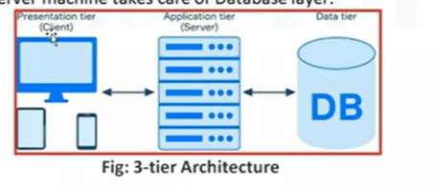
n-tier architecture:
it is also known as the multi-tier architecture..
the next generation of client/server architecture is n-tier architecture.
- It is similar to the three-tier architecture except that, middle layer i.e application layer is further divided into different components based on the functionalities provided.
- Main advantage: large applications can be developed in a short span of time. And reusable components

Classification of DBMS refers to the different types of database management systems based on how they organize, store, and manage data: Hierarchical, Network, Relational, and Object-Oriented DBMS.

Codd’s 12 rules:
1. Information Rule
- Rule: All information in the database should be stored only in tables.
- Easy: Every piece of data must be stored as rows and columns.
- Example: Student Table → Roll No, Name, Marks.
2. Guaranteed Access Rule
- Rule: Every data item should be accessible using the table name, primary key, and column name.
- Easy: Any cell in the table should be easy to access.
- Example: Student → Roll No = 101 → Name = Aparna.
3. Systematic Treatment of NULL Values
- Rule: Missing or unknown information should be represented using NULL.
- Easy: Use NULL when data is not available.
- Example: Phone Number = NULL.
4. Dynamic Online Catalog Rule
- Rule: Database metadata (information about tables, columns, etc.) should also be stored as tables.
- Easy: Users should be able to view database details using queries.
- Example: Viewing table information using SQL commands.
5. Comprehensive Data Sublanguage Rule
- Rule: A single language should be used to define, manipulate, and control the database.
- Easy: Use SQL for all database operations.
- Example: SELECT, INSERT, UPDATE, DELETE.
6. View Updating Rule
- Rule: All updateable views should allow updates.
- Easy: If a view can be updated, users should be able to update data through it.
- Example: Updating marks through a Student View.
7. High-Level Insert, Update, Delete Rule
- Rule: The database should support operations on multiple rows at once.
- Easy: One query should work on many rows.
- Example:
UPDATE Student
SET Marks = 50;
8. Physical Data Independence
- Rule: Changes in physical storage should not affect applications.
- Easy: If the storage method changes, the program should still work.
- Example: Moving data from HDD to SSD.
9. Logical Data Independence
- Rule: Small changes in table structure should not affect applications.
- Easy: Programs should continue to work even if new columns are added.
- Example: Adding an Email column to the Student table.
10. Integrity Independence
- Rule: Integrity constraints should be stored in the database, not in application programs.
- Easy: Database rules should be managed by the database itself.
- Example: Age must be greater than 18.
11. Distribution Independence
- Rule: Users should not know whether the database is stored on one server or many servers.
- Easy: The location of the data should be hidden from users.
- Example: Online banking databases.
12. Non-Subversion Rule
- Rule: Low-level access should not bypass database rules and constraints.
- Easy: No one should be able to break database rules using direct access.
- Example: Users cannot ignore constraints by accessing database files directly.
RELATION DATA MODEL:
The Relational Data Model represents data in the form of tables (relations). Each table consists of rows (tuples) and columns (attributes). It is the most widely used data model in DBMS.
Example: Student Table
Roll No | Name | Age | Department
101 | Aparna | 20 | CSE
102 | srii | 21 | ECE
- Relation: simply defined as table in a data base.
- Tuple: one complete row in a table is called as tuple.
- Attribute/column/field: one complete column in a table. Ex: roll.no, name ,marks.. are attributes.
- Domain: domain is a set of allowed values for an attribute. Ex: age 18-60, gender- male,female,others..domain specifies that what are the values satisfied the attributes.
- Degree of a relation: degree of a relation is defined as , in a table total number of attributes are considered as the degree of a relation.
if the table contains 3 attributes namely name, roll_no, marks are the three attributes. So the degree of the relation is “3”.
- Cardinality of a relation: it is defined as the total number of rows in a table, nothing but number of tuples (complete rows in a table)
if there are 3 tuples or rows then cardinality of a relation I “3”.
- Relation schema: it contains the structure of the data but it doesnot contain the actual data of the table.
example: student(name, marks, roll_no)
in the above example there we can see only the structure of the table but not contain any data about the table in the schema.
- Relation instance : it means the condition of the table at that particular instant, if the data changes the instance also changes,,at that particular time which data is present in the table , that only considered at that instance.
Keys: they are used to identify the records quickly. There are different types of keys:
1. Super Key
Definition
A Super Key is a set of one or more attributes that can uniquely identify each record in a table.
Example
Possible Super Keys:
- Roll No
- Email
- Roll No + Name
- Roll No + Phone
- Email + Name
All of these uniquely identify a student.
Easy Definition
Any combination of columns that uniquely identifies a row is called a Super Key.

2. Candidate Key
Definition
A Candidate Key is the smallest (minimal) Super Key. It contains no unnecessary attributes.
Example
Roll No | Name | Email
101 | Aparna | aparna@gmail.com
Candidate Keys:
- Roll No
- Email
Both uniquely identify a student by themselves.
Easy Definition
A minimal Super Key is called a Candidate Key.

3. Primary Key
Definition
A Primary Key is the Candidate Key chosen to uniquely identify each record.
Properties
- Must be unique
- Cannot be NULL
- One Primary Key per table
Example
Roll No (PK) | Name
101 | Aparna
102 | sri
Here, Roll No is the Primary Key.
Easy Definition
The main key used to identify each record uniquely.

4. Alternate Key
Definition
An Alternate Key is a Candidate Key that is not selected as the Primary Key.
Example
Candidate Keys:
- Roll No
- Email
Primary Key → Roll No
Alternate Key → Email
Easy Definition
A Candidate Key that is not chosen as the Primary Key.

5. Foreign Key
Definition
A Foreign Key is an attribute in one table that refers to the Primary Key of another table.
Example
Department Table
DeptID (PK) | DeptName
D1 | CSE
D2 | ECE
Student Table
Roll No | Name | DeptID (FK)
101 | Aparna | D1
102 | sri | D2
DeptID in the Student table is a Foreign Key because it refers to the Primary Key in the Department table.
Easy Definition
A Foreign Key connects two tables.

6. Composite Key (Compound Key)
Definition
A Composite Key is a Primary Key made u
p of two or more attributes.
Example
StudentID | CourseID | Marks
101 | C101 | 90
101 | C102 | 85
Here:
- StudentID alone → Not unique
- CourseID alone → Not unique
- StudentID + CourseID → Unique
So, (StudentID, CourseID) is the Composite Key.
Easy Definition
A key formed by combining two or more columns.

- Integrity constraints:
  - Domain constraint
  - Entity integrity constraint – primary key cannot be null and must be unique.
  - Referential integrity constraint: Foreign Key value must exist in the referenced table.
Example:
Student DeptID = D1
Department table must contain D1.
- Relational algebra operations:
- Selection(sigma) – select rows
- Projection (pie) – select columns
- Union (U)– combines rows and columns
conditions:
same data types
same number of coulmns
- Intersection – return common rows
- Difference(-) - return rows in one table but not in another table.
- Cartesian product (*): combines every row of one table with every row of another table.
row = table1* table2
- Join – combines related rows using the common attribute.

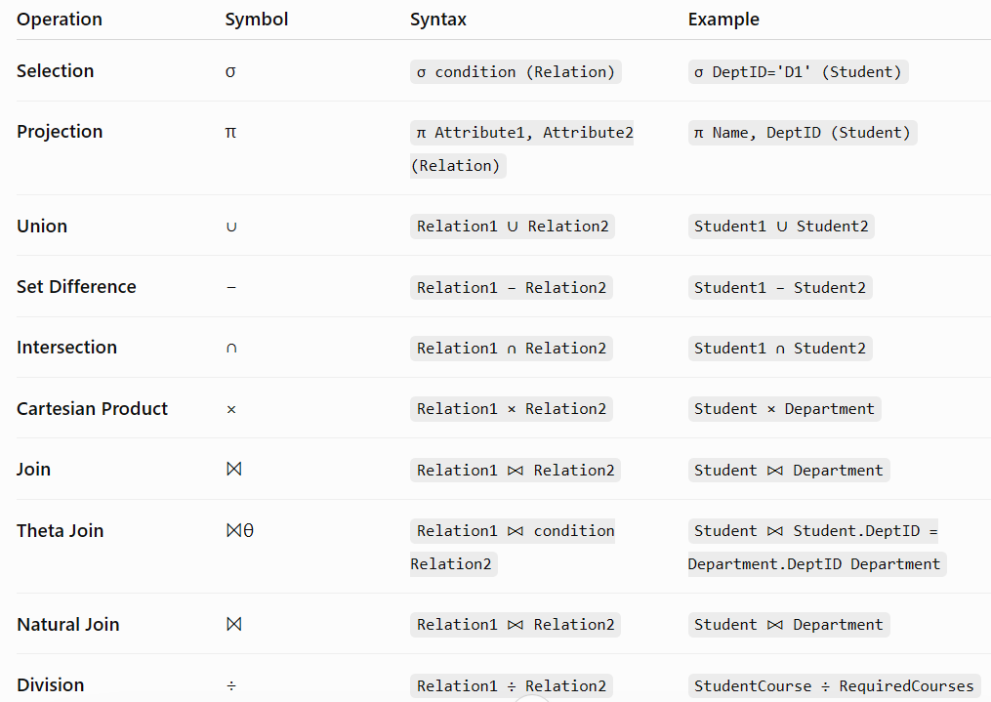

Question | Relational Algebra Query
1. Display all students. | Student
2. Display students whose marks are greater than 80. | σ Marks > 80 (Student)
3. Display students whose marks are less than 70. | σ Marks < 70 (Student)
4. Display students belonging to Department D1. | σ DeptID = 'D1' (Student)
5. Display students with marks between 70 and 90. | σ Marks >= 70 ∧ Marks <= 90 (Student)
6. Display only student names. | π Name (Student)
7. Display student names and marks. | π Name, Marks (Student)
8. Display SID, Name, and DeptID. | π SID, Name, DeptID (Student)
9. Display all department names. | π DeptName (Department)
10. Display student details along with department names. | Student ⨝ Student.DeptID = Department.DeptID Department
11. Display students who belong to the CSE department. | σ DeptName = 'CSE' (Student ⨝ Student.DeptID = Department.DeptID Department)
12. Display students whose marks are greater than 80 and belong to CSE. | σ Marks > 80 ∧ DeptName = 'CSE' (Student ⨝ Student.DeptID = Department.DeptID Department)
13. Display every student with every department. | Student × Department
14. Combine Student1 and Student2 tables. | Student1 ∪ Student2
15. Display students present in Student1 but not in Student2. | Student1 − Student2
16. Display common students in Student1 and Student2. | Student1 ∩ Student2
17. Display students who completed all required courses. | StudentCourse ÷ RequiredCourse
18. Display students whose marks are exactly 90. | σ Marks = 90 (Student)
19. Display names of students from the ECE department. | π Name (σ DeptName = 'ECE' (Student ⨝ Student.DeptID = Department.DeptID Department))
20. Display names and department names of all students. | π Name, DeptName (Student ⨝ Student.DeptID = Department.DeptID Department)

ER model to relational model:
Er model is a god overview of entity-relationship model , which is easier to understand, ER diagrams can be mapped to relational schema, that is, it is possible to create relational schema using ER diagram. We cannot import all the ER constraints into relational model, but an approximate schema can be generated.
There are several processes and algorithms available to convert ER Diagrams into Relational Schema. Some of them are automated and some of them are manual. We may focus here on the mapping diagram contents to relational basics.
Er diagrams are mainly based on –
  - Entities and their attributes
  - Relationship between the entites

Mapping entity:
A entity is a real world object with some attributes.
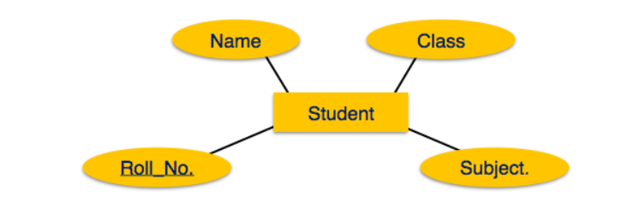
Mapping process:
Create table for each entity, entity’s attributes should become the fields(columns) of the tables with respect to their data types. After that declare the primary key(unique values).

Mapping relationship:
A relationship is an association among entities.
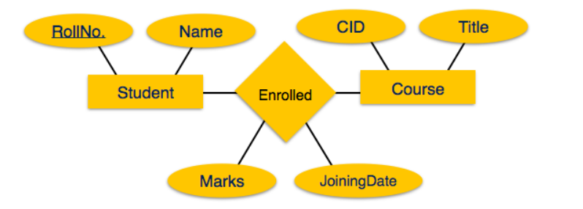
Process of mapping:
  - Create a table for the relationship.

