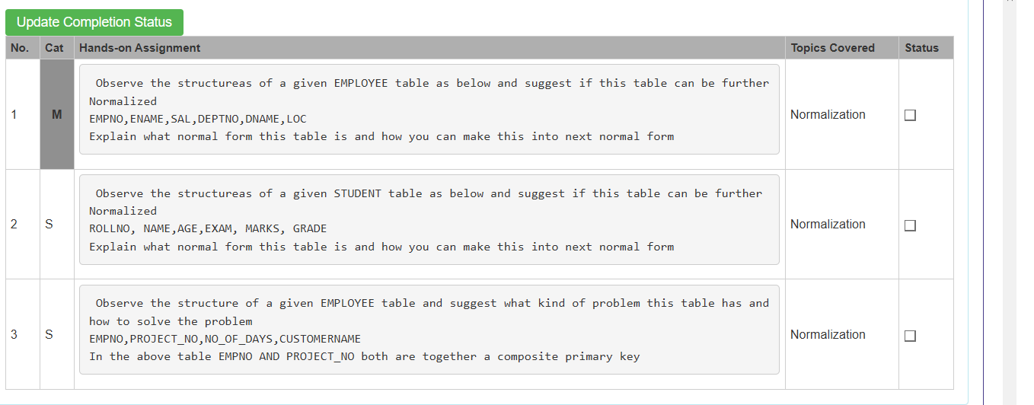

- Given table having the attributes which are :
emp_no, ename,sal,dept_no,dname,loc
step1: identify the primary key
Primary key: empno
Step2: functional dependencies
Empno -> ename,sal,dept_no
Dept_no -> dname, loc
Since dname and loc depends on the dept_no , notdirectly on the emp_no, there is a transitive dependency.

Current Normal Form
- The table is in Second Normal Form (2NF).
- It is not in Third Normal Form (3NF) because of transitive dependency.

First we have to convert into the 3NF:
We have to divide the table into two different table they are employee and department.
In the employee table(emp_no,enmae,sal,dept_no) , primary key is emp_no
In the department table(dept_no,dname,loc), primary key is dept_no

- Student table(roll_no, name,age,exam,marks,grade)
In the student table , the roll number is not only the considerable primary key because one student can write many exams, so in this primary key is (roll_no,exam)
Functional dependencies:
Roll_no -> name, age
(Roll_no , exam) -> marks
Marks->grade
There are partial dependency and transitive dependency.

Current normal form:
The table is only in the 1 Nf.
It is not in 2NF because NAME and AGE depend only on ROLLNO.
It is not in 3NF because GRADE depends on MARKS.

Convert the 1NF to 2Nf
Two tables:
- Student table(roll_no, name,age) , primary key = roll_no
- Student_result(roll_no, exam,marks,grade), primary key = (roll_no, exam)
Partial dependency was removed.

Current Normal Form: 1NF
Problem: Partial Dependency exists because CUSTOMERNAME depends only on PROJECT_NO, which is part of the composite primary key (EMPNO, PROJECT_NO).
Solution: Convert the table into 2NF by decomposing it into:
EMPLOYEE_PROJECT(EMPNO, PROJECT_NO, NO_OF_DAYS)
PROJECT(PROJECT_NO, CUSTOMERNAME)
This removes the partial dependency, eliminates redundancy, and avoids insertion, update, and deletion anomalies.

