Chandini t r
1nt20is403
EXPLICIT INTENT

1.Create an Android application to demonstrate the working of Explicit Intent

activity_main.xml

<?xml version="1.0" encoding="utf-8"?>
<LinearLayout xmlns:android="http://schemas.android.com/apk/res/android"
xmlns:app="http://schemas.android.com/apk/res-auto"
xmlns:tools="http://schemas.android.com/tools"
android:layout_width="match_parent"
android:layout_height="match_parent"
tools:context=".MainActivity"
android:orientation="vertical">
<EditText
android:id="@+id/Name"
android:layout_width="match_parent"
android:layout_height="wrap_content"
android:hint="chandini"
app:layout_constraintBottom_toBottomOf="parent"
app:layout_constraintTop_toTopOf="parent"
app:layout_constraintVertical_bias="0.209"
tools:layout_editor_absoluteX="20dp" />
<Button
android:id="@+id/click"
android:layout_width="match_parent"
android:layout_height="wrap_content"
android:layout_margin="20dp"
android:text="CLICK"
app:layout_constraintBottom_toBottomOf="parent"
app:layout_constraintTop_toBottomOf="@+id/Name"
app:layout_constraintVertical_bias="0.307"
tools:layout_editor_absoluteX="0dp" />
</LinearLayout>

activity_secondactivity.xml

<?xml version="1.0" encoding="utf-8"?>
<LinearLayout xmlns:android="http://schemas.android.com/apk/res/android"
xmlns:app="http://schemas.android.com/apk/res-auto"
xmlns:tools="http://schemas.android.com/tools"
android:layout_width="match_parent"
android:layout_height="match_parent"
tools:context=".secondactivity"
android:orientation="vertical">
<TextView
android:id="@+id/mytext"
android:layout_width="match_parent"
android:layout_height="wrap_content"
android:text="NAMES COMES HERE"
android:textSize="50dp"
android:textAlignment="center"/>
</LinearLayout>

mainactivity.java

package com.example.chandiniint;
import androidx.appcompat.app.AppCompatActivity;
import android.content.Intent;
import android.os.Bundle;
import android.view.View;
import android.widget.Button;
import android.widget.EditText;
public class MainActivity extends AppCompatActivity {
EditText name;
Button click;
@Override
protected void onCreate(Bundle savedInstanceState) {
super.onCreate(savedInstanceState);
setContentView(R.layout.activity_main);
name=findViewById(R.id.Name);
click=findViewById(R.id.click);
click.setOnClickListener(new View.OnClickListener() {
@Override
public void onClick(View view) {
Intent it=new Intent(MainActivity.this,secondactivity.class);
Bundle b=new Bundle();
b.putString("name",name.getText().toString());
it.putExtras(b);
startActivity(it);
}
});
}
}

secondactivity.java

package com.example.chandiniint;
import androidx.appcompat.app.AppCompatActivity;
import android.os.Bundle;
import android.widget.TextView;
public class secondactivity extends AppCompatActivity {
TextView mytext;
String nameMainactivity=" ";
@Override
protected void onCreate(Bundle savedInstanceState) {
super.onCreate(savedInstanceState);
setContentView(R.layout.activity_secondactivity);
mytext=findViewById(R.id.mytext);
nameMainactivity=getIntent().getStringExtra("name");
mytext.setText(nameMainactivity);
}
}

OUTPUT:

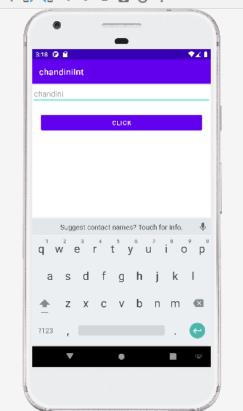

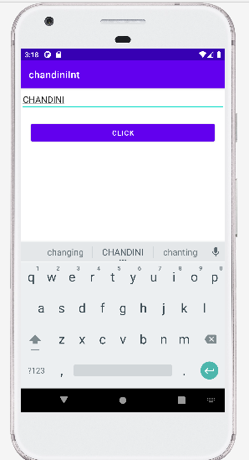

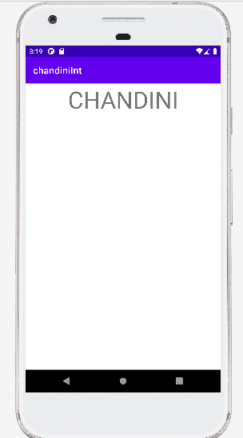

2.Create an Android application to demonstrate the working of Implicit Intent

main_activity.xml

<?xml version="1.0" encoding="utf-8"?>
<LinearLayout xmlns:android="http://schemas.android.com/apk/res/android"
xmlns:app="http://schemas.android.com/apk/res-auto"
xmlns:tools="http://schemas.android.com/tools"
android:layout_width="match_parent"
android:layout_height="match_parent"
tools:context=".MainActivity"
android:orientation="vertical">
<EditText
android:id="@+id/myphone"
android:layout_width="match_parent"
android:layout_height="wrap_content"
android:hint="enter phone number"
app:layout_constraintBottom_toBottomOf="parent"
app:layout_constraintTop_toTopOf="parent"
app:layout_constraintVertical_bias="0.209"
tools:layout_editor_absoluteX="20dp" />
<Button
android:id="@+id/call"
android:layout_width="match_parent"
android:layout_height="wrap_content"
android:layout_margin="20dp"
android:text="CALL"
app:layout_constraintBottom_toBottomOf="parent"
app:layout_constraintTop_toBottomOf="@+id/Name"
app:layout_constraintVertical_bias="0.307"
tools:layout_editor_absoluteX="0dp" />
</LinearLayout>

mainactivity.java

package com.example.chandiniint;
import androidx.appcompat.app.AppCompatActivity;
import android.content.Intent;
import android.os.Bundle;
import android.view.View;
import android.widget.Button;
import android.widget.EditText;
public class MainActivity extends AppCompatActivity {
EditText phone;
Button call;
@Override
protected void onCreate(Bundle savedInstanceState) {
super.onCreate(savedInstanceState);
setContentView(R.layout.activity_main);
phone=findViewById(R.id.Name);
call=findViewById(R.id.call);
call.setOnClickListener(new View.OnClickListener() {
@Override
public void onClick(View view) {
Intent it=new Intent(MainActivity.this,secondactivity.class);
Bundle b=new Bundle();
b.putString("phone",phone.getText().toString());
it.putExtras(b);
startActivity(it);
}
});
}
}

OUTPUT
