CHANDINI T R
1NT20IS403

FLUTTER BASICS

Main.dart

import 'package:flutter/material.dart';
void main() {
runApp( MaterialApp(
home:Scaffold(
appBar: AppBar(
title: Text("Fiirst Flutter App"),
),
body : Center(
child:Text(
'This is a first App',
style:TextStyle(
fontSize:40.0,
fontStyle:FontStyle.italic,
fontWeight:FontWeight.bold,
),
),
),
),
),
);
}
Widgets_test.darts

import 'package:flutter/material.dart';
import 'package:flutter_test/flutter_test.dart';
import 'package:chandini/main.dart';
void main() {
testWidgets('Counter increments smoke test', (WidgetTester tester) async {
// Build our app and trigger a frame.
await tester.pumpWidget( MaterialApp());
// Verify that our counter starts at 0.
expect(find.text('0'), findsOneWidget);
expect(find.text('1'), findsNothing);
// Tap the '+' icon and trigger a frame.
await tester.tap(find.byIcon(Icons.add));
await tester.pump();
// Verify that our counter has incremented.
expect(find.text('0'), findsNothing);
expect(find.text('1'), findsOneWidget);
});
}
OUTPUT

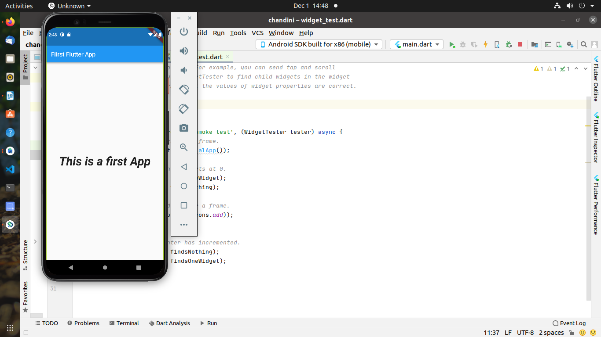

OUTPUT
