Dicision Tree
import pandas as pd
import numpy as np
import matplotlib.pyplot as plt

df= pd.read_csv("/home/ignis/zoo11.csv")
df.head()

class_type_output = df["class_type"]
df = df.drop("class_type", axis=1).drop("animal_name",axis=1)
print(df)
from sklearn.model_selection import train_test_split
x_train, x_test, y_train, y_test = train_test_split(df, class_type_output, test_size=0.20)

from sklearn.tree import DecisionTreeClassifier
classifier = DecisionTreeClassifier()
classifier.fit(x_train, y_train)

y_prediction = classifier.predict(x_test)
y_prediction

from sklearn.metrics import classification_report, confusion_matrix, accuracy_score
confusion_matrix(y_test,y_prediction)

print(classification_report(y_test, y_prediction))

print(accuracy_score(y_test, y_prediction))

predicted_class = list(y_prediction)
actual_class = list(y_test)
for i in range(len(predicted_class)):
print("Predicted class =", predicted_class[i],"\tActual class =",actual_class[i])

OUTPUT

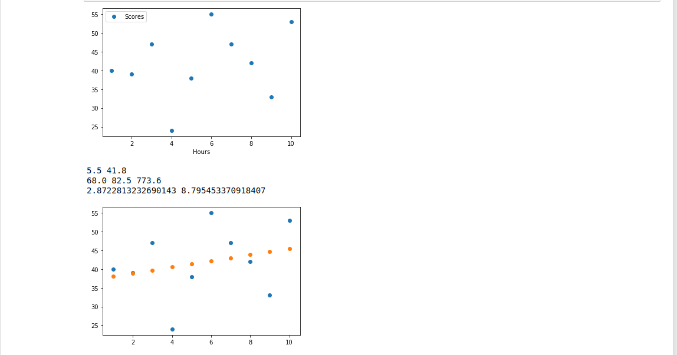

Regression

import pandas as pd
import matplotlib.pyplot as plt

df = pd.read_csv("/home/ignis/Desktop/Scores2.csv")
df

df.plot(x="Hours", y="Scores", style="o")
plt.show()

x_mean = df["Hours"].mean()
y_mean = df["Scores"].mean()
print(x_mean, y_mean)

df["x"] = df["Hours"] - x_mean
df["y"] = df["Scores"] - y_mean
df["x*y"] = df["x"] * df["y"]
df["x^2"] = df["x"]**2
df["y^2"] = df["y"]**2
df

summation_x_y = df["x*y"].sum()
summation_x_squared = df["x^2"].sum()
summation_y_squared = df["y^2"].sum()
print(summation_x_y, summation_x_squared, summation_y_squared)

correlation = summation_x_y / (summation_x_squared * summation_y_squared)**0.5
correlation

def getMean(numbers):
if len(numbers) == 0:
return None
else:
current_sum = 0
for i in numbers:
current_sum += i
current_avg = current_sum/len(numbers)
return current_avg

def getStandardDeviation(numbers):
if len(numbers) == 0:
return 0
else:
mean = getMean(numbers)
std_deviation = 0
for i in numbers:
std_deviation += (i - mean)**2
return (std_deviation/len(numbers))**0.5

std_deviation_x = getStandardDeviation(df["x"].tolist())
std_deviation_y = getStandardDeviation(df["y"].tolist())
print(std_deviation_x, std_deviation_y)

m = correlation * (std_deviation_y / std_deviation_x)
m

c = df["Scores"].mean() - m * df["Hours"].mean()
c

df["y_prediction"] = m * df["Hours"] + c
df

plot1 = plt.scatter(df["Hours"], df["Scores"])
plot2 = plt.scatter(df["Hours"], df["y_prediction"])
plt.show()

df["error"]=df["y"]-df["y_prediction"]
df
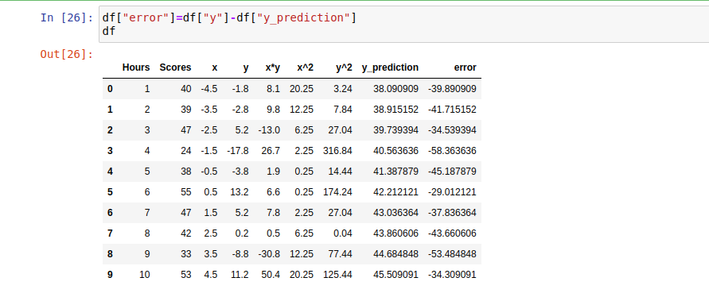

df["sse"]=df["error"]*df["error"]
df
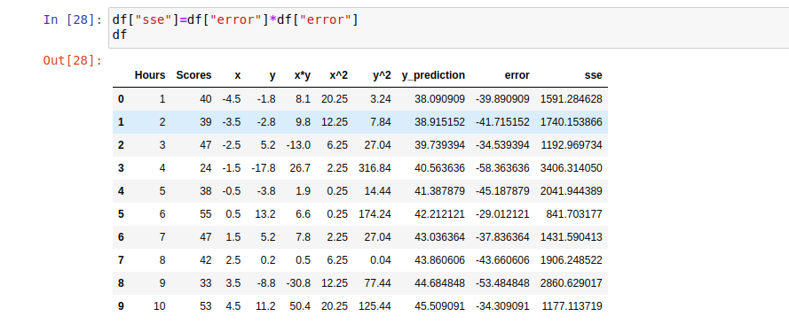

df["sst1"]=df["y"]-y_mean
df
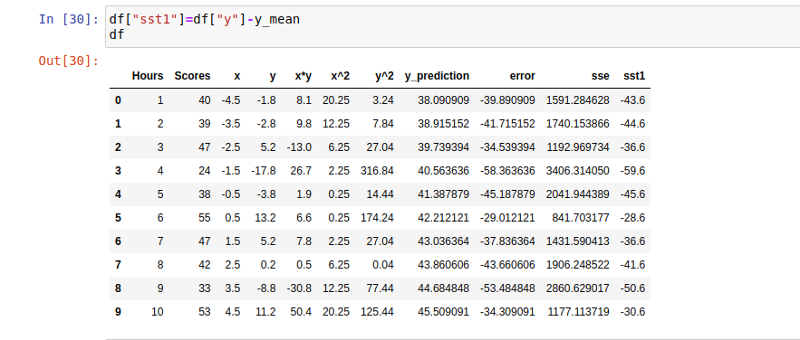

df["SST"]=df["sst1"]*df["sst1"]
df

df["yprediction"]=df["y_prediction"].mean()
df
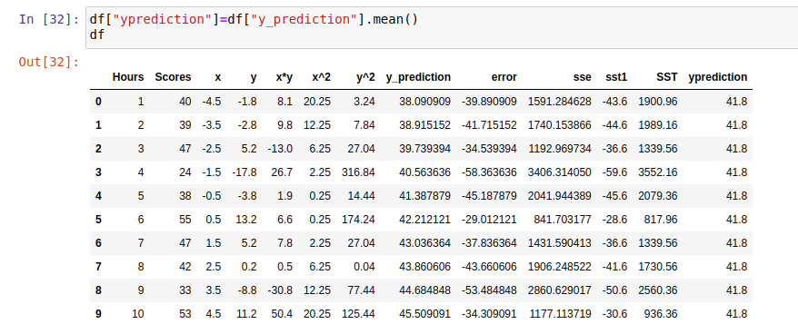

df["ypredycsquare"]=df["y_prediction"]*df["y_prediction"]
df

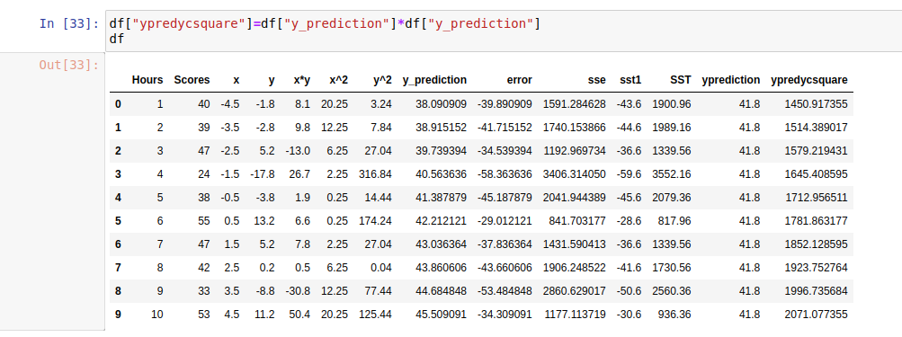

df["ssr"]=df["y_prediction"]-df["ypredycsquare"]
df
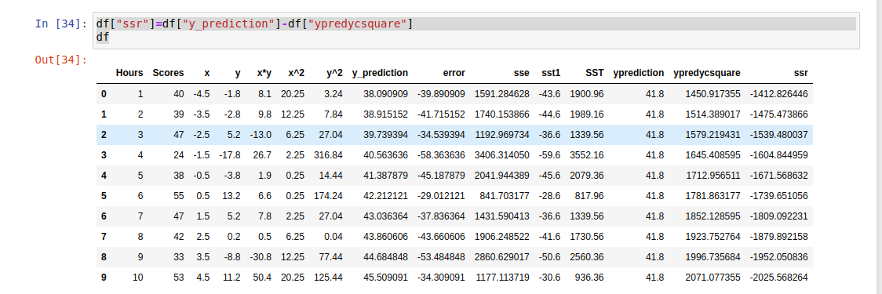

df["SSR"]=df["ssr"]*df["ssr"]
df

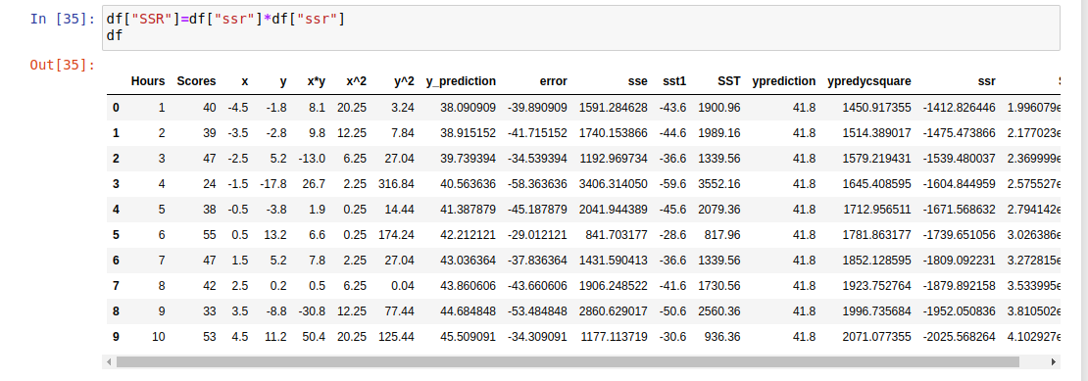

df["R^2"]=df["SSR"]/df["SST"]
df
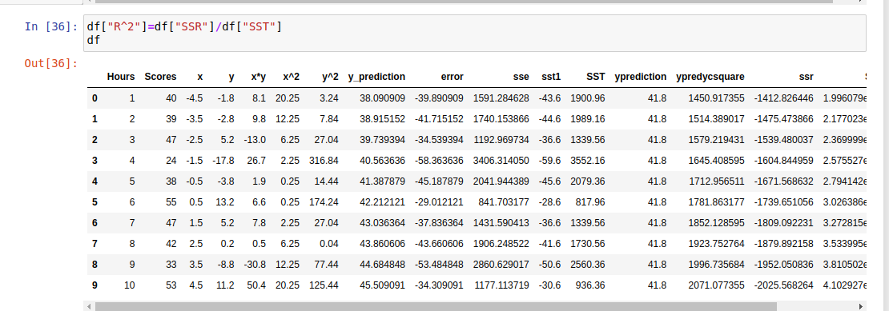

df["sum ssr"]=df["SSR"].sum()
df

