**Chandini T R**

**1NT20IS403**

**C3 BATCH**

**PIPELINE AGGREGATE FUNCTIONS**

db.chandini.aggregate([{$match:{name:"keerthi"}},{$group:{_id:"$name",count:{$count:{}}}},{$sort:{count:1}},{$limit:1}])

{ "_id" : "keerthi", "count" : 1 }

> db.chandini.aggregate([{$group:{_id:"$name",count:{$count:{}}}},{$sort:{count:1}},{$limit:1}])

{ "_id" : "chetan", "count" : 1 }

> db.chandini.aggregate([{$group:{_id:"$name",count:{$count:{}}}},{$sort:{count:1}},{$limit:4}])

{ "_id" : "keerthi", "count" : 1 }

{ "_id" : "chandini", "count" : 1 }

{ "_id" : "chetan", "count" : 1 }

{ "_id" : "testing", "count" : 1 }

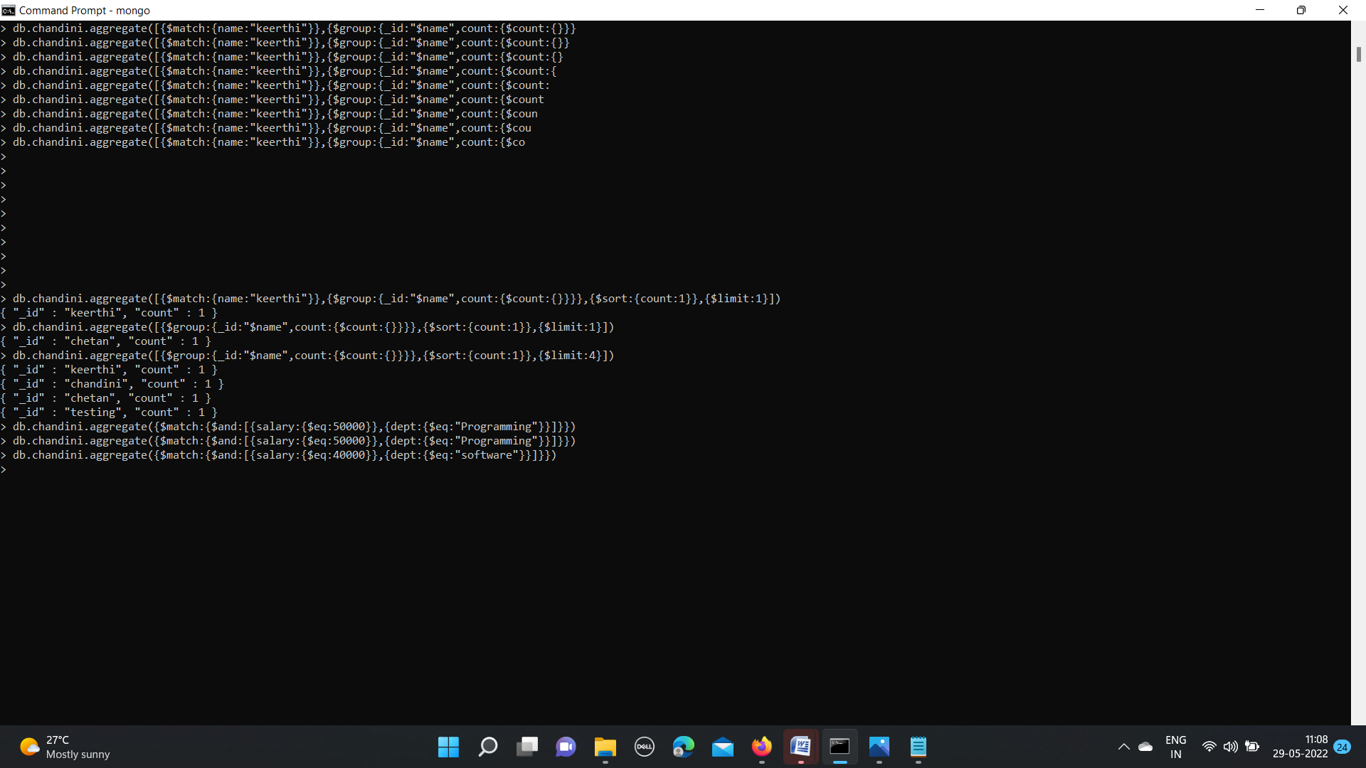

**$MATCH :**

db.chandini.aggregate({$match:{$and:[{salary:{$eq:50000}},{dept:{$eq:"Programming"}}]}})

{ "_id" : ObjectId("62925adc5224f5271c396dab"), "name" : "keerthi", "id" : 104, "dept" : "Programming", "salary" : 40000 }

{ "_id" : ObjectId("629264bd5224f5271c396db0"), "name" : "keerthi", "id" : 104, "dept" : "Programming", "salary" : 40000 }

