**NAME:CHANDINI T R**

**1NT20IS403**

**Sec:c**

**CREATE DATABSE**

**USE Chandini1NT20IS403**

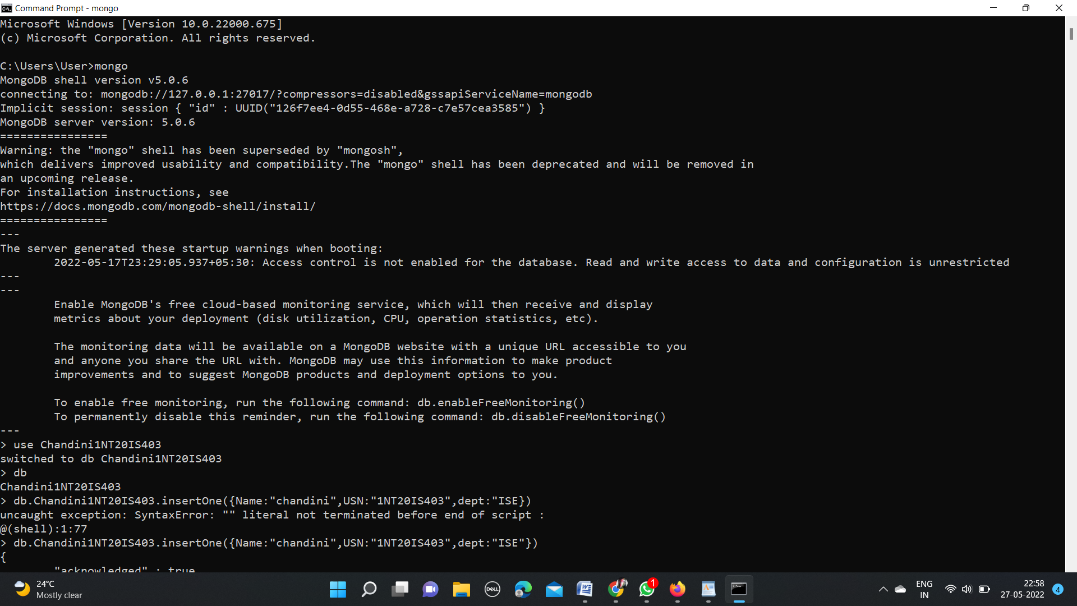

**SHOW dbs**

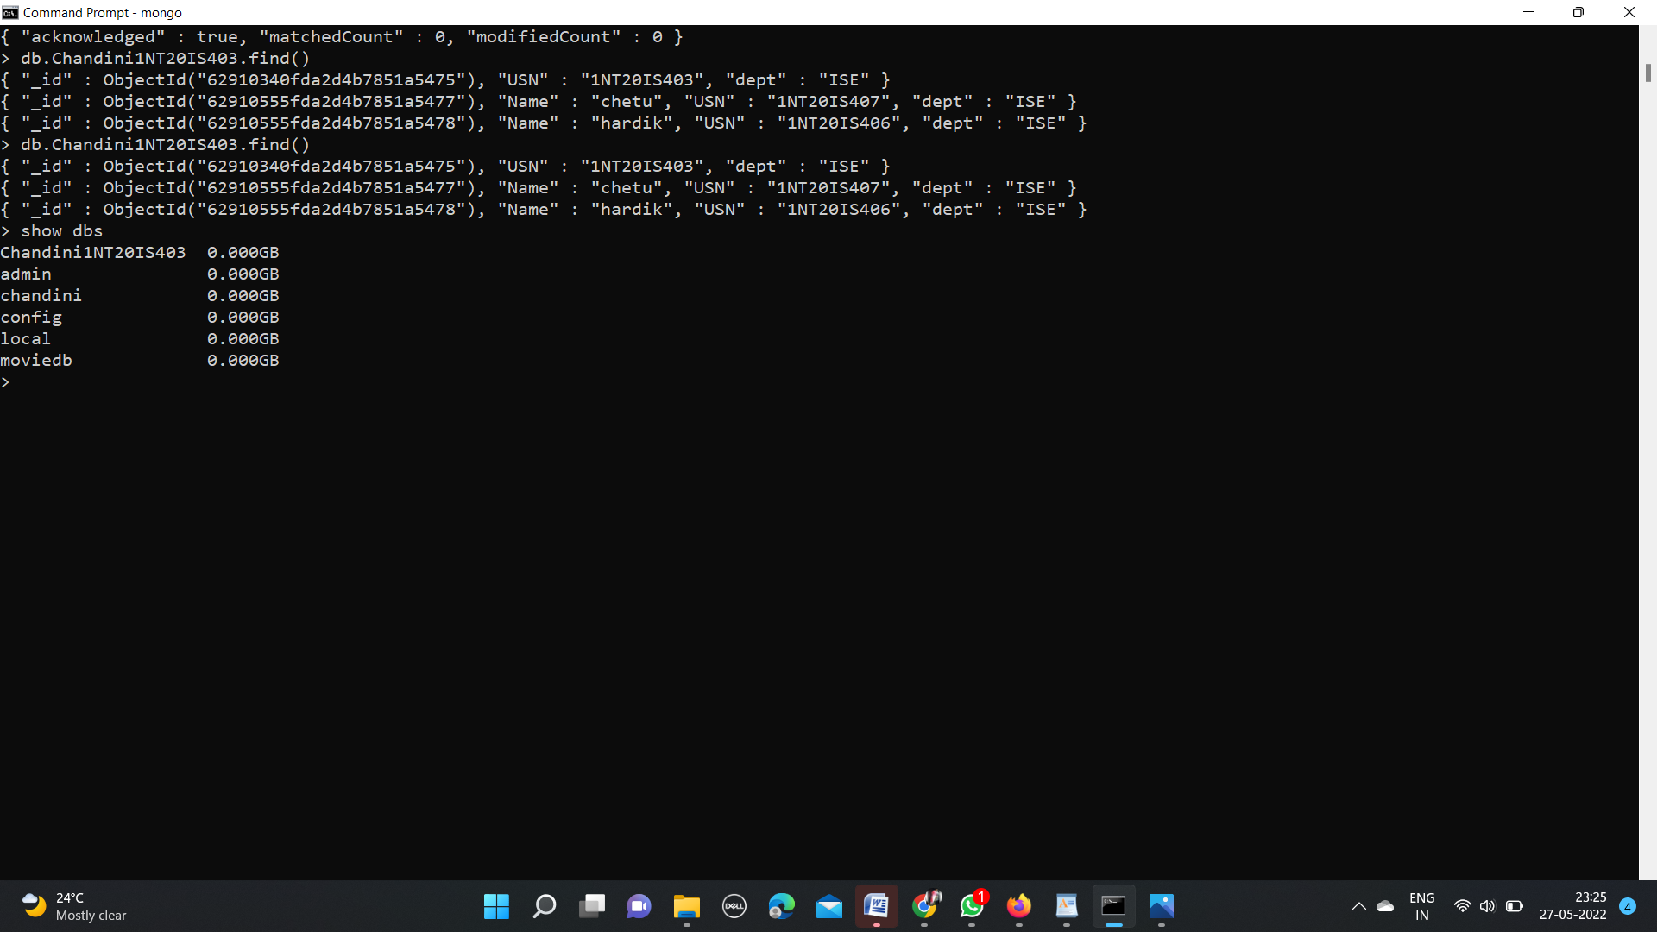



**INSERTONE and INSERT MANY COMMAND:**

db.Chandini1NT20IS403.insertOne({Name:"chandini",USN:"1NT20IS403",dept:"ISE"})

{

"acknowledged" : true,

"insertedId" : ObjectId("62910340fda2d4b7851a5475")

}

db.Chandini1NT20IS403.insertMany([{Name:"chandu",USN:"1NT20IS405",dept:"ISE"},

{Name:"chetu",USN:"1NT20IS407",dept:"ISE"},{Name:"navi",USN:"1NT20IS406",dept:"ISE"}])

{

"acknowledged" : true,

"insertedIds" : [

ObjectId("62910555fda2d4b7851a5476"),

ObjectId("62910555fda2d4b7851a5477"),

ObjectId("62910555fda2d4b7851a5478")

]

}

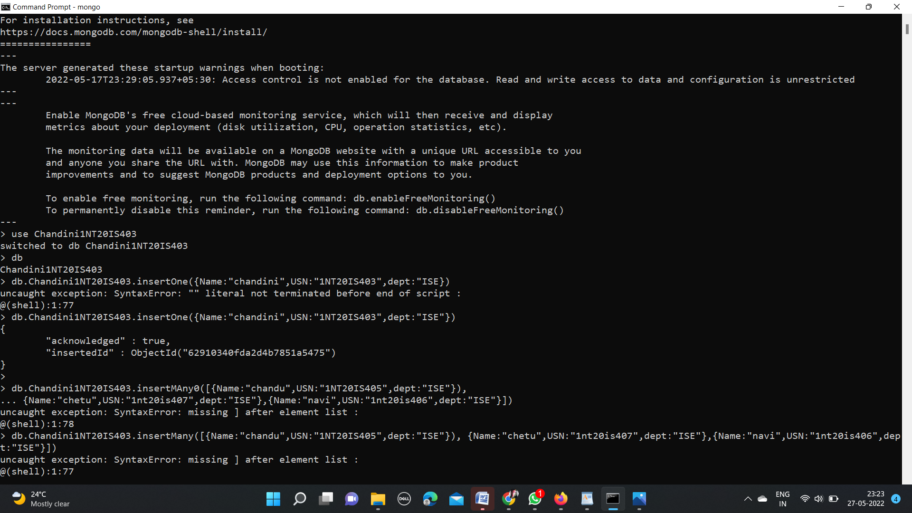

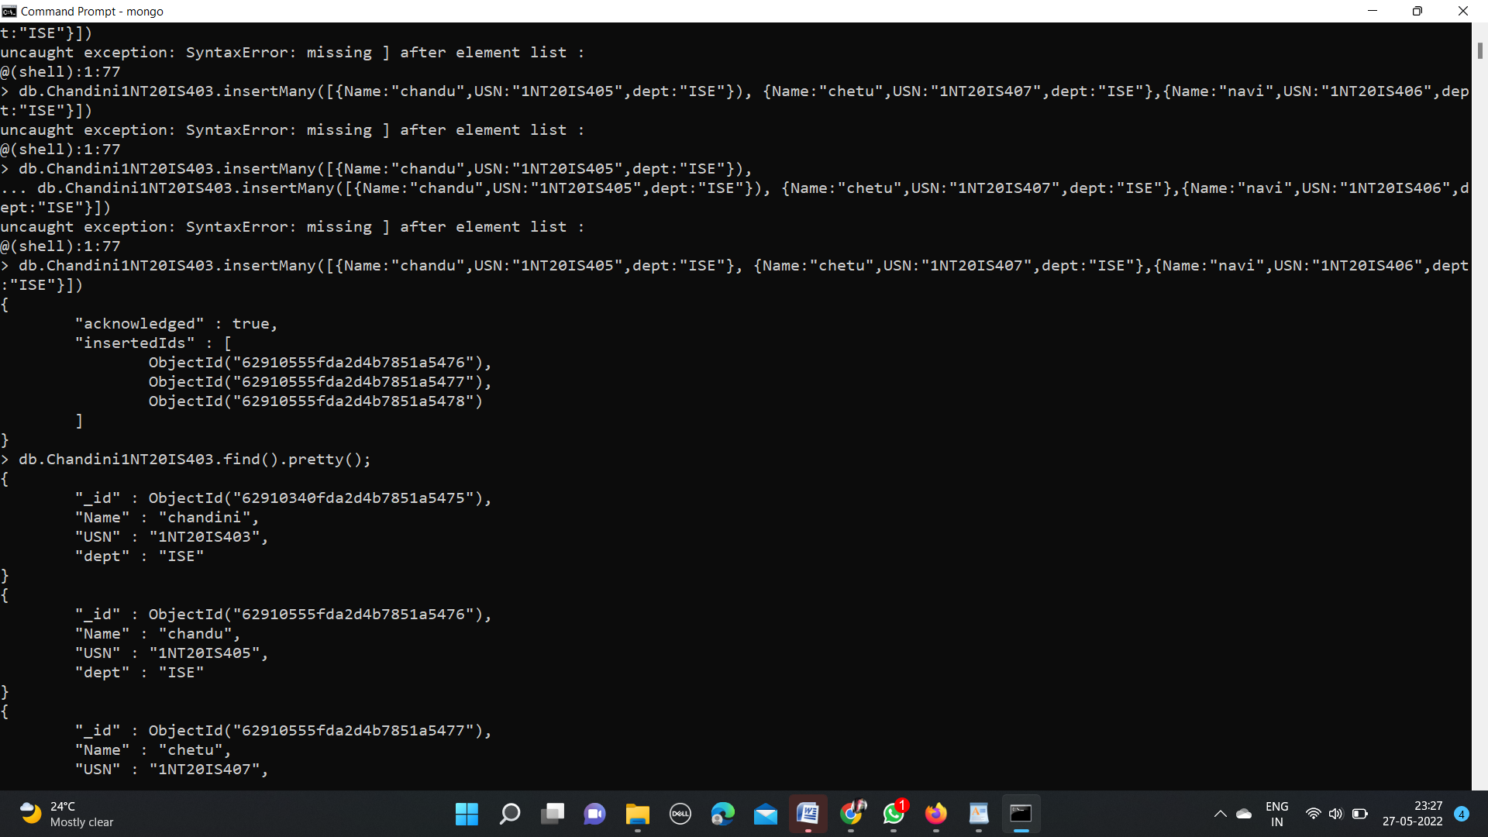

**output of insertOne and insertMany:**

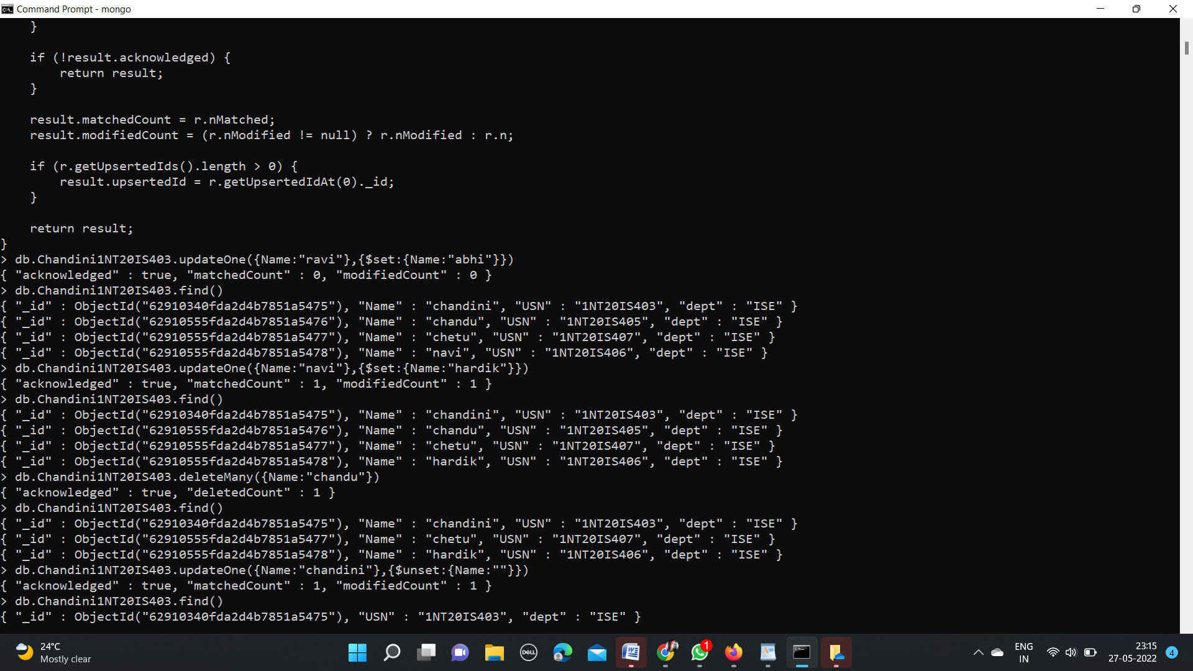

**using pretty command:**

> db.Chandini1NT20IS403.find().pretty();

{

"_id" : ObjectId("62910340fda2d4b7851a5475"),

"Name" : "chandini",

"USN" : "1NT20IS403",

"dept" : "ISE"

}

{

"_id" : ObjectId("62910555fda2d4b7851a5476"),

"Name" : "chandu",

"USN" : "1NT20IS405",

"dept" : "ISE"

}

{

"_id" : ObjectId("62910555fda2d4b7851a5477"),

"Name" : "chetu",

"USN" : "1NT20IS407",

"dept" : "ISE"

}

{

"_id" : ObjectId("62910555fda2d4b7851a5478"),

"Name" : "navi",

"USN" : "1NT20IS406",

"dept" : "ISE"

}

**output using pretty command:**

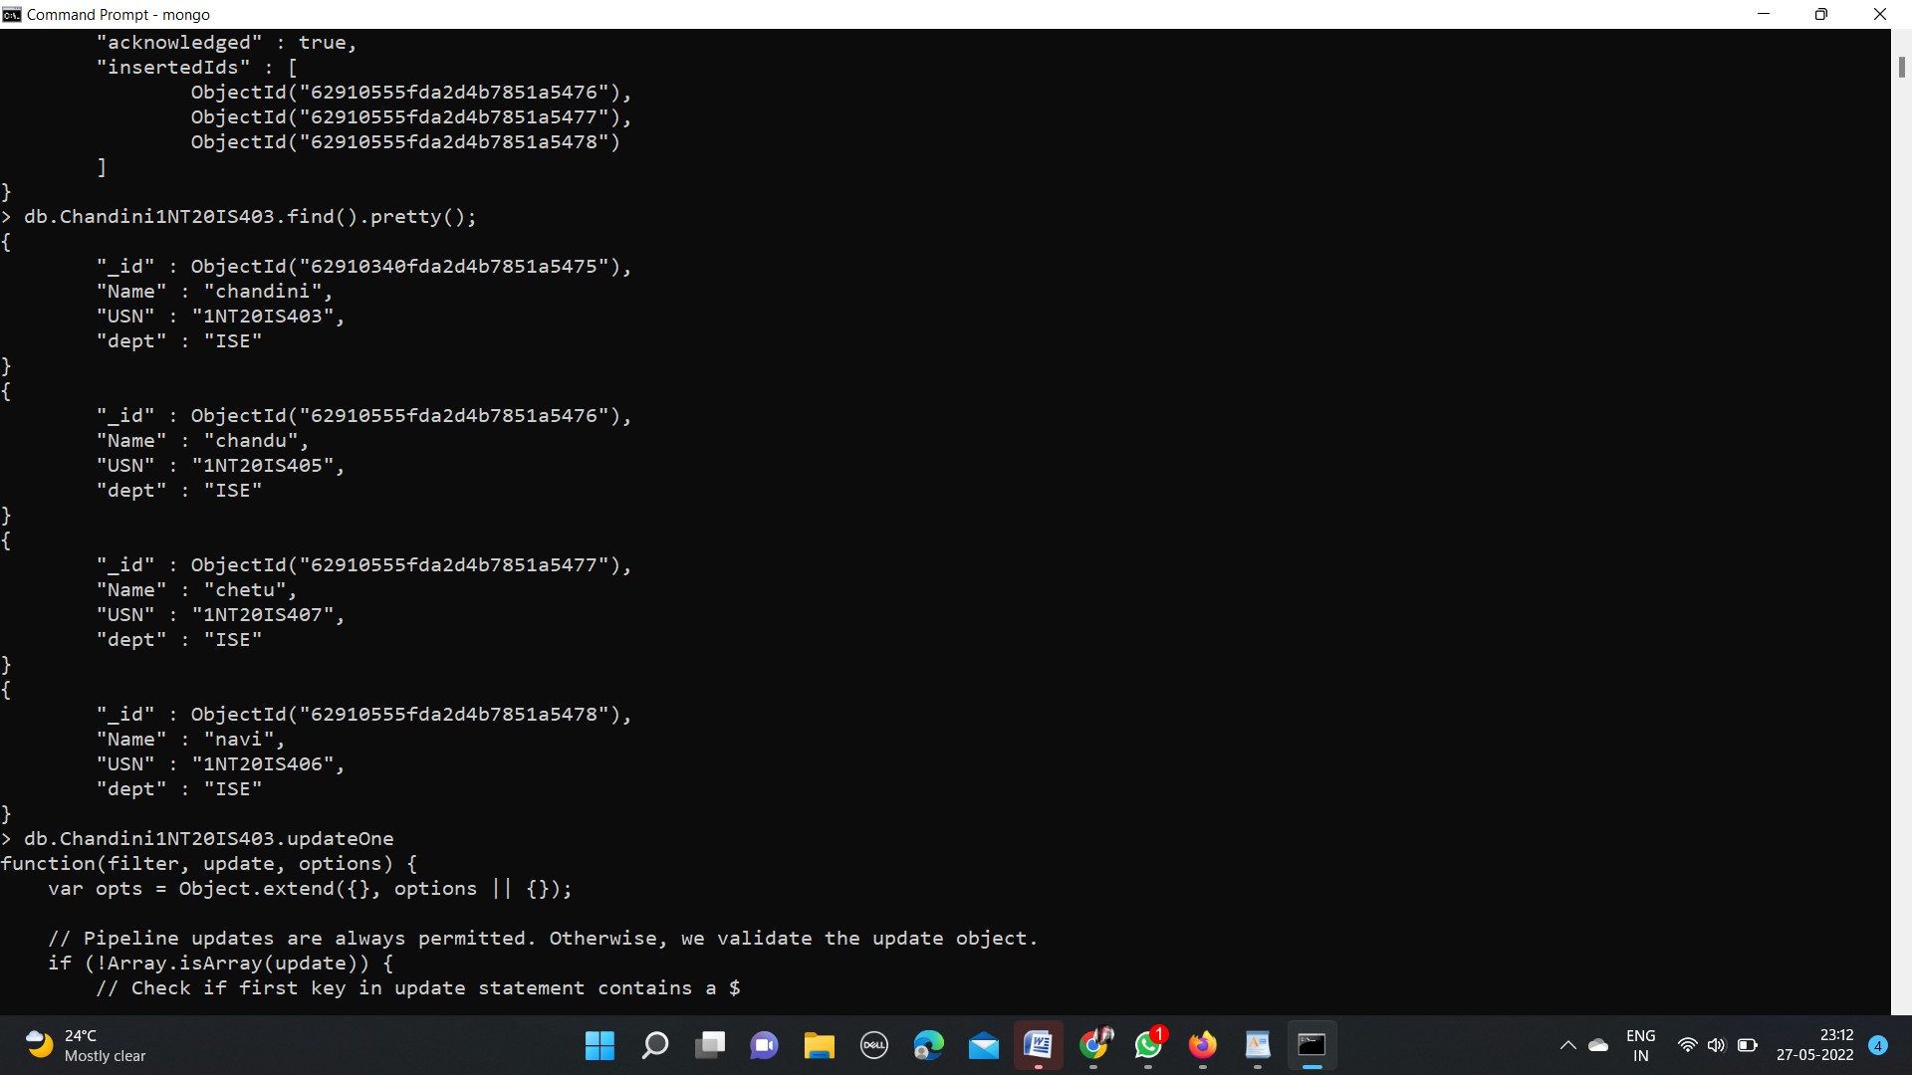

**update one and update many command:**

> db.Chandini1NT20IS403.updateOne({Name:"navi"},{$set:{Name:"hardik"}})

{ "acknowledged" : true, "matchedCount" : 0, "modifiedCount" : 0 }

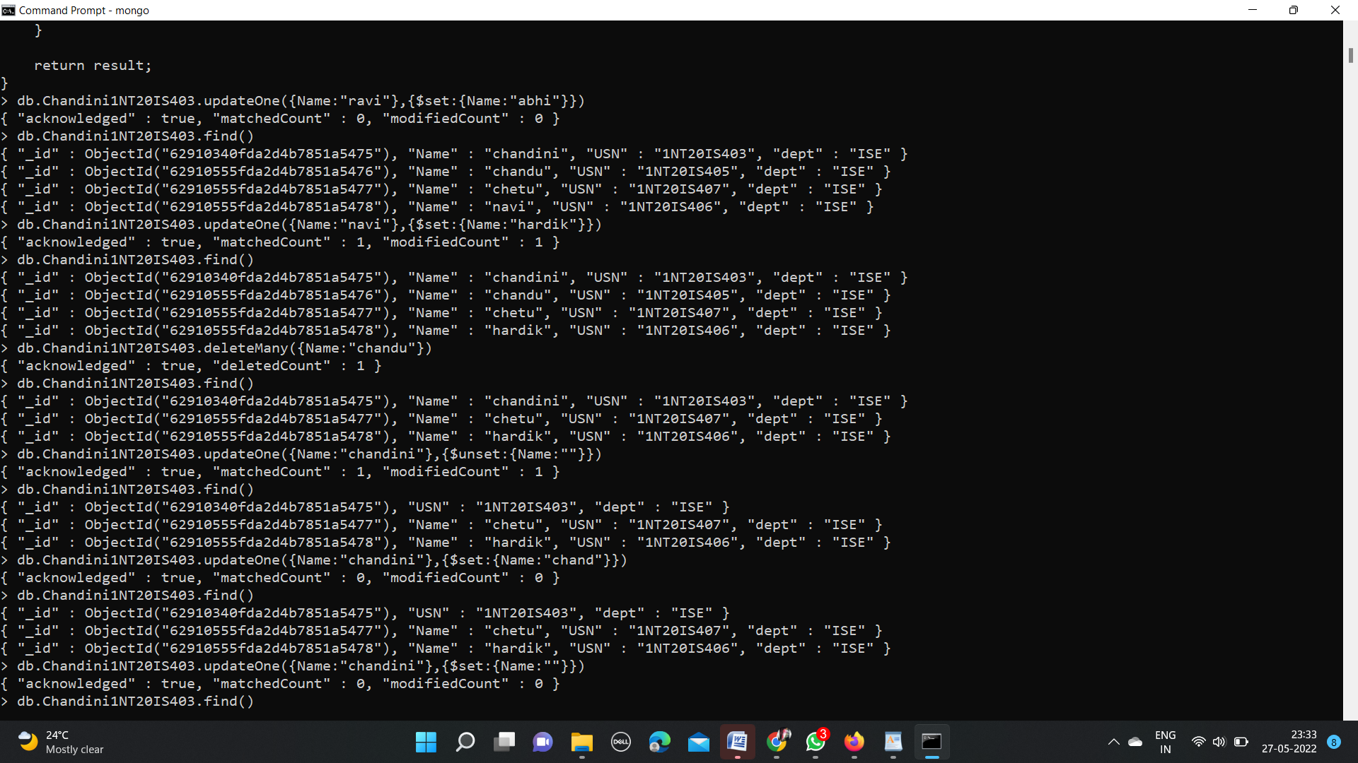

**Delete command:**

> db.Chandini1NT20IS403.deleteMany({Name:"chandu"})

{ "acknowledged" : true, "deletedCount" : 1 }



**Output for update and delete command:**

> db.Chandini1NT20IS403.find()

{ "_id" : ObjectId("62910340fda2d4b7851a5475"), "USN" : "1NT20IS403", "dept" : "ISE" }

{ "_id" : ObjectId("62910555fda2d4b7851a5477"), "Name" : "chetu", "USN" : "1NT20IS407", "dept" : "ISE" }

{ "_id" : ObjectId("62910555fda2d4b7851a5478"), "Name" : "hardik", "USN" : "1NT20IS406", "dept" : "ISE" }



**set function in update:**

> db.Chandini1NT20IS403.updateOne({Name:"navi"},{$set:{Name:"hardik"}})

{ "acknowledged" : true, "matchedCount" : 1, "modifiedCount" : 1 }



**unset function in update:**

> db.Chandini1NT20IS403.updateOne({Name:"chandini"},{$unset:{Name:""}})

{ "acknowledged" : true, "matchedCount" : 1, "modifiedCount" : 1 }



**Output for set and unset function:**



**And command:**

db.Chandini1NT20IS403.find({$and:[{"Name":"chetu"},{"dept":"ISE"}]})

{ "_id" : ObjectId("62910555fda2d4b7851a5477"), "Name" : "chetu", "USN" : "1NT20IS407", "dept" : "ISE" }

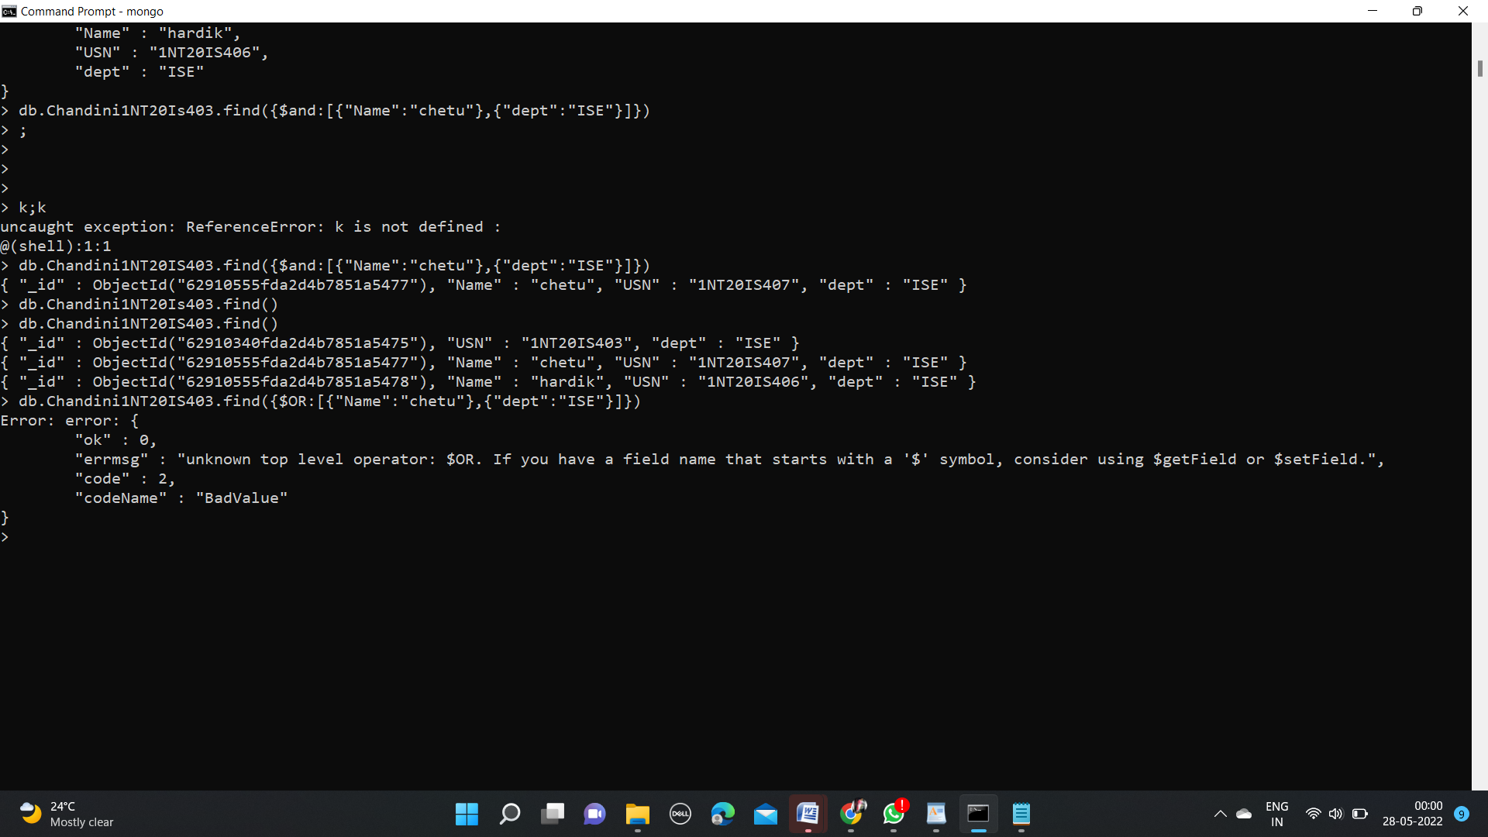

**OR command**:

> db.Chandini1NT20IS403.find({$or:[{"Name":"hardik"},{"dept":"ISE"}]})

{ "_id" : ObjectId("62910340fda2d4b7851a5475"), "USN" : "1NT20IS403", "dept" : "ISE" }

{ "_id" : ObjectId("62910555fda2d4b7851a5477"), "Name" : "chetu", "USN" : "1NT20IS407", "dept" : "ISE" }

{ "_id" : ObjectId("62910555fda2d4b7851a5478"), "Name" : "hardik", "USN" : "1NT20IS406", "dept" : "ISE" }

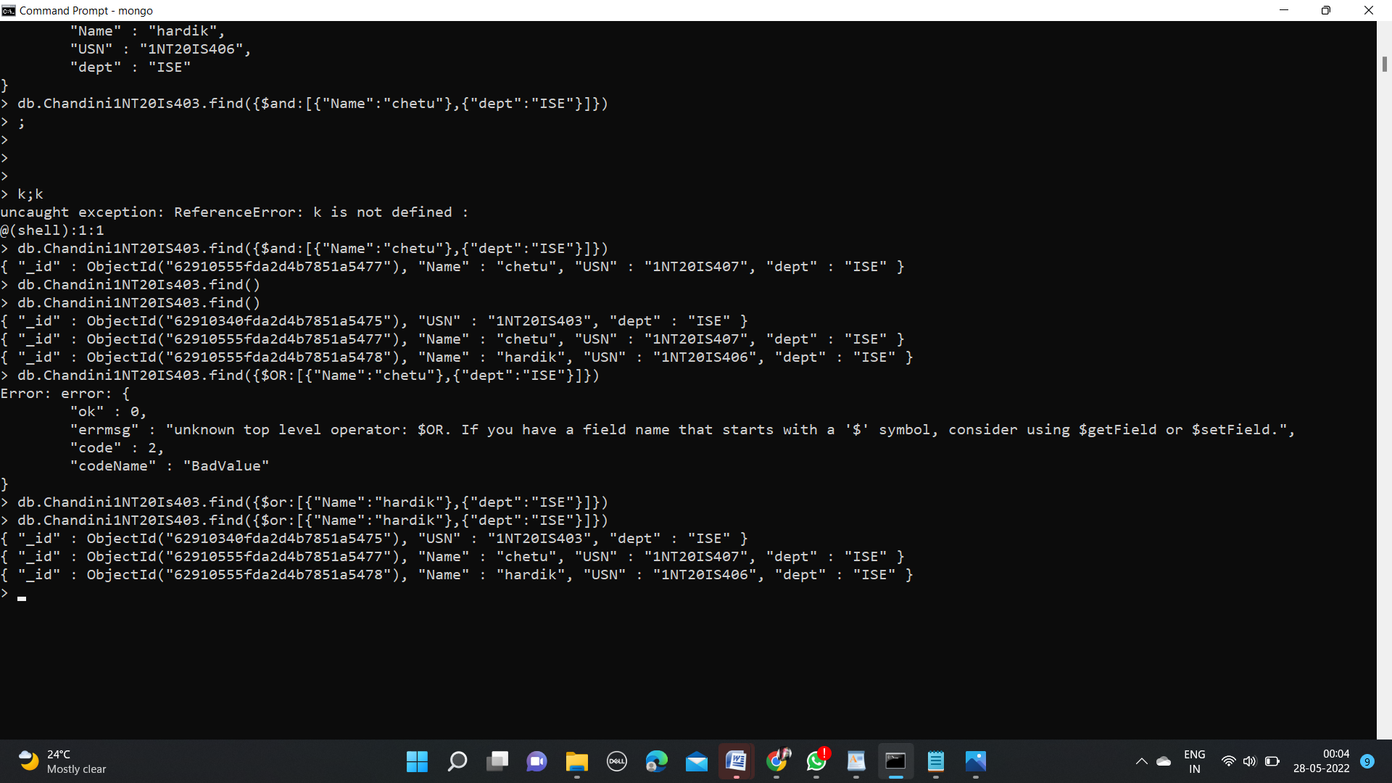

**Aggregate function:**

> db.Chandini1NT20IS403.insertMany( [

... { _id: 0, name: "Pepperoni", size: "small", price: 19,

... quantity: 10, date: ISODate( "2021-03-13T08:14:30Z" ) },

... { _id: 1, name: "Pepperoni", size: "medium", price: 20,

... quantity: 20, date : ISODate( "2021-03-13T09:13:24Z" ) },

... { _id: 2, name: "Pepperoni", size: "large", price: 21,

... quantity: 30, date : ISODate( "2021-03-17T09:22:12Z" ) },

... { _id: 3, name: "Cheese", size: "small", price: 12,

... quantity: 15, date : ISODate( "2021-03-13T11:21:39.736Z" ) },

... { _id: 4, name: "Cheese", size: "medium", price: 13,

... quantity:50, date : ISODate( "2022-01-12T21:23:13.331Z" ) },

... { _id: 5, name: "Cheese", size: "large", price: 14,

... quantity: 10, date : ISODate( "2022-01-12T05:08:13Z" ) },

... { _id: 6, name: "Vegan", size: "small", price: 17,

... quantity: 10, date : ISODate( "2021-01-13T05:08:13Z" ) },

... { _id: 7, name: "Vegan", size: "medium", price: 18,

... quantity: 10, date : ISODate( "2021-01-13T05:10:13Z" ) }

... ] )

{

"acknowledged" : true,

"insertedIds" : [

0,

1,

2,

3,

4,

5,

6,

7

]

}

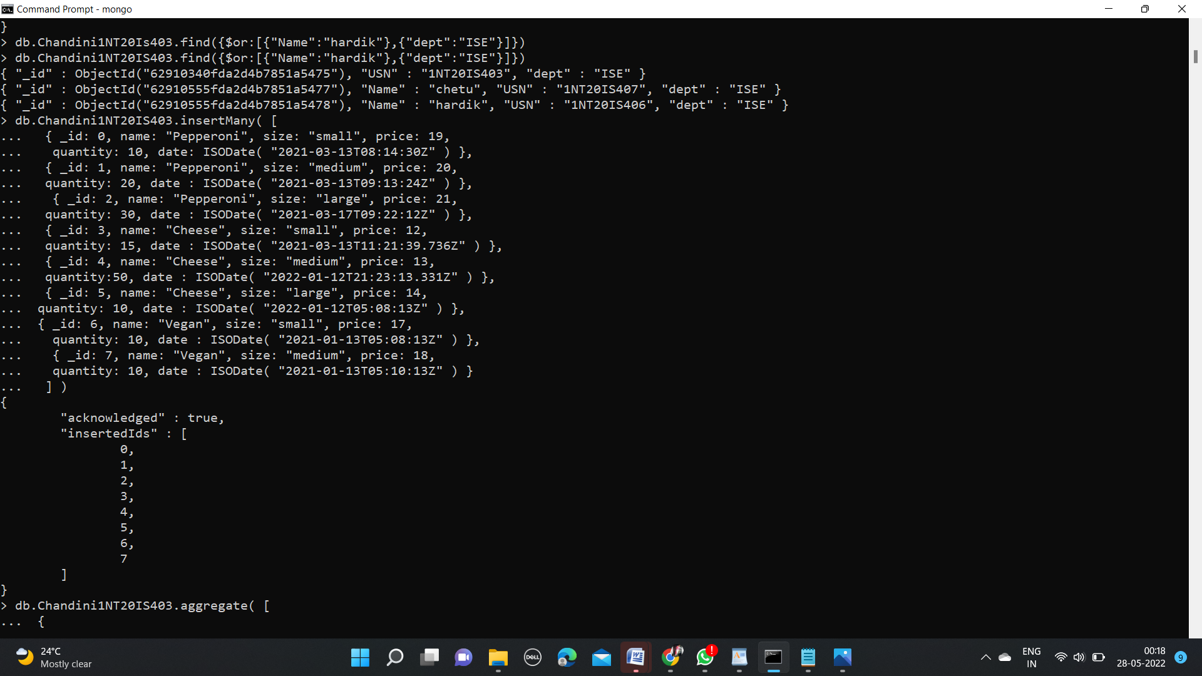

**OUTPUT:**

> db.Chandini1NT20IS403.aggregate( [

... {

... $match: { size: "medium" }

... },

... {

... $group: { _id: "$name", totalQuantity: { $sum: "$quantity" } }

... }

... ] )

{ "_id" : "Pepperoni", "totalQuantity" : 20 }

{ "_id" : "Cheese", "totalQuantity" : 50 }

{ "_id" : "Vegan", "totalQuantity" : 10 }

>

