Chandini T R

1NT20IS403

C3 BATCH

**INSERT ONE:**

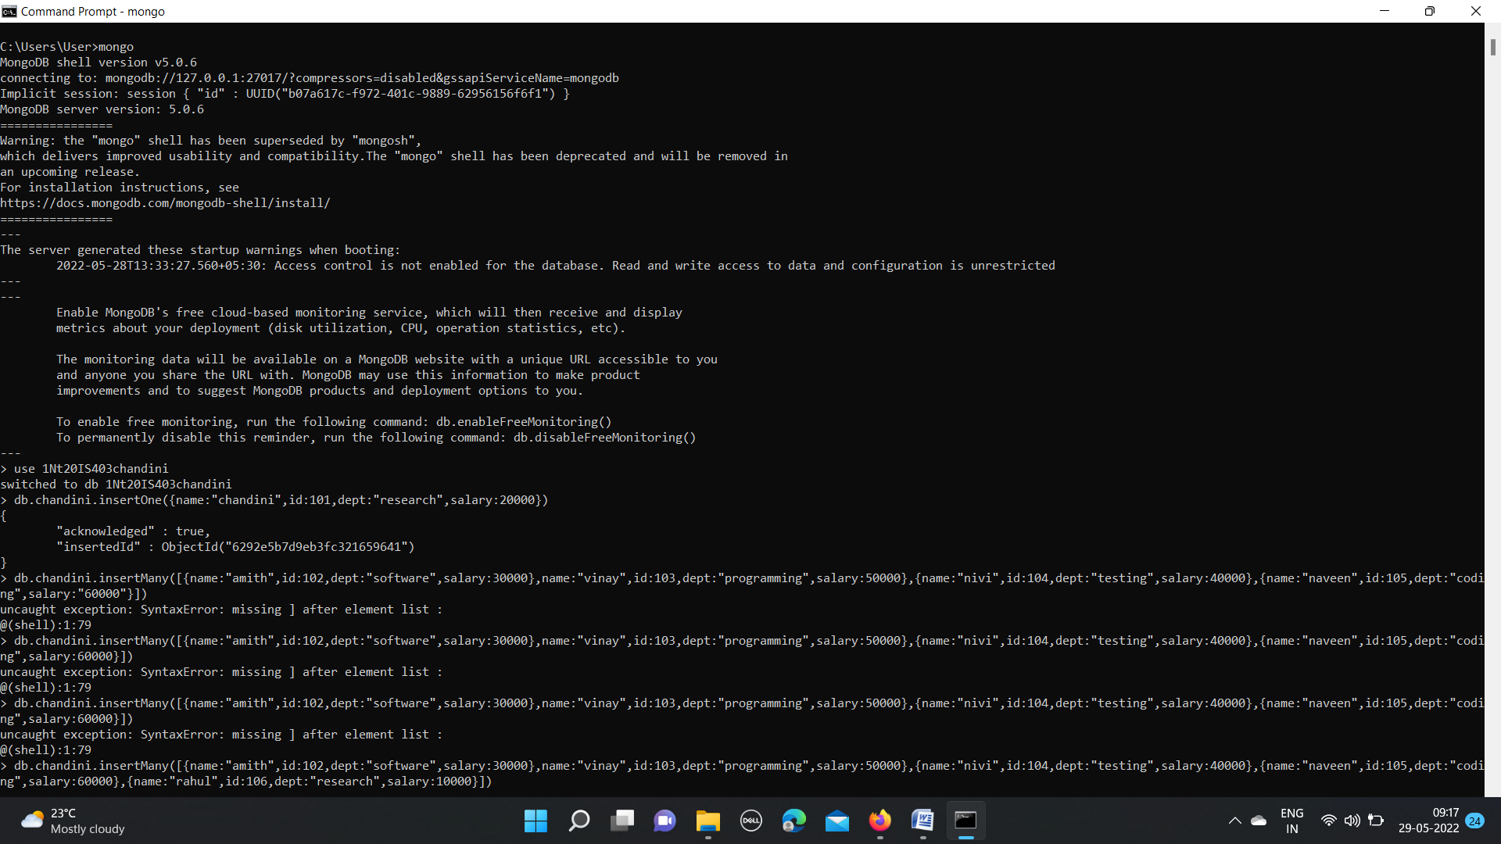

**INSERT MANY:**

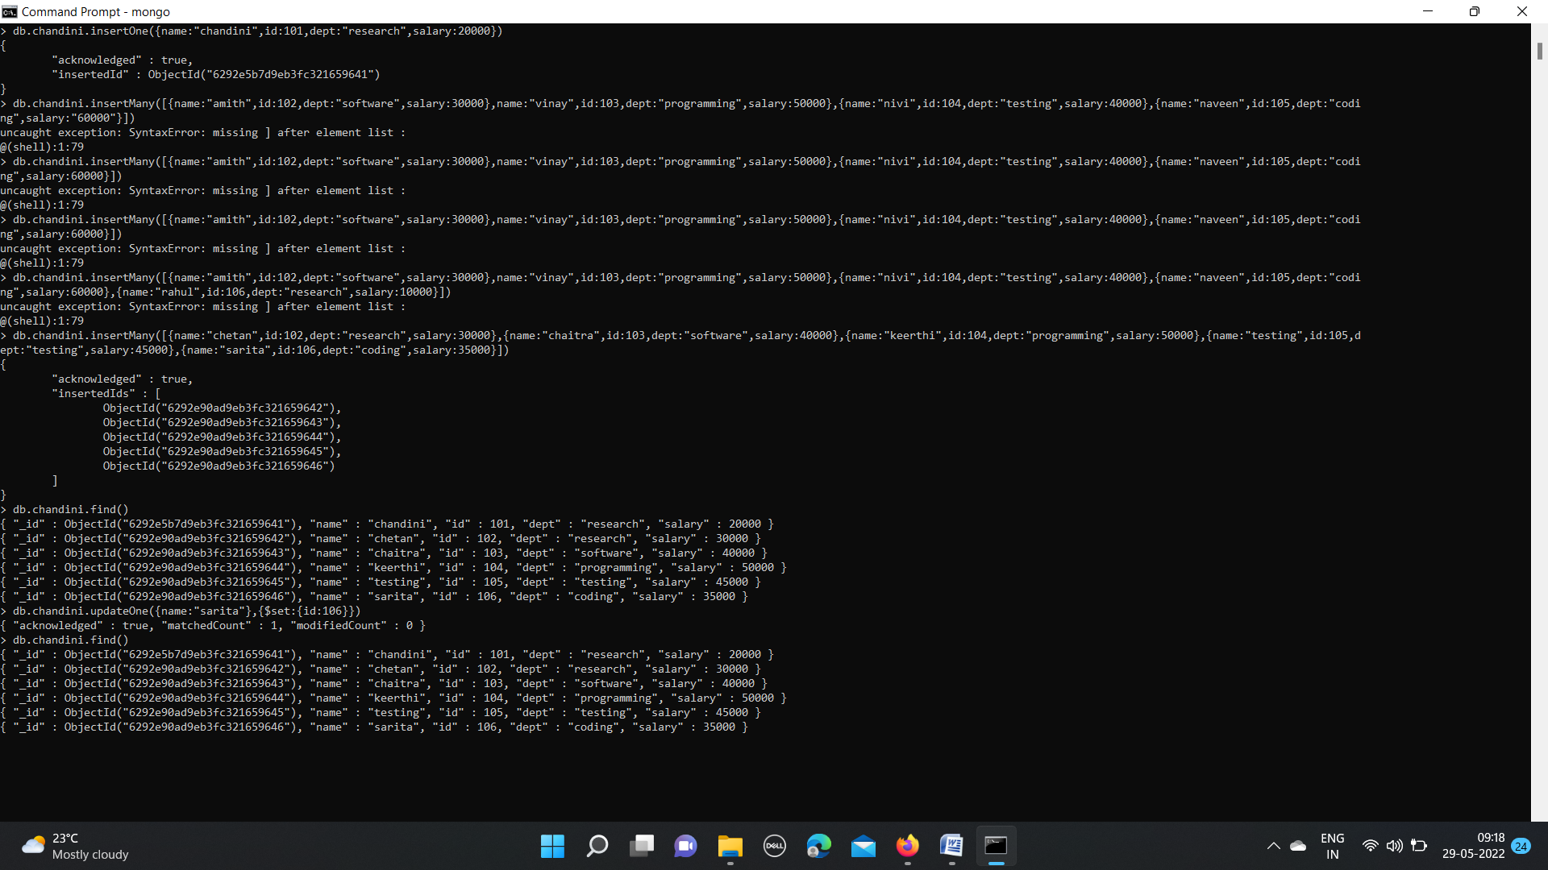

OUTPUT:



**CRUD OPERATIONS:**

**UPDATE ONE**: Updates only one record at a time.



**UPDATE MANY**:Updates only multiple record at a time.

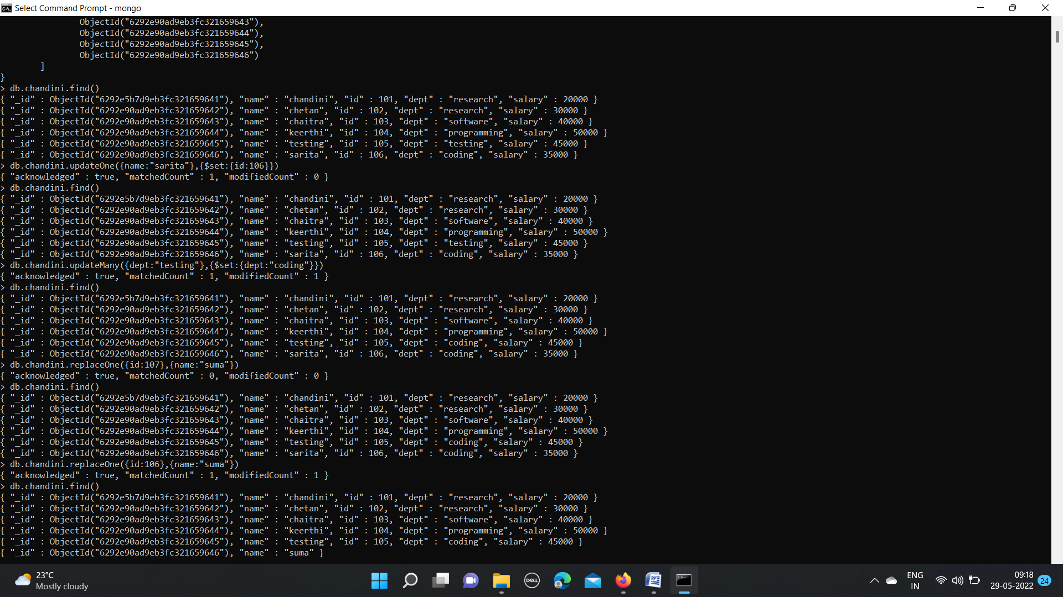

**REPLACE ONE**: Replaces one record with other in a database.



**DELETE ONE:**

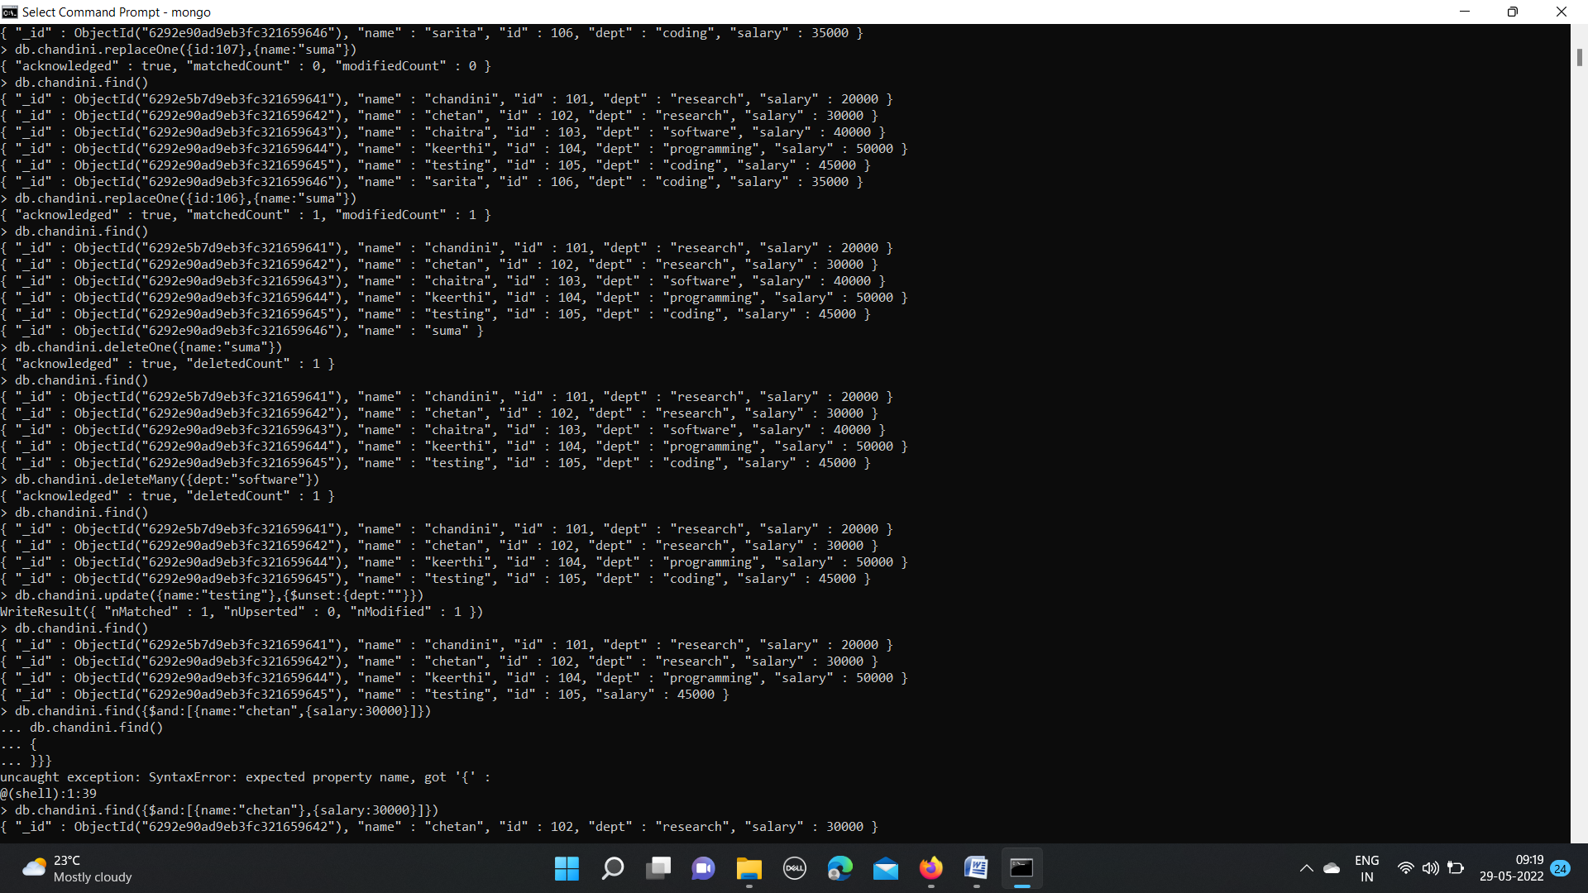

**DELETE MANY**:



**UNSET:**



**LOGICAL AND:**

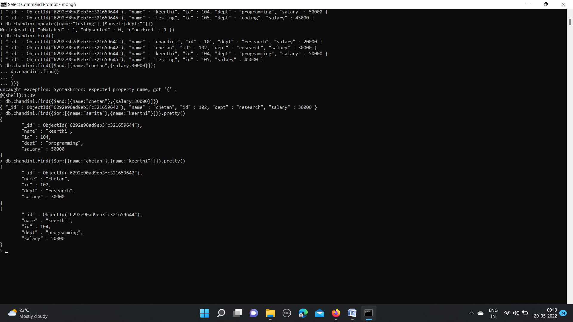

**LOGICAL OR:**

