**Chandini T R**

**1NT20IS403**

**C3 BATCH**

**$PROJECT OPERATION:**

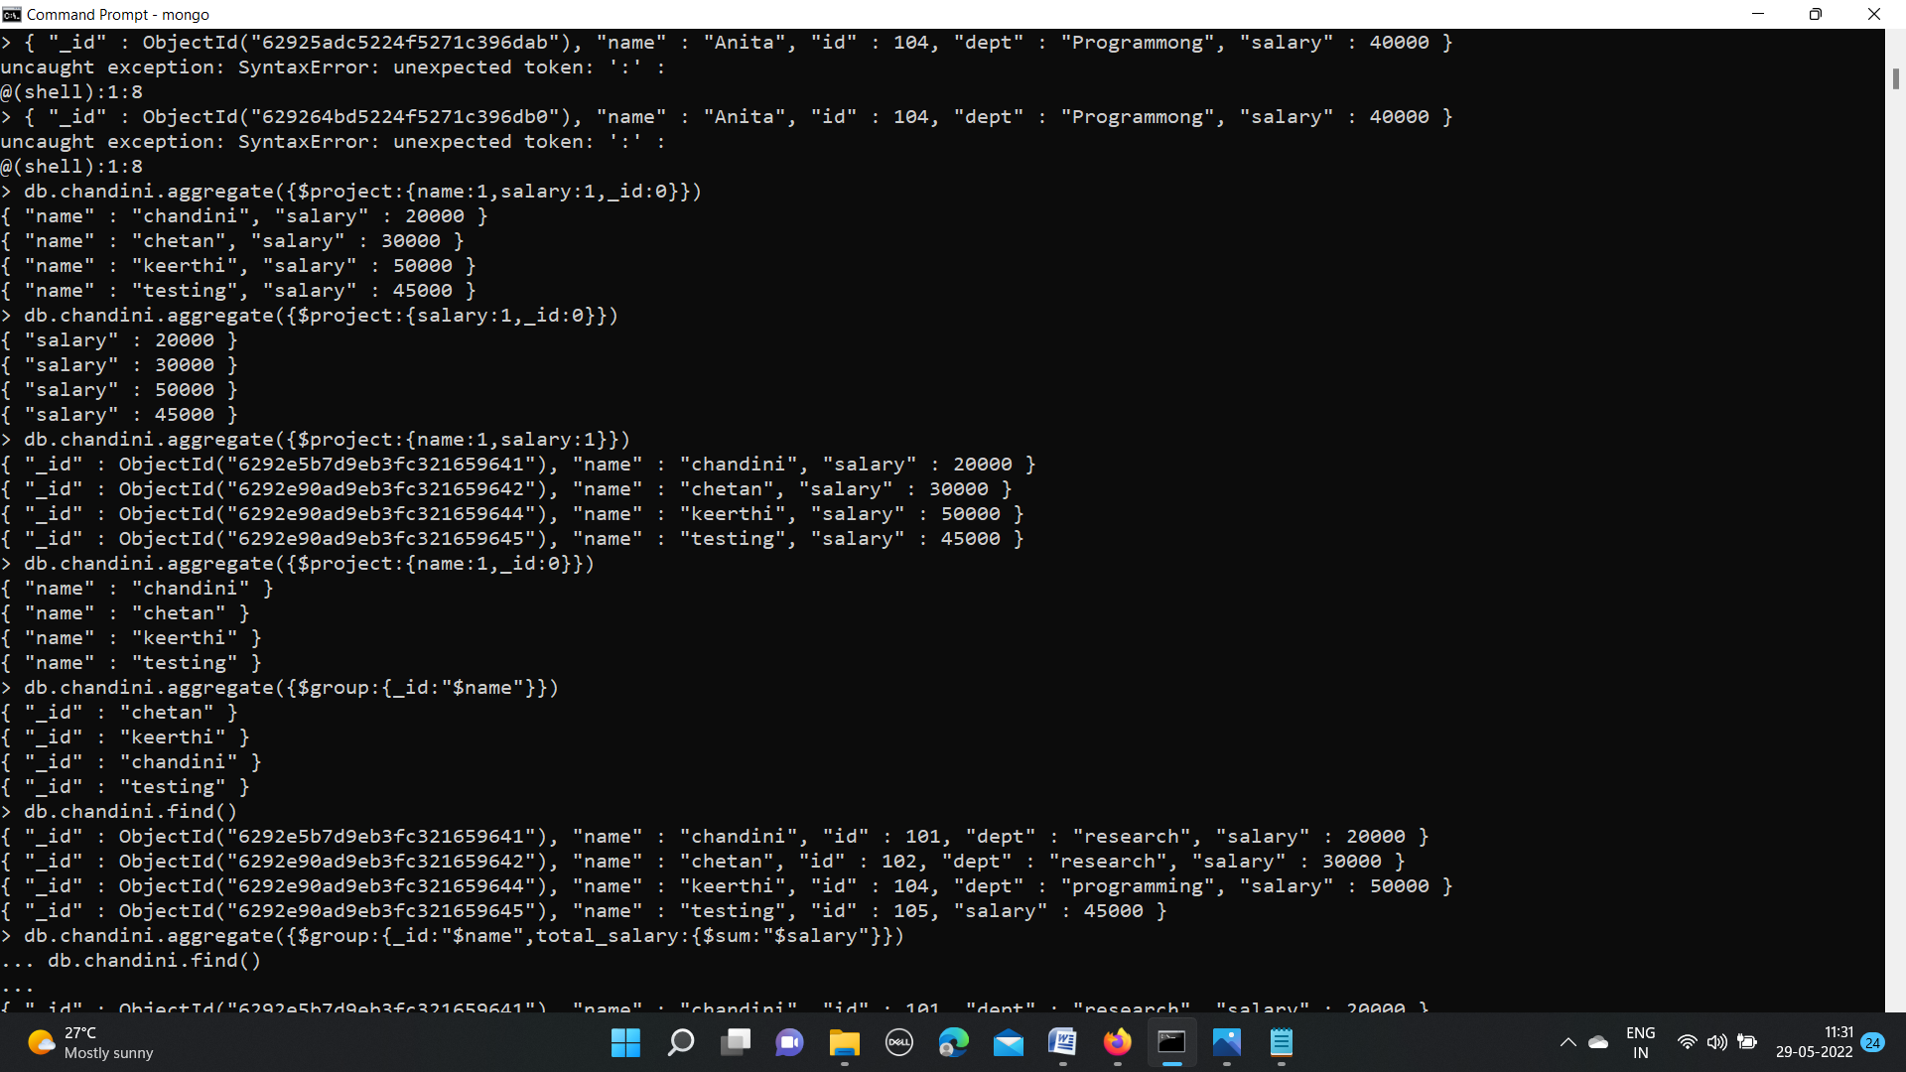



**GROUPBY OPERATION:**

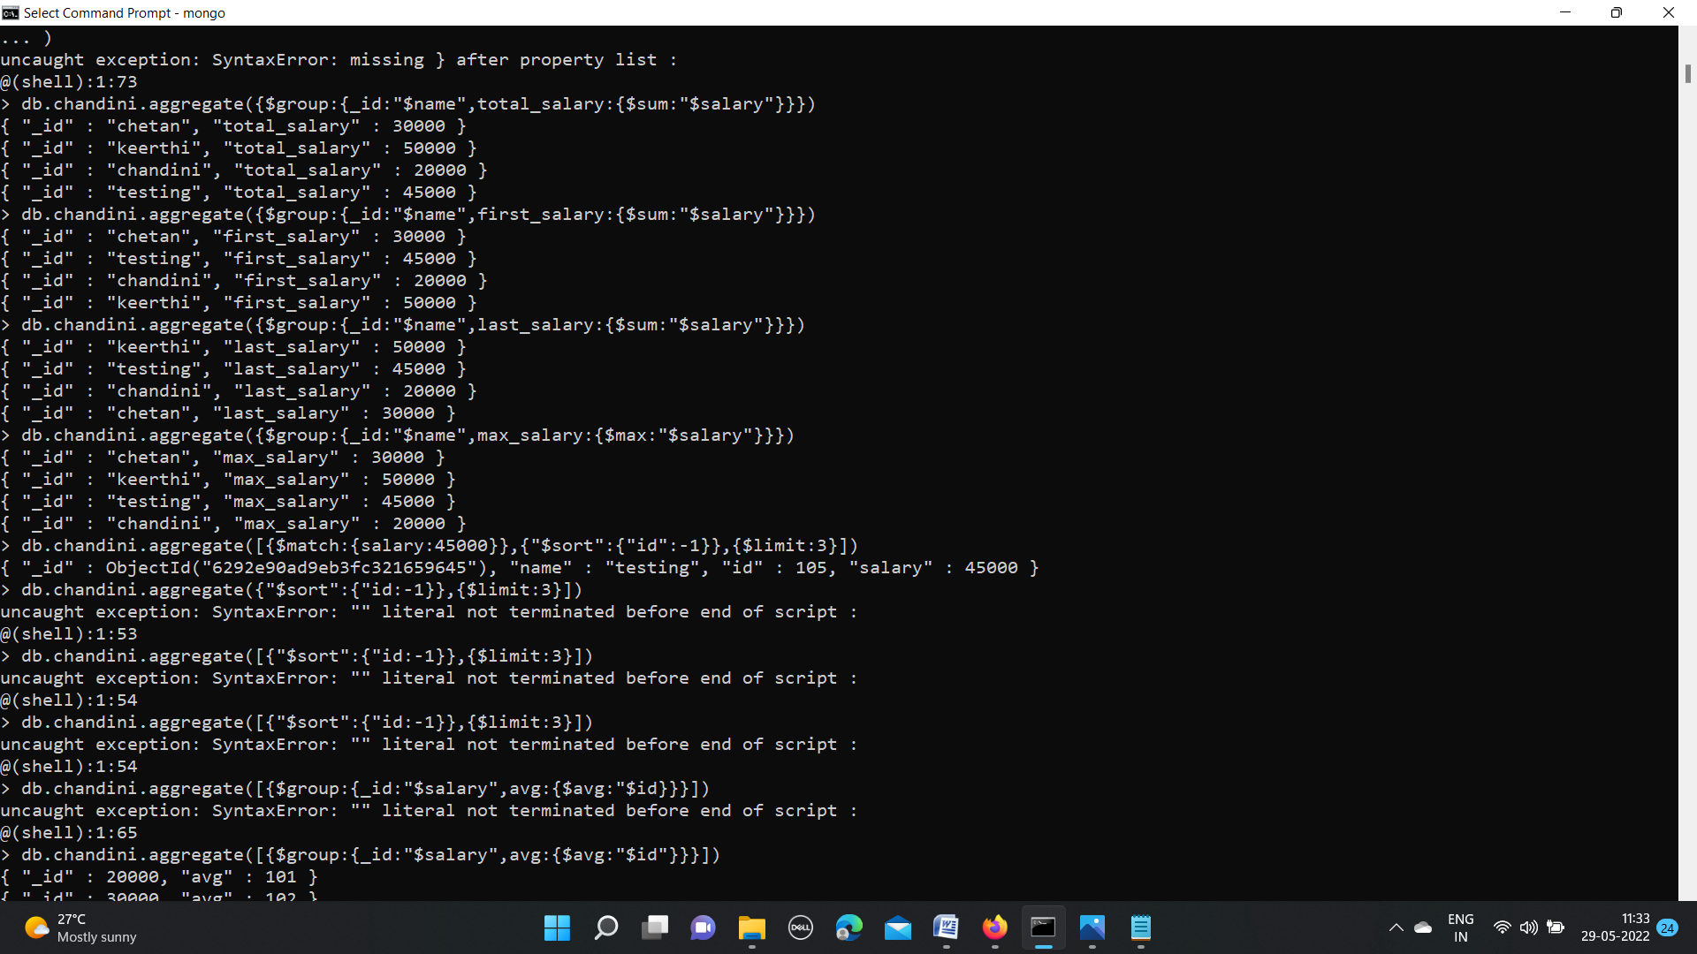

**FIRST SALARY:**



**LAST SALARY:**



**MAX SALARY:**



**MIN SALARY:**

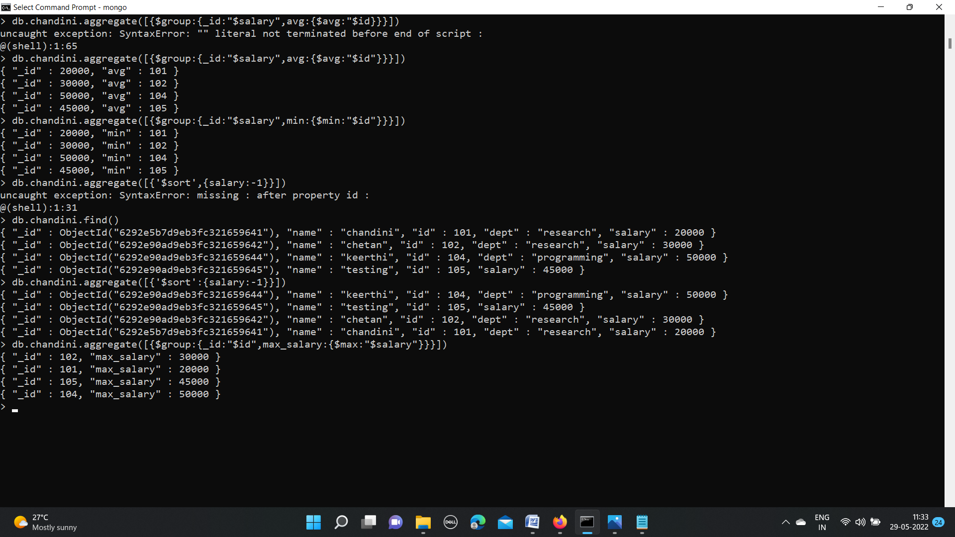

**AVERAGE SALARY:**



**$SORT:**



**GROUPBY MAX SALARY:**

