**Name:chandini T R**

**USN:1nt20is403**

**C section**

> use chandinitr

switched to db chandinitr

> db.collection.insertOne(

{

name:"chandini",

usn:"1nt20is403",

sec:"c", }

)

{

"acknowledged" : true,

"insertedId" : ObjectId("6246bb57b91954a70c2958e6")

}

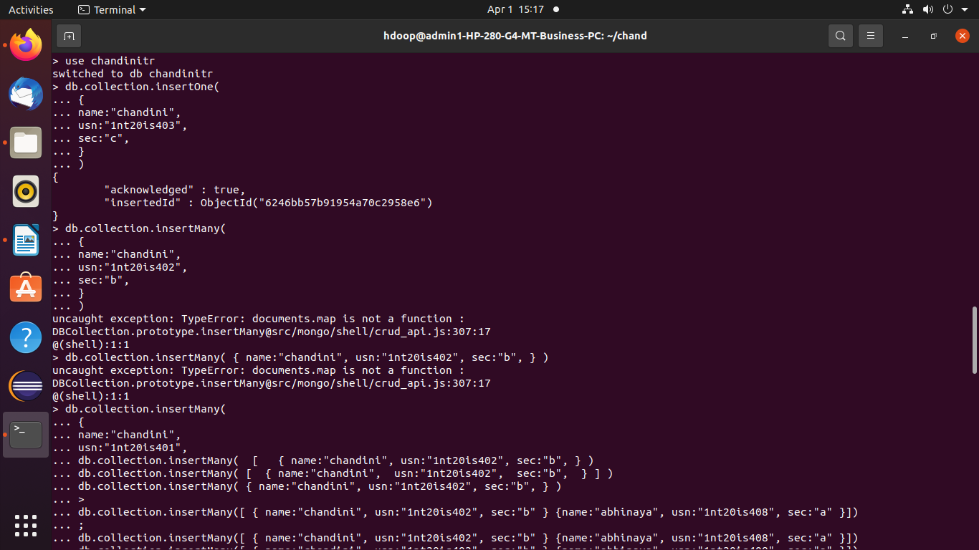

> db.collection.insertMany(

... [

... {

... name:"smaya",

... usn:"1nt20is489",

... sec:"c"

... }

... ,

... {

... name:"maya",

... usn:"1nt20is412",

... sec:"a"

... }

... ]

... )

{

"acknowledged" : true,

"insertedIds" : [

ObjectId("6246bdd6b91954a70c2958e7"),

ObjectId("6246bdd6b91954a70c2958e8")

]

}

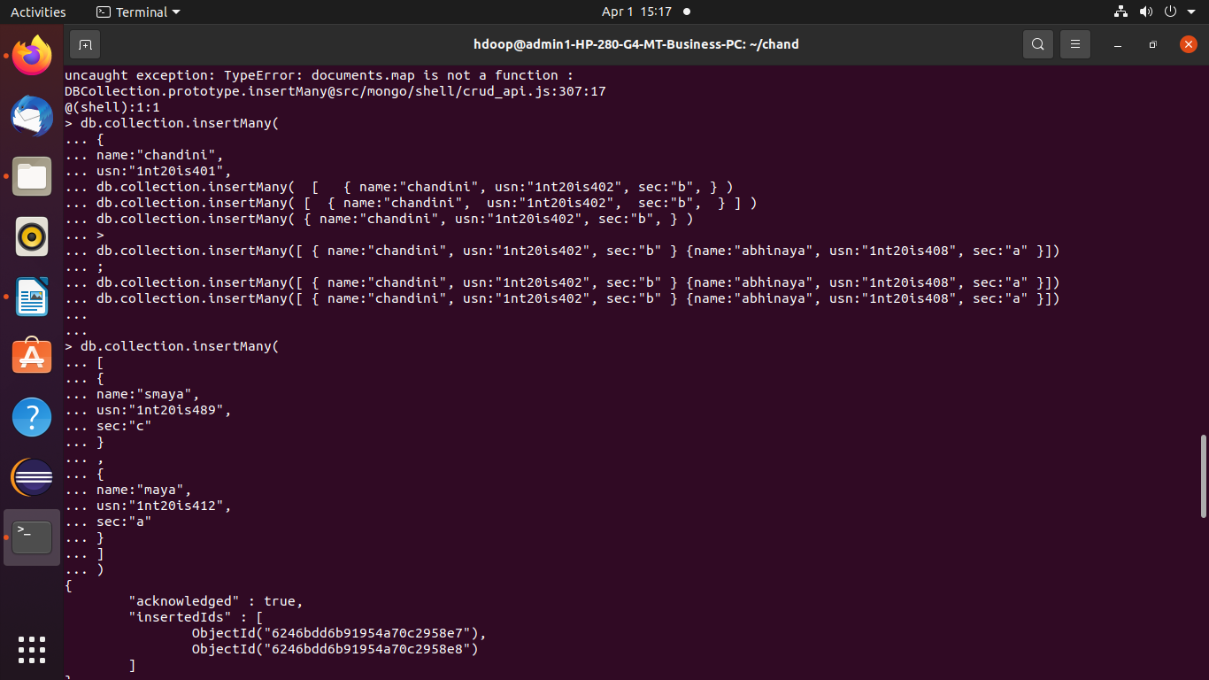

> db.collection.find({})

{ "_id" : ObjectId("6246bb57b91954a70c2958e6"), "name" : "chandini", "usn" : "1nt20is403", "sec" : "c" }

{ "_id" : ObjectId("6246bdd6b91954a70c2958e7"), "name" : "smaya", "usn" : "1nt20is489", "sec" : "c" }

{ "_id" : ObjectId("6246bdd6b91954a70c2958e8"), "name" : "maya", "usn" : "1nt20is412", "sec" : "a" }

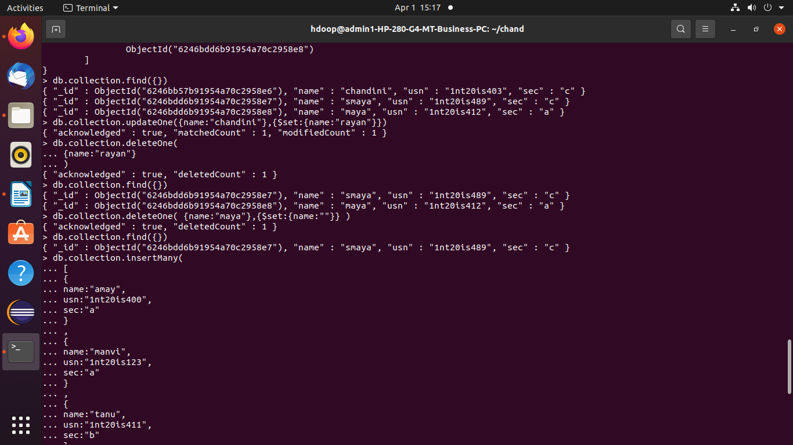

**UPDATE OPERATION ON SET:**

> db.collection.updateOne({name:"chandini"},{$set:{name:"rayan"}})

{ "acknowledged" : true, "matchedCount" : 1, "modifiedCount" : 1 }



**UPDATE OPERATION ON UNSET:**

> db.collection.updateMany( {name:"smaya"},{$unset:{name:"roy"}})

{ "acknowledged" : true, "matchedCount" : 1, "modifiedCount" : 1 }

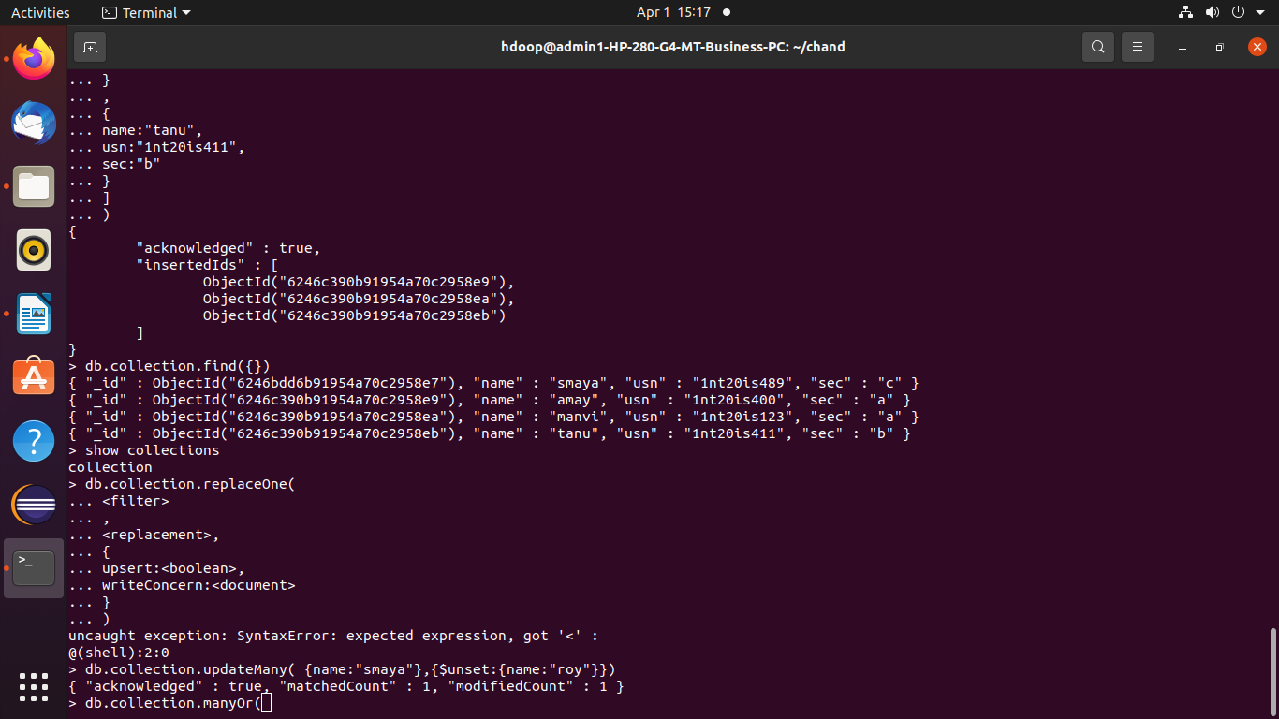

**DELETE OPERATION:**

> db.collection.deleteOne(

... {name:"rayan"}

... )

{ "acknowledged" : true, "deletedCount" : 1 }



> db.collection.insertOne(

... {

... name:"chandini",

... usn:"1nt20is403",

... sec:"c", }

... )

{

"acknowledged" : true,

"insertedId" : ObjectId("6246ca9cb91954a70c2958ec")

}

**OR OPERATION:**

> db.collection.find({$or:[{name:'chandini'},{sec:'c'}]})

{ "_id" : ObjectId("6246bdd6b91954a70c2958e7"), "usn" : "1nt20is489", "sec" : "c" }

{ "_id" : ObjectId("6246ca9cb91954a70c2958ec"), "name" : "chandini", "usn" : "1nt20is403", "sec" : "c" }

**AND OPERATION :**

> db.collection.find({$and:[{name:'chandini'},{sec:'c'}]})

{ "_id" : ObjectId("6246ca9cb91954a70c2958ec"), "name" : "chandini", "usn" : "1nt20is403", "sec" : "c" }

>

