Excercise 3

import java.io.IOException;
import java.util.*;
import java.util.StringTokenizer;

import org.apache.hadoop.fs.Path;
import org.apache.hadoop.io.IntWritable;
import org.apache.hadoop.io.LongWritable;
import org.apache.hadoop.io.Text;
import org.apache.hadoop.mapred.JobClient;
import org.apache.hadoop.mapred.JobConf;
import org.apache.hadoop.mapred.MapReduceBase;
import org.apache.hadoop.mapred.Mapper;
import org.apache.hadoop.mapred.OutputCollector;
import org.apache.hadoop.mapred.Reporter;
import org.apache.hadoop.mapred.Reducer;
import org.apache.hadoop.mapred.TextOutputFormat;
import org.apache.hadoop.mapred.TextInputFormat;
import org.apache.hadoop.mapred.FileInputFormat;
import org.apache.hadoop.mapred.FileOutputFormat;

public class WordCount {
public static class Map extends MapReduceBase implements
Mapper<LongWritable, Text, Text, IntWritable> {
private final static IntWritable one = new IntWritable(1);
private Text word = new Text();
public void map(LongWritable key, Text value, OutputCollector<Text, IntWritable>
output, Reporter reporter) throws IOException {
String line = value.toString();
StringTokenizer tokenizer = new StringTokenizer(line);
while (tokenizer.hasMoreTokens()) {
word.set(tokenizer.nextToken());
output.collect(word, one);
}
}
}
public static class Reduce extends MapReduceBase implements
Reducer<Text, IntWritable, Text, IntWritable> {
public void reduce(Text key, Iterator<IntWritable> values,
OutputCollector<Text, IntWritable> output, Reporter reporter)
throws IOException {
int sum = 0;
while (values.hasNext()) {
sum += values.next().get();
}
output.collect(key, new IntWritable(sum));
}

}

public static void main(String[] args) throws Exception {

JobConf conf = new JobConf(WordCount.class);
conf.setJobName("WordCount");

conf.setOutputKeyClass(Text.class);
conf.setOutputValueClass(IntWritable.class);

conf.setMapperClass(Map.class);
conf.setCombinerClass(Reduce.class);
conf.setReducerClass(Reduce.class);

conf.setInputFormat(TextInputFormat.class);

conf.setOutputFormat(TextOutputFormat.class);

FileInputFormat.setInputPaths(conf, new Path(args[0]));
FileOutputFormat.setOutputPath(conf, new Path(args[1]));

JobClient.runJob(conf);
}

}

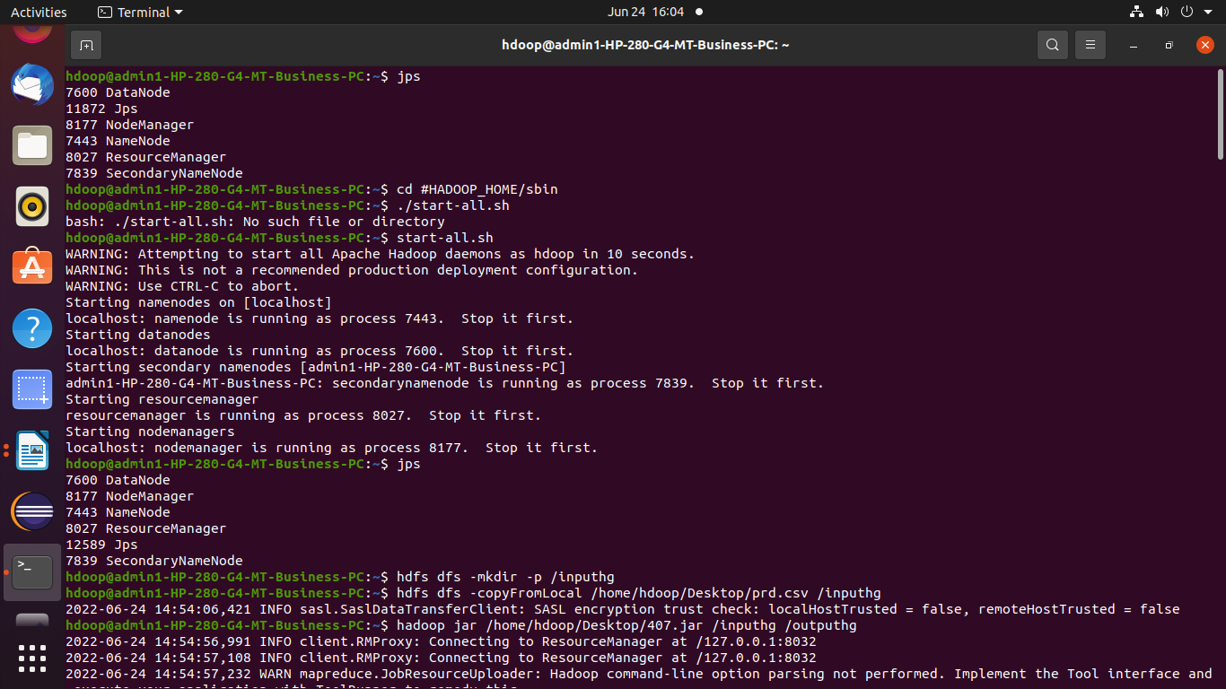

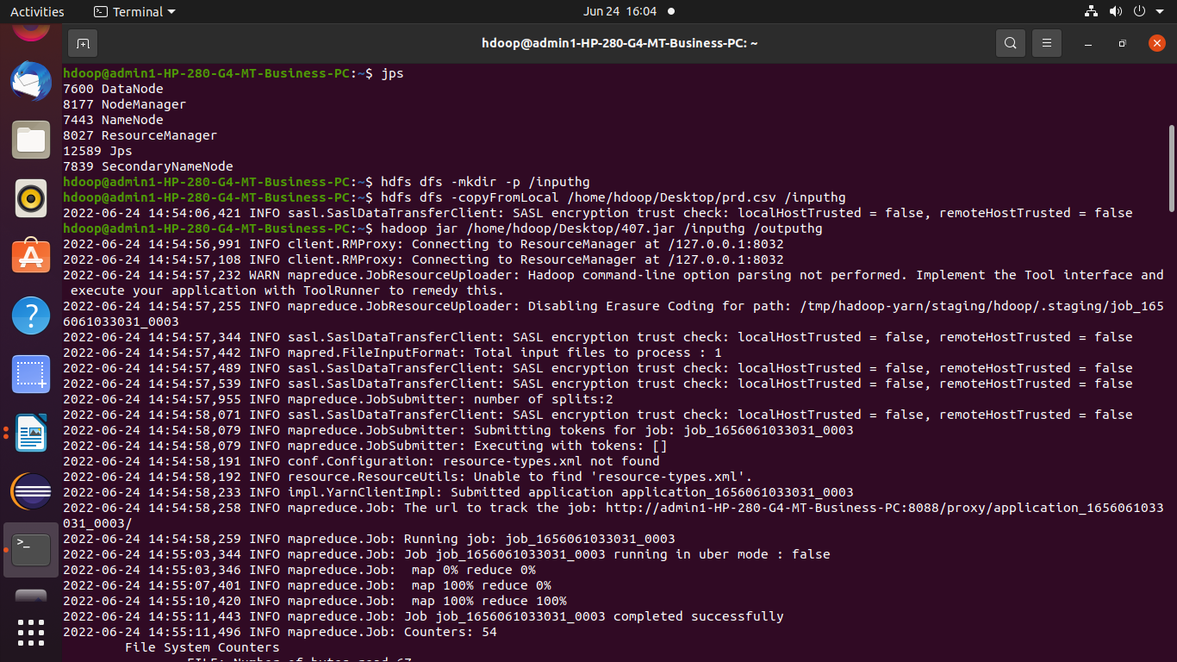

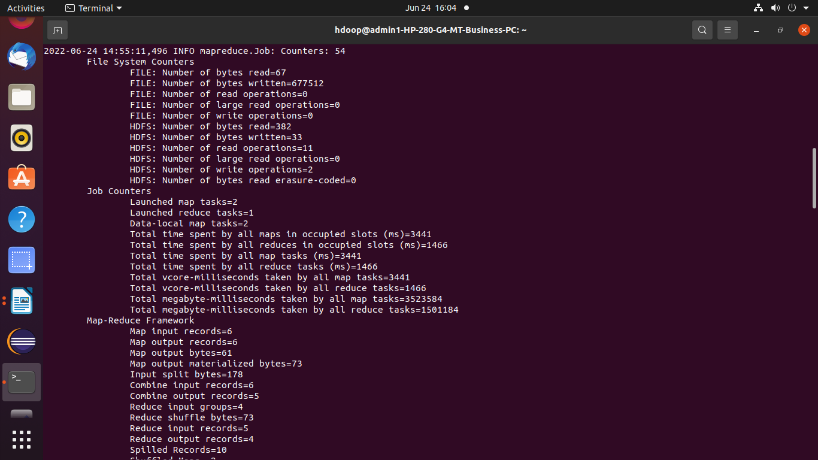

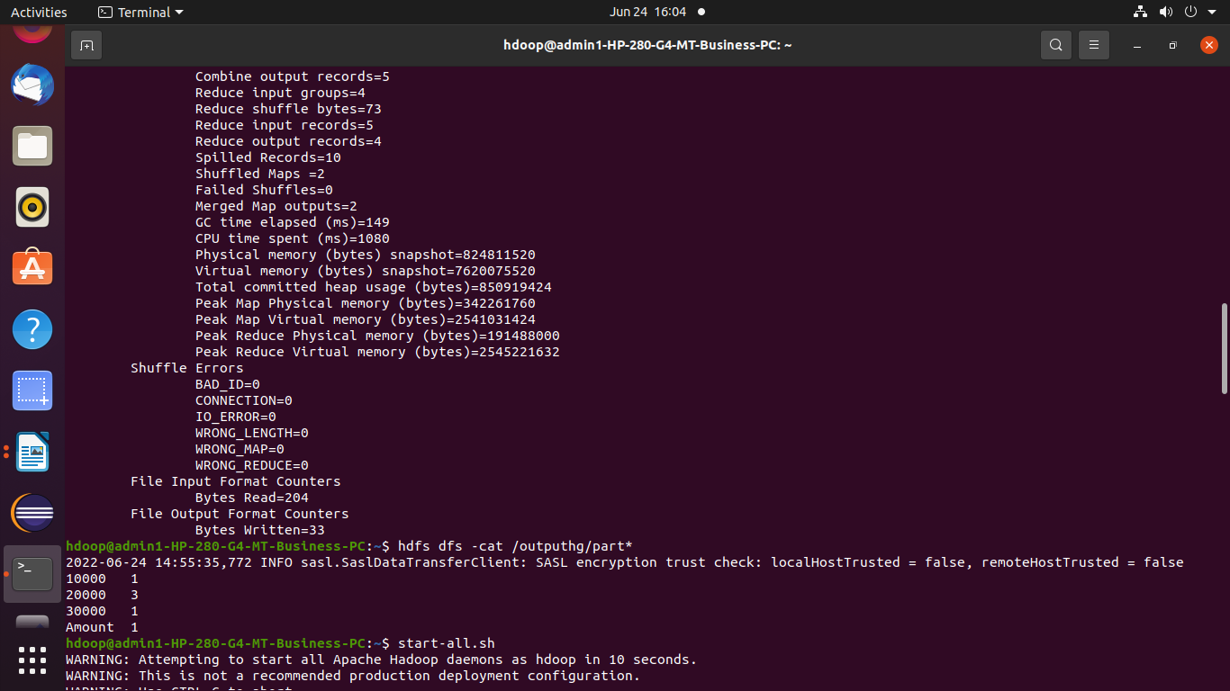

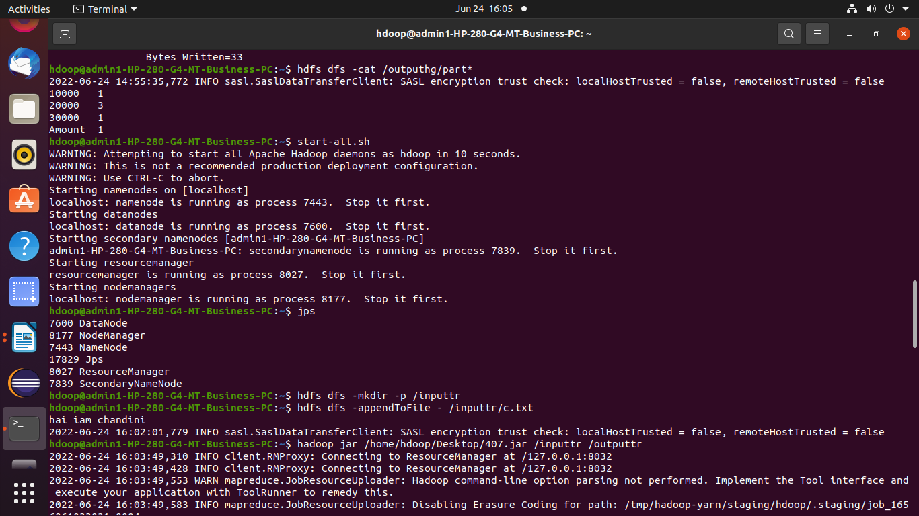

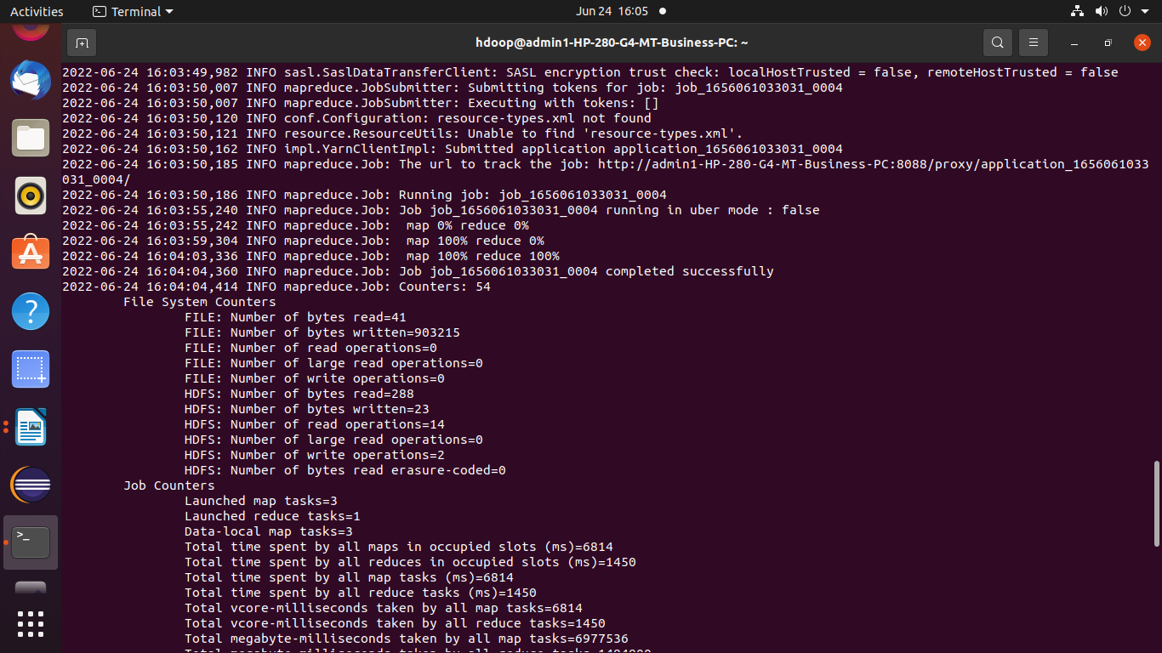

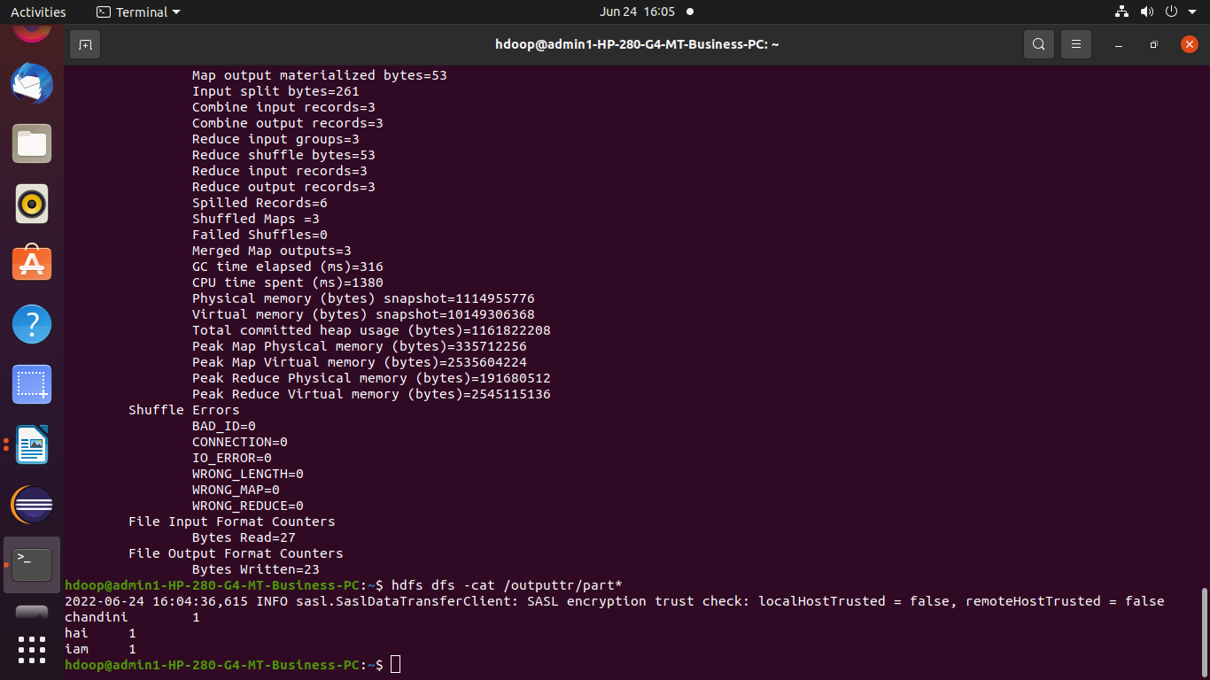

Excercise 4

import java.io.IOException;
import java.util.*;
import org.apache.hadoop.fs.Path;
import org.apache.hadoop.io.*;
import org.apache.hadoop.mapred.*;

public class Count {
//MAPPER CODE

public static class Map extends MapReduceBase implements
Mapper<LongWritable, Text, Text, IntWritable> {
private final static IntWritable one = new IntWritable(1);
//private Text word = new Text();

public void map(LongWritable key, Text value, OutputCollector<Text,
IntWritable> output, Reporter reporter) throws IOException {
String myString = value.toString();
String[] userCount = myString.split(",");
output.collect(new Text(userCount[3]), one);

}
}

//REDUCER CODE
public static class Reduce extends MapReduceBase implements
Reducer<Text, IntWritable, Text, IntWritable> {
public void reduce(Text key, Iterator<IntWritable> values,
OutputCollector<Text, IntWritable> output, Reporter reporter) throws
IOException { //{little: {1,1}}
int finaluserCount = 0 ;
Text mykey = key ;
while(values.hasNext()) {
IntWritable value = values.next();
finaluserCount += value.get();
}
output.collect(mykey, new IntWritable(finaluserCount));
}
}
//DRIVER CODE
public static void main(String[] args) throws Exception {
JobConf conf = new JobConf(Count.class);
conf.setJobName("wordcount");
conf.setOutputKeyClass(Text.class);
conf.setOutputValueClass(IntWritable.class);
conf.setMapperClass(Map.class);
conf.setCombinerClass(Reduce.class);
conf.setReducerClass(Reduce.class);
conf.setInputFormat(TextInputFormat.class);
conf.setOutputFormat(TextOutputFormat.class);
FileInputFormat.setInputPaths(conf, new Path(args[0]));
FileOutputFormat.setOutputPath(conf, new Path(args[1]));
JobClient.runJob(conf);
}

}

