Chandini T R
USN:1NT20IS403

Execise 2 Hadoop:
hadoop version
Hadoop 3.2.1

$ start-all.sh

$ jps

hadoop fs -mkdir chandini123
$ fs -ls

$ hadoop fs du -s

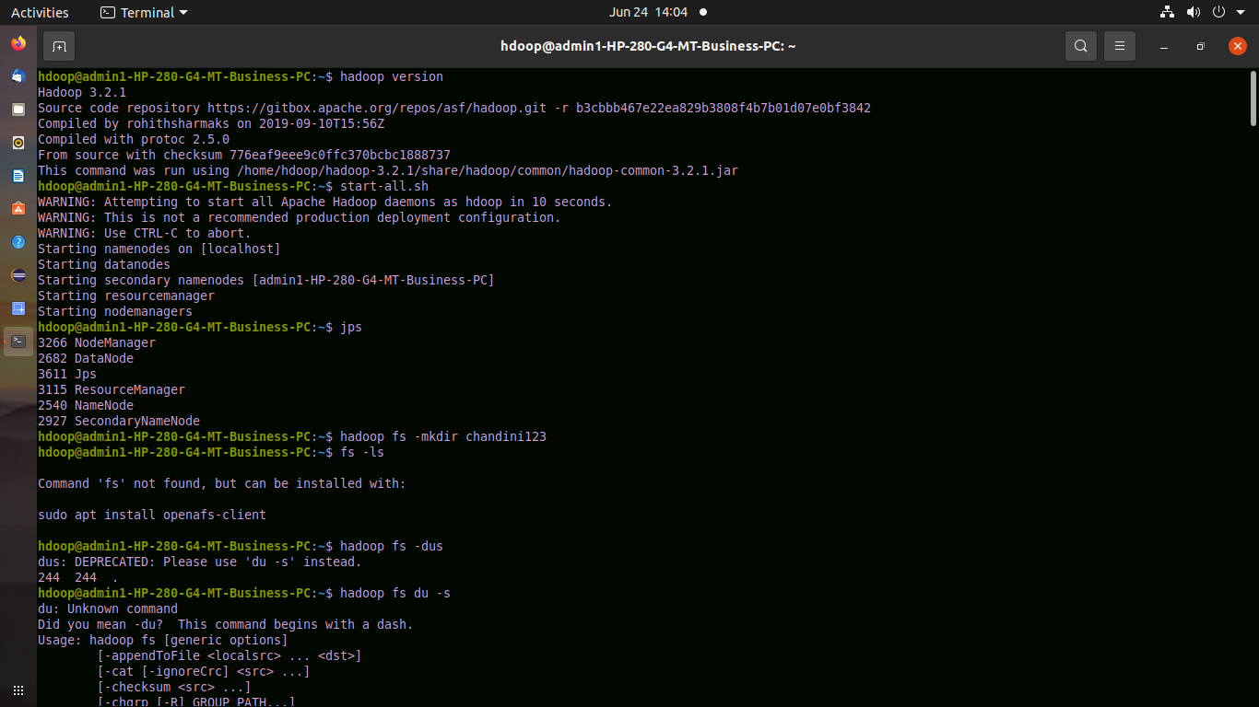

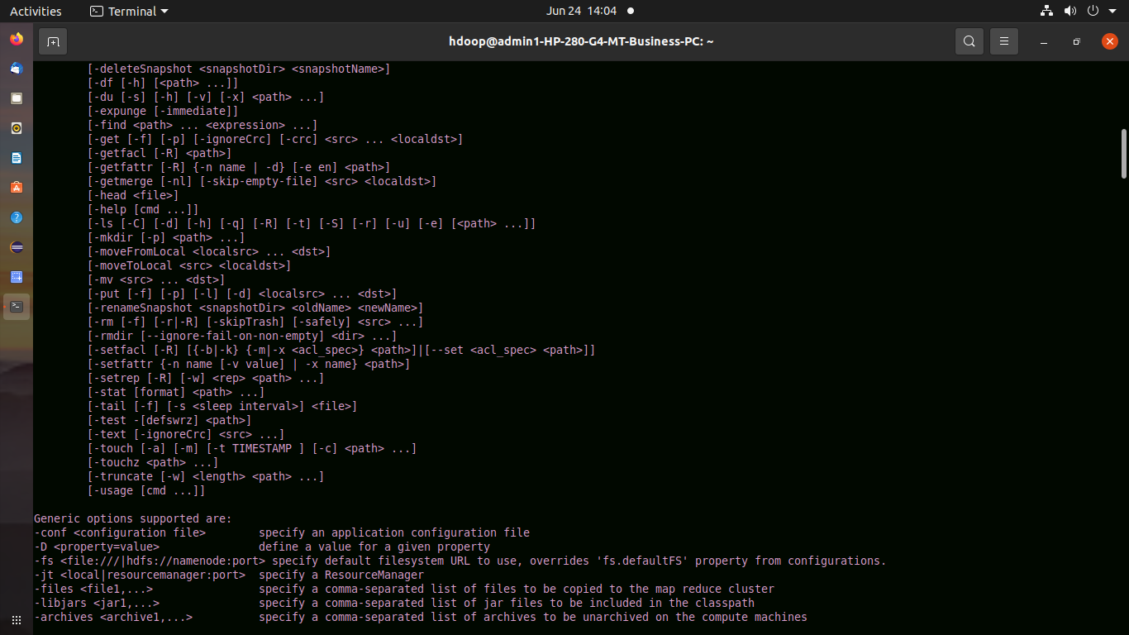

gedit s1.txt
$ gedit chandini123.txt
$ hadoop fs -copyFromLocal chandini123.txt s1.txt
hadoop fs -cat s1.txt

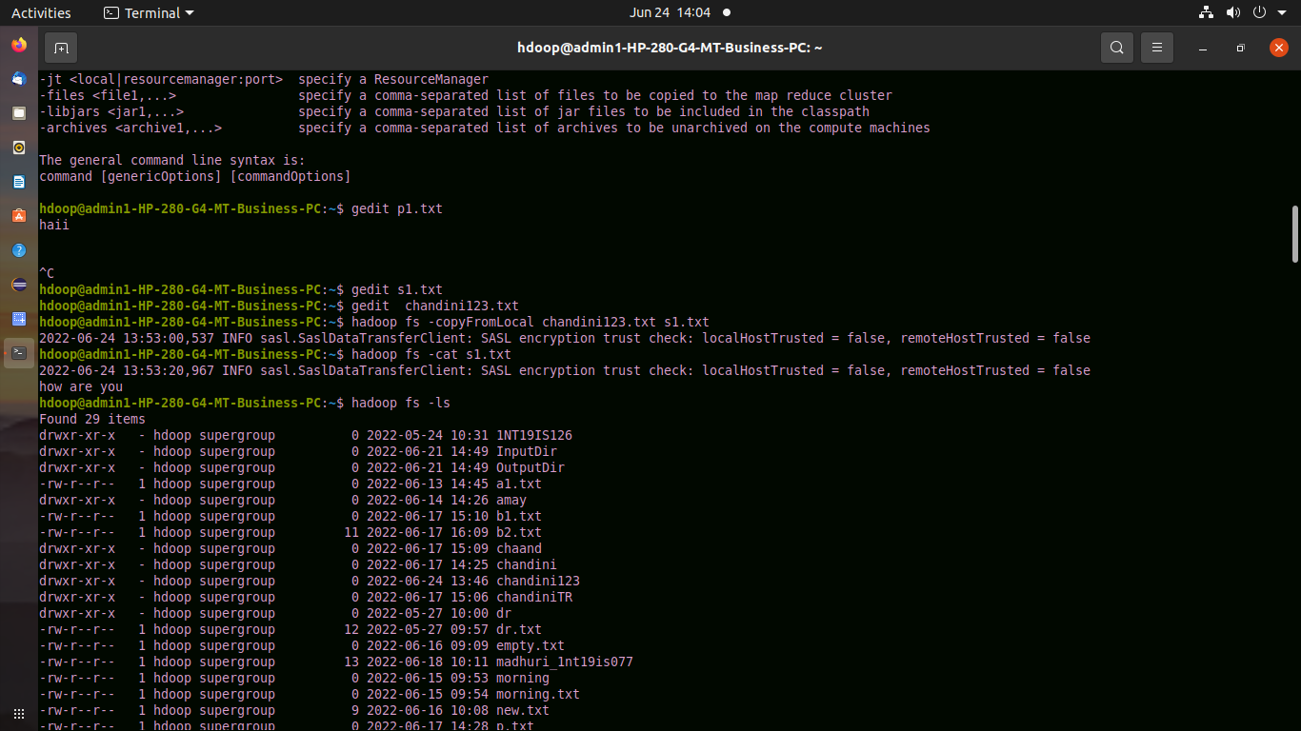

hadoop fs -copyToLocal s1.txt chand1.txt
hadoop fs -mkdir 1nt20is403
$ hadoop fs -ls

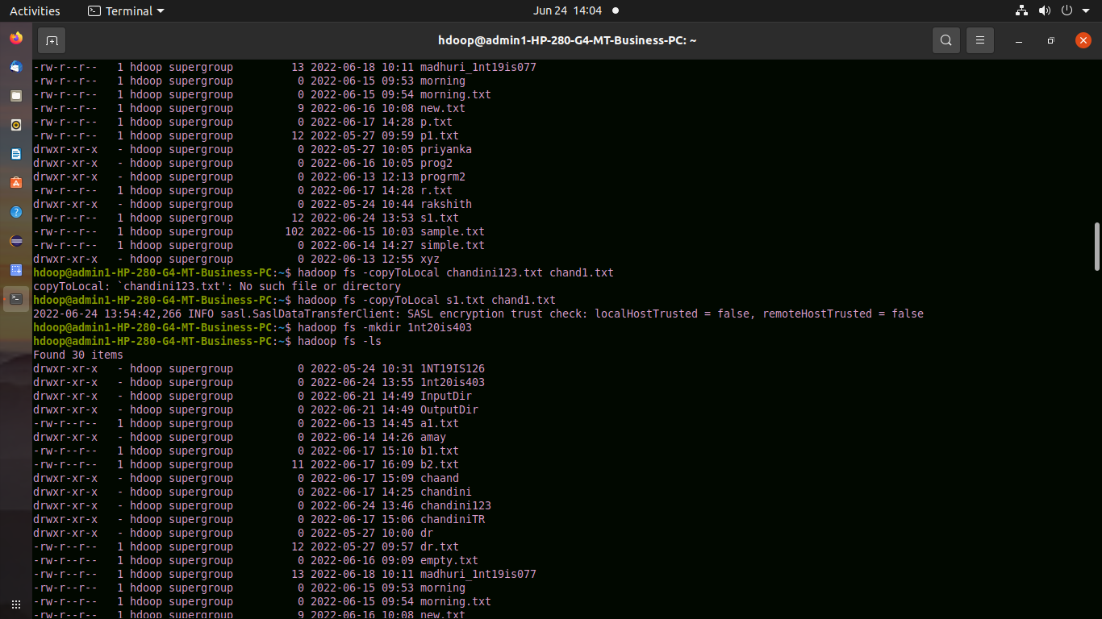
$ hadoop fs -cp s1.txt chand2.txt

$ hadoop fa -cat chand2.txt

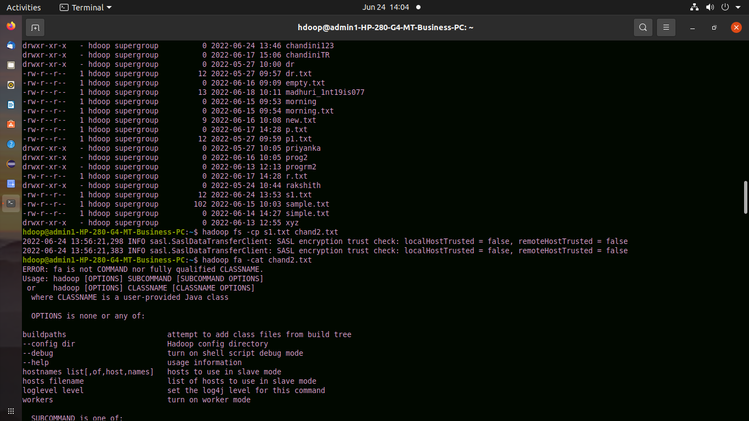

$ hadoop fs -cp s1.txt chand2.txt
hadoop fs -du

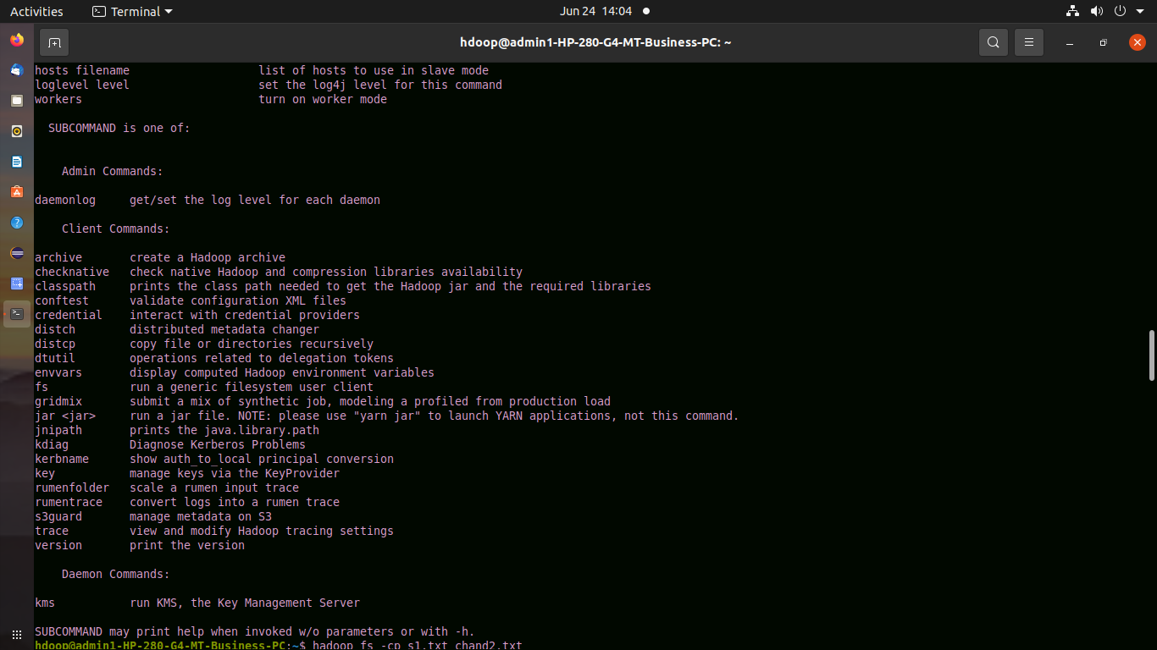
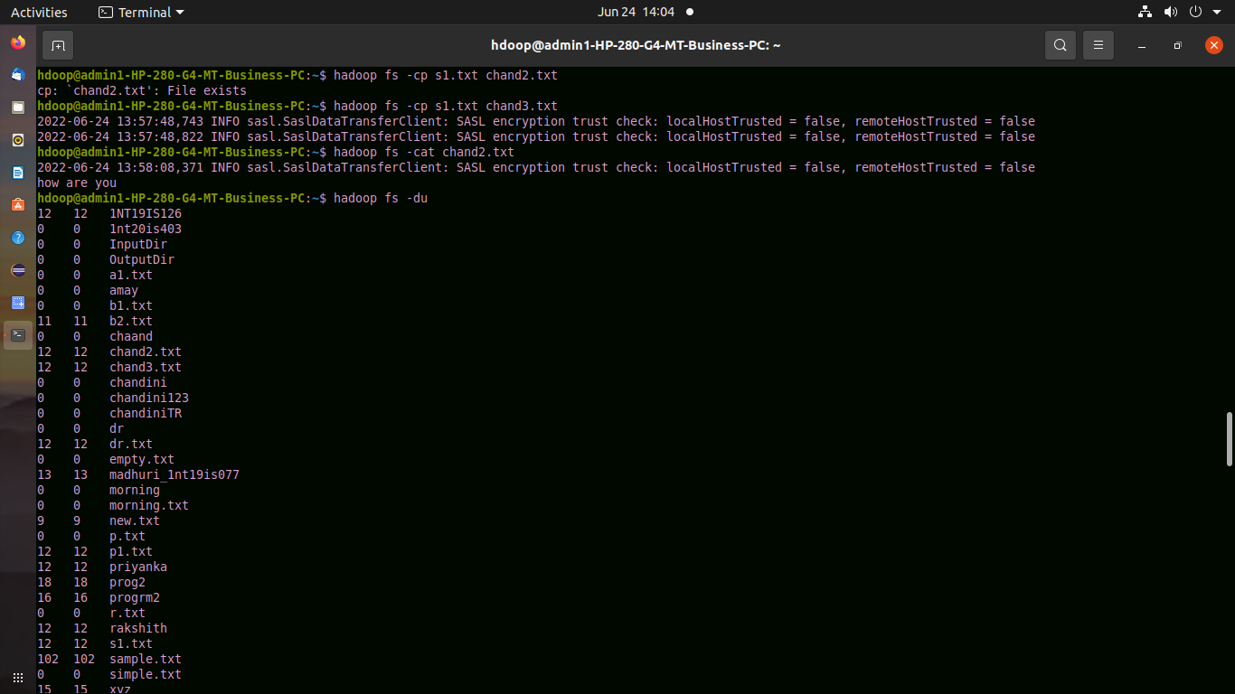

$ hadoop fs -rmr s1.txt

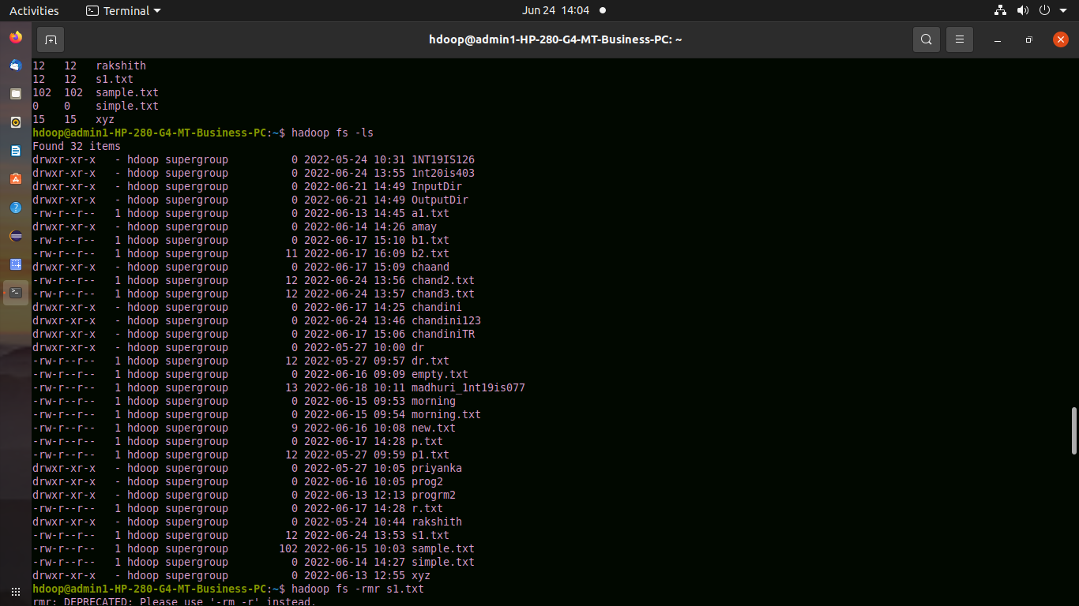
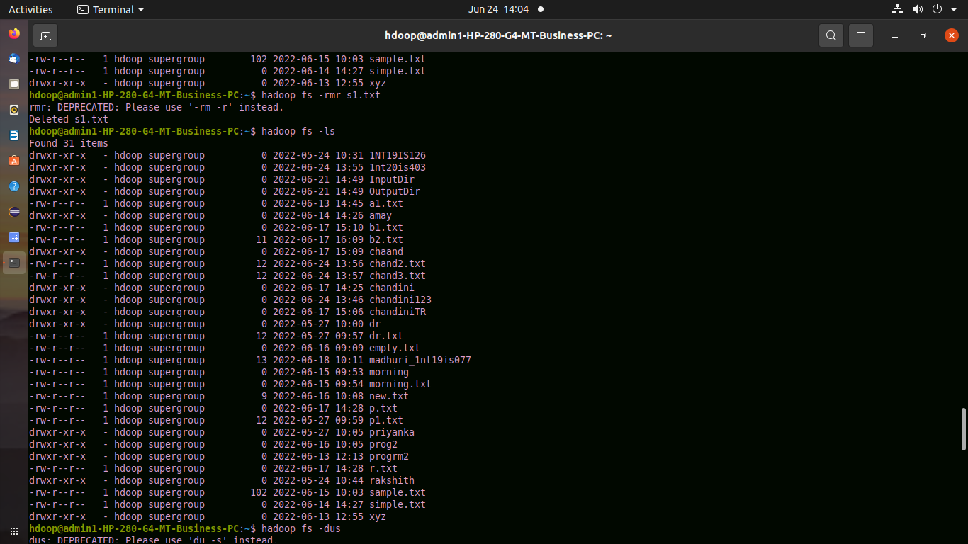

$ hadoop fs -stat chandini123

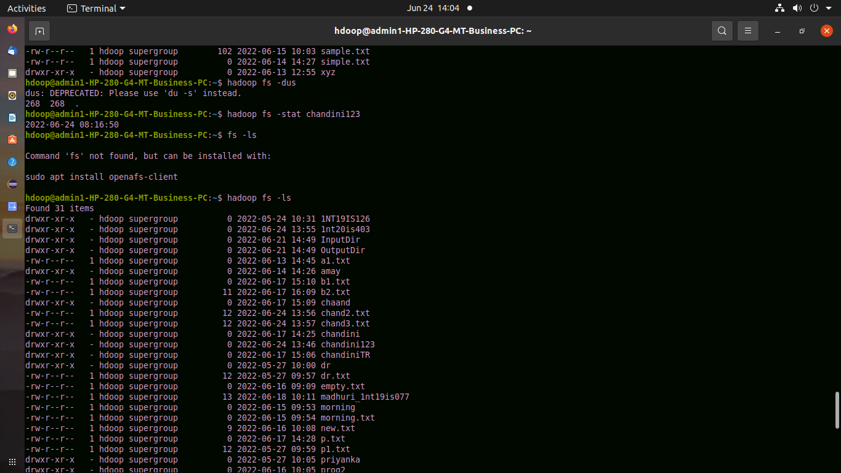
hadoop fs -mv chand2.txt chandini123
hdoop@admin1-HP-280-G4-MT-Business-PC:~$ hadoop fs -ls

