**PIPELINE AGGREGATE FUNCTIONS:**

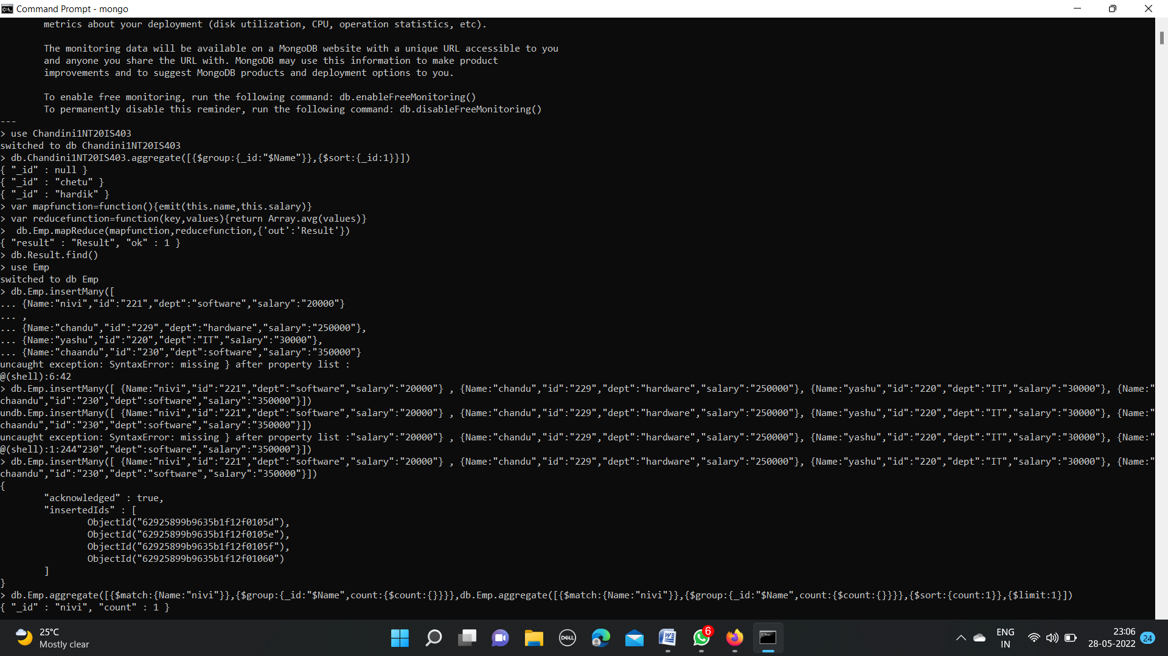



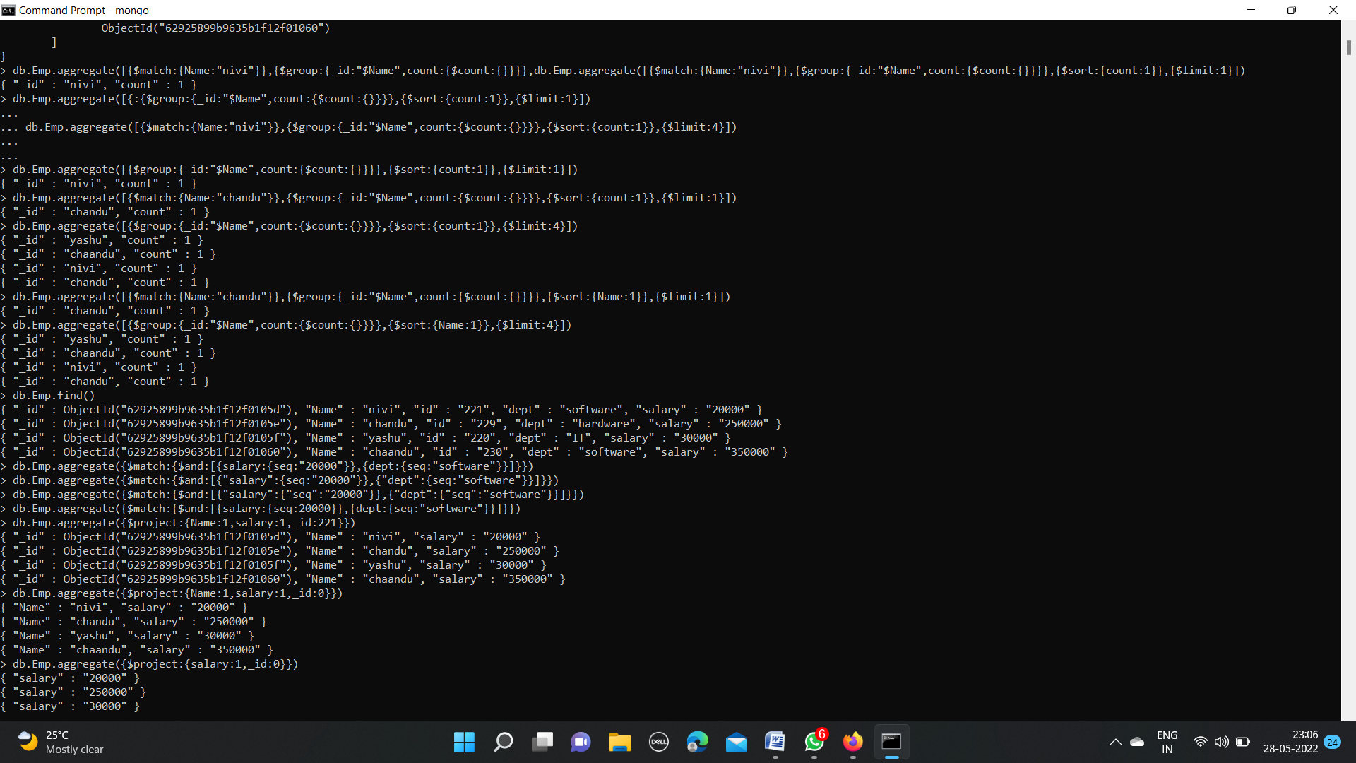

**MATCH operation** :



**PROJECT operation:**



**GROUP BY:**





**TOTAL SALARY**

**FIRST SALARY**



**MAX SALARY**

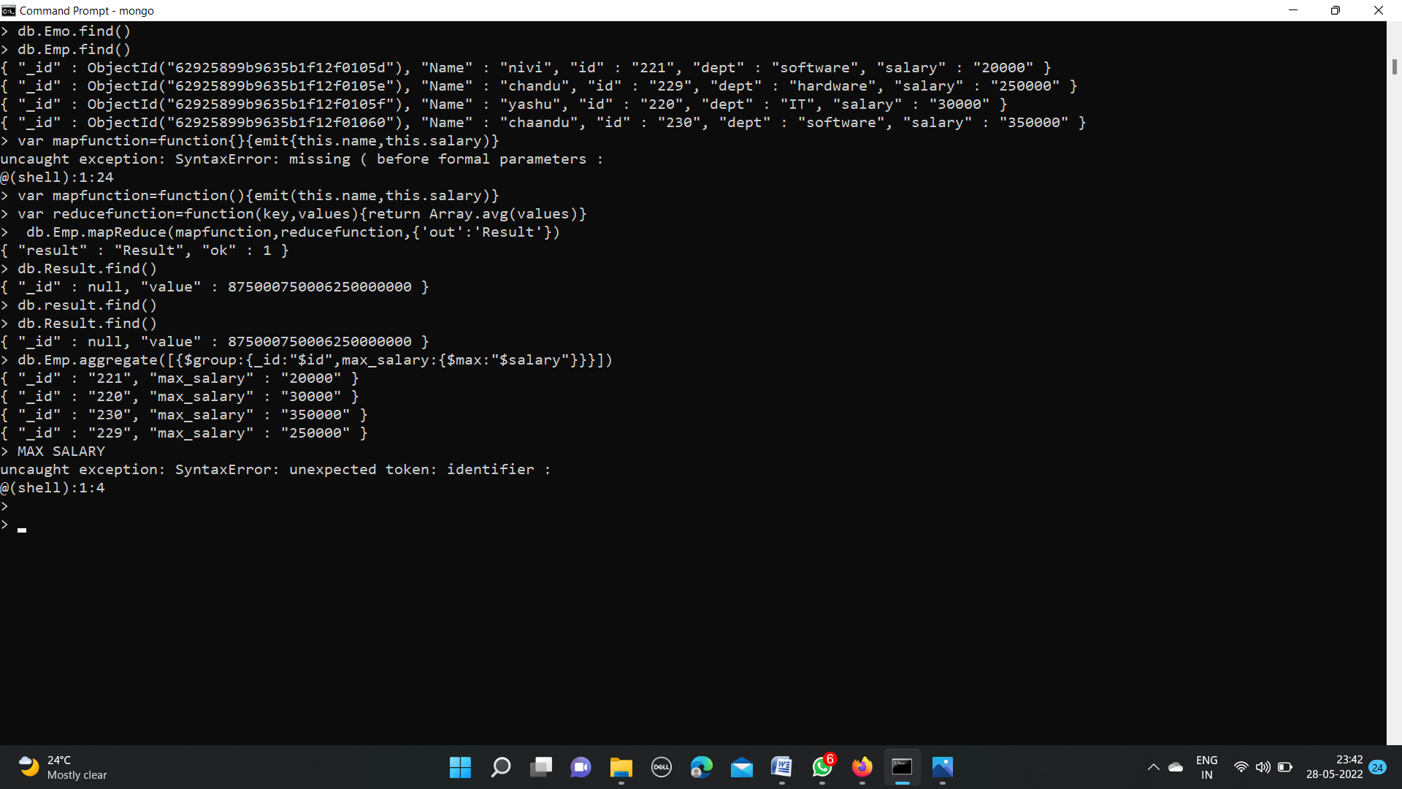

**MIN SALARY:**

**AVG SALARY:**



**GROUP BY MAX SALARY**



**MAP FUNCTION : taking 2 same names and those 2 names have different salaries after mapping them with sum operation salary will get combined.**

