# **set up a Caddy web server and implement basic application monitoring using Prometheus:**

**Caddy:**

Caddy is an open-source HTTP Web server that is used for various platforms including Windows, Mac, Linux, FreeBSD, etc. It is a full-featured HTTP/2 web server that can instantly enable HTTPS. It permits designers to create amazing things with high flexibility and low overhead.

**Pre-requisites :**

* A Linux Server(selected Distribution is Ubuntu)
* Install Ansible and Python using below commands
* sudo apt install ansible
* Sudo apt install python

**Installation of caddy:**

I have written an ansible playbook named install_caddy_ansible.yaml which does

* Install caddy.
* Start the caddy service.
* Enables the caddy service.
* Install Prometheus
* Enables and starts Prometheus.

**Challenges** I faced during the execution of playbook: Unable to start the caddy service due to address already in use.

**Troubleshooting** steps and commands I followed : To list the process using port 2019 in Linux

netstat -anp | awk '/:2019/{print $7}'

netstat -anp | grep ":2019 " | cut -d/ -f1

After I get the list of PID then I killed them using kill -9 PID.

I did systemctl start caddy then service started.

**Fix:**

Sometimes when we do manual installation of any service and execute it to run on particular port number , we need to reverify the process running in background.

Error Screenshots :



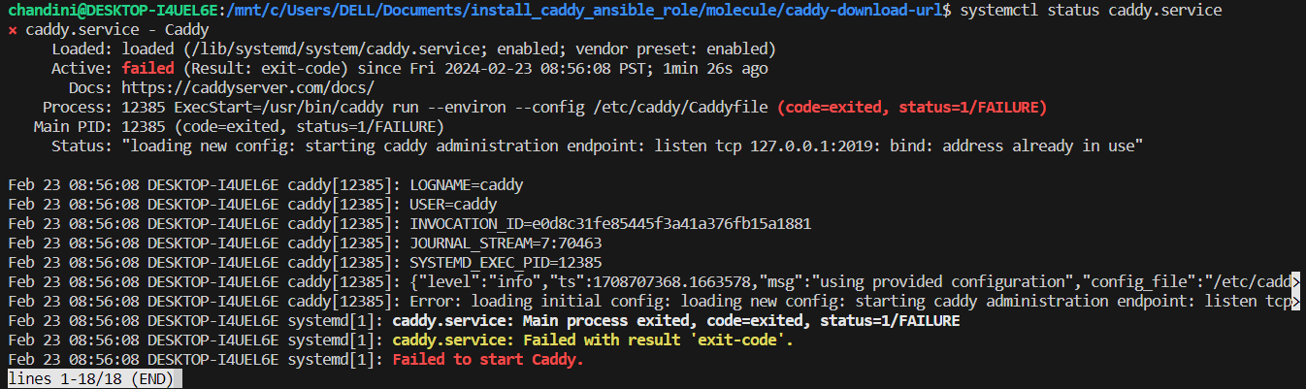

**Fixed Issue:**

After killing the processes running , caddy service is started.

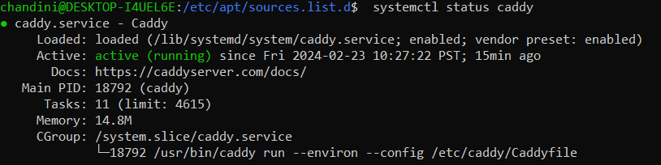

**Caddy file changes :**

I added a simple statement in caddy file when we brow through localhost url with port number 2019.

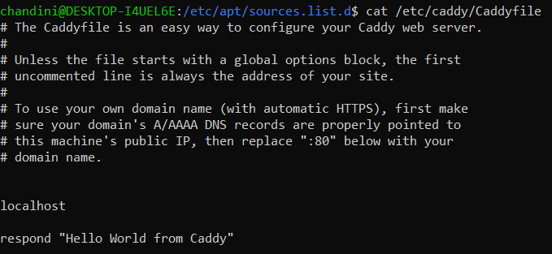

Sample data from Caddyfile which displays over browser :



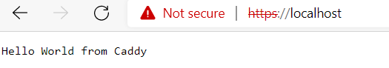

**Prometheus Installation and Enablement:**

[Prometheus](https://prometheus.io/) is a monitoring platform that collects metrics from monitored targets by scraping metrics HTTP endpoints on these targets.

To enable Prometheus metrics in Caddy configuration, we can use our Caddyfile.

sudo apt install Prometheus – Installs Prometheus(we can do it via ansible script too)

prometheus --config.file=prometheus.yaml

**Addition in Caddyfile:**

# Second site configuration with Prometheus metrics enabled

localhost:2019 {

root * /var/www/metrics

file_server

metrics

curl -s http://localhost:2019/metrics | grep ^caddy_admin - we can browse in web browser or curl can be used.



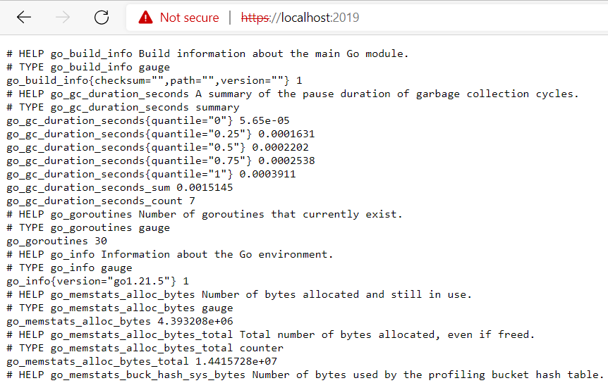

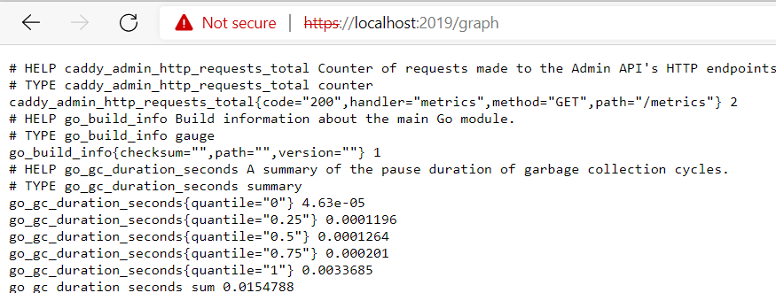

**Reference Links followed :**

[Install — Caddy Documentation (caddyserver.com)](https://caddyserver.com/docs/install#debian-ubuntu-raspbian)

[Caddyfile Quick-start — Caddy Documentation (caddyserver.com)](https://caddyserver.com/docs/quick-starts/caddyfile)

[Monitoring Caddy with Prometheus metrics — Caddy Documentation (caddyserver.com)](https://caddyserver.com/docs/metrics)a