Brian S. Callies

**=Gamblers-Anonymous=  
Overview:**

This document outlines the High-Level Design information for the Texas Holdem app's User Interface component. We are aiming to create a user-centric, engaging, and seamless gaming experience that focuses on specifying the 'what' aspects of the design, detailing design choices and justifying architectural decisions based on the user interface requirements.

**Architecture:**

The user interface for the Texas Holdem app will be built on a 3-tier architecture, which includes the Presentation, Logic, and Data tiers. This separation ensures that the user interface (Presentation layer) can evolve independently from the other two, allowing for greater scalability and flexibility. This architecture improves maintenance and future growth, critical for the app’s long-term success.

Reference for 3-tier architecture: IBM Three-Tier Architecture  
 <https://www.ibm.com/cloud/learn/three-tier-architecture>

**Security:**

Security measures for the web-app include secure login procedures for third-party authentication, ensuring that sensitive user data is protected. Logging of sensitive operations is limited to respect user privacy, critical actions within the app are audited to ensure accountability and to enhance security.

An IP-based firewall rule is in place to secure access to the web application, only permitting traffic from trusted sources.

**System Entities:**

Here is a class diagram that identifies system nouns and outlines preliminary relationships and dependencies.

[class diagram needed]

**Hardware:**

The Texas Holdem app is designed to for web access; the app will be compatible with all modern browsers.

**External Systems:**

The app will interface with a third-party authentication provider to enable logins through services like GitHub and Google.

**User Interface:**

The navigation is structured to be intuitive and responsive, with a focus on a seamless transition from lobby to game rooms. Mock-ups from design sessions are attached to provide a conceptual visualization of the interface.

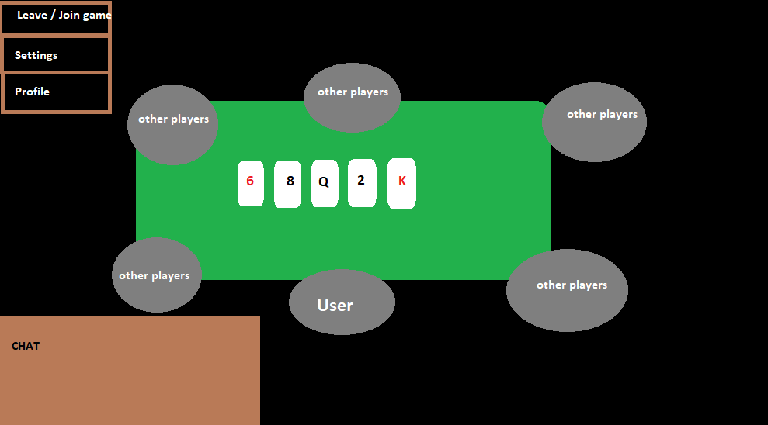

**Data Storage:**

Data will be handled using the XYUL database system, a relational database known for its robustness and scalability. A high-level conceptual model of the database design is included, highlighting the tables and their primary relationships.

[database design mock-up needed]

**Other Outputs**:

Email notifications for user-related events, such as registration confirmations and password resets.

Reports:

Potential report features for system analytics include:

Most popular and least popular pages.

User engagement metrics based on browser and hardware type.

Daily and monthly active user reports.

This High-Level Design document serves as a foundation for the detailed design phase, where each aspect will be fleshed out with precise specifications and implementation details.