

Shape



Color



Color

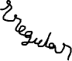

Shape

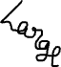

Size