The project is developed using java, MySQL, jsp, servlet, css, javascript, testng, and deployed on AWS.

The project basically has two modules, Customer and Admin

Run Project.

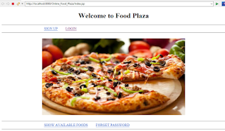

      When click on SIGN-UP link it will be redirected to sign up page.

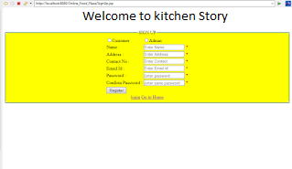

Sign in as admin

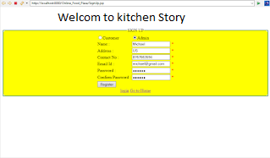

Each field is validated using Javascript which means we are not allowed to leave any field as blank otherwise we will get a message as "Enter Name" in place of ”\*" beside that field.

After entering all the details properly and once we click on the register button, our details will get added to the database, and thereafter we will get redirected to the log in page with suitable message.

https://1.bp.blogspot.com/-CaoWzJk7BYU/X4V_aU9HIpI/AAAAAAAAJyU/rKrX0T_6tmYT8RvlZi5tlGmRHwgM5YYLgCLcBGAsYHQ/w320-h55/Screenshot%2B%252865%2529.png

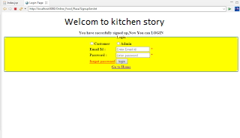

     Login as admin, click on the login link.

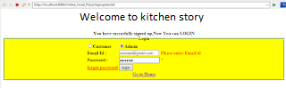

 Now if after entering proper login credentials if we click on the login button.

    we will be redirected to the new page with a proper message.

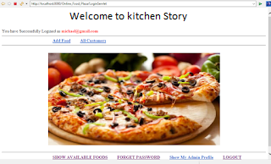

After login, as we can see admin got some privilege like add food, all customers, show my profile, logout, food click on add food link, and we'll be redirected to that page.

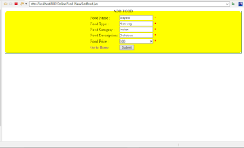

    In the above screenshot, I have entered details of food and after clicking on the submit button food will get added into the database. and message will be displayed.

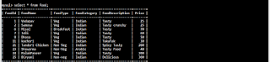

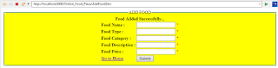

  Available food from admin perspective

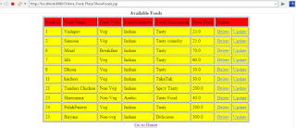

Admin will have to option—Update add and delete

Update the price for food biryani, for that, first, click on the update link beside the biryani food row. Then we will be redirected to the update page of the biryani food.

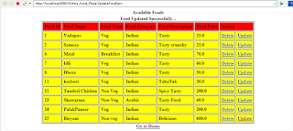

Delete food biryani. For that just click on the delete link beside biryani food.

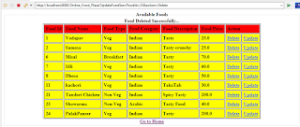

   
 Admin can see own profile by clicking on show my profile and thereafter he can update his profile.

https://1.bp.blogspot.com/--xjE_hJScrk/X4XSoUCWs_I/AAAAAAAAJ0Y/nw4FbSfK5BoW3okoDTb_PyzitcPMdjtwwCLcBGAsYHQ/w320-h52/Screenshot%2B%252878%2529.png

Admin can also change his password in case he forgot it by clicking on forgot password

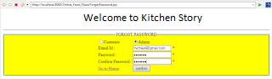

     After pressing the confirm button password will be updated in the database.

https://1.bp.blogspot.com/-qf_pq3zzdzs/X4XUgT9UvCI/AAAAAAAAJ0s/TjK1vVWt3YIdeNvskvk-JHa0N5NNsuv4ACLcBGAsYHQ/w320-h47/Screenshot%2B%252886%2529.png

   Log out from the admin. For that just click on the logout link in the application.

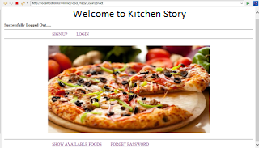

    Sign up as customer, after entering all details and pressing the register button data will be added into the database.

https://1.bp.blogspot.com/-JhgttL1pNfA/X4XYPuClIGI/AAAAAAAAJ1Q/z4iD0ZDVB-kfew6mJ-qltBsXu9UR8VBwgCLcBGAsYHQ/w320-h41/Screenshot%2B%2528103%2529.png

Login as CUSTOMER.

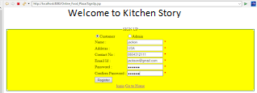

After pressing the login button customer will be redirected to the home page with some option

Like show my cart, show my profile, show available food, forgot password, logout.

and now a customer can make order

.

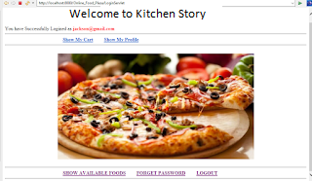

 Now the customer can see all foods and he can add foods into his cart

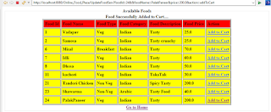

After adding foods to the cart, check the cart.

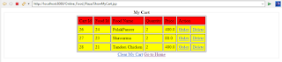

Customer can delete particular food through the delete button, and he can also delete all foods from the cart through the clear my cart button.

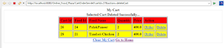

Order tandoori chicken.

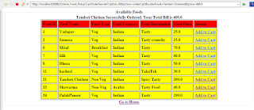

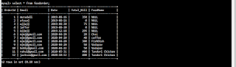

Customer can also see his profile and thereby can update his profile, change his password like in ADMIN MODULE.