**SCREENSHOTS**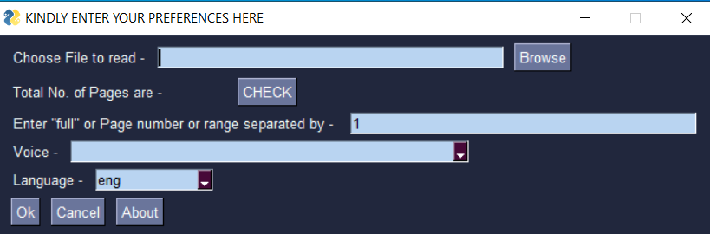

Figure 6.1. Input Page for taking user preferences like input file to be read, page number,

voice and language.

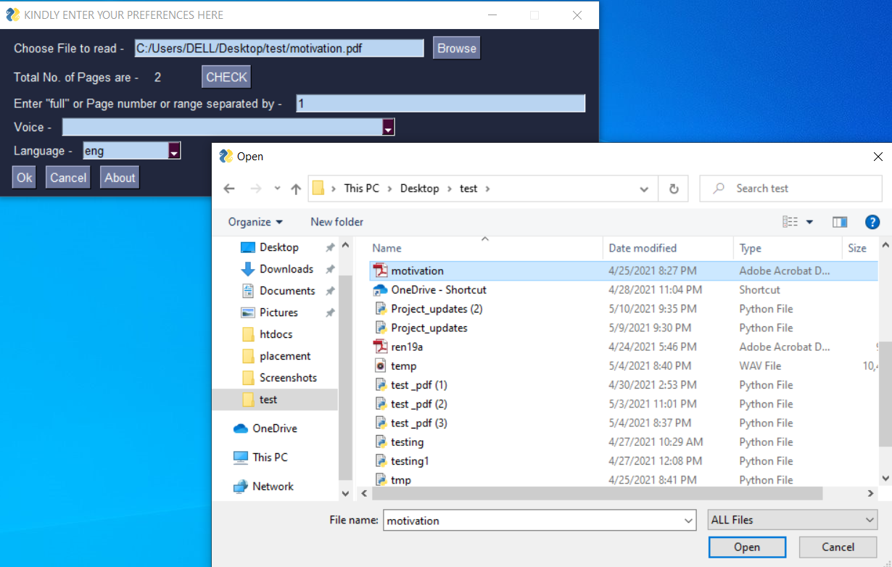

Figure 6.2. Pop-up window to choose the file to be read.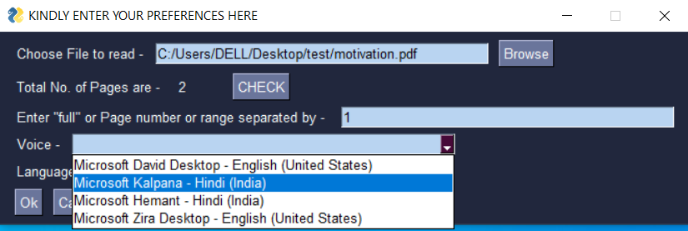

Figure 6.3. User gets to choose from various voice options as shown in the figure.

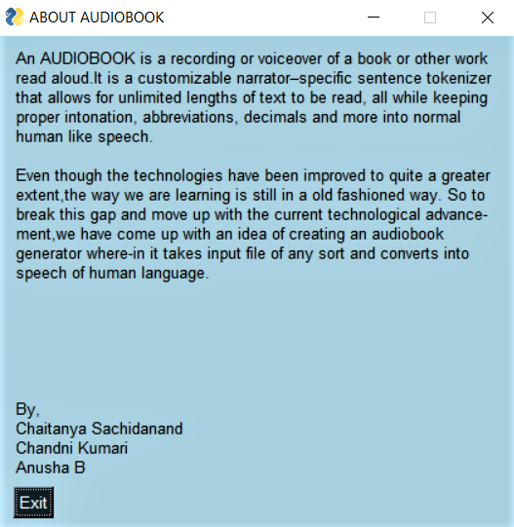

Figure 6.4. About page opens up on clicking about button in input

page which displays brief description of an audiobook.

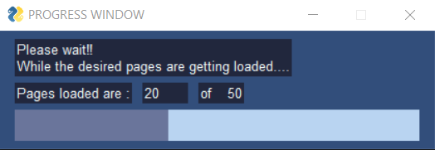

Figure 6.5. Progress Window.

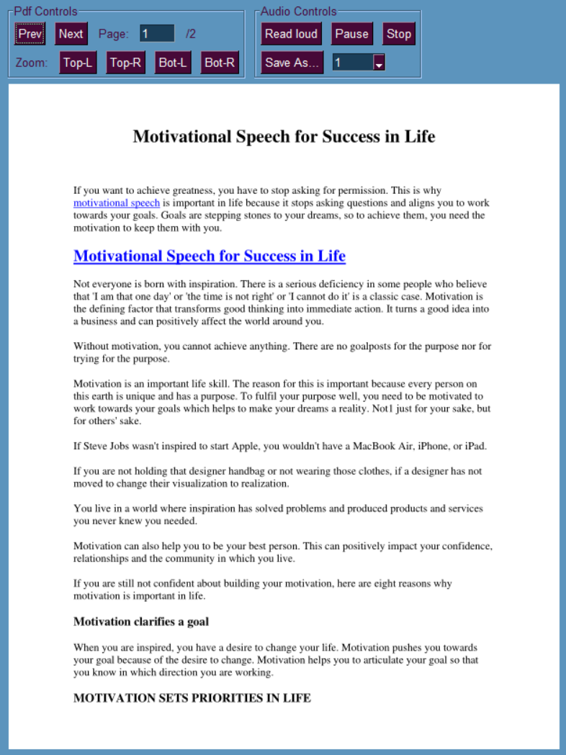

Figure 6.6. Selected file is displayed in the following manner with pdf control and

audio control buttons.