Home Page

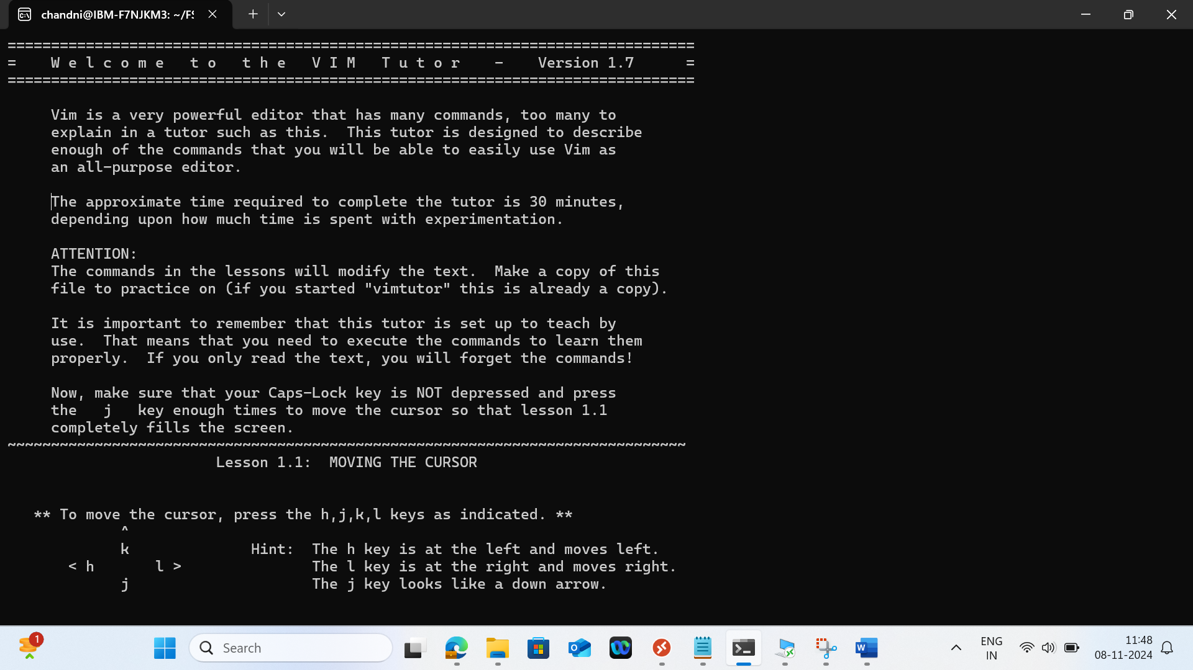

Lession1.3

Lesion 1.4

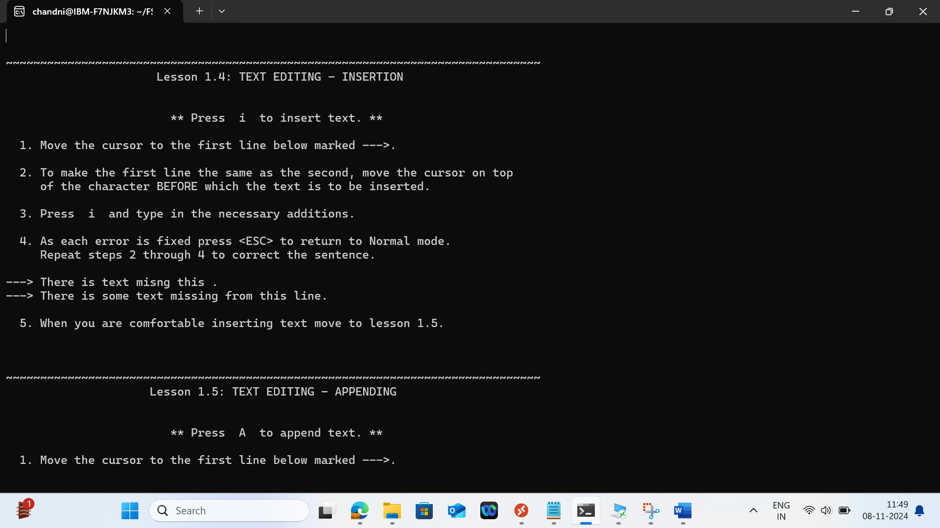

Lesion 1.5

