NORTHWIND INTERACTIVE SALES DASHBOARD
Using Microsoft Power BI
Project Report

Submitted By
Name: Chandni
Tool Used: Microsoft Power BI Desktop

1. Introduction
For this project, I built an interactive Northwind sales dashboard in Power BI. The report converts order, customer, product, employee and category information into a set of summary KPIs and visual analyses.
The dashboard is designed to make overall sales performance, order trends, category contribution and customer distribution easy to review.

2. Objectives
- Analyse total orders, customers, quantity sold and freight.
- Track orders by month.
- Compare orders by employee.
- Compare sales across product categories.
- Analyse the number of customers by country.
- Provide interactive filtering for year, country and category.

3. Dataset Description
The report uses Northwind sales data and the visible fields include Order, Customer, Product, Category, Employee, Country, Quantity and Freight-related measures.

4. Data Preparation
The data was prepared in Power BI so that order, customer, product, category, employee and geographic fields could be used in measures and visuals.
- Prepared order and customer fields.
- Prepared product and category fields.
- Prepared employee and country dimensions.
- Prepared month and year information.
- Created measures for order, quantity, freight and customer KPIs.

5. DAX / Measures Used
- Total Orders – 809
- Number of Customers – 91
- Total Quantity Sold – 51K
- Total Freight – 63.96K
- Average Freight – 79.05
The KPI values above are the values visible in the supplied Power BI screenshots.

6. Dashboard Components
The main SALES OVER VIEW page contains KPI cards, a monthly order trend, category sales and employee order distribution.
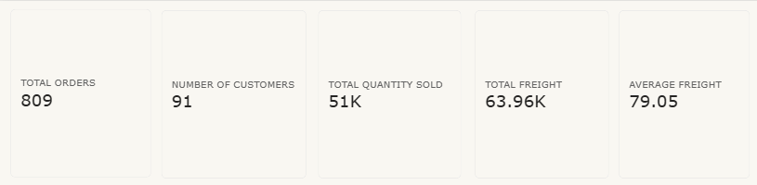
Figure 1: SALES OVER VIEW
The displayed KPI cards show 809 total orders, 91 customers, 51K quantity sold, 63.96K freight and 79.05 average freight.

7. Orders by Month
The monthly order chart shows the number of orders from January through December. The visible trend rises around March, falls sharply in May and June, then recovers toward December.
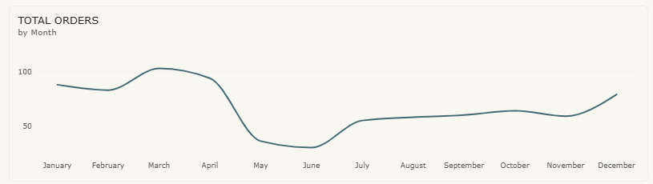
Figure 2: TOTAL ORDERS by Month

Orders by Employee
The employee chart compares total orders across employees, with Margaret Peacock shown at the top of the displayed ranking.

8. Sales by Category
The category chart compares total sales across the Northwind product categories. Beverages and Dairy Products are the two largest displayed categories, followed by Confections, Meat & Poultry, Seafood, Condiments, Produce, and Grains & Cereals.
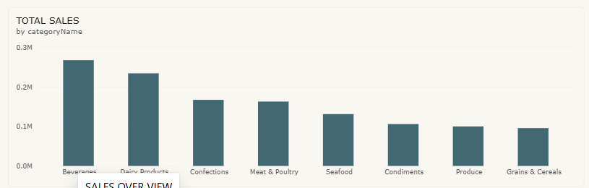
Figure 3: TOTAL SALES by Category

9. Customer Analysis by Country
The customer analysis page shows the number of customers by country. USA, France and Germany are the largest displayed country groups, followed by Brazil and the UK.
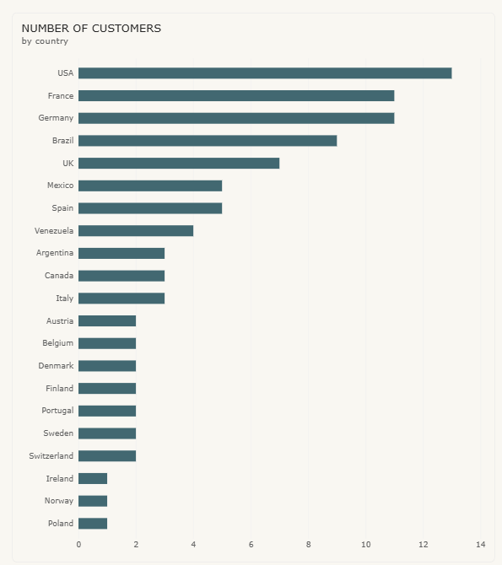
Figure 4: NUMBER OF CUSTOMERS by country

10. Interactive Sales Board and Filters
The INTERACTIVE SALES BOARD combines the monthly order trend, employee order chart and category sales chart with filters.
The visible slicers are:
- Year – options include 2013 and 2014.
- Country – filters the dashboard by country.
- Category Name – filters the dashboard by product category.
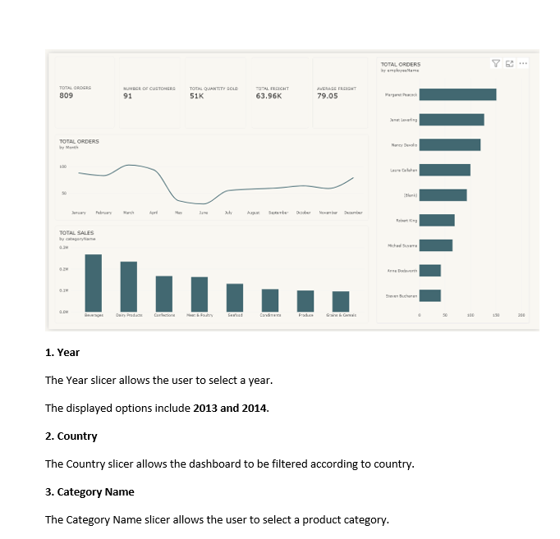
Figure 5: Interactive dashboard / filters

Key Findings
- Total Orders: 809.
- Number of Customers: 91.
- Total Quantity Sold: 51K.
- Total Freight: 63.96K.
- Average Freight: 79.05.
- Orders vary considerably by month, with a low point around May–June in the displayed trend.
- Beverages is the largest displayed category by total sales.
- The USA has the largest displayed customer count.

Conclusion
The Northwind dashboard demonstrates how Power BI can combine operational KPIs, time trends, employee analysis, category analysis and customer geography in an interactive report.

References
- Microsoft Power BI Desktop
- Northwind Sales Dataset
- Microsoft Power BI Documentation

