WALMART SALES PERFORMANCE DASHBOARD
Using Microsoft Power BI
Project Report

Submitted By
Name: Chandni
Tool Used: Microsoft Power BI Desktop

1. Introduction
For this project, I built a sales performance dashboard in Power BI using Walmart's weekly sales data. The dataset includes store-level sales, dates, fuel prices, CPI, unemployment and a holiday flag.
The dashboard is intended to turn the weekly sales records into an interactive report that can be filtered and reviewed through KPI cards and visualizations.

2. Objectives
- Analyse Walmart weekly sales across all 45 stores.
- Build an interactive rather than static report.
- Compare sales on holiday weeks versus regular weeks.
- Track how sales moved over time.
- Examine fuel price against weekly sales.

3. Dataset Description
- Store — store identifier (1 to 45)
- Date — the week the sales were recorded
- Weekly Sales — total sales for that store in that week
- Fuel Price — average fuel price for that week
- CPI — Consumer Price Index
- Unemployment — unemployment rate
- Holiday Flag — whether that week included a holiday

4. Data Preparation
The Date column was prepared as a proper date field and the sales, fuel price, CPI and unemployment fields were treated as numeric fields. Measures were created for the dashboard KPIs.

5. DAX Measures Used
- Total Sales
- Average Sales
- Store Count
- Maximum Sales
The supplied reference report describes these as SUM, AVERAGE, DISTINCTCOUNT and MAX measures based on Weekly Sales.

6. Dashboard Components
The dashboard contains KPI cards for Total Sales, Average Sales, Store Count and Maximum Sales, together with weekly sales trend, holiday/non-holiday sales, CPI and unemployment trends, sales by store, sales contribution by store and fuel price versus weekly sales.
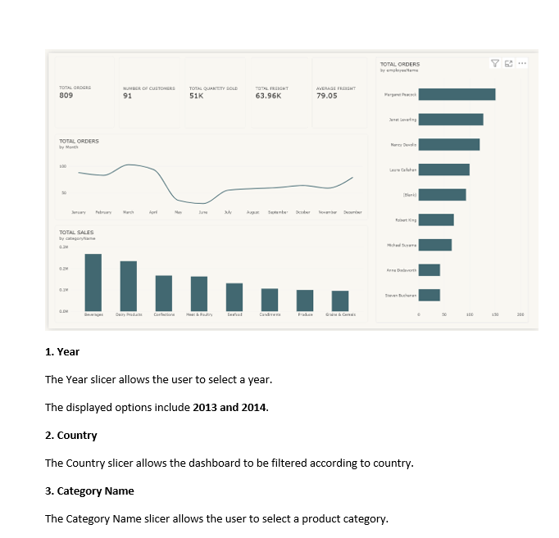
Figure 1: Walmart sales dashboard

7. Weekly Sales Trend
A line/area chart tracks weekly sales over the full dataset period. The supplied report notes visible seasonal spikes around holiday periods.
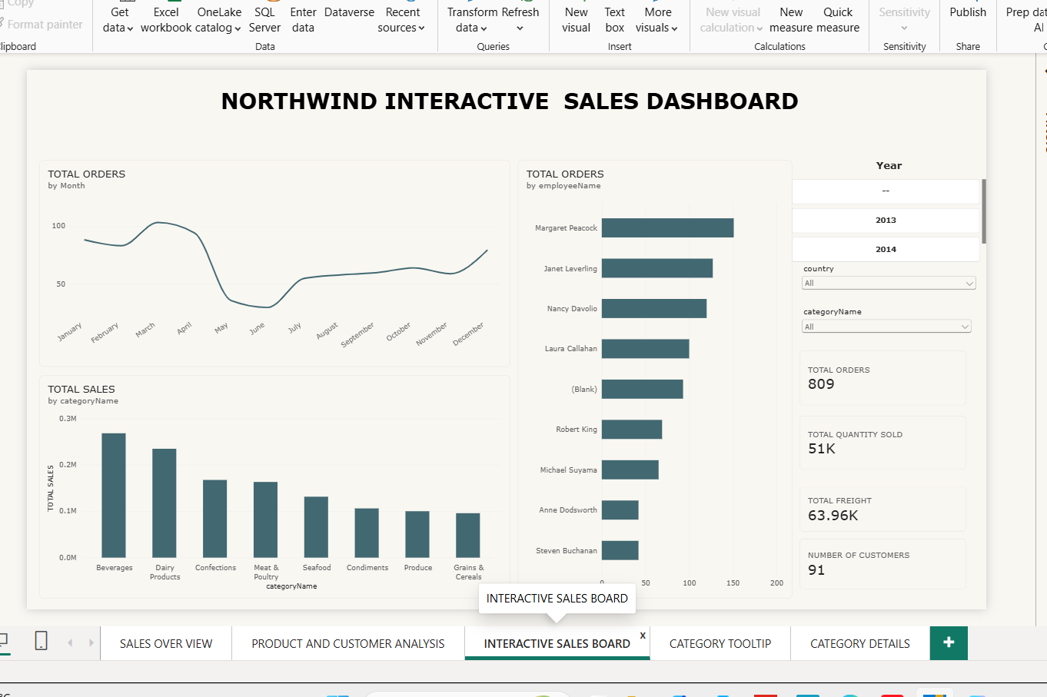
Figure 2: Weekly Sales Trend

Sales by Store
A clustered bar chart compares all 45 stores by total weekly sales.

8. Holiday vs Non-Holiday Sales
A pie chart compares total sales between holiday and non-holiday weeks. In the supplied dashboard screenshot, the displayed values are approximately 6.23bn (92.5%) and 0.51bn (7.5%).
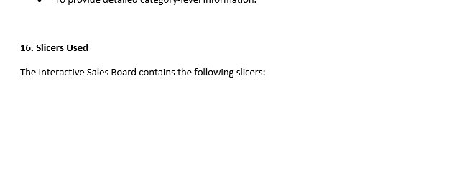
Figure 3: Holiday vs Non-Holiday Sales

Sales Contribution by Store
A treemap shows each store's contribution to total sales, where larger tiles represent larger contributions.

9. Fuel Price vs Weekly Sales
A scatter chart plots fuel price against weekly sales. The supplied report describes the points as fairly scattered, with no clear pattern.
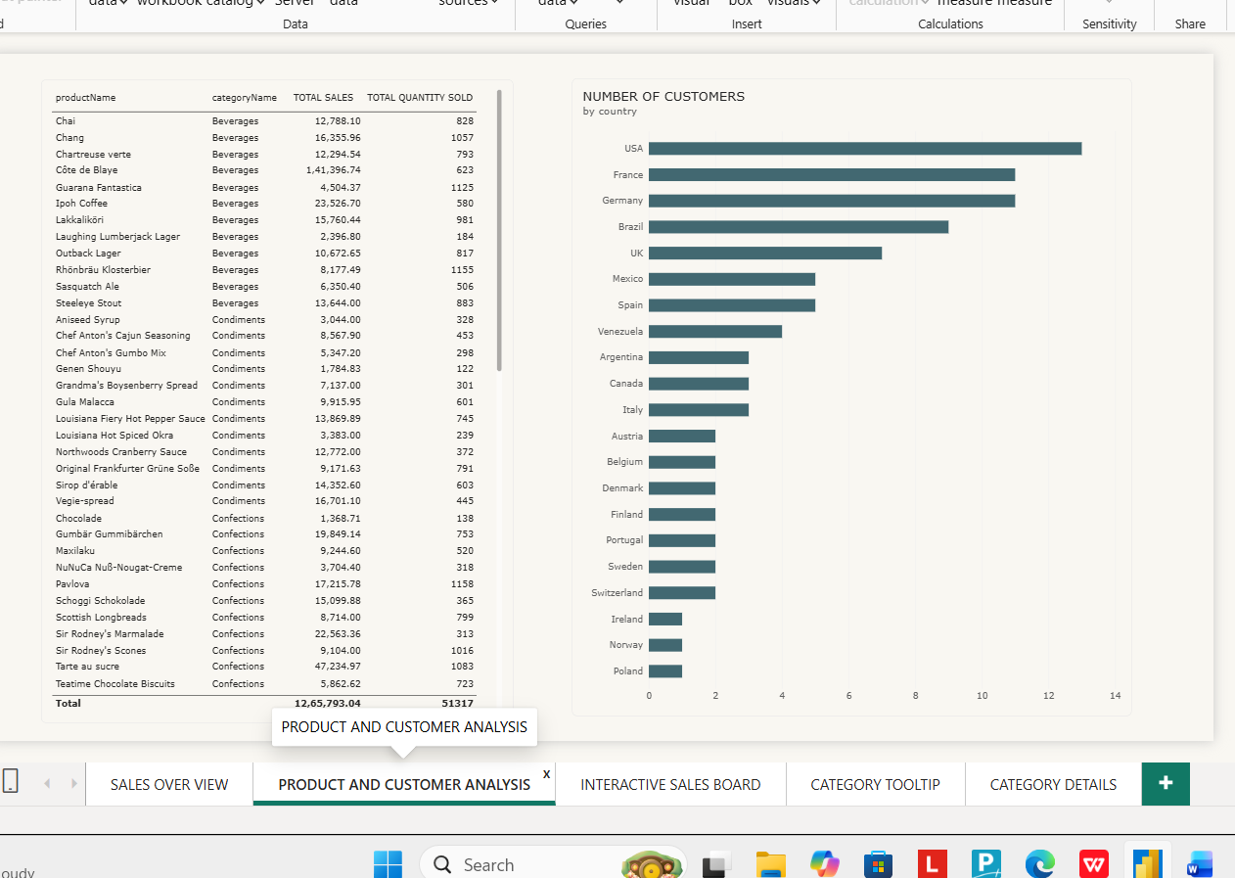
Figure 4: Fuel Price vs Weekly Sales

CPI and Unemployment Trends
A separate line chart tracks CPI and unemployment over time alongside the sales analysis.

10. Slicers Used
- Year
- Store
- Holiday Status
These slicers allow the dashboard to be narrowed to a particular year, store or holiday status, with the visuals updating together.
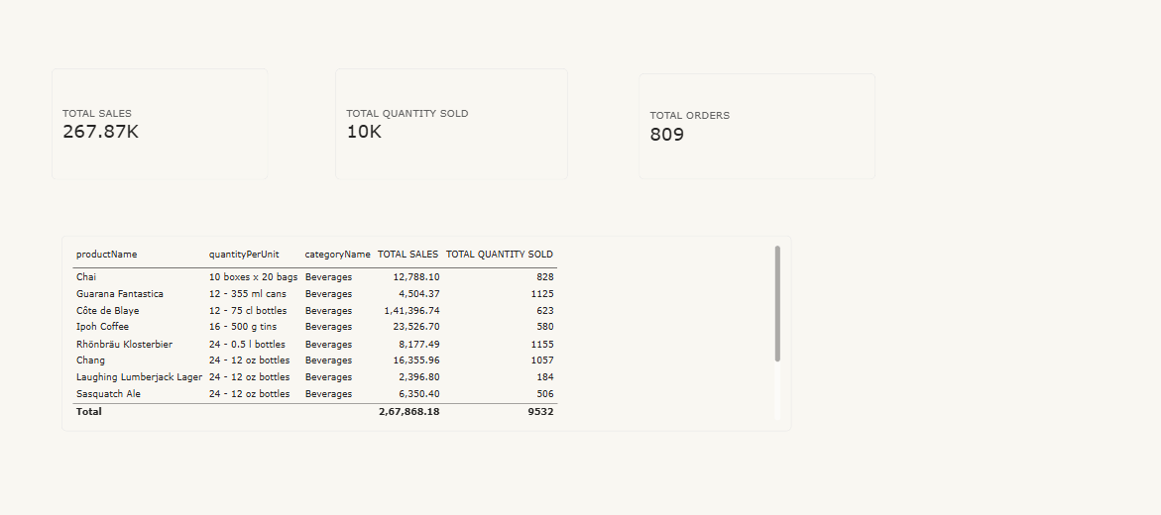
Figure 5: CPI and Unemployment Trends / slicer section

Key Findings
- Total sales across all stores are roughly $6.73 billion in the reference report.
- Average weekly sales are around $1.05 million.
- The dataset covers 45 stores.
- The maximum weekly sales figure is about $3.82 million.
- Sales performance varies across stores.
- Non-holiday weeks have more total sales in the report because they occur more frequently.
- Weekly sales fluctuate across the year.
- The reference report describes no strong relationship between fuel price and weekly sales.

Conclusion
The Walmart dashboard demonstrates how Power BI can turn weekly store sales data into an interactive report using KPI cards, trends, store comparisons, holiday analysis, economic context and slicers.

References
- Microsoft Power BI Desktop
- Walmart Sales Dataset
- Microsoft Power BI Documentation

